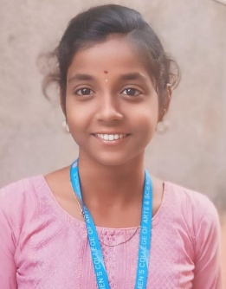**Resume**

**Name:** K. Harshitha

**Email id:** [harshithakrishnamoorthy06@gmail.com](mailto:harshithakrishnamoorthy06@gmail.com)

**Phone Number:** 8248895993

**Address:** No. 13, Bharathi street, Sri Devi nagar,

Avadi, Chennai-600071.

**CAREET OBJECTIVE:**

* Recent Graduate with a Bachelor in computer Application seeking an entry level position in IT industry to leverage my skills and contribution a dynamic team.

**ACADEMIC QUALIFICATIONS:**

* 10th from IHM girls’ higher secondary school.
* 12th from IHM girls’Higher secondary school.
* BCA Graduate from Mahalakshmi college of arts and sciences.

**SKILLS :**

* Communication
* Problem solving
* Basic knowledge of computer
* Easy to adapt in every environment

**KNOW PROGRAMMING LANGUAGE:**

* HTML
* PYTHON
* JAVA

**WORK EXPERIENCE:**

* Fresher

**PERSONAL DETAILS:**

**D.O.B:** 06.04.2006

**Gender:** Female

**Nationality:** Indian

**Father’s Name:** P. Krishnamoorthy

**Mother’s Name:** K. Dhatchayani

**Language known:** Tamil & English

**Hobbies:** Reading books, Drawing

**Place:** Avadi

**Date:** 20.03 2025