================================================================
MOBITREND RETAIL INDIA — MOBILE SALES INTELLIGENCE DASHBOARD
Project Notes | Power BI Documentation
================================================================
Data Period : Oct 2021 – Oct 2024
Raw Records : 5,200
Clean Records : 4,409
Total Revenue : 881M
Brands : Apple, Samsung, OnePlus, Vivo, Xiaomi
Cities : 19 Indian Cities
Models : 15 Smartphone Models
================================================================

----------------------------------------------------------------
SECTION 1: BUSINESS PROBLEM
----------------------------------------------------------------
MobiTrend Retail India — a multi-brand smartphone retailer operating across 19 cities — experienced consecutive revenue declines after peaking at ₹299M in 2022.

Leadership Questions:
1. Diagnose the root cause of post-2022 revenue decline
2. Identify brands, models, and cities growing vs falling
3. Understand customer behaviour by age, payment, and satisfaction
4. Prioritize inventory, promotions, and expansion decisions

Target: 15% YoY growth (IDC India Smartphone Retail, 2023)

Stakeholder: Head of Sales & Strategy

----------------------------------------------------------------
SECTION 2: ASSUMPTIONS
----------------------------------------------------------------
1. Units <= 0 and PricePerUnit <= 0 are invalid
2. Customer ratings outside 1–5 clamped to boundary values:
- Below 1 → replaced with 1
- Above 5 → replaced with 5
- Reason: Avoid data loss while maintaining the valid range
3. Target growth rate of 15% YoY bench-marked against India's smartphone retail industry average (IDC, 2023)
4. 2021 data covers Oct–Dec only (partial year)
5. 2024 data covers Jan–Oct only (partial year)
6. YoY% for 2022 is not reliable due to the partial 2021 base

----------------------------------------------------------------
SECTION 3: DATA CLEANING — POWER QUERY
----------------------------------------------------------------
RAW FILE: Mobile_Sales_Data.xlsx
SHEETS: FactSales, DimDate, DimProduct, DimCustomer, DimPayment

---- DimCustomer ----
- Validated data types for all columns, removed duplicate row, blank rows
- Added custom column: Age Group
Formula:
if [Customer Age] >= 18 and [Customer Age] <= 25
then "Youth"
else if [Customer Age] >= 26 and [Customer Age] <= 40
then "Adults"
else if [Customer Age] > 40
then "Seniors"
else "Kids"
Changed data type to Text

---- DimProduct ----
- Validated data types for all columns
- Removed duplicate rows & blank rows

---- DimPayment ----
- Verified all payment method values
(UPI, Cash, Credit Card, Debit Card)

---- DimDate ----
- Removed unnecessary columns: Year, Month, Day, DateKey
- Validated data types for all columns

---- FactSales ----
- Validated data types for all columns

Based on the Assumptions:
- Filtered out rows where Units <= 0
- Filtered out rows where PricePerUnit <= 0
- Replaced CustomerRatings:
-1 → 1 | 0 → 1 | 8 → 5
- Filtered null values in:
CustomerKey, ProductKey, PaymentKey

Date Validation (Custom Column — OrderDate):
Step 1: Changed DateKey datatype to Text (String)
Step 2: Added custom column:
= try Date.From(
Text.Start([DateKey], 4) & "-" &
Text.Middle([DateKey], 4, 2) & "-" &
Text.End([DateKey], 2)
) otherwise null
Step 3: Changed OrderDate type to Date
Step 4: Filtered blank/null rows (invalid dates removed)
Step 5: Removed DateKey column

FK Integrity Validation (DAX Calculated Tables):
InvalidProducts = EXCEPT(VALUES(Sales[ProductKey]), VALUES(Products[ProductKey]))
→ Result: 9999 (one invalid product found)
→ Action: Filtered out ProductKey = 9999 in Power Query

InvalidCustomers = EXCEPT(VALUES(Sales[CustomerKey]), VALUES(Customers[CustomerKey]))
→ Result: (blank) — no invalid customers found

FINAL RECORD COUNT:
Before cleaning : 5,200 rows
After cleaning : 4,409 rows
Removed : 791 rows
Fixed (clamped) : 138 rows (ratings)

----------------------------------------------------------------
SECTION 4: DATA MODEL — STAR SCHEMA
----------------------------------------------------------------
Fact Table : FactSales
Dimensions : DimDate, DimProduct, DimCustomer, DimPayment

Relationships:
FactSales[DateKey] → DimDate[DateKey] (Many-to-One)
FactSales[ProductKey] → DimProduct[ProductKey] (Many-to-One)
FactSales[CustomerKey] → DimCustomer[CustomerKey](Many-to-One)
FactSales[PaymentKey] → DimPayment[PaymentKey] (Many-to-One)

Filter Direction: Single (Dimension → Fact)
Date Table: DimDate marked as official date table

----------------------------------------------------------------
SECTION 5: DAX MEASURES
----------------------------------------------------------------

==== CORE METRICS ====

1. Total Revenue = SUMX(Sales, Sales[Units] * Sales[PricePerUnit])
Note: Used SUMX (measure) instead of calculated column to avoid model bloat and maintain filter context flexibility

- Total Quantity = SUM(Sales[Units])

3. Total Transactions = DISTINCTCOUNT(Sales[TransactionID])

4. Average Order Value = DIVIDE([Total Revenue],[Total Transactions],0)
Note: Revenue per transaction (one transaction can have multiple units)

5. Total Customers = DISTINCTCOUNT(Sales[CustomerKey])
Note: DISTINCTCOUNT on FactSales (not DimCustomer) to count only customers who actually transacted

6. Avg Customer ratings = AVERAGE(Sales[CustomerRatings])

==== TIME INTELLIGENCE ====

7. lastYrSales = CALCULATE([Total Revenue], SAMEPERIODLASTYEAR('Date'[Date]))

8. Target Sales = ([Last Year Sales] * 0.15) + [Last Year Sales]
Simplified: [Last Year Sales] * 1.15
Note: 15% more than the previous year = last year × 1.15

9. YoY growth% = IF(HASONEVALUE('Date'[Date].[Year]),
IF(SELECTEDVALUE('Date'[Date].[Year]) in {2021, 2022}, "NA", DIVIDE([Total Revenue] - [lastYrSales], [lastYrSales],0)),
"NA")
Note: HASONEVALUE ensures measure only shows when exactly one year is selected — avoids misleading aggregated % when no year is filtered

==== PRODUCT KPIs ====
10. Highest Selling Product = var topSellingProd = TOPN(1,VALUES(Products[Mobile Model]), CALCULATE(SUM(Sales[Units])), DESC)
RETURN MAXX(topSellingProd, Products[Mobile Model])
Note: Based on total units sold (not revenue or transaction count) — most accurate definition of "highest selling"

11. Top 5* orders = CALCULATE(DISTINCTCOUNT(Sales[TransactionID]), Sales[CustomerRatings]=5)
Note: Count of transactions rated 5 stars per product

12. Avg Rating = CALCULATE(AVERAGE(Sales[CustomerRatings]), ALL(Products[Mobile Model]))
Note: ALL() removes product filter — returns global average across all products for quadrant benchmarking

13. Avg Revenue = AVERAGEX(ALL(Products[Mobile Model]), [Total Revenue])
Note: AVERAGEX iterates over all products ignoring current filter — consistent benchmark regardless of which product is being evaluated

==== PRODUCT QUADRANT CLASSIFICATION ====
14. Quadrant Label =
VAR AvgRating = [Avg Rating]
VAR AvgRevenue = [Avg Revenue]
VAR CurrentRating = AVERAGE(Sales[CustomerRatings])
VAR CurrentRevenue = [Total Revenue]
RETURN
SWITCH(
TRUE(),
CurrentRevenue >= AvgRevenue && CurrentRating >= AvgRating,
"⭐ Star — Protect & Invest",
CurrentRevenue >= AvgRevenue && CurrentRating < AvgRating,
"🔍 Investigate — High Revenue, Low Satisfaction",
CurrentRevenue < AvgRevenue && CurrentRating >= AvgRating,
"💎 Hidden Gem — Promote & Push Inventory",
"⚠️ Reconsider — Low Revenue & Low Satisfaction"
)
Note: SWITCH(TRUE()) used instead of nested IF for readability and maintainability. Default case handles Low Revenue + Low Satisfaction by elimination.

15. Quadrant Color =
SWITCH(
[Quadrant Label],
"⭐ Star — Protect & Invest", "#2E8B57",
"🔍 Investigate — High Revenue, Low Satisfaction", "#FF8C00",
"💎 Hidden Gem — Promote & Push Inventory", "#1E90FF",
"⚠️ Reconsider — Low Revenue & Low Satisfaction", "#DC143C",
"#808080"
)
Usage: Format → Markers → Color → Field value → [Quadrant Color]

16. Strategic Recommendation =
SWITCH(
[Quadrant Label],
"⭐ Star — Protect & Invest",
"Maintain premium positioning, ensure inventory availability, and strengthen loyalty campaigns.",
"🔍 Investigate — High Revenue, Low Satisfaction",
"Analyze customer complaints, improve quality/service issues, and monitor churn risk.",
"💎 Hidden Gem — Promote & Push Inventory",
"Increase marketing visibility and bundle promotions to unlock growth potential.",
"⚠️ Reconsider — Low Revenue & Low Satisfaction",
"Review pricing, redesign strategy, or reduce inventory exposure."
)
Usage: Added to scatter plot Tooltips field well

==== CUSTOMER RETENTION ANALYSIS ====

17. Customer Purchase Frequency = CALCULATE(DISTINCTCOUNT(Sales[TransactionID]), ALLEXCEPT(Sales, Sales[CustomerKey]))
Note: ALLEXCEPT removes all filters on Sales EXCEPT CustomerKey — counts unique transactions per customer regardless of other filter context

18. Repeated Customers = CALCULATE(DISTINCTCOUNT(Sales[CustomerKey]), FILTER(VALUES(Sales[CustomerKey]), [Customer Purchase Frequency]>1))
Note: FILTER iterates customer list, keeps only those with Purchase Frequency > 1

19. One Time Customers = [Total Customers] - [Repeated Customers]

20. Repeated Customer Revenue% = DIVIDE(CALCULATE([Total Revenue], FILTER(VALUES(Sales[CustomerKey]), [Customer Purchase Frequency]>1)), [Total Revenue], 0)

21. OneTime Cust Revenue% = DIVIDE(CALCULATE([Total Revenue], FILTER(VALUES(Sales[CustomerKey]), [Customer Purchase Frequency]=1)), [Total Revenue], 0)

22. Avg Revenue per Repeat Customer =
DIVIDE(
CALCULATE([Total Revenue],
FILTER(VALUES(Sales[CustomerKey]), [Customer Purchase Frequency] > 1)),
[Repeated Customers],
0
)

23. Avg Revenue per One Time Customer =
DIVIDE(
CALCULATE(
[Total Revenue],
FILTER(VALUES(Sales[CustomerKey]),
[Customer Purchase Frequency] = 1)),
[One Time Customers],
0
)

- OneTime cust% = DIVIDE([One Time Customers], [Total Customers], 0)
- RepeatedCust% = DIVIDE([Repeated Customers], [Total Customers], 0)
- Display OneTimeCust = [One Time Customers]& " ("& FORMAT([OneTime cust%], "0.00%") & ")"
- Display Repeated Cust = [Repeated Customers]&" ("&FORMAT([RepeatedCust%], "0.00%")&")"

==== RETENTION RISK ====
28. Last purchase date = CALCULATE(MAX(Sales[OrderDate]), Sales[CustomerKey])

29. Reference Date = CALCULATE(MAX(Sales[OrderDate]), ALL(Sales))
Note: Uses last date in dataset (Oct 2024) instead of TODAY() — avoids inflated inactive days due to data ending in 2024

- Inactive days = DATEDIFF([Last purchase date], [Reference Date], DAY)

31. Retention risk =
var days_inactive = [Inactive days]
RETURN
IF(days_inactive <= 180, "Active",
IF(days_inactive <= 365, "At Risk",
IF(days_inactive <= 730, "Churned",
"Lost"
)
)
)

==== DYNAMIC UX MEASURES ====
32. Display PartialYear warning = IF(HASONEVALUE('Date'[Date].[Year]),
IF(SELECTEDVALUE('Date'[Date].[Year])=2022,
"⚠️ 2022 YoY% appears high due to partial 2021 data (Oct–Dec only). Not a reliable YoY comparison.",
" "),
"**YoY% is visible only when a year is selected!!")
Note: Returns single space (not blank) when inactive so card doesn't collapse. Applies same fix for 2021.

- Display Avg revenue = FORMAT(DIVIDE([Avg Revenue], 1000000, 0), "0.00") & "M"
- Display currRevenue = FORMAT([Total Revenue] / 1000000, "0.00") & "M"
- Display Customer Insights = "*Repeated customers ("&FORMAT([RepeatedCust%], "0.0%")&") spend 2x more than one-time buyers (" &FORMAT(DIVIDE([Avg Revenue per Repeat Customer],1000,0), "0.00")& "K vs "&FORMAT(DIVIDE([Avg Revenue per One Time Customer],1000,0), "0.00")& "K avg) and contribute "& FORMAT([Repeated Customer Revenue%], "0%")& " of total revenue - making retention campaigns significantly more cost-effective than new customer acquisition for reversing the revenue decline."
- Display LastPurchaseDate = FORMAT([Last purchase date], "DD-MM-YYYY")
- Display OneTimeCust = [One Time Customers]& " ("& FORMAT([OneTime cust%], "0.00%") & ")"
- Display Repeated Cust = [Repeated Customers]&" ("&FORMAT([RepeatedCust%], "0.00%")&")"

==== HIGHEST/LOWEST RATED PRODUCTS ====
39. Highest Rated Product =
var highRateProd = TOPN(1, VALUES(Products[Mobile Model]), CALCULATE(AVERAGE(Sales[CustomerRatings])), DESC)
return MAXX(highRateProd, Products[Mobile Model])

40. Lowest Rated Product =
var lowRateProd = TOPN(1, VALUES(Products[Mobile Model]), CALCULATE(AVERAGE(Sales[CustomerRatings])), ASC)
RETURN MAXX(lowRateProd, Products[Mobile Model])

==== VALIDATION MEASURES (Can be deleted post-verification) ====
41. InvalidCustomers = EXCEPT(VALUES(Sales[CustomerKey]), VALUES(Customers[CustomerKey]))
→ Used to identify ProductKey = 9999

- InvalidProducts = EXCEPT(VALUES(Sales[ProductKey]), VALUES(Products[ProductKey]))
→ Returned blank — no invalid customers

----------------------------------------------------------------
SECTION 6: KEY DESIGN DECISIONS
----------------------------------------------------------------
1. SUMX over Calculated Column for Revenue
Reason: Measure is filter-context aware, no storage overhead

2. SWITCH(TRUE()) over nested IF
Reason: Readability, maintainability, DAX best practice

3. ALL(Products) vs ALL(Products[Mobile Model])
Reason: ALL(Products[Mobile Model]) only removes model filter;
residual brand/date context shifts benchmark. ALL(Products)
ensures truly global benchmark for quadrant classification.

4. HASONEVALUE for YoY%
Reason: Prevents misleading aggregated % when multiple
years selected or no year selected — shows "--" instead

5. SELECTEDVALUE for partial year warning
Reason: Triggers only for 2022 — avoids static text that
clutters dashboard for other year selections

6. Reference Date vs TODAY() for inactive days
Reason: TODAY() gives 500+ days for all customers since
data ends Oct 2024. Reference Date uses last date in
dataset — gives meaningful relative inactivity.

7. Rating clamping vs row removal
Reason: Preserves 138 records. Ratings of -1, 0 → 1
and 8 → 5 are valid data points with boundary correction
rather than corrupt data requiring deletion.

8. ALLEXCEPT for Purchase Frequency
Reason: Removes all filters except CustomerKey —
ensures frequency counts all of a customer's transactions
regardless of current brand/city/date filter context.

9. Sales Trend ignores year slicer
Reason: Always shows full 4-year picture — single dot
appears when year is filtered, making trend unreadable.
Slicer interaction disabled for this visual only.

10. Page 2 filters hidden on Page 1
Reason: Page 1 = executive overview (time filters only).
Page 2 = analyst deep dive (granular filters). Separation
prevents cognitive overload for leadership audience.

----------------------------------------------------------------
SECTION 7: DASHBOARD SCREENSHOTS
----------------------------------------------------------------
Main Dashboard:
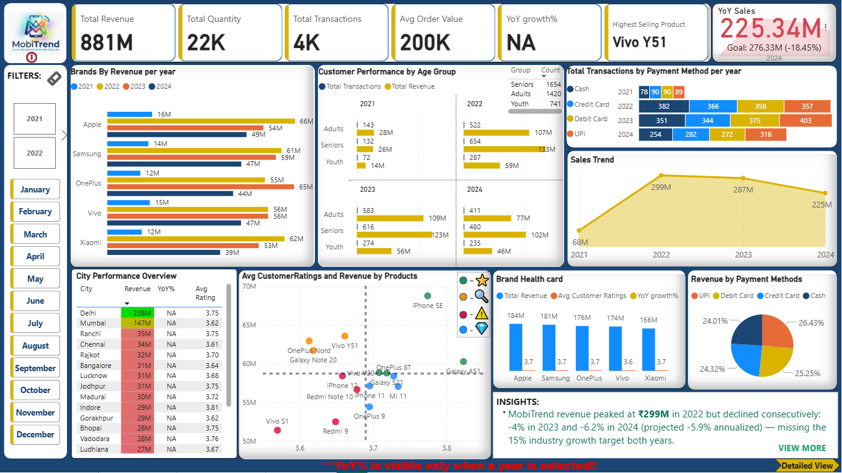

On click of ‘Detailed View’:
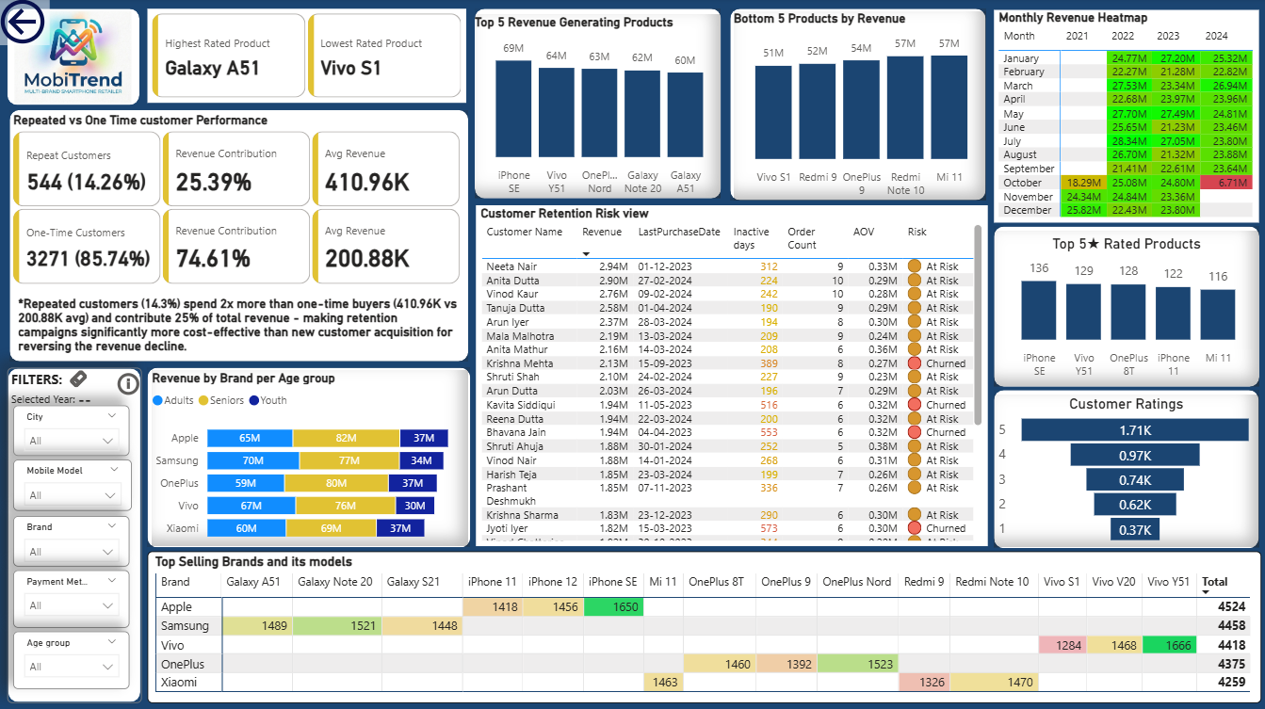

Year 2021:
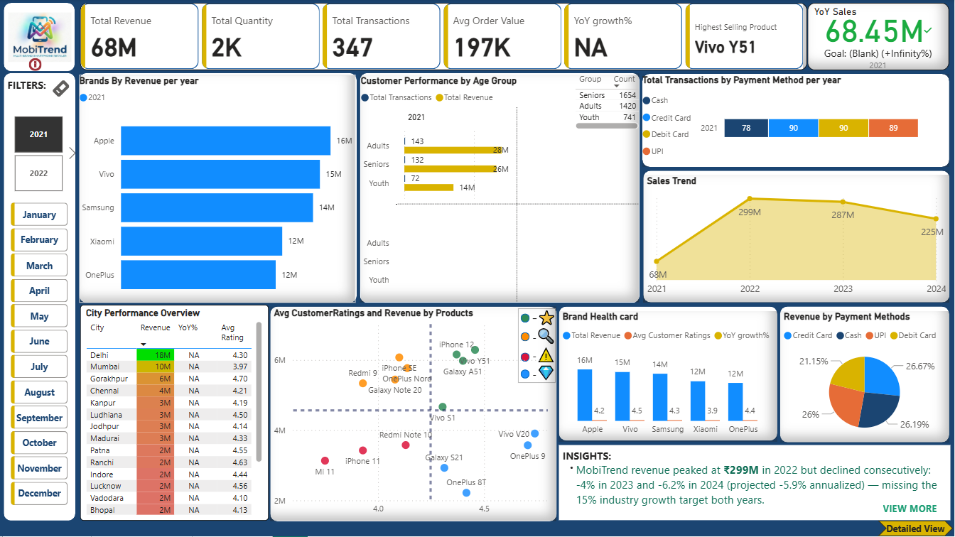

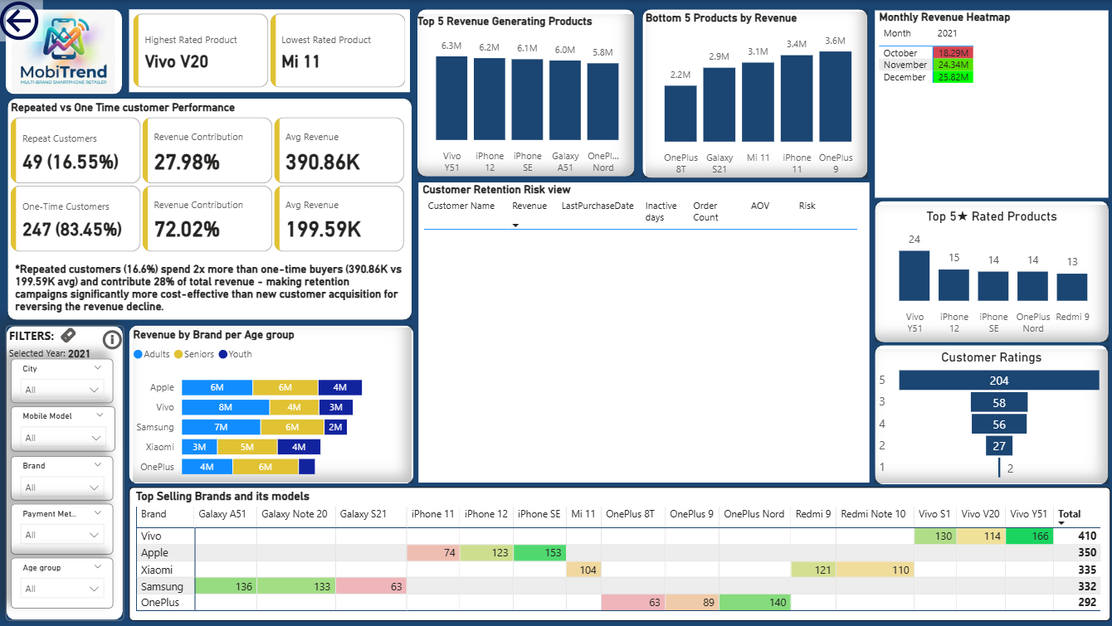

Year 2022:
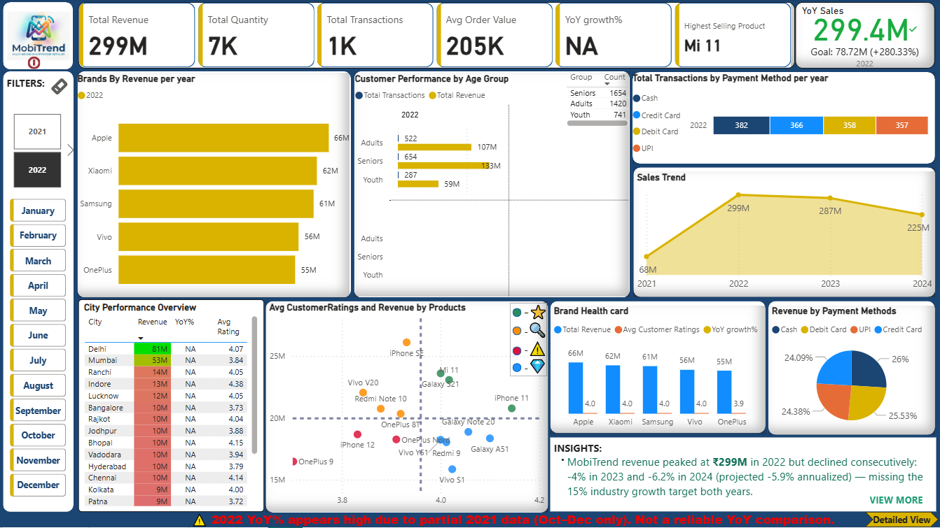

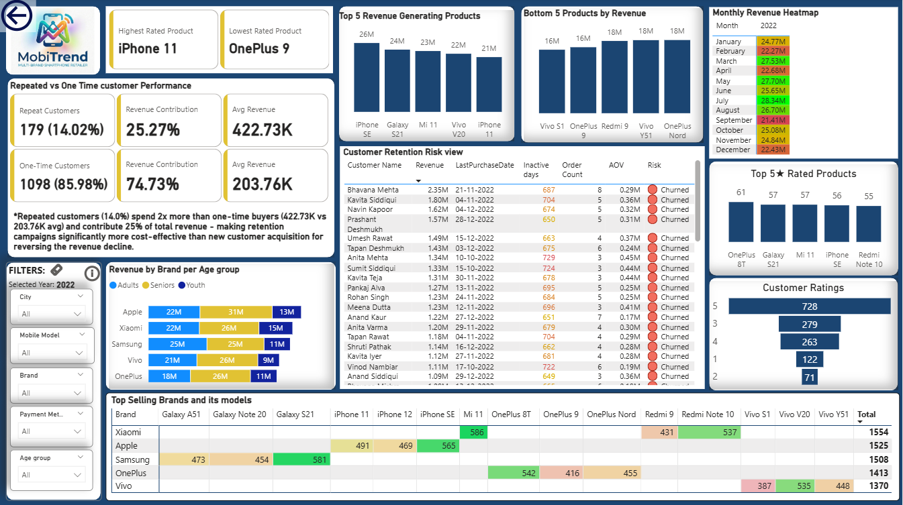

Year 2023:
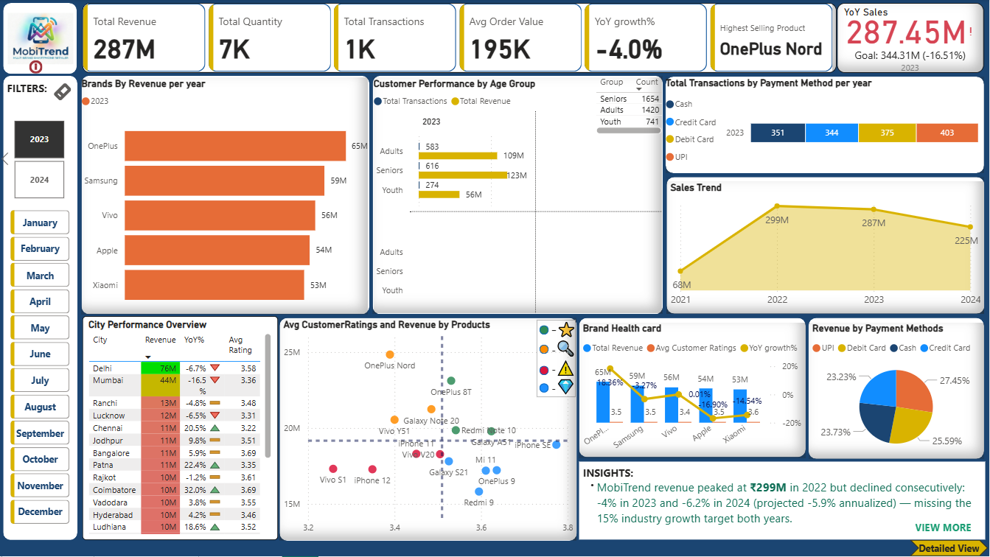

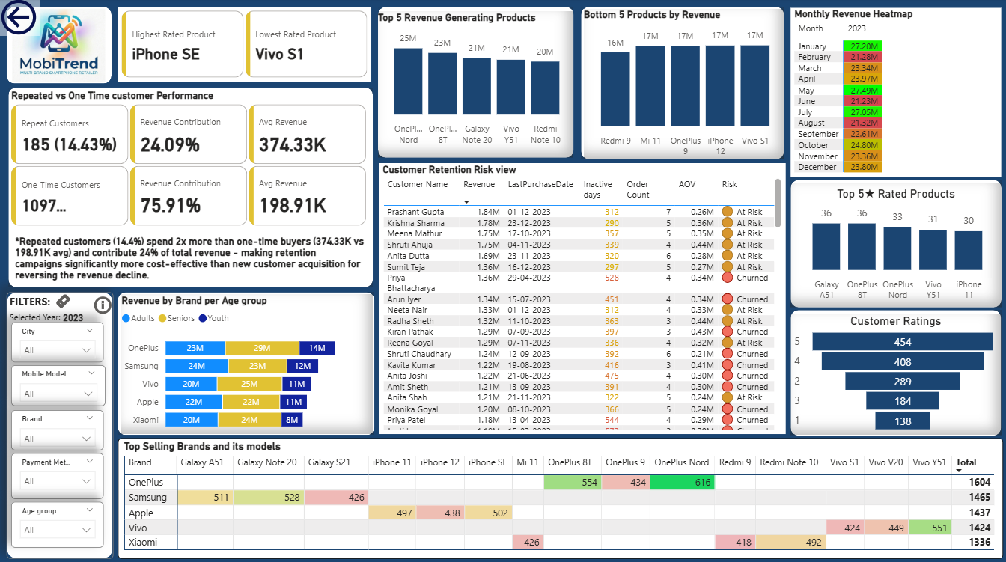

Year 2024:
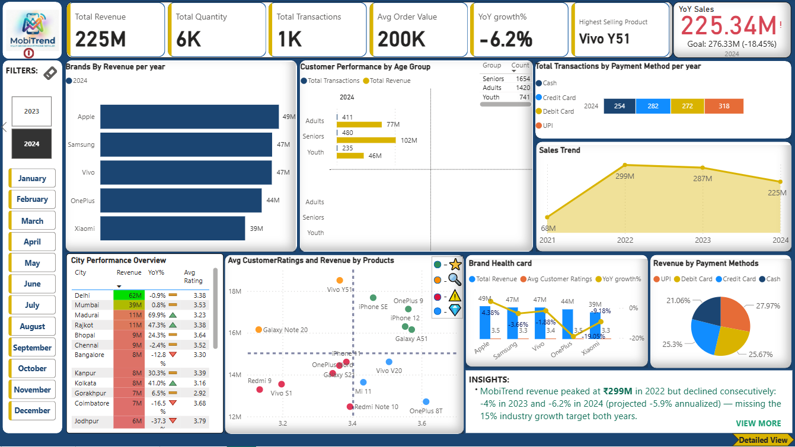
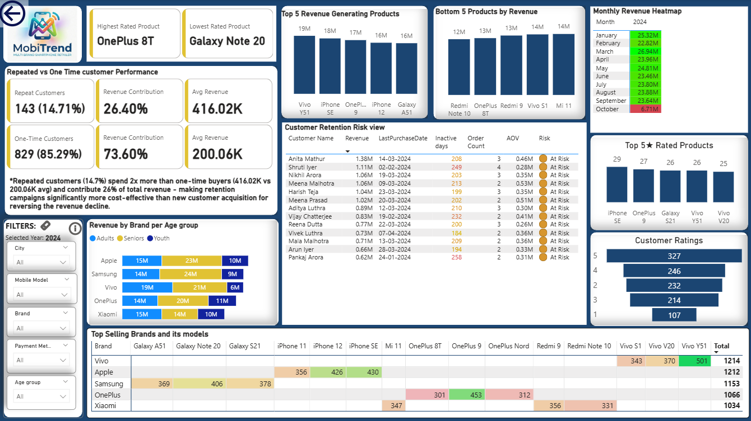

On click of ‘View More’ button in the Main Dashboard:
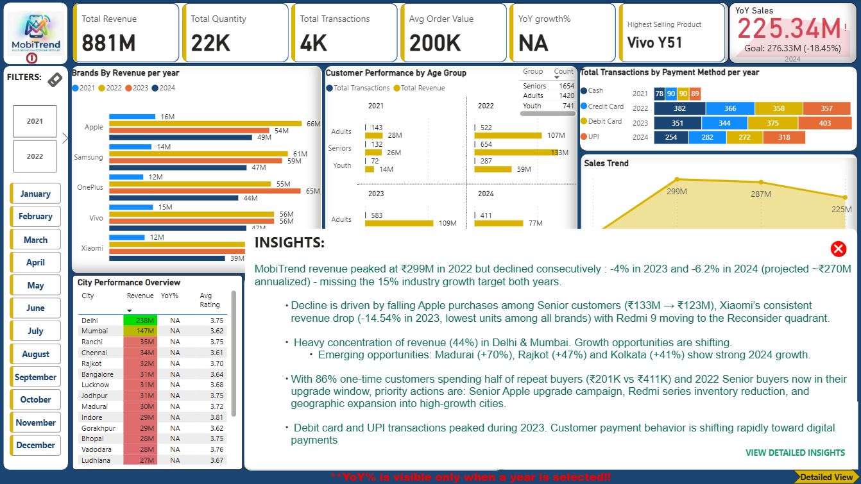

On click of ‘View Detailed Insights’ from the Insights popup,
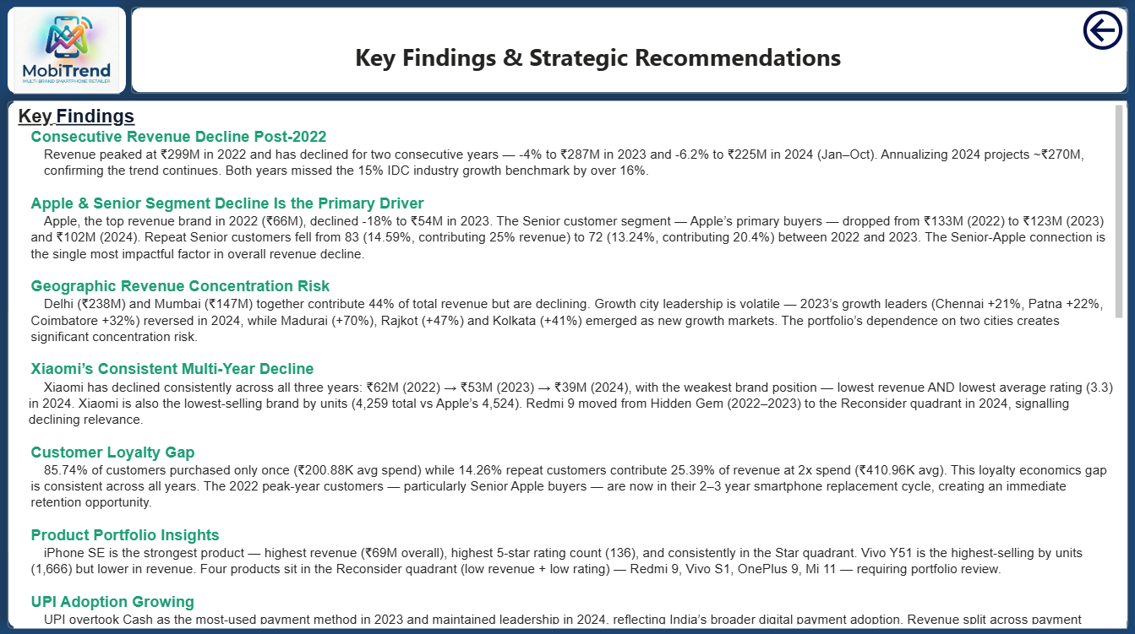

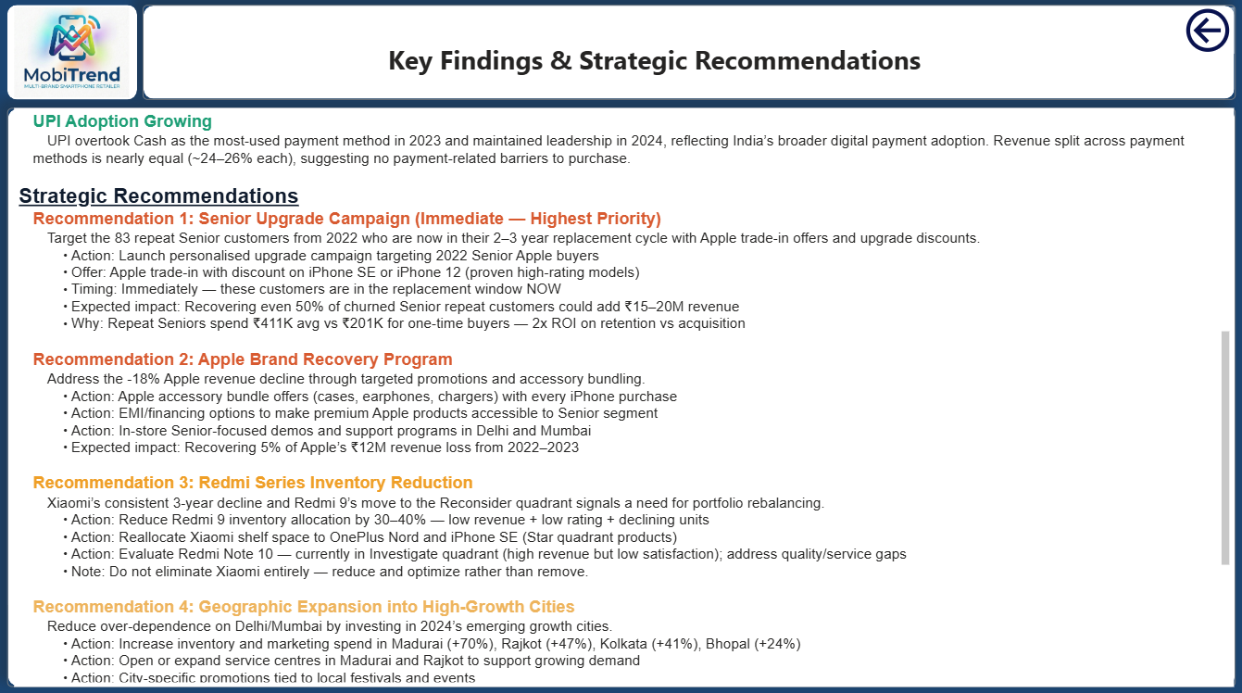

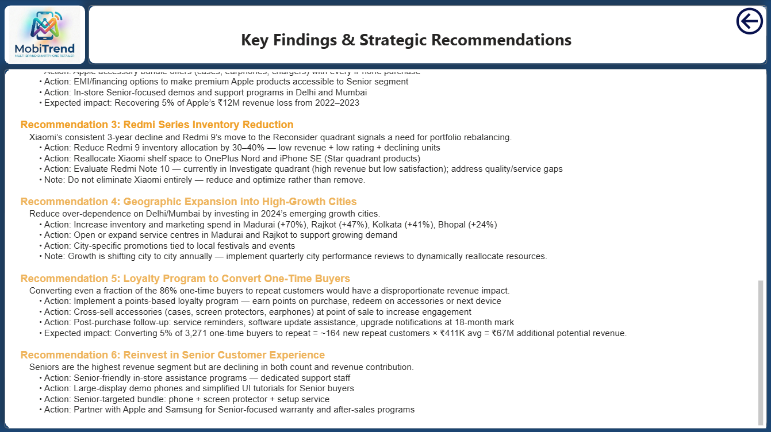

----------------------------------------------------------------
SECTION 8: KEY FINDINGS SUMMARY
----------------------------------------------------------------
1. Revenue declined -4% (2023) and -6.2% (2024) post-2022 peak
Annualised 2024: ₹225M / 10 months × 12 = ~₹270M
Both years missed 15% target by >16%

2. Apple + Senior = primary decline driver
Apple: ₹66M (2022) → ₹54M (2023) — -18% YoY
Senior revenue: ₹133M → ₹123M → ₹102M
Repeat Senior customers: 83 (14.59%, 25% rev) →
72 (13.24%, 20.4% rev)

3. Geographic concentration risk
Delhi + Mumbai = 44% of total revenue
Both declining; Growth city leadership shifting annually
2024 leaders: Madurai +70%, Rajkot +47%, Kolkata +41%

4. Xiaomi consistent 3-year decline
₹62M → ₹53M → ₹39M
Lowest avg rating (3.3) in 2024
Redmi 9: Hidden Gem (2022–23) → Reconsider (2024)

5. Customer loyalty gap
85.74% one-time (₹200.88K avg)
14.26% repeat (₹410.96K avg — 2x spend)
Repeat customers = 25.39% of revenue
2022 buyers in 2–3yr upgrade window NOW

6. iPhone SE = strongest product
₹69M overall, 136 five-star count, Star quadrant

7. UPI overtook Cash in 2023
Payment split nearly equal (24–26% each)

----------------------------------------------------------------
SECTION 9: STRATEGIC RECOMMENDATIONS
----------------------------------------------------------------
R1. Senior Upgrade Campaign (IMMEDIATE — HIGHEST PRIORITY)
Target : 2022 repeat Senior Apple buyers
Action : Trade-in offers + upgrade discounts on iPhone SE
Timing : NOW — 2–3yr replacement cycle window
Impact : +₹15–20M potential revenue recovery

R2. Apple Brand Recovery Program
Action : Accessory bundles, EMI options, Senior demos
Impact : Recover 5% of ₹12M Apple revenue loss

R3. Redmi Series Inventory Reduction
Action : Reduce Redmi 9 allocation 30–40%
Reallocate space to Star quadrant products
Evaluate Redmi Note 10 (Investigate quadrant)
Note : Reduce and optimise — do not eliminate Xiaomi

R4. Geographic Expansion
Action : Increase inventory + marketing in:
Madurai (+70%), Rajkot (+47%),
Kolkata (+41%), Bhopal (+24%)
Quarterly city performance reviews
Note : Growth cities shift annually — dynamic allocation

R5. Loyalty Program
Action : Points program, accessory cross-sell,
18-month upgrade notifications
Impact : 5% conversion × 3,271 one-time buyers
= ~164 new repeat customers × ₹411K
= ~₹67M additional potential revenue

R6. Reinvest in Senior Customer Experience
Action : Dedicated support staff, large-display demos,
Senior bundle (phone + protector + setup),
Apple/Samsung Senior warranty partnerships

----------------------------------------------------------------
SECTION 10: TOOLS & TECHNOLOGIES
----------------------------------------------------------------
Tool | Usage
------------------|------------------------------------------
Power BI Desktop | Dashboard, DAX, visualisations
Power Query (M) | Data cleaning & transformation
Microsoft Excel | Source data
Star Schema | Data modelling pattern

----------------------------------------------------------------
END OF PROJECT NOTES
MobiTrend Retail India | Mobile Sales Intelligence Dashboard
Data: Oct 2021 – Oct 2024 | Records: 4,409 | Revenue: ₹881M
================================================================

