1.CONTIGUOUS :

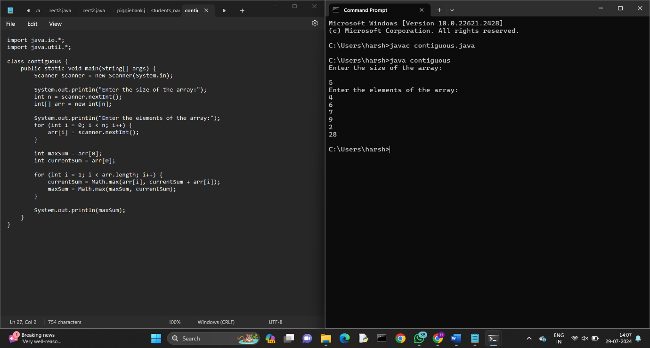

2.ZIGZAG:

3.LENGTH OF THE STRING:

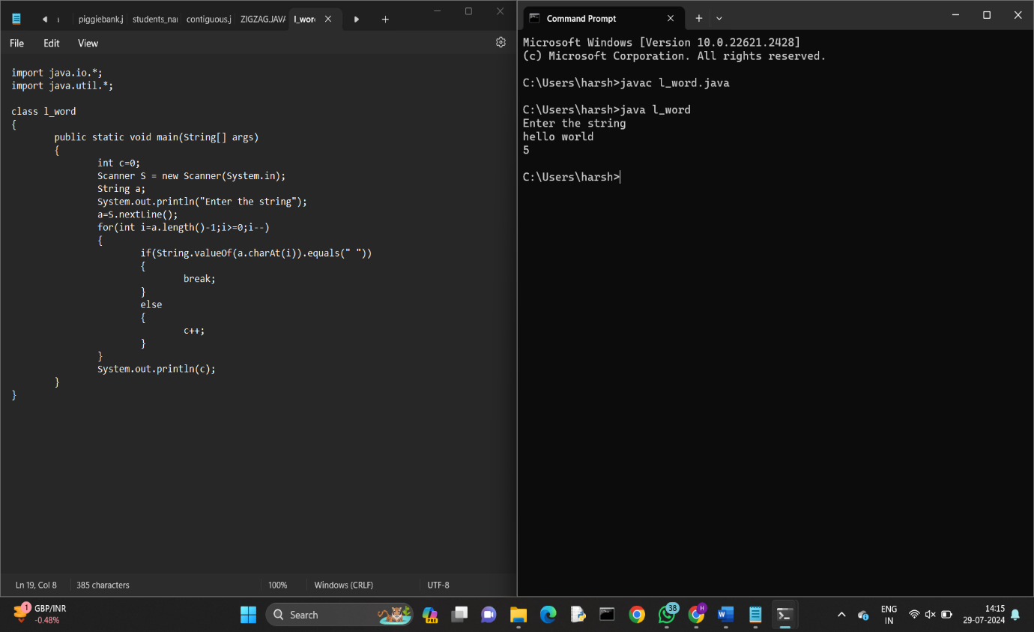

4.PEAL ELEMENT IN AN ARRAY:

