11. APPENDIX:
Source code:
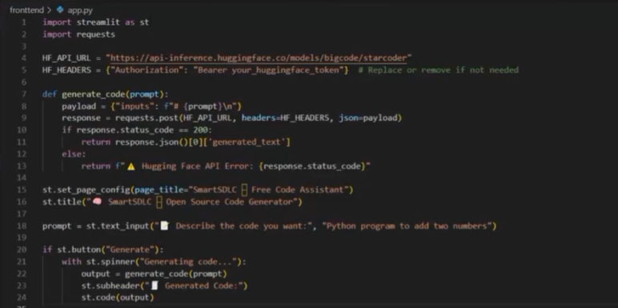

Video demo link:
video demo.mp4
GitHub Link:
https://github.com/Harshitha12-web/smartSDLC--AI-Enhanced-Software-Development-Lifecycle

