2.3 Brainstorming:

-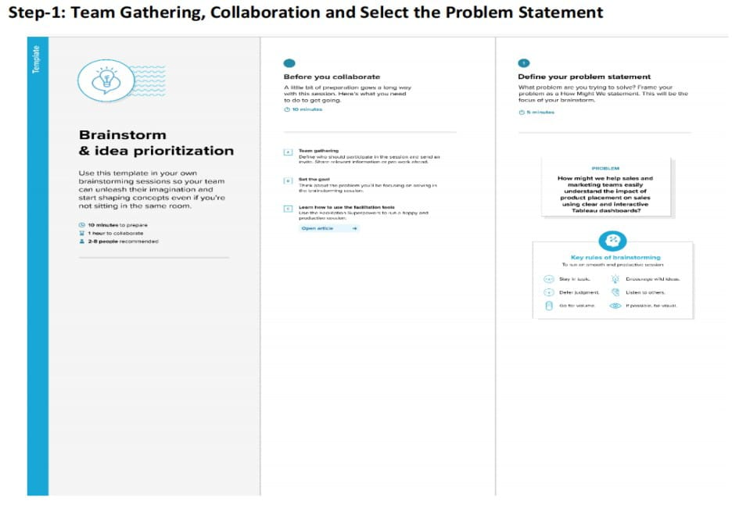
Brainstrom: Write down any ideas that comes to mind that address your problem statement.
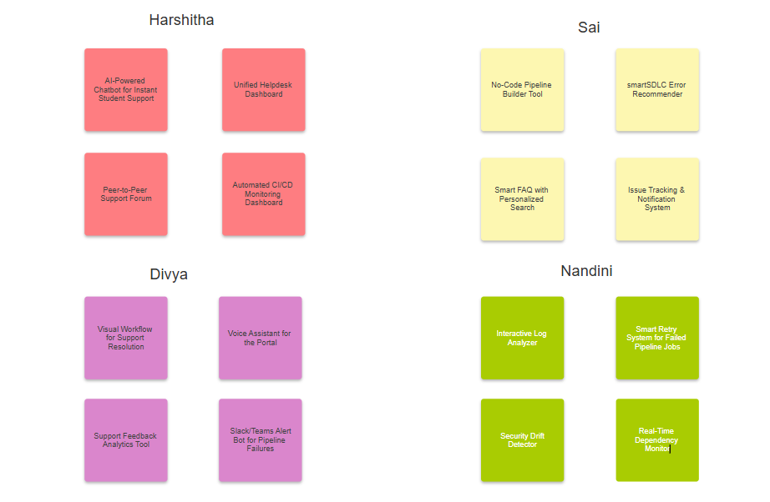

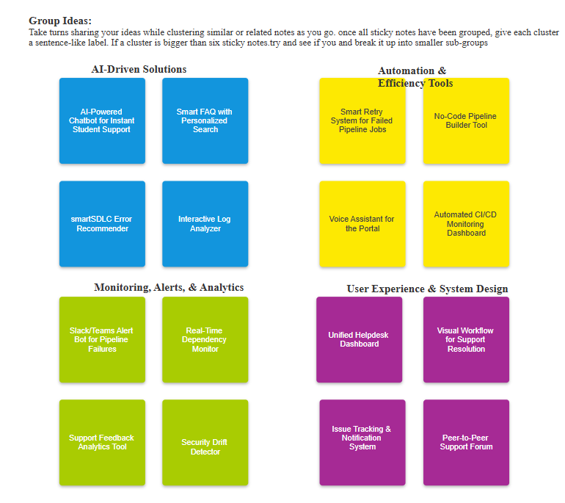
Prioritize: your team should all be on the same page about what’s important moving forward. Place your ideas on this grid to determine which ideas are important and which ideas are important and which important and which are feasible

