Emotion-Based Music Recommendation System- A Deep Learning Approach

Bharathi Mohan G.  
*Department of CSE(AI)   
Amrita Vishwa Vidhyapeetham*Chennai, India  
g_bharathimohan@ch.amrita.edu

Harshitha M.  
*Department of CSE(AI)  
Amrita Vishwa Vidhyapeetham*Chennai, India  
muramuttlaharshitha@gmail.comPrasanna Kumar R.  
*Department of CSE(AI)  
Amrita Vishwa Vidhyapeetham*Chennai, India  
r_prasannakumar@ch.amrita.edu

B S S Chaithanya.  
*Department of CSE(AI)  
Amrita Vishwa Vidhyapeetham*Chennai, India  
chaitanya19.balla@gmail.com

G V Rohan.  
*Department of CSE(AI)  
Amrita Vishwa Vidhyapeetham*Chennai, India  
venkatarohangudimetla@gmail.com Korrayi Saiteja.  
*Department of CSE(AI)  
Amrita Vishwa Vidhyapeetham*Chennai, India  
saiteja.korrayi@gmail.com

Kundula Saiteja.  
*Department of CSE(AI)   
Amrita Vishwa Vidhyapeetham*Chennai, India  
bannukundula@gmail.com

***Abstract*— People and musicians often form a close bond, some songs can transport listeners to different eras or locations, and listeners frequently turn to music for emotional support. By classifying music according to emotions, emotion-based recommendation algorithms and music suggestion assist users in elevating their present mood. This also saves time, as it suggests music based on the user's mood rather than forcing them to perform a time-consuming search. Aural feature categorization, wearable computers, and hand-performed music are just a few of the methods used these days. Most of these methods were developed using CNN and VGG-16 models to improve accuracy and performance, these models have produced highest accuracy rates of 68.28% and 54.27%, respectively. Thus far, we have suggested a method that leverages big data analytics and deep learning models to improve accuracy rate and performance. Through this paradigm, which employs streamlit to deliver an intuitive online interface, customers can access services. This paper compares assessment metrics of deep learning models trained and assessed on the FER2013 and CK+48 datasets on CNN, VGG with XGBoost, and VGG-16. For photos taken in static mode, the accuracy of the emotion extraction method ranges from 79% to 98%. On the CK+48 and Fer2013 datasets, VGG with XGBoost receives scores of 98% and 85%, respectively. Facial expressions are captured by an integrated webcam, and features are extracted to identify a range of emotions, including happy, disguist, angry, contempt, sadness, surprise, and fear. The YouTube page is redirected to offer a recommended music playlist. This work focuses on the reader's emotions while highlighting the importance of music. Here's a brief explanation of the idea.**

***Keywords—Convolutional Neural Network, Deep Learning, Music recommendation, Streamlit, VGG XGBoost.***

# Introduction

In this modern era, the demand for music recommendation systems has emerged significantly. Emotion detection plays an important role nowadays, which is used for human-computer interactions and helping a user with their mood [1]. These systems completely rely on users’ personalized preferences, and listening history. The development of information technology enhanced the new music platforms to listen to music irrespective of place, and time to improve the mood of a person. The system can suggest songs that are appropriate for the noticed mood by storing the recorded users' facial expression data. This can improve the user's listening experience and perhaps their emotional condition. It describes how the process of making music recommendations based on content must incorporate several different fields, such as feature-based classification, emotion detection and identification, emotion description, and inference-based recommendation [2]. In some cases, songs that are added to the playlist are never played which results in using memory, to delete we tend to search the songs manually to free up the space [3]. This process consumes more time to address this kind of problem we designed a Deep learning approach that depends on the emotions detected through facial expressions. This study is innovative in that the suggested system entails the combination of two datasets and users’ faces can be detected through a webcam which can detect and recommend music with a good accuracy rate and better performance. The experiment's datasets were gathered from Fer2013 and Ck+48, and are collected from internet source. But if the other dataset has comparable properties and emotions, the suggested model can also be used.

According to, the limitations of existing techniques for music recommendation based on emotions are that they use previous data to suggest music, which requires a lot of manual work, and the algorithms used are usually slow and less accurate [4]. The proposed system aims to overcome these limitations by using real-time capturing of the user’s emotions through facial expressions and recommending music accordingly. In our daily lives, music is frequently utilized to control our moods and our emotions. Emotion and mood have become the primary factors that ICT systems utilize in the digital age to forecast social behaviors or mold individuals in their social interactions and professional activities. The group exploring emotional computing has therefore worked to understand how music and emotion are related [5]. Several sectors, including entertainment, healthcare, education, affective ambient intelligence, multimedia retrieval, and music creation and production, can benefit from the use of emotional computing research.

Human emotions can be classified into happy, sad, angry, disgust, fear, contempt, and surprise these emotions can be identified using facial detection. While, the emotions nervous and excited are not identified, which is a challenging task to detect and analyze facial expressions. Expressions of users may differ for emotion. These captured image data are trained on the DL algorithm's Convolutional Neural Network (CNN), VGG with XGBoost, and VGG-16. Normalization is performed on these images for better identification of the user’s facial emotions. Integrating emotion detection and a recommendation system can identify based on the information, the user's current emotional state data, enabling them to recommend music. Not only benefits in music recommendation systems, also in various applications like human-computer interaction systems and music diversion [6].

# Literature Survey

A neural network approach that focuses on filtering algorithms based on individual proximity is modeled by emotion-based music recommendation systems. Additionally, the limits of currently used methods for automatically creating playlists were explored, and a method based on the extraction of facial expressions was proposed [7]. H. Immanuel James. et. al, discussed developing a technique that makes use of facial expressions to provide music recommendations depending on emotions to create a personalized playlist based on the user’s mood. The system eliminates the need for manual segregation of music into different lists and also discusses how the system allows the user to browse their music library according to latent emotional dimensions and demonstrates how to include user input at the recommendation stage using predictions made from their user profile. Also, mentions the process of examining a user's face to identify emotions using a facial expression detection module. The suggested approach aims to lower the system's total computing expense and time. An algorithm that uses Bezier curve fitting to analyze facial expressions and recognize emotions, and an algorithm that uses animated mood pictures in a music recommendation system. Based on facial expressions, this work highlights the importance of emotion recognition in all aspects. Also discusses various approaches including emotion recognition, face recognition, brain-computer interfaces, and audio information retrieval. To keep track of the subject's cognitive state of mind, an EEG apparatus is employed. An algorithm built on MID, which continuously monitors signals coming from the user's brain, is used to create the feelings the user is now feeling [8]. The feature extraction process using deep convolutional neural networks (DCNN) and weighted feature extraction (WFE). Deep convolutional neural networks (DCNN) are used for feature extraction, weighted feature extraction (WFE) for feature selection, and content-based recommendation systems (CBRS) are used for music recommendation. This paper also discusses the use of electroencephalography (EEG) feedback to improve the accuracy of the system. The DCNN, WFE, and CBRS algorithms are used in this system [9]. A simple face emotion-based music selection system is described in the article "Music recommendation using emotion detection." For face detection and basic CNN, the author used OpenCV and DLlib. The obtained result of the model is 74.8% with a set of size 128. The model created with the MobileNet idea in mind. When a small-sized trained model is created using the Keras machine-learning technique, Android-ML recognition becomes simpler. The dataset used to train the system was created by combining the facial expression data from FER 2013 and MMA. The article can determine the user's facial expression [10]. Facial landmarks can be used to infer the user's expression. The proposed architecture consists of three modules: emotion audio extraction, audio extraction, and emotion extraction. The proposed method divides facial emotion categorization into three steps: pre-processing, feature extraction, and classification. Train accuracy for the system was 97% when using the CNN model. Emotion-based music recommendation systems analyze users' emotions in real-time through their facial expressions. Using ML techniques, the system is able to identify the features from the captured image and recommend personalized music.

The CNN technique and collaborative filtering are used by an interactive chatbot-powered emotion-based music playlist recommendation system to concentrate on audio signals. Using a chatbot, the research piece develops a tailored system that recognizes a user's current emotions. The chatbot ascertains the user's emotional condition by asking a series of general questions. Each response is given a score based on the user's input, and the playlist is then created using the total score. The suggested recommendation system creates and suggests playlists using the Spotify platform and API [11]. Music recommendation through Reinforcement Learning is a revolutionary technique that modifies music recommendations based on the emotional state of the user. The recommended technique, called Moodify, uses reinforcement learning to recommend music based on user experiences that lead to a certain goal. The writers examine how music affects emotions and contrast their method with previous works of literature. They also formalize the music recommendation system and offer some background information on the methodologies and approaches employed by Moodify. This system provides information on the online application that was created as well as the findings of a user satisfaction and usability study conducted on MoodifyWeb. The possible uses of this research in the area of emotional Computer-human interaction are covered by the authors in their conclusion. Implementation and analysis of mood-based music recommendation system focuses on music recommendation systems based on probability-based music suggestion players on the web, and mobile devices. It measures customer satisfaction over three months and also examines how consumers’ moods and levels of satisfaction changed two months after listening to music [12]. K. Jaichandran. et. al. employed emotion based music recommendation system based on facial extractions using computer Vision and ML Techniques. The system that works on computer vision and machine learning techniques to recommend dynamic music based on human emotions. And also, discusses the potential applications of emotion detection technology and presents experimental findings on the accuracy. Uses a point detection algorithm to extract features from input images, and for input picture training for face expression recognition, OpenCV is employed. The approach of automatically creating an audio list based on facial expressions is presented as an algorithmic rule. D Roja. et. al. employed the system's camera, either in real-time or from any previously saved image, so that the system can recognize the users' emotions. The objective is to create a system that can read an image and identify a person's facial expression. The investigation demonstrated that this process is feasible and yields reliable results. Decision tree classifiers, gradient boosting, KNN, logistic regression classifiers, Naïve Bayes, Random Forest, and SVM are among the algorithms utilized in the research. About 75% of the system's accuracy was attained [13]. Amornvit Vatcharaphrueksadee. et al. proposed VGG-16 and Optimized CNN for Emotion. This system discusses the effectiveness of classifying human facial emotions using VGG-16 and Optimised CNN [14]. 68.28% validation accuracy is the greater rate of model correctness attained by the suggested model than by VGG16, which is only 54.27% accurate. Furthermore, the optimized CNN outperformed VGG16 in terms of accuracy while requiring less training time [15]. The two sources from which the experiment's datasets were gathered were FER2013 and CK+48. Four primary preprocessing steps have been applied to the datasets: data preparation, RGB to grayscale picture conversion, face identification and cropping, image normalization, and image augmentation. The proposed model's adaptability makes it possible to apply it to other datasets with comparable emotional characteristics [16]. The authors do, however, agree that there is a need for improvements in a few areas, most notably the ability to identify emotions in real-time and differentiate between rage and despair. These enhancements deal with problems such as imbalance in the dataset and lack of rage-related data [17]. Table. I. presents a similar model overview of our proposed model with existing systems, emphasizing its advantages and contrasts. It highlights the possibility of a wider use of our algorithm and acknowledges the continuous effort needed to improve its performance in different emotional classification scenarios.

TABLE I. Comparision accuracy rate of existing model and proposed model

|  |  |  |  |  |
| --- | --- | --- | --- | --- |
| **Vgg-16 and optimized CNN for emotion detection** | | **Our proposed model: Emotion-based Music Recommendation System** | | |
| ***Deep learning models*** | ***Accuracy rate*** | ***Deep learning models*** | ***Accuracy rate*** | |
| ***Ck+48*** | ***Fer2013*** |
| Optimized CNN | 68.78% | CNN | 97% | 85% |
| VGG-16 | 59.27% | VGG-16 | 94% | 79% |
| - | - | VGG + XGBoost | 98% | 85% |

# Methodology

The proposed model describes the following steps for the emotion detection and music recommendation system. The data collection process involves the collection of dataset’s Fer2013 and ck+48. Add emotional labels to the dataset. This may be accomplished in a variety of methods, for as by hand labelling, crowdsourcing, or the use of existing emotional datasets. The creation of a system that suggests music based on feelings must include this phase. are processed in advance of training. Then, using deep learning algorithms like CNN, VGG-16, and VGG with XGBoost, the pre-processed data is put through testing and training. The next step is to validate the model and deploy the model into the web interface. systems primarily use sentiment analysis in conjunction with collaborative filtering. Sentiment analysis evaluates the user's feelings, whereas collaborative filtering leverages the user's decisions and actions to suggest music that corresponds with emotional states. Examples of machine learning algorithms that enhance recommendations based on shifting user feedback are decision trees and neural networks. This hybrid approach creates a user experience that is more emotionally engaging and appealing by successfully tailoring music recommendations.

## VGG with XGBoost

Vgg-16 is a Convolutional Neural Network architecture. It mostly performs computer vision-related tasks such as image classification and facial recognition. It takes the input image which passes through a series of convolutional layers. Each layer takes the input from previous layers. In addition to the system convolutional layer, there is a max pooling layer that chooses the maximum value from each pixel's window to lower the feature map's resolution. Finally, the output made it beyond a fully connected layer. The completely connected layer makes the final decision by combining the traits that it has retrieved from previous tiers. Additionally, characteristics from photos are extracted using the VGG-16.

## XGBoost

XGBoost is the machine algorithm that mainly works on two concepts: Gradient Boosting and Regulation. It was made of decision trees and iterative adding of weak learns. At every iteration the new learner was added to the model to rectify the errors of the previous errors. Regularization is used to reduce the overfitting in the machine-learning model. The VGG with XGBoost achieved an accuracy of 97% which gives better performance in comparison with other deep learning models.

## Convolutional Neural Network (CNN)

The data is pre-processed to fit the input requirements of the CNN. Using the Keras framework which is now a part of TensorFlow, CNN is implemented in this model. Given the input shape (48, 48, 1), this model appears to be created for an image classification job on a 48*48 pixel grayscale picture dataset. The model is built employing a categorical cross-entropy loss function and a learning rate of 0.0005, which is suitable for multi-class classification applications.

## VGG-16

'Imagenet' is used to load the pre-trained weights of the VGG16 model, which is imported from Keras. Taking the same input as VGG16, it builds a new model that outputs the characteristics from one of the deeper levels of the VGG16 model, the 'block5_pool' layer, and predicts characteristics for the input data X using this new model. You will then get feature vectors for every input in X as a result. Features are the extracted features that are returned.

The web interface is deployed using Streamlit where the machine learning model is converted into a user-friendly web interface. Through the usage of APIs, it combines sentiment analysis with cooperative filtering techniques. Real-time user interactions that dynamically adjust suggestions set off the model. Continuous monitoring refines the model, ensuring accurate and distinctive music suggestions according to users' emotional states. Developing a deep learning model to detect or classify the emotional content of the music. Train the model using labeled datasets. Using a web interface the user captures the image through webcam access. After the image is captured, the image data is stored and undergoes an image segmentation process to identify which emotional state the user is facing. The next step is to recommend a song that redirects the user to the YouTube page where the song is streamed in Fig.1.

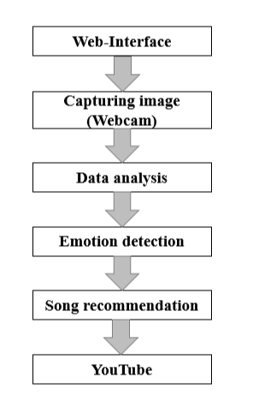

Fig. 1. Process of recommending music through web-interface.

Evaluating user input to identify emotions is the first stage in the sentiment analysis process. Then, from the music database, a feature extraction layer pulls out pertinent musical characteristics like key, tempo, and mood. Recommendation system that combines human sentiments with music data extraction through machine learning techniques. This engine is constantly being improved in response to user feedback. Finally, customized music recommendations are displayed via an interface. Our technology offers a dynamic and emotionally resonant music recommendation experience by seamlessly integrating emotion analysis, feature extraction, and machine learning. The design of the system makes use of deep learning techniques to select music based on users' present emotional states. It is divided into three stages: feature extraction, music suggestion, and mood state analysis depicted in Fig.2. Together, these phases provide the user with specialized music selections according to their emotional state.

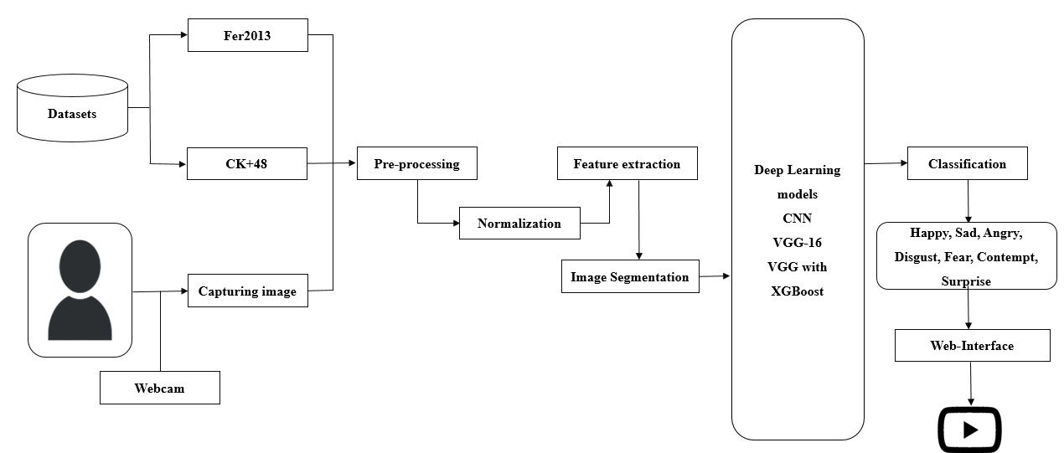

Fig. 2. Proposed model architecture

# Experimental Setup And Research

## About Dataset

Dataset’s Fer2013 and ck+48 are retrieved from Kaggle. These image datasets consist of human emotions such as happy,sad, angry, disgust, fear, contempt, or surprise. The total number of samples of the Fer-2013 dataset is 37,000 which consists of 48*48 pixel grayscale images with 7 labeled emotions like Happy, Sad, Surprise, Neutral, Disgust, Fear, and Angry. Ck+48 is 1000 with 5 emotions Sad, Happy, Fear, Angry, and Surprise. When the CK+48 dataset is trained with Vgg-16 it achieved an accuracy of 93%, CNN 98%. Similarly, in fer2013 when trained with Vgg-16 the accuracy was 76%, and CNN 85%.

## Evaluation Metrics

The architecture includes four convolutional layers, followed by dropout layers, max-pooling, batch normalization, and ReLU activation to prevent overfitting. The last layers include batch normalization, dropout, and ReLU activation shown in Table II. The layers are completely connected layers.

|  |  |
| --- | --- |
| ***HyperParameters*** | ***Values*** |
| No.of Layers | 4 |
| Activation function | Softmax, Relu |
| Loss-function | Categorical-crossentropy |
| Optimizer | Adam |
| Optimizer rate | 0.0005 |
| No.of Neurons | 7 |

TABLE II. Hyperparameters and values of the CNN model.

The Python Keras framework is the foundation for assessing performance measures like F1-score, recall, and accuracy in the deployment of deep learning models via a web interface using Streamlit. These measures are essential for evaluating the performance of models like as CNN, VGG-16, and VGG XGboost on datasets such as Ck+48 in Table. III. These quantitative metrics aid in evaluating the models' precision and potency in properly classifying and categorizing data.

|  |  |  |  |
| --- | --- | --- | --- |
| ***Model*** | ***Precision*** | ***Recall*** | ***F1-score*** |
| CNN | 0.97 | 0.98 | 0.96 |
| VGG-16 | 0.94 | 0.95 | 0.95 |
| VGG XGBoost | 0.98 | 0.96 | 0.97 |

TABLE III. Evaluation metrics of the Ck+48 dataset

The efficiency of an emotion-based music recommendation system using the FER2013 dataset shown in Table. IV. Typical evaluation criteria include F1 score, recall, and precision for CNN, VGG-16, and VGG with XGBoost models. The system's ability to consistently recognize human emotions from facial expressions allows for improved music selection, user experience, and system performance.

TABLE IV. Evaluation metrics of the FER2013 dataset

|  |  |  |  |
| --- | --- | --- | --- |
| ***Model*** | ***Precision*** | ***Recall*** | ***F1-score*** |
| CNN | 0.85 | 0.84 | 0.85 |
| VGG-16 | 0.82 | 0.79 | 0.81 |
| VGG XGBoost | 0.86 | 0.88 | 0.85 |

The "CNN" model has the highest recall in this comparison, whereas the "VGG with XGboost" model has the highest precision and F1 score.

# Results And Discussions

The results of the Deep learning algorithms on Fer-2013 and ck+48 datasets are plotted in the graph. The performance of deep learning models during training is monitored using the accuracy vs. Epochs graph. It displays the accuracy of the validation and training sets throughout epochs in Fig. 3. Train and test accuracy of VGG-16 on the Ck+48 dataset is 94%.

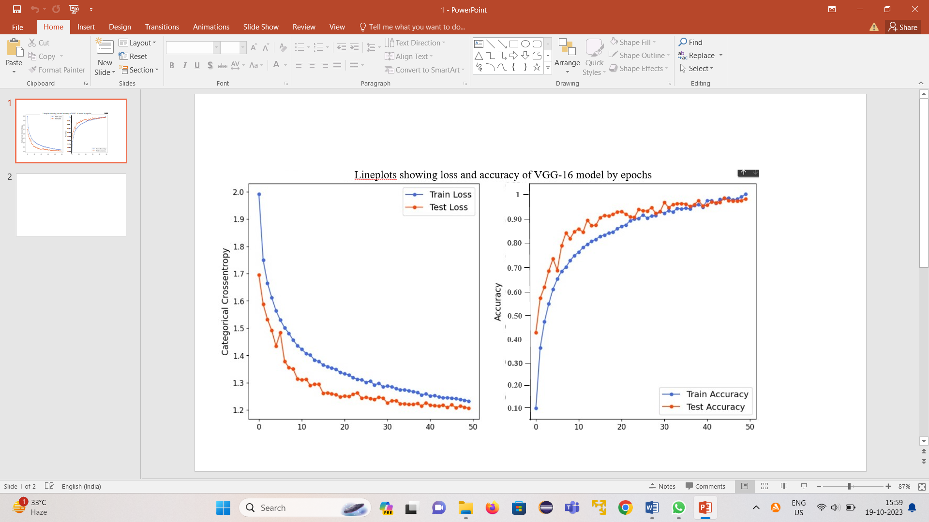

Fig. 3. Test and Train accuracy of VGG-16 on the CK+48 dataset.

On the CK+48 dataset, the CNN model performs exceptionally well, achieving an astounding 97% accuracy on both training and test data. This high degree of accuracy highlights how well the model identified the facial expressions in the sample. The training and test accuracy throughout several epochs are visually shown in Fig. 4, which provides a greater understanding of the learning process. The graph's X-axis represents the number of training epochs or the number of times the model has iteratively learned from the dataset. The matching accuracy rate is represented by the Y-axis, which shows how well the model is working at each epoch. The graph begins at zero, representing the starting state, and then changes as the model keeps learning. The graph's constant high accuracy rate during training is evidence of the model's dependability and resilience in identifying the various facial expressions in the CK+48.

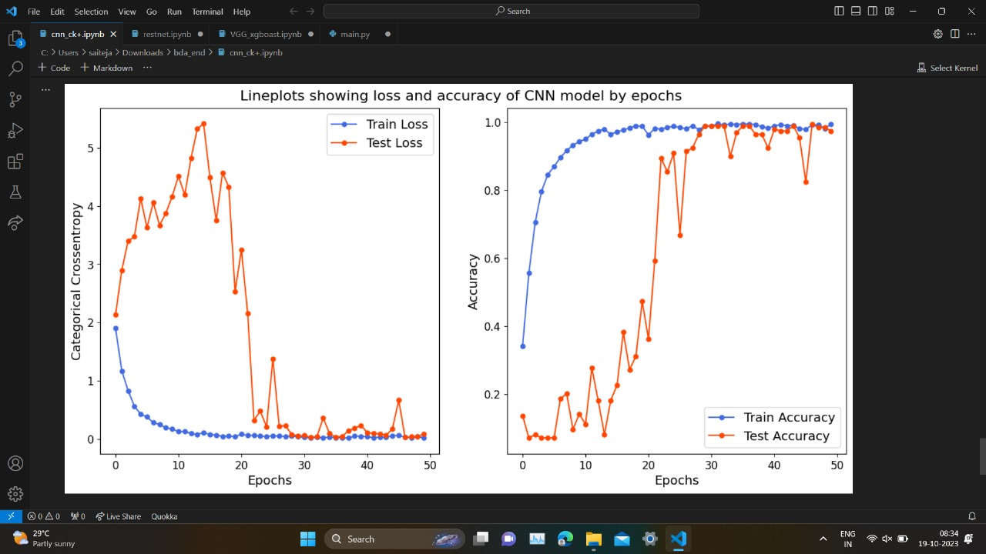Fig. 4. Train and test accuracy for the CNN Ck+48 dataset

In the graph Fig. 5 VGG-16 model learns to identify emotions in the training data, and the train accuracy curve in the graph increases from a low starting value. The model's ability to predict emotions is improving. The accuracy vs epochs graph gives accuracy about 79% on Fer-2013 trained on VGG-16.

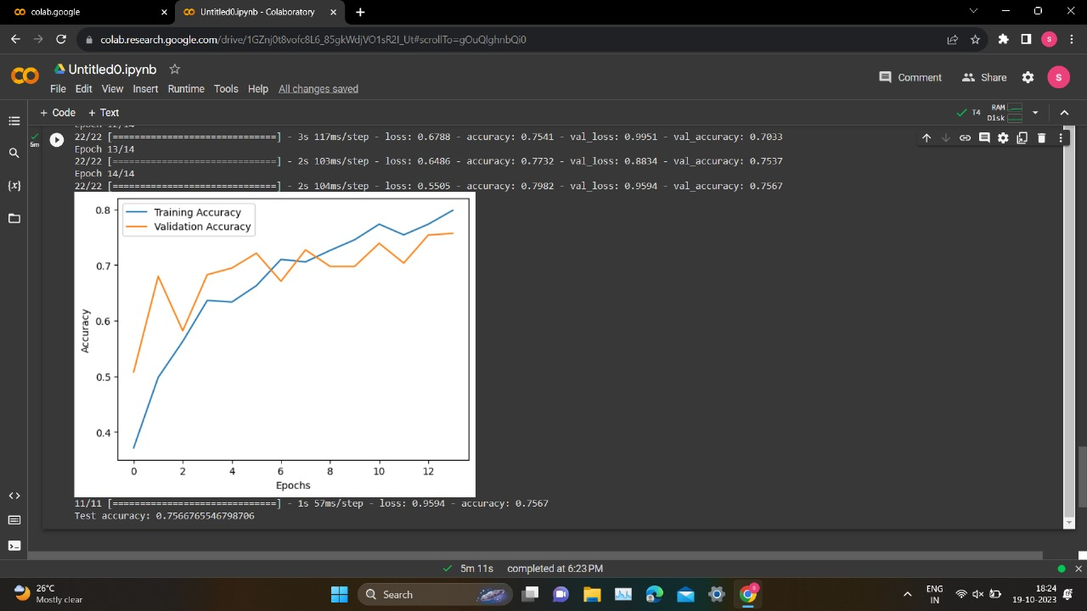

Fig. 5. The accuracy graph of VGG-16 on the FER2013 dataset.

On the CK+48 dataset, it appears that the VGG16 model with XGBoost obtains the maximum accuracy, but on the Fer2013 dataset, the simple CNN and VGG-16 with XGBoost model achieves the highest accuracy of 85% represented in Table V. The performance of each model on the corresponding datasets is shown by the accuracy scores.

|  |  |  |
| --- | --- | --- |
| ***Model*** | ***Ck+48*** | ***Fer-2013*** |
| CNN | 0.97 | 0.85 |
| VGG-16 | 0.94 | 0.79 |
| VGG-16 with XGBoost | 0.98 | 0.85 |

TABLE V. Comparison of deep learning models on Ck+48 and Fer-2013 datasets.

# Conclusion And Future Work

In this study, deep learning algorithms such as CNN, VGG-16, and VGG with XGBoost for training and testing the image datasets for image recognition. Firstly, we combined two datasets namely, Ck+48 and FER-2013. Then the data is split into a set of training, testing, and validation samples to evaluate model performance. In order to achieve a better accuracy rate four primary preprocessing steps have been applied to the datasets: data preparation, RGB to grayscale picture conversion, face identification and cropping, image normalization, and image augmentation. The accuracy rates of the CNN, VGG-16, and VGG with XGBoost for the Ck+48 dataset are 97%, 94%, and 98% respectively. For Fer-2013 dataset accuracy rates are CNN at 85%, VGG-16 at 79%, and VGG with XGBoost at 85%. Our hybrid algorithm VGG-16 with XGBoost achieved a higher rate of model accuracy in comparison with CNN and VGG-16.

Future research and development in emotion-based music recommendation systems for improving the system's capabilities and user experience. Furthermore, by identifying more emotions that are not currently included in the system, the approach that improves the songs that are automatically played may be enhanced. To the advantage of the users, the suggested system may be updated often with cutting-edge features. These approaches include sentiment analysis from user-generated content and social media data. Contextual data, such as user behaviors and environmental characteristics, may also improve the customization of music suggestions by allowing for the creation of recommendations.

##### References

1. Mahadik, Ankita, Shambhavi Milgir, Janvi Patel, Vijaya Bharathi Jagan, and Vaishali Kavathekar. "Mood based music recommendation system." International Journal Of Engineering Research & Technology (IJERT) Volume 10 (2021).
2. James, H. Immanuel, J. James Anto Arnold, J. Maria Masilla Ruban, M. Tamilarasan, and R. Saranya. "Emotion based music recommendation system." Emotion 6, no. 3 (2019).
3. Phaneendra, A., Madhusmitha Muduli, Siri Lakshmi Reddy, and R. Veenasree. "EMUSE–An emotion based music recommendation system." International Research Journal of Modernization in Engineering Technology and Science 4, no. 5 (2022): 4159-4163.
4. Bhutada, Sunil, C. Sadhvika, G. Abigna, and S. Reddy. "Emotion based music recommendation system." J. Emerg. Technol. Innov. Res 7 (2020): 2170-2175.
5. De Prisco, Roberto, Alfonso Guarino, Delfina Malandrino, and Rocco Zaccagnino. "Induced Emotion-Based Music Recommendation through Reinforcement Learning." Applied Sciences 12, no. 21 (2022): 11209.
6. Shalini, Shantha K., R. Jaichandran, S. Leelavathy, R. Raviraghul, J. Ranjitha, and N. Saravanakumar. "Facial Emotion Based Music Recommendation System using computer vision and machine learning techiniques." Turkish journal of computer and mathematics education 12, no. 2 (2021): 912-917.
7. Vidyasagar, Bagde Sarika, and V. Karwande. "Emotion Based Music Recommendation System by Using Different ML Approach." International Journal 6, no. 6 (2021).
8. Florence, S. Metilda, and M. Uma. "Emotional detection and music recommendation system based on user facial expression." In IOP conference series: Materials science and engineering, vol. 912, no. 6, p. 062007. IOP Publishing, 2020.
9. Abdul, Ashu, Jenhui Chen, Hua-Yuan Liao, and Shun-Hao Chang. "An emotion-aware personalized music recommendation system using a convolutional neural networks approach." Applied Sciences 8, no. 7 (2018): 1103.
10. Srivastava, Aneesh, Devesh Kumar Srivastava, and Mehak Shandilya. "Facial Emotion-based Music Recommender System using CNN." In 2023 International Conference on Artificial Intelligence and Smart Communication (AISC), pp. 113-118. IEEE, 2023.
11. Nair, Amrita, Smriti Pillai, Ganga S. Nair, and T. Anjali. "Emotion based music playlist recommendation system using interactive chatbot." In 2021 6th international conference on communication and electronics systems (ICCES), pp. 1767-1772. IEEE, 2021.
12. Kim, JungHyun, Seungjae Lee, and WonYoung Yoo. "Implementation and analysis of mood-based music recommendation system." In 2013 15th International Conference on Advanced Communications Technology (ICACT), pp. 740-743. IEEE, 2013.
13. Naga Bhavani, P. U. V. V. A. L. A. Siddi Kavya, And Tallapogu Viswas. "Music Recommendation System For Detection Of Emotion." (2023).
14. Mohan, G. Bharathi, R. Prasanna Kumar, R. Elakkiya, and Snehitha Gorantla. "Enhancing Personality Classification through Textual Analysis: A Deep Learning Approach Utilizing MBTI and Social Media Data." In 2023 International Conference on Network, Multimedia and Information Technology (NMITCON), pp. 01-06. IEEE, 2023.
15. Mohan, G. Bharathi, R. Prasanna Kumar, and T. Ravi. "Coalescing Clustering and Classification." (2012): 446-450.
16. Rithani, M., R. Prasanna Kumar, and Srinath Doss. "A review on big data based on deep neural network approaches." Artificial Intelligence Review (2023): 1-37.
17. Vatcharaphrueksadee, Amornvit, Rattikarn Viboonpanich, Puttakul Sakul-ang, and Maleerat Maliyaem. "Vgg-16 and optimized cnn for emotion classification." Information Technology Journal 16, no. 2 (2020): 10-15.