2303A51588
Batch-10
Assignment-14.3
Task 1: AI-Assisted Personal Portfolio Website
#PROMPT
Use GitHub Copilot to generate a semantic HTML portfolio website with sections: Home, About, Projects, and Contact. Add responsive CSS using Flexbox or Grid for desktop and mobile screens. Include hover effects on project cards and smooth scrolling navigation.
#CODE
HTML
<!DOCTYPE html>
<html lang="en">
<head>
<meta charset="UTF-8">
<meta name="viewport" content="width=device-width, initial-scale=1.0">
<title>Personal Portfolio</title>
<link rel="stylesheet" href="style.css">
</head>
<body>
<!-- Navigation -->
<nav>
<a href="#home">Home</a>
<a href="#about">About</a>
<a href="#projects">Projects</a>
<a href="#contact">Contact</a>
</nav>
<!-- Home Section -->
<section id="home">
<h1>Welcome to My Portfolio</h1>
<p>B.Tech Student | Web Developer</p>
</section>
<!-- About Section -->
<section id="about">
<h2>About Me</h2>
<p>
I am a B.Tech student interested in web development and programming.
I enjoy building projects using HTML, CSS, and databases.
</p>
</section>
<!-- Projects Section -->
<section id="projects">
<h2>My Projects</h2>
<div class="projects-container">
<div class="project-card">
<h3>Blood Donation System</h3>
<p>A website to find blood donors and request blood during emergencies.</p>
</div>
<div class="project-card">
<h3>DBMS Course Platform</h3>
<p>Database design for managing instructors, students, and courses.</p>
</div>
<div class="project-card">
<h3>Portfolio Website</h3>
<p>A responsive personal portfolio created using HTML and CSS.</p>
</div>
</div>
</section>
<!-- Contact Section -->
<section id="contact">
<h2>Contact</h2>
<p>Email: student@email.com</p>
<p>Phone: 9876543210</p>
</section>
<!-- Footer -->
<footer>
<p>© 2026 My Portfolio</p>
</footer>
</body>
</html>
CSS
/* Smooth Scrolling */
html{
scroll-behavior:smooth;
}
/* Basic Styling */
body{
font-family:Arial;
margin:0;
background:#f4f7fb;
}
/* Navigation */
nav{
display:flex;
justify-content:center;
gap:30px;
background:#2c3e50;
padding:15px;
}
nav a{
color:white;
text-decoration:none;
font-weight:bold;
}
nav a:hover{
color:#00d9ff;
}
/* Sections */
section{
padding:60px;
text-align:center;
}
/* Home Section */
#home{
background:linear-gradient(120deg,#6a11cb,#544a57);
color:white;
}
/* About */
#about{
background:rgb(134, 113, 113);
}
/* Projects */
#projects{
background:#eef2f7;
}
/* Project Cards Container */
.projects-container{
display:flex;
justify-content:center;
flex-wrap:wrap;
gap:20px;
margin-top:20px;
}
/* Project Cards */
.project-card{
background:rgba(131, 129, 148, 0.595);
padding:20px;
width:250px;
border-radius:10px;
box-shadow:0 5px 15px rgba(0,0,0,0.1);
transition:0.3s;
}
/* Hover Effect */
.project-card:hover{
transform:translateY(-8px);
box-shadow:0 10px 20px rgba(0,0,0,0.2);
}
/* Contact */
#contact{
background:#dfe9f3;
}
/* Footer */
footer{
background:#2c3e50;
color:white;
text-align:center;
padding:15px;
}
/* Responsive Design */
@media(max-width:768px){
nav{
flex-direction:column;
align-items:center;
}
.projects-container{
flex-direction:column;
align-items:center;
}.project-card{
width:80%;
}
}
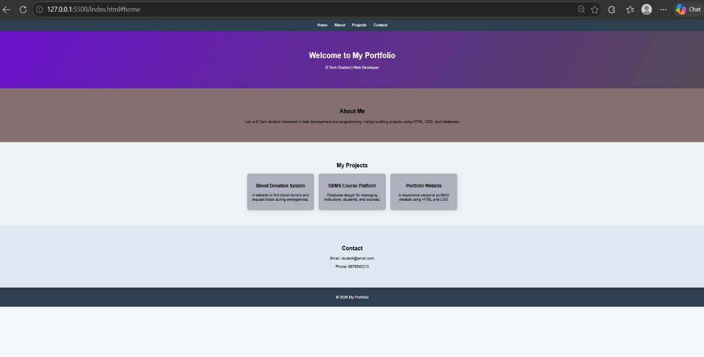
#OUTPUT
#ANALYSIS
The AI-generated code provides a structured HTML layout and responsive CSS design quickly. Developers can customize the styles to improve appearance, such as adding hover effects for interactivity and smooth scrolling for better user experience. This approach speeds up development while keeping the design flexible and user-friendly.
Task 2: AI-Generated Restaurant Landing Page
#PROMPT
Use GitHub Copilot to generate a restaurant landing page with a navigation bar containing Home, Menu, Gallery, and Contact links. Create a menu section using CSS cards and implement a JavaScript image slider for the gallery. Add animations or transitions to improve the user experience.

#CODE (html, css, js)
<!DOCTYPE html>
<html>
<head>
<title>Restaurant</title>
<style>
body{font-family:Arial;margin:0;text-align:center;background:#f4f4f4;}
nav{background:#333;padding:10px;}
nav a{color:white;margin:10px;text-decoration:none;font-weight:bold;}
nav a:hover{color:orange;}
section{padding:20px;}
#home{background:linear-gradient(#ff9800,#ff5722);color:white;}
.menu{display:flex;justify-content:center;flex-wrap:wrap;gap:10px;}
.card{
background:white;
padding:15px;
width:150px;
box-shadow:0 3px 8px rgba(0,0,0,0.2);
transition:0.3s;
}
.card:hover{transform:scale(1.05);}
img{width:300px;height:150px;border-radius:8px;}
#contact{background:#333;color:white;}
</style>
</head>
<body>
<nav>
<a href="#home">Home</a>
<a href="#menu">Menu</a>
<a href="#gallery">Gallery</a>
<a href="#contact">Contact</a>
</nav>
<section id="home">
<h2>Foodies Restaurant</h2>
<p>Delicious food made with love</p>
</section>
<section id="menu">
<h3>Menu</h3>
<div class="menu">
<div class="card">Pizza</div>
<div class="card">Burger</div>
<div class="card">Pasta</div>
<div class="card">Dessert</div>
</div>
</section>
<section id="gallery">
<h3>Gallery</h3>
<img id="slide" src="https://images.unsplash.com/photo-1513104890138-7c749659a591">
</section>
<section id="contact">
<h3>Contact</h3>
<p>📞 9876543210</p>
</section>
<script>
let imgs=[
"https://images.unsplash.com/photo-1513104890138-7c749659a591",
"https://images.unsplash.com/photo-1550547660-d9450f859349",
"https://images.unsplash.com/photo-1473093295043-cdd812d0e601"
];
let i=0;
setInterval(()=>{
i=(i+1)%imgs.length;
document.getElementById("slide").src=imgs[i];
},2000);
</script>
</body>
</html>

#OUTPUT

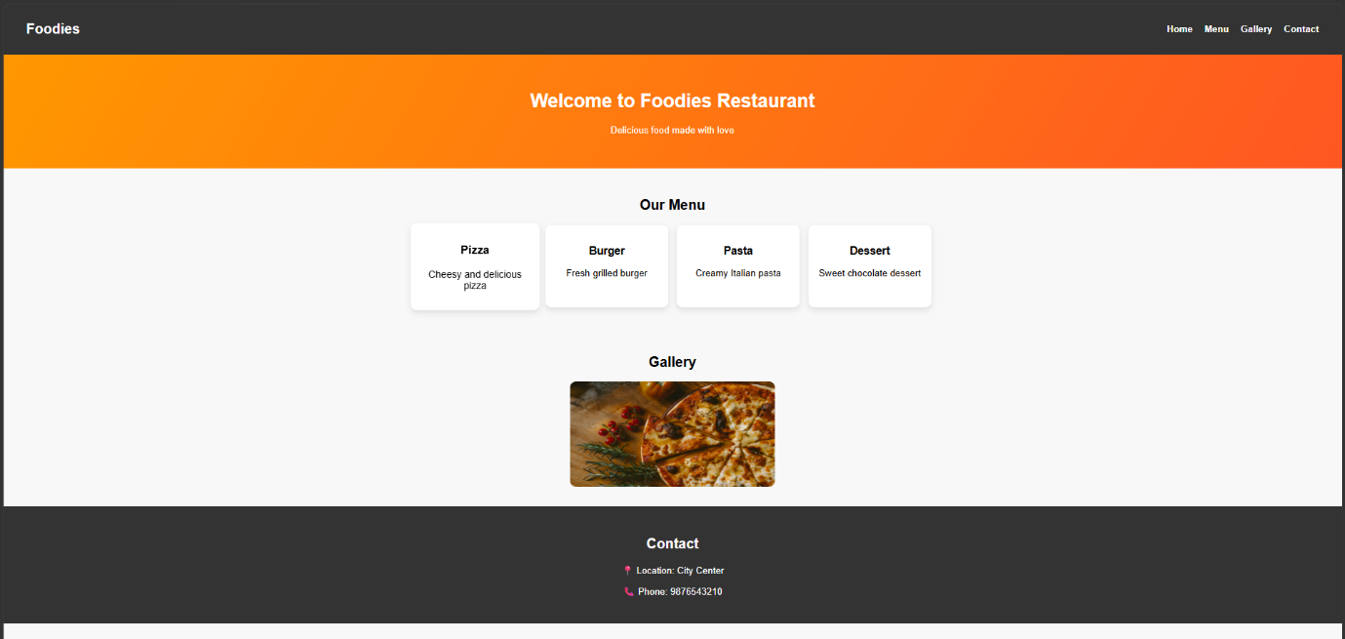
#ANALYSIS
AI-generated code helps quickly create the layout, navigation bar, and UI components for the restaurant landing page. The developer customizes the CSS cards and animations to make the page visually attractive. JavaScript is used to implement an image slider, making the gallery interactive and improving the overall user experience.
Task 3: AI-Powered Event Registration Form
#PROMPT
Use GitHub Copilot to generate an event registration form for SR University with fields: Name, Email, Phone Number, Department, and Event Selection. Style the form using CSS for better readability and accessibility. Implement JavaScript validation for email format, phone number length, and required fields.
#CODE(html, css, js)
<!DOCTYPE html>
<html>
<head>
<title>Event Registration</title>
<style>
body{
font-family:Arial;
background:#f4f6fb;
display:flex;
justify-content:center;
align-items:center;
height:100vh;
}
form{
background:white;
padding:20px;
width:300px;
box-shadow:0 5px 15px rgba(0,0,0,0.2);
border-radius:8px;
}
h2{text-align:center;}
input,select{
width:100%;
padding:8px;
margin:8px 0;
}
button{
width:100%;
padding:10px;
background:#4CAF50;
color:white;
border:none;
}
.error{
color:red;
font-size:12px;
}
</style>
</head>
<body>
<form onsubmit="return validateForm()">
<h2>Event Registration</h2>
<input type="text" id="name" placeholder="Name">
<div id="nameErr" class="error"></div>
<input type="text" id="email" placeholder="Email">
<div id="emailErr" class="error"></div>
<input type="text" id="phone" placeholder="Phone Number">
<div id="phoneErr" class="error"></div>
<select id="dept">
<option value="">Select Department</option>
<option>CSE</option>
<option>ECE</option>
<option>EEE</option>
<option>MECH</option>
</select>
<div id="deptErr" class="error"></div>
<select id="event">
<option value="">Select Event</option>
<option>Coding</option>
<option>Hackathon</option>
<option>Robotics</option>
</select>
<div id="eventErr" class="error"></div>
<button type="submit">Register</button>
</form>
<script>
function validateForm(){
let valid=true;
/* Name */
if(document.getElementById("name").value==""){
document.getElementById("nameErr").innerText="Name required";
valid=false;
}else{
document.getElementById("nameErr").innerText="";
}
/* Email */
let email=document.getElementById("email").value;
let emailPattern=/^\S+@\S+\.\S+$/;
if(!emailPattern.test(email)){
document.getElementById("emailErr").innerText="Invalid email";
valid=false;
}else{
document.getElementById("emailErr").innerText="";
}
/* Phone */
let phone=document.getElementById("phone").value;
if(phone.length!=10){
document.getElementById("phoneErr").innerText="Phone must be 10 digits";
valid=false;
}else{
document.getElementById("phoneErr").innerText="";
}
/* Department */
if(document.getElementById("dept").value==""){
document.getElementById("deptErr").innerText="Select department";
valid=false;
}else{
document.getElementById("deptErr").innerText="";
}
/* Event */
if(document.getElementById("event").value==""){
document.getElementById("eventErr").innerText="Select event";
valid=false;
}else{
document.getElementById("eventErr").innerText="";
}
return valid;
}
</script>
</body>
</html>
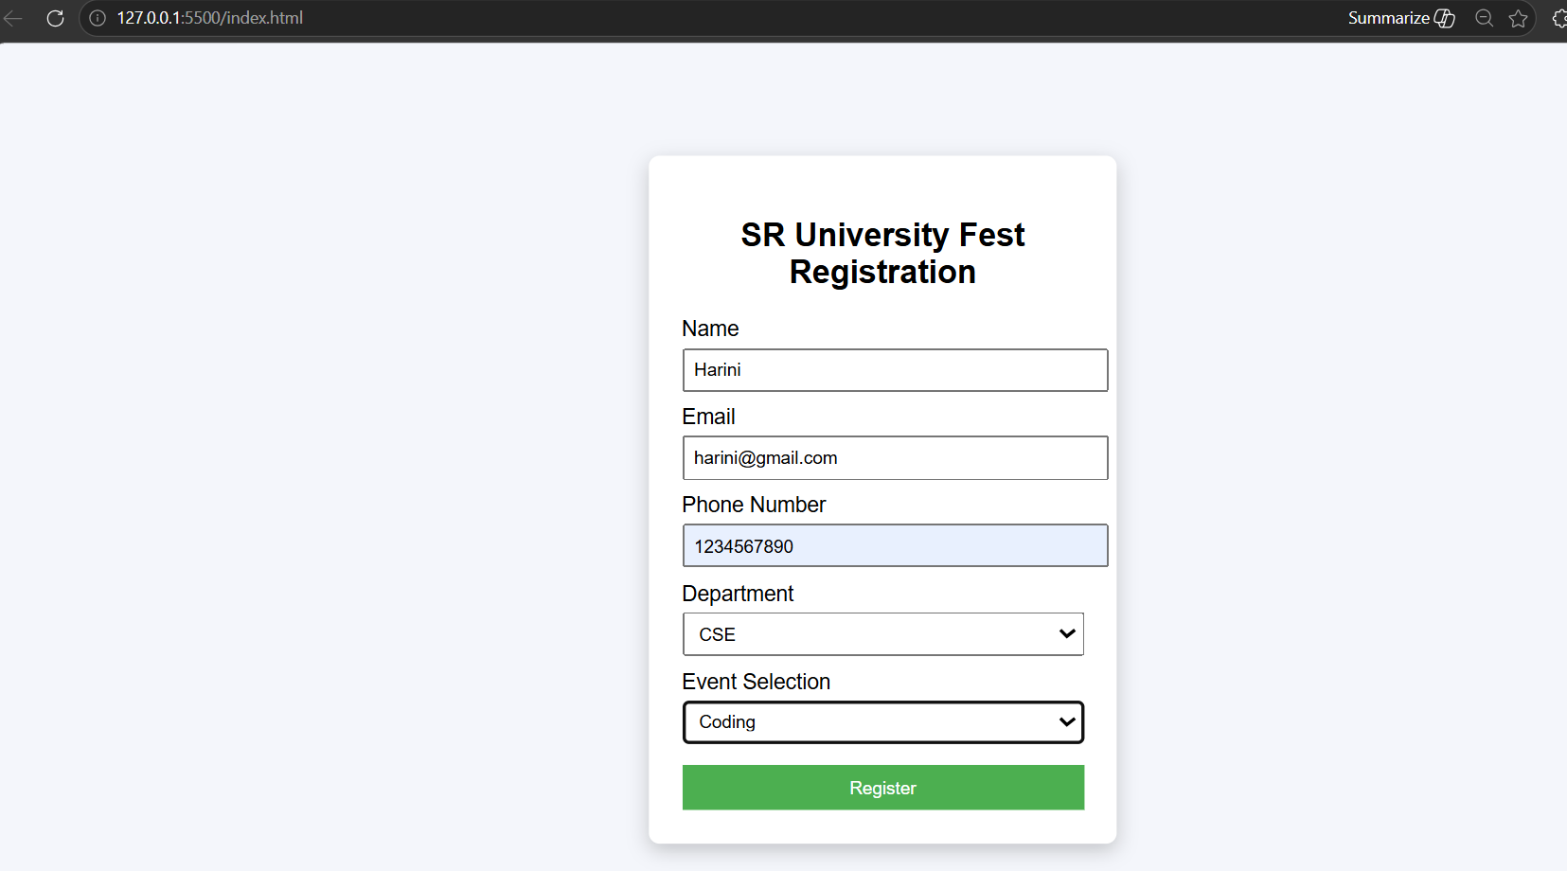
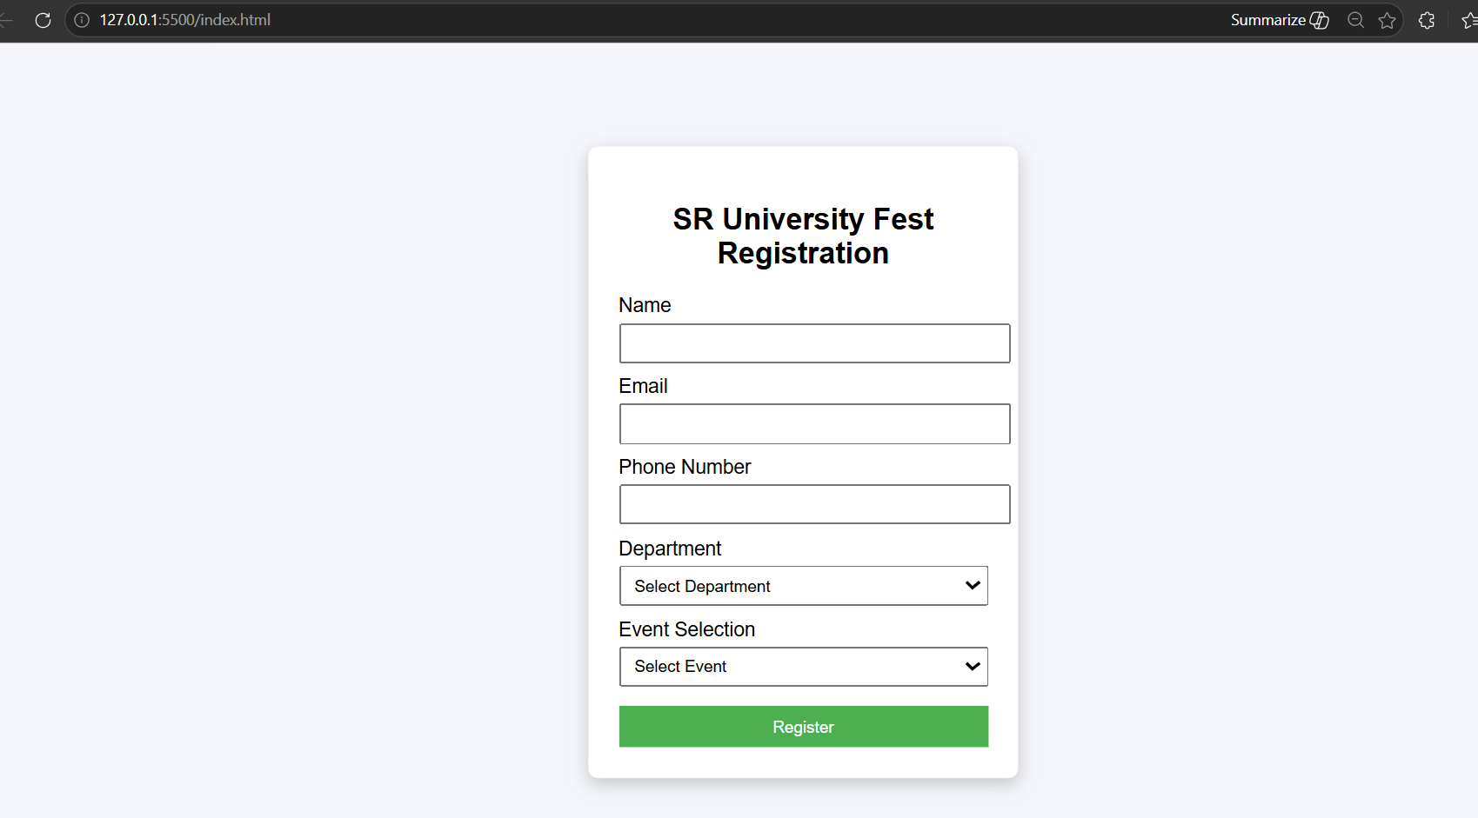
#OUTPUT
#ANALYSIS
AI assistance helps quickly generate the form structure, styling, and validation logic. The developer refines the CSS to improve usability and accessibility. JavaScript validation ensures correct user input and prevents invalid submissions, making the registration process more reliable.
Task 4: AI-Assisted E-Commerce Product Page
#PROMPT
Use GitHub Copilot to generate a grid-based e-commerce product catalog using HTML and CSS. Add an “Add to Cart” button for each product and implement JavaScript to update a cart counter at the top-right corner. Include visual feedback when a product is added to the cart.
#CODE (HTML, CSS, JS)
<!DOCTYPE html>
<html>
<head>
<title>Product Page</title>
<style>
body
{
font-family:Arial;
margin:0;
background:#eef1f5;
}
header
{
display:flex;
justify-content:space-between;
padding:15px 30px;
background:#333;
color:white;
}
.cart
{
background:white;
color:black;
padding:5px 10px;
border-radius:15px;
}
.products
{
display:grid;
grid-template-columns:repeat(2,1fr);
gap:20px;
padding:30px;
}
.card
{
background:white;
padding:15px;
text-align:center;
border-radius:10px;
box-shadow:0 3px 10px gray;
}
button
{
padding:8px 12px;
background:#007bff;
color:white;
border:none;
border-radius:5px;
cursor:pointer;
}
</style>
</head>
<body>
<header>
<h2>My Store</h2>
<div class="cart">Cart <span id="count">0</span></div>
</header>
<div class="products">
<div class="card">
<h3>Headphones</h3>
<p>$50</p>
<button onclick="add()">Add to Cart</button>
</div>
<div class="card">
<h3>Phone</h3>
<p>$300</p>
<button onclick="add()">Add to Cart</button>
</div>
<div class="card">
<h3>Laptop</h3>
<p>$900</p>
<button onclick="add()">Add to Cart</button>
</div>
<div class="card">
<h3>Watch</h3>
<p>$80</p>
<button onclick="add()">Add to Cart</button>
</div>
</div>
<script>
let cart=0;
function add()
{
cart++;
document.getElementById("count").innerText=cart;
alert("Product added to cart");
}
</script>
</body>
</html>
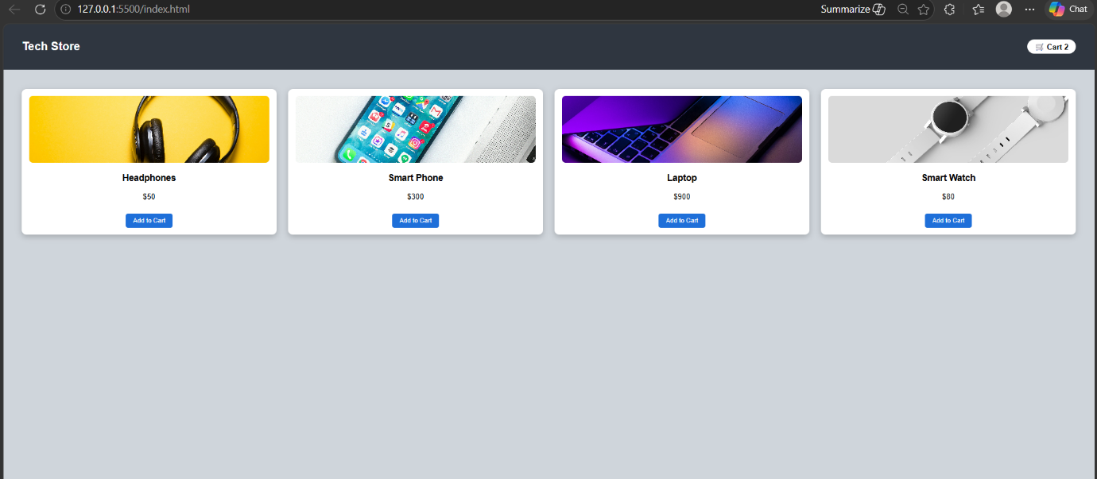
#OUTPUT

#ANALYSIS
AI assistance helps quickly generate the product layout, styling, and cart functionality. The developer can refine the UI and interaction to improve the user experience. The cart counter and visual feedback make the product page interactive and easier for users to understand their actions.
Task 5: Create a Responsive Web Page Layout
#PROMPT
Use GitHub Copilot to generate a responsive web page layout with a header, navigation links, main content section, and footer using HTML and CSS. Apply responsive design techniques such as Flexbox and media queries to adapt the layout for desktop, tablet, and mobile screens.
#CODE
<!DOCTYPE html>
<html>
<head>
<title>Responsive Layout</title>
<style>
body
{
font-family: Arial;
margin: 0;
}
header
{
background: #333;
color: white;
padding: 15px;
display: flex;
justify-content: space-between;
}
nav a
{
color: white;
margin: 10px;
text-decoration: none;
}
.main
{
display: flex;
padding: 20px;
gap: 20px;
}
.content
{
flex: 2;
background: #f2f2f2;
padding: 20px;
}
.sidebar
{
flex: 1;
background: #ddd;
padding: 20px;
}
footer
{
background: #333;
color: white;
text-align: center;
padding: 10px;
}
/* Responsive */
@media(max-width:768px)
{
.main{
flex-direction: column;}
header{
flex-direction: column;
align-items: center;}}
</style>
</head>
<body>
<header>
<h2>My Website</h2>
<nav>
<a href="#">Home</a>
<a href="#">About</a>
<a href="#">Services</a>
<a href="#">Contact</a>
</nav>
</header>
<div class="main">
<div class="content">
<h3>Main Content</h3>
<p>This is placeholder text for the main section of the webpage.</p>
</div>
<div class="sidebar">
<h3>Sidebar</h3>
<p>Additional information or images can be placed here.</p>
</div>
</div>
<footer>
<p>© 2026 My Website | Contact: info@email.com</p>
</footer>
</body>
</html>
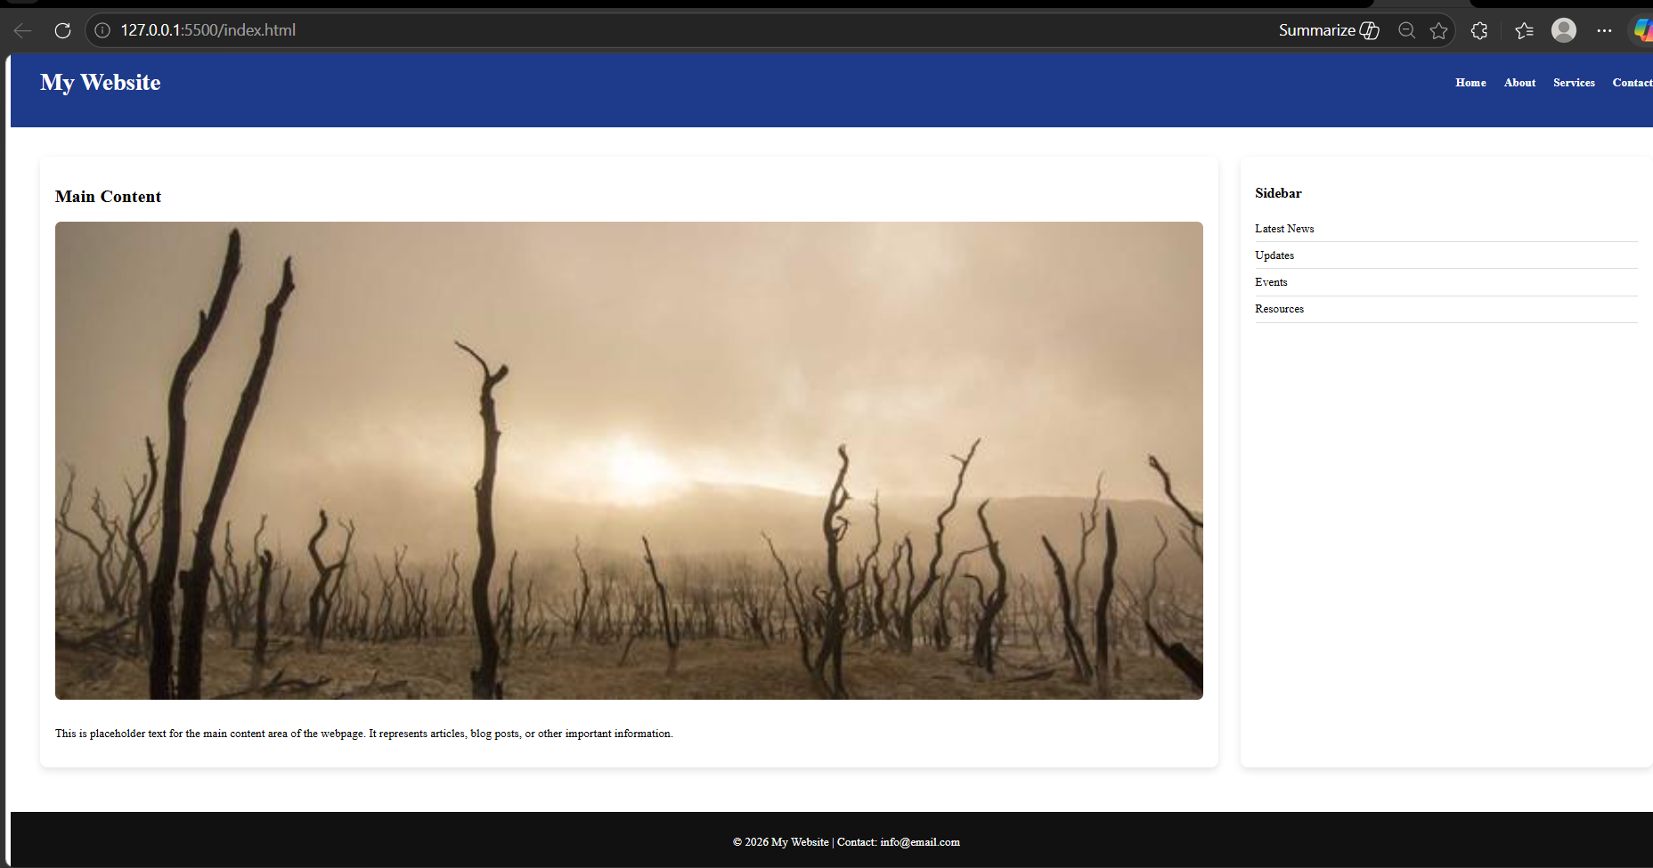
#OUTPUT
#ANALYSIS
AI tools help quickly generate the base structure and responsive CSS for the layout. Developers can refine spacing, colors, and alignment to maintain a clean design across devices. Media queries ensure that the page automatically adjusts to different screen sizes for better usability.

