2303A51588
Batch-10
WEEK-11.3
Task 1: Smart Contact Manager (Arrays & Linked Lists)
#PROMPT
Create a Python Contact Manager that stores student names and phone numbers. Implement the program using both an array (list) and a linked list, with operations to add, search, and delete contacts.
#CODE (Using Array)
contacts = []
while True:
print("\n1. Add Contact")
print("2. Search Contact")
print("3. Delete Contact")
print("4. Display Contacts")
print("5. Exit")
choice = int(input("Enter your choice: "))
if choice == 1:
name = input("Enter name: ")
phone = input("Enter phone number: ")
contacts.append((name, phone))
print("Contact added successfully")

elif choice == 2:
name = input("Enter name to search: ")
found = False
for contact in contacts:
if contact[0] == name:
print("Contact found:", contact[0], contact[1])
found = True
if not found:
print("Contact not found")
elif choice == 3:
name = input("Enter name to delete: ")
for contact in contacts:
if contact[0] == name:
contacts.remove(contact)
print("Contact deleted successfully")
break
else:
print("Contact not found")
elif choice == 4:
print("Contacts List:")
for contact in contacts:
print(contact[0], contact[1])
elif choice == 5:
break
#OUTPUT
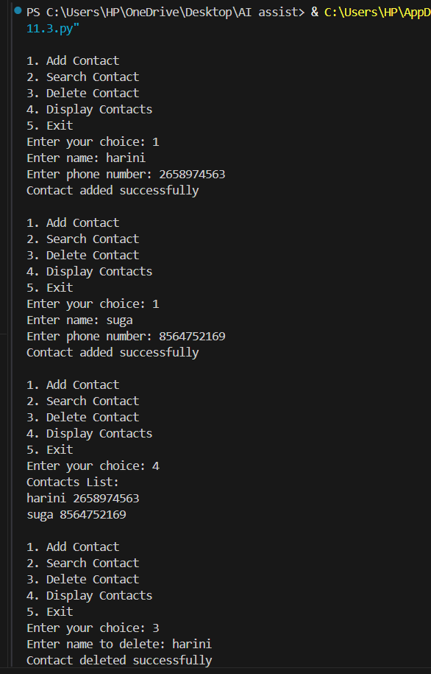

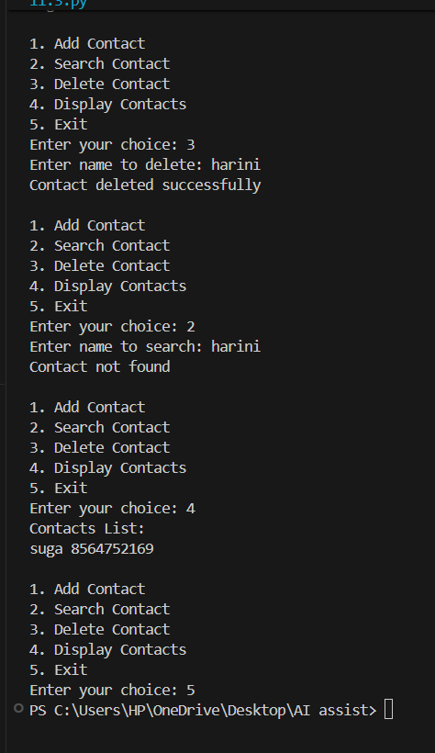

Using LinkedList
class Node:
def __init__(self, name, phone):
self.name = name
self.phone = phone
self.next = None
class ContactList:
def __init__(self):
self.head = None
def add_contact(self, name, phone):
new_node = Node(name, phone)
if self.head is None:
self.head = new_node
return
temp = self.head
while temp.next:
temp = temp.next
temp.next = new_node
print("Contact added")
def search_contact(self, name):
temp = self.head
while temp:
if temp.name == name:
print("Contact found:", temp.name, temp.phone)
return
temp = temp.next
print("Contact not found")
def delete_contact(self, name):
temp = self.head
prev = None
while temp:
if temp.name == name:
if prev is None:
self.head = temp.next
else:
prev.next = temp.next
print("Contact deleted")
return
prev = temp
temp = temp.next

print("Contact not found")
def display(self):
temp = self.head
while temp:
print(temp.name, temp.phone)
temp = temp.next
cl = ContactList()
while True:
print("\n1. Add Contact")
print("2. Search Contact")
print("3. Delete Contact")
print("4. Display Contacts")
print("5. Exit")
choice = int(input("Enter your choice: "))
if choice == 1:
name = input("Enter name: ")
phone = input("Enter phone number: ")
cl.add_contact(name, phone)
elif choice == 2:
name = input("Enter name to search: ")
cl.search_contact(name)
elif choice == 3:
name = input("Enter name to delete: ")
cl.delete_contact(name)
elif choice == 4:
cl.display()
elif choice == 5:
break
#OUTPUT
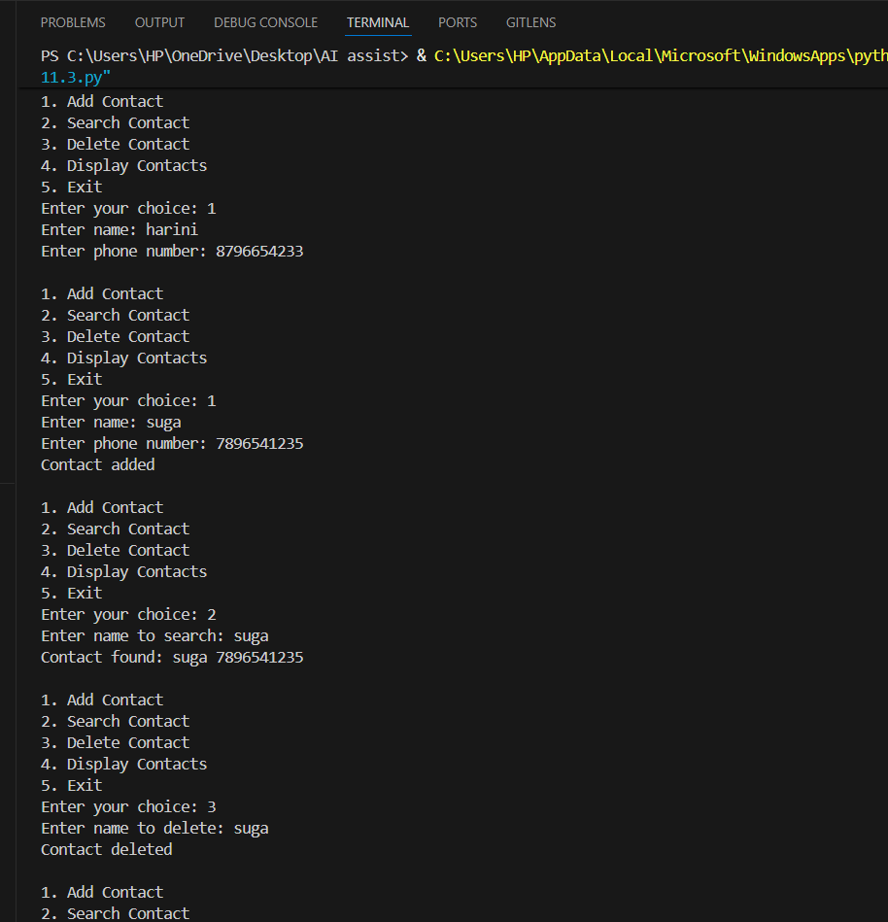

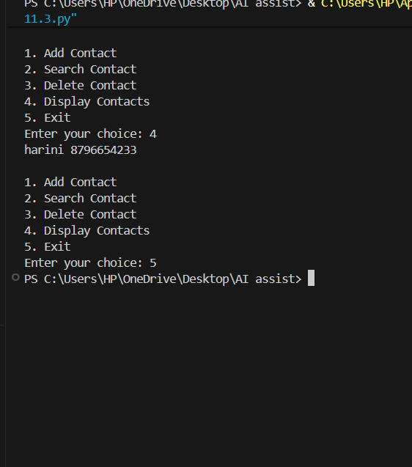

#ANALYSIS
The program manages contact details efficiently using two data structures. Arrays provide simple and fast insertion, while linked lists allow dynamic memory allocation and easier deletion by updating pointers.
Task 2: Library Book Search System (Queues & Priority Queues)
#PROMPT
Create a Python program to manage library book requests using Queue and Priority Queue. The system should allow users to enqueue (add request) and dequeue (process request). Faculty requests must be given higher priority than student requests in the priority queue.
#CODE (Queue (FIFO)
from collections import deque
queue = deque()
def enqueue():
name = input("Enter name: ")
book = input("Enter book name: ")
role = input("Enter role (Student/Faculty): ")
queue.append((name, book, role))
print("Request added")
def dequeue():
if queue:
req = queue.popleft()
print("Processing request:", req[0], "-", req[1], "-", req[2])
else:
print("No requests in queue")
def display():
print("Current Requests:")
for r in queue:
print(r[0], "-", r[1], "-", r[2])
while True:
print("\n1. Add Request")
print("2. Process Request")
print("3. Display Requests")
print("4. Exit")
choice = int(input("Enter choice: "))
if choice == 1:
enqueue()
elif choice == 2:
dequeue()
elif choice == 3:
display()
elif choice == 4:
break
Priority Queue (Faculty Priority)
import heapq
pq = []
def enqueue():
name = input("Enter name: ")
book = input("Enter book name: ")
role = input("Enter role (Student/Faculty): ")
if role.lower() == "faculty":
priority = 1
else:
priority = 2
heapq.heappush(pq, (priority, name, book, role))
print("Request added")
def dequeue():
if pq:
req = heapq.heappop(pq)
print("Processing request:", req[1], "-", req[2], "-", req[3])
else:
print("No requests")
def display():
print("Current Requests:")
for r in pq:
print(r[1], "-", r[2], "-", r[3])
while True:
print("\n1. Add Request")
print("2. Process Request")
print("3. Display Requests")
print("4. Exit")
choice = int(input("Enter choice: "))
if choice == 1:
enqueue()
elif choice == 2:
dequeue()
elif choice == 3:
display()
elif choice == 4:
break
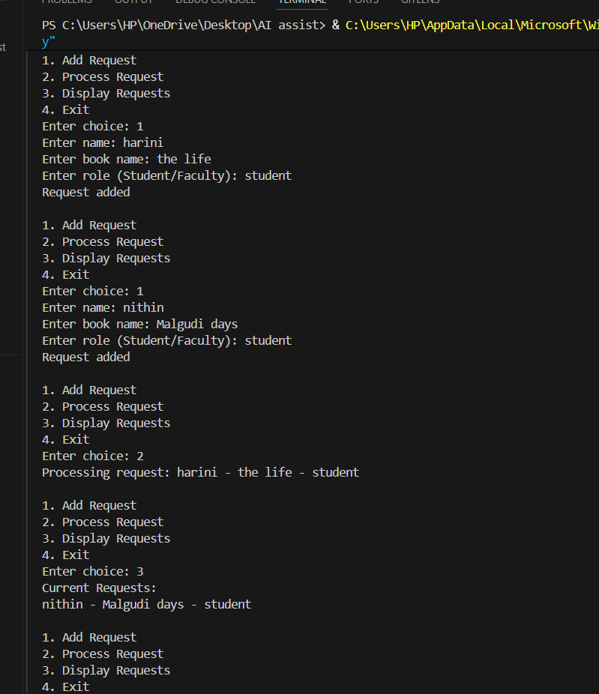
#OUTPUT

#ANALYSIS
A Queue (FIFO) processes requests in the order they arrive. A Priority Queue processes requests based on priority, where faculty requests are handled before student requests. This ensures important requests are served first.
Task 3: Emergency Help Desk (Stack Implementation)
#PROMPT
Create a Python program to manage IT Help Desk tickets using a Stack (LIFO). The system should support push (add ticket), pop (resolve ticket), and peek (view latest ticket) operations. Also include functions to check if the stack is empty or full.
#CODE
stack = []
MAX = 5
def push():
if len(stack) == MAX:
print("Stack is full. Cannot add more tickets.")
else:
ticket = input("Enter ticket issue: ")
stack.append(ticket)
print("Ticket added")
def pop():
if len(stack) == 0:
print("No tickets to resolve")
else:
ticket = stack.pop()
print("Resolved ticket:", ticket)
def peek():
if len(stack) == 0:
print("No tickets in stack")
else:
print("Latest ticket:", stack[-1])
def display():
if len(stack) == 0:
print("No tickets available")
else:
print("Current Tickets:")
for t in reversed(stack):
print(t)
while True:
print("\n1. Raise Ticket (Push)")
print("2. Resolve Ticket (Pop)")
print("3. View Latest Ticket (Peek)")
print("4. Display Tickets")
print("5. Exit")
choice = int(input("Enter your choice: ")
if choice == 1:
push()
elif choice == 2:
pop()
elif choice == 3:
peek()
elif choice == 4:
display()
elif choice == 5:
break
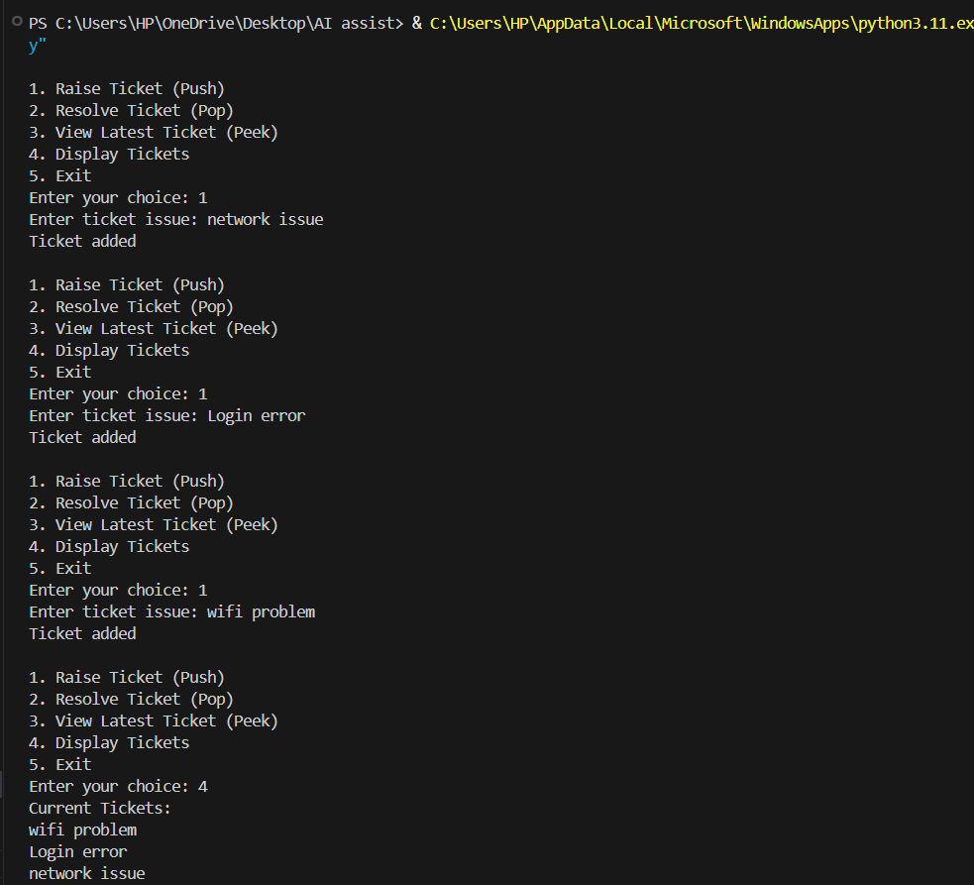
#OUTPUT

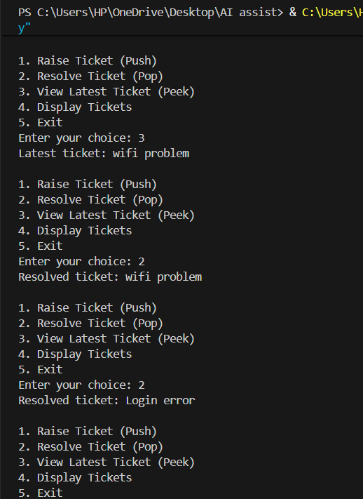

#ANALYSIS
A Stack follows the Last-In, First-Out (LIFO) principle, meaning the most recently added ticket is resolved first. The system stores tickets in a stack and processes them using push, pop, and peek operations, ensuring efficient ticket escalation.
Task 4: Hash Table
#PROMPT
Create a Python program to implement a Hash Table using chaining for collision handling. The hash table should support insert, search, and delete operations. Each index should store multiple elements using a list to handle collisions.
#CODE
class HashTable:
def __init__(self, size):
self.size = size
self.table = [[] for _ in range(size)]
def hash_function(self, key):
return key % self.size
def insert(self, key):
index = self.hash_function(key)
self.table[index].append(key)
print("Inserted:", key)
def search(self, key):
index = self.hash_function(key)
if key in self.table[index]:
print("Key found:", key)
else:
print("Key not found")
def delete(self, key):
index = self.hash_function(key)
if key in self.table[index]
self.table[index].remove(key)
print("Key deleted:", key)
else:
print("Key not found")
def display(self):
for i in range(self.size):
print(i, ":", self.table[i])
size = int(input("Enter hash table size: "))
ht = HashTable(size)
while True:
print("\n1.Insert")
print("2.Search")
print("3.Delete")
print("4.Display")
print("5.Exit")
choice = int(input("Enter choice: "))
if choice == 1:
key = int(input("Enter key to insert: "))
ht.insert(key)
elif choice == 2:
key = int(input("Enter key to search: "))
ht.search(key)
elif choice == 3:
key = int(input("Enter key to delete: "))
ht.delete(key)
elif choice == 4:
ht.display()
elif choice == 5:
break
#OUTPUT
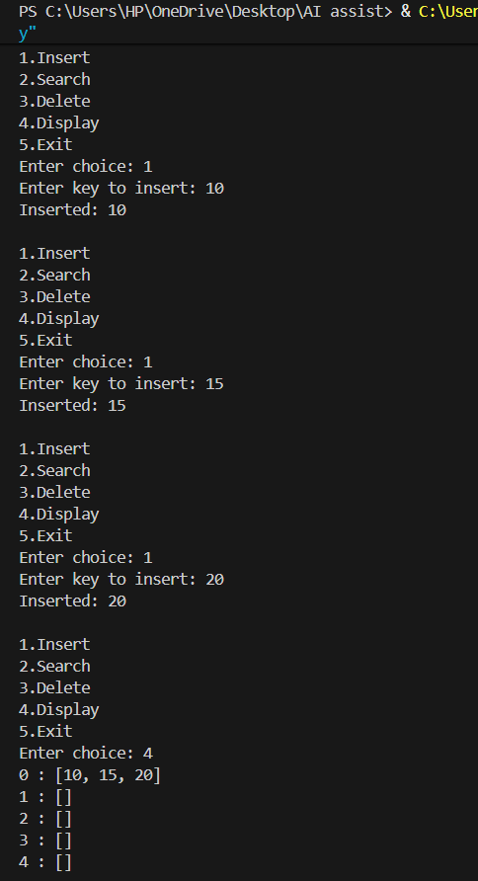

#ANALYSIS
A Hash Table stores data using a hash function that converts keys into array indices. When two keys map to the same index, collision occurs, which is handled using chaining (a list at each index). This allows multiple values to be stored at the same location.

Task 5: Real-Time Application Challenge
#PROMPT
Create a Python program for a Campus Resource Management System. Select suitable data structures for features like attendance tracking, event registration, library borrowing, bus scheduling, and cafeteria order queue, and implement one feature (such as cafeteria order queue) using a Queue data structure.
#CODE
from collections import deque
orders = deque()
def place_order():
name = input("Enter student name: ")
item = input("Enter food item: ")
orders.append((name, item))
print("Order placed successfully")
def serve_order():
if orders:
order = orders.popleft()
print("Serving order:", order[0], "-", order[1])
else:
print("No orders in queue")
def display_orders():
if not orders:
print("No pending orders")
else:
print("Pending Orders:")
for order in orders:
print(order[0], "-", order[1])
while True:
print("\n1.Place Order")
print("2.Serve Order")
print("3.Display Orders")
print("4.Exit")
choice = int(input("Enter your choice: "))
if choice == 1:
place_order()
elif choice == 2:
serve_order()
elif choice == 3:
display_orders()
elif choice == 4:
break

#OUTPUT

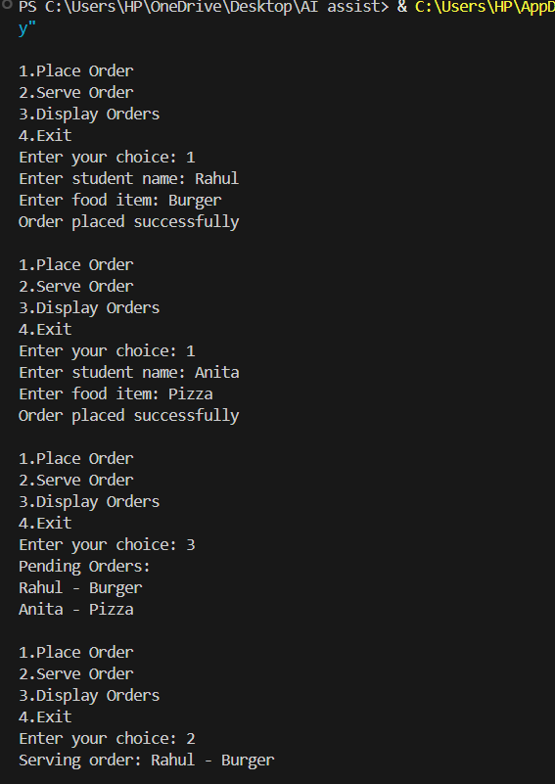

#ANALISYS
Different system features require different data structures for efficiency. For example, Hash Tables allow fast attendance lookup, Lists help store event participants, and Queues ensure fair processing of orders or borrowing requests using FIFO order. Selecting the right structure improves performance and system organization.

