2303A51588
Batch-10
Assignment-9.3
Task-1
#Prompt
Act as an auto generating function documentation in a shared code. In python script with multiple functions without any doc strings. Now generate google-style function docstrings for each function in the script. The docstrings should include a brief description of the function's purpose, its parameters, and its return value. Take user input for the functions and print the results.
#CODE
def add(a, b):
return a + b
def subtract(a, b):
return a - b
def multiply(a, b):
def divide(a, b):
if b == 0:
raise ValueError("Cannot divide by zero")
return a / b
try:
num1 = float(input("Enter first number: "))
num2 = float(input("Enter second number: "))
print("Addition:", add(num1,
num2))
print("Subtraction:", subtract(num1, num2))
print("Multiplication:", multiply(num1, num2))
print("Division:", divide(num1, num2))
except ValueError as e:
print(e)
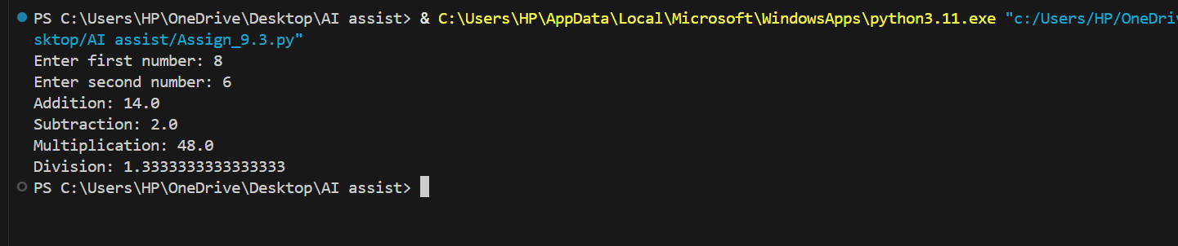
#OUTPUT

#ANALYSIS
The program defines basic arithmetic functions such as addition, subtraction, multiplication, and division. Each function performs its operation correctly, and the divide function also handles division by zero using error handling. The generated docstrings improve readability and make the code more suitable for shared codebases.
Task-2
#PROMPT
In this task, I used an AI tool to automatically generate inline comments for a Python program that contains loops and conditional statements. The goal was to explain the logic and flow of the program clearly so that even beginners can understand how the code works step by step.
#CODE
def factorial(n):
if n < 0:
return "Not defined for negative numbers"
elif n == 0 or n == 1:
return 1
else:
result = 1
for i in range(2, n + 1):
result *= i
return result
try:
num = int(input("Enter number: "))
print("Factorial:", factorial(num))
except ValueError:
print("Invalid input")
#OUTPUT
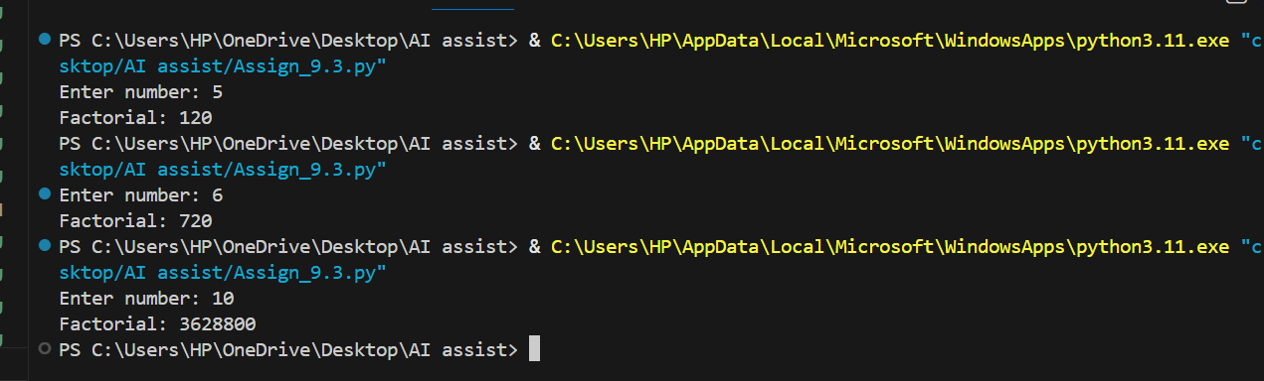
#ANALYSIS
The program calculates the factorial of a number using conditions and loops. It handles negative numbers and base cases properly and uses a loop to compute the factorial. Inline comments help in understanding each part of the logic, making the program easier to read and debug.
TASK 3
#PROMPT
In this task, I used AI to generate a professional module-level docstring for a Python module. The prompt included requirements such as describing the purpose of the module, listing key functions and classes, and providing a small usage example suitable for real-world projects.
#CODE
class Student:
def __init__(self, student_id, name, marks):
self.student_id = student_id
self.name = name
self.marks = marks
def calculate_average(self):
if not self.marks:
return 0
return round(sum(self.marks) / len(self.marks), 2)
def add_student(student_list, student):
student_list.append(student)
def find_student_by_id(student_list, student_id):
for student in student_list:
if student.student_id == student_id:
return student
return None
if __name__ == "__main__":
students = []
sid = int(input("Enter Student ID: "))
name = input("Enter Name: ")
marks = list(map(int, input("Enter marks: ").split()))
student = Student(sid, name, marks)
add_student(students, student)
search_id = int(input("Enter ID to search: "))
result = find_student_by_id(students, search_id)
if result:
print("Student Found:", result.name)
print("Average Marks:", result.calculate_average())
else:
print("Student not found")

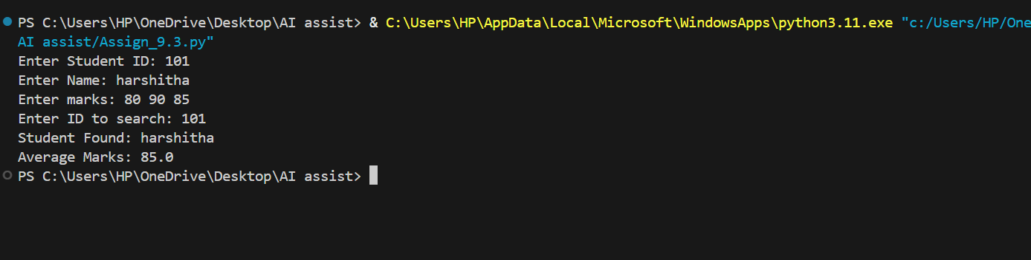
#OUTPUT
#ANALYSIS
The module implements a simple student management system with a class and utility functions. It allows adding and searching for students and calculating their average marks. The documentation clearly explains the structure and usage, which helps developers reuse the module easily.
TASK 4
#PROMPT
In this task, I used AI to convert existing inline comments into structured Google-style docstrings. The prompt ensured that the docstrings include function descriptions, parameters, return values, and examples while removing unnecessary inline comments to keep the code clean.
#CODE
class ShoppingCart:
def __init__(self):
self.cart = {}
def add_item(self, item_name, price):
if item_name in self.cart:
self.cart[item_name] += price
else:
self.cart[item_name] = price
print(f"Added {item_name} to cart.")
def remove_item(self, item_name):
if item_name in self.cart:
del self.cart[item_name]
else:
print("Item not found in cart.")
def calculate_total(self):
return sum(self.cart.values())
cart = ShoppingCart()
while True:
action = input("Enter 'add' to add an item, 'remove' to remove an item, 'total' to calculate total price, or 'exit' to quit:\n")

if action == 'add':
item_name = input("Enter the name of the item: ")
try:
price = float(input("Enter the price of the item: "))
cart.add_item(item_name, price)
except ValueError:
print("Invalid price. Please enter a number.")
elif action == 'remove':
item_name = input("Enter the name of the item to remove: ")
cart.remove_item(item_name)
elif action == 'total':
total_price = cart.calculate_total()
print(f"The total price of items in the cart is: ${total_price:.2f}")
elif action == 'exit':
print("Exiting the shopping cart program.")
break
else:
print("Invalid action. Please try again.")

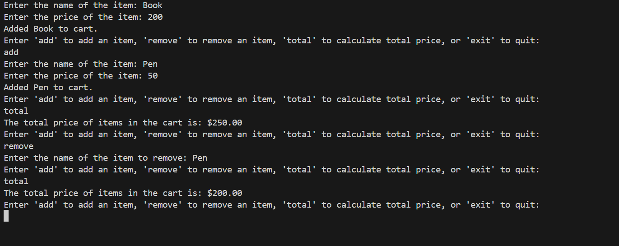
#OUTPUT

#ANALYSIS
The program manages a shopping cart with functions to add, remove, and calculate total price. Converting inline comments into docstrings improves the overall structure of the code and makes it more professional. It also helps developers quickly understand the purpose of each function.
Task 5
#PROMPT
In this task, I used AI to design a Python utility script that reads a file and detects functions and classes. The prompt asked to generate placeholder Google-style docstrings for each detected element, focusing on documentation scaffolding rather than perfect content.
#CODE
import re
import os
def generate_docstrings(file_path):
if not os.path.isfile(file_path):
print("File not found.")
return
with open(file_path, 'r') as file:
content = file.read()
class_pattern = re.compile(r'class\s+(\w+)')
function_pattern = re.compile(r'def\s+(\w+)\s*\(')
classes = class_pattern.findall(content)
functions = function_pattern.findall(content)
for cls in classes:
print(f'Class: {cls}\n"""[Class description here]"""\n')
for func in functions:
print(f'Function:{func}\n"""[Functiondescription here]\nArgs:\n [parameters]\nReturns:\n [return value]\n"""\n')
if __name__ == "__main__":
file_path = input("Enter the path of the .py file to analyze: ")
generate_docstrings(file_path)

#OUTPUT

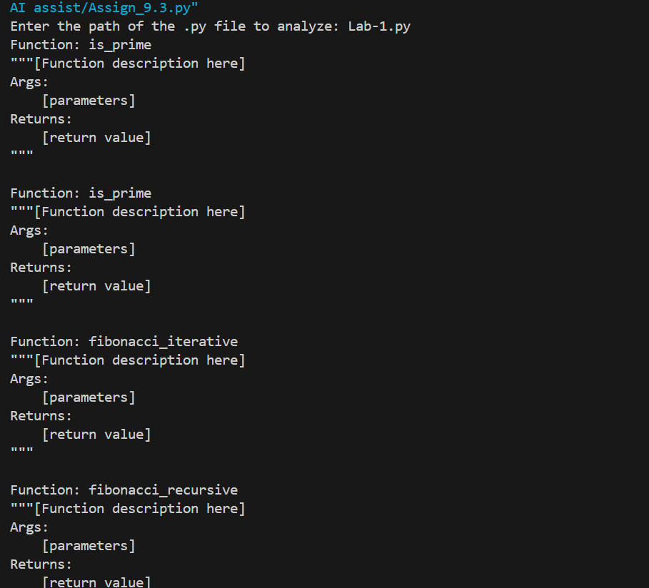
#ANALYSIS
The script uses regular expressions to identify functions and classes in a Python file. It then generates basic docstrings automatically, which can be further refined later. This approach saves time and helps developers quickly create documentation for large codebases.

