**Online Subsidy Seed Distribution System (OSSDS)**

URL is :<http://ossds.telangana.gov.in>

**Workflow of DAO Login – Screen Shots**

**INDEX**

|  |  |  |
| --- | --- | --- |
| **S.NO** | **ITEM NAME** | **PAGE NO.** |
| **1** | **A. Check Dashboard and allotment to Mandals** | **2** |
| **2** | **B. Seed allotment to DAO** | **3** |
| **3** | **C .Delete/Update Seed allotment to MAO by DAO** | **4** |
| **4** | **D. Freeze the seed allotment to MAO by DAO** | **5** |
| **5** | **E. Adding a Sale Point to a particular mandal by DAO** | **6** |
| **6** | **F. Reports in DAO Login** | **7** |
| **7** | **G. SEED REQUEST option in main menu** | **8** |
| **8** | **H. Stock Transfer option in main menu** | **9** |
| **9** | **I. Discussion Option in main menu** | **10** |
| **10** | **J. ACCOUNT option in the main menu** | **11** |

1. **Check Dashboard and allotment to Mandals**

After login, we can see DAO Dashboard.

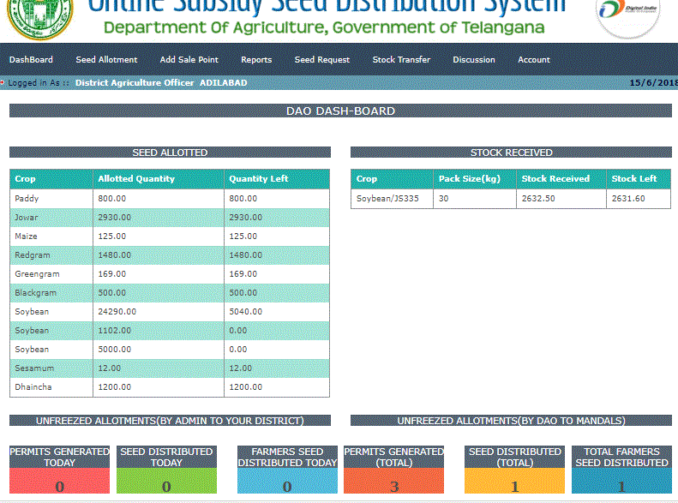

1. **SEED ALLOTMENT TO DAO**

Click on menu **Seed Allotment🡪 View Allotted (s**ee below screen)

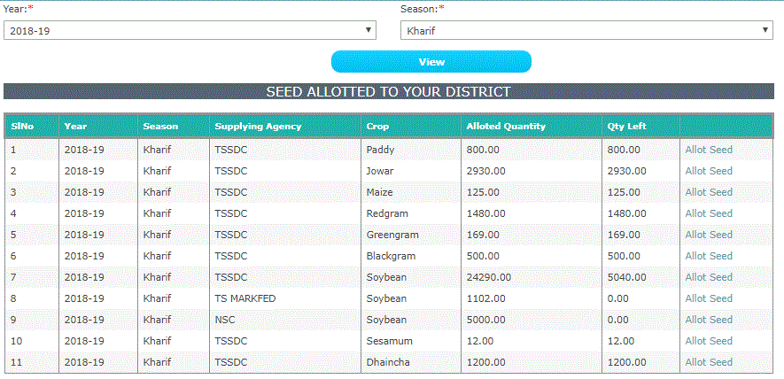

Click on **Allot Seed** to seed allotment to mandals under DAO(See below screen)

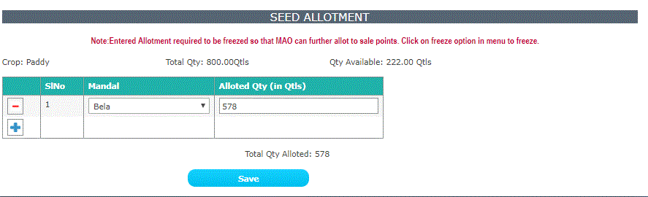

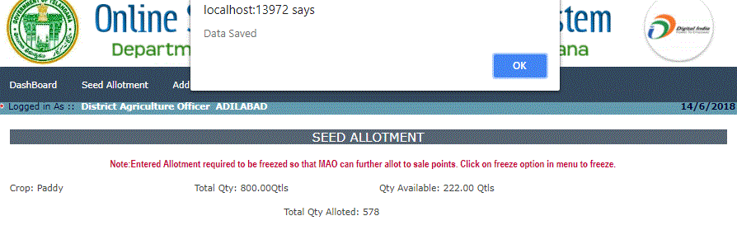

In the above screen, DAO allotted quantity is 578 qtls out of 800 qtls available. The balance quantity is 222 qtls for the DAO.

1. **Delete/Update Seed allotment to MAO by DAO**

Click on **Seed Allotment🡪Delete/Update**menu to **edit/delete** the allotted seed

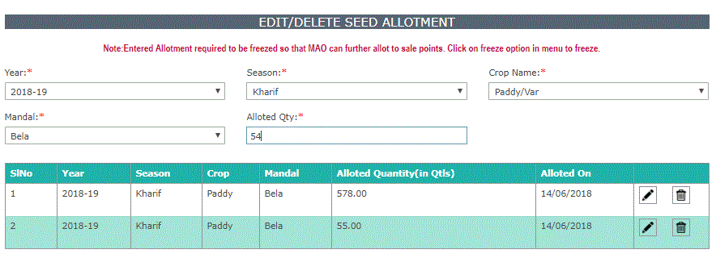

You have to click on edit button to change, it will be updated (please see below screen)

After select year and season data will be displayed

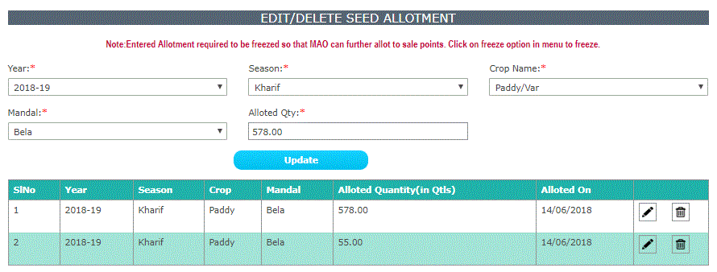

edit Symbol to edit the data Delete symbol to delete data

1. **Freeze the seed allotment to MAO by DAO**

Click on**Seed Allotment🡪Freeze Allotment** menu(see below screen)

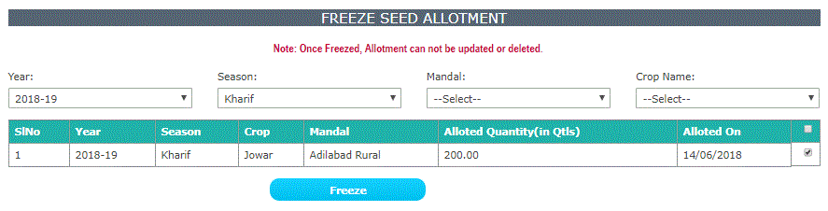

Select check box and click on **FREEZE** button to freeze the data (see below screen)

**Note: Once Freezed, Allotment can not be updated or deleted.**

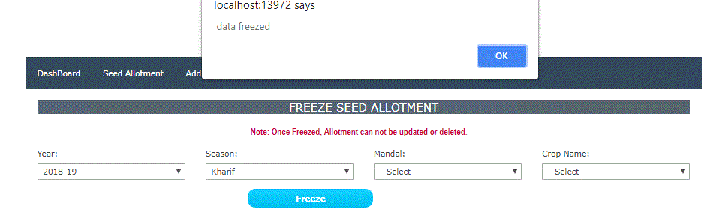

To check the freeze seed allotment ,click on **Seed Allotment🡪View Seed Allotment** menu, as shown below

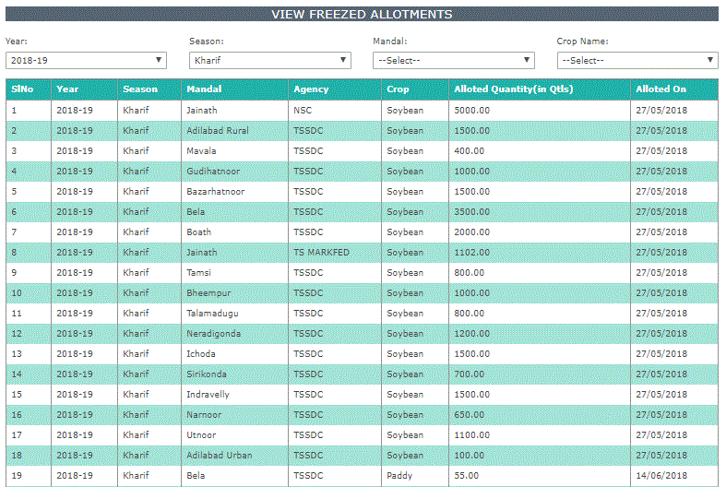

NOTE: Once Freezed be allotments can’t be changed. Please make sure that allotments are correct before freezing.

1. **Adding a Sale Point to a particular mandal by DAO**

Click on **Add Sale Point** in the main menu. Here select mandal name, enter Sale point name, sale

Pointincharge, Mobile number and username. Also select **YES** button under**Active** Column. In case,

if anysalepoint is to be made as inactive, select **NO** under Active Column.

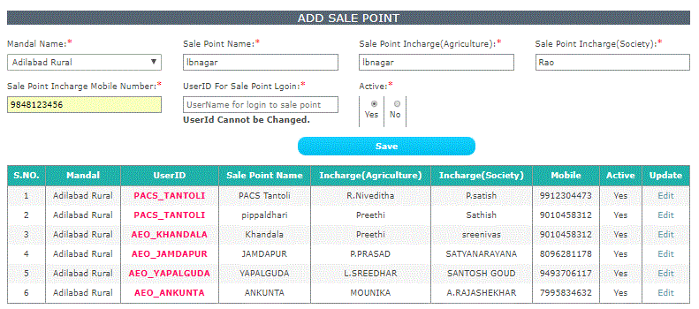

Use above User ID to login as **salepoint** login with default password i.e. Sa@12345. After login, here system prompts for changing the default password.

1. **Reports in DAO Login:-**

if you click on **Reports🡪 View Sale Points** menu

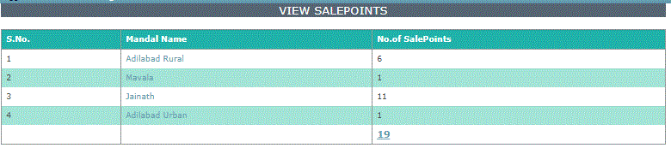

Click on **Mandal name,** to see Sale Points

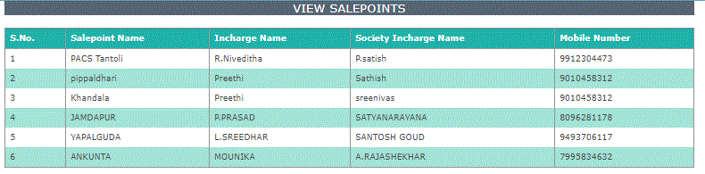

Also, click on **View Seed Distribution**, **View Stock Position** and **Daily Report** in

Reports option of mainmenu**.**

1. **SEED REQUEST option in main menu**

Click on SEED REQUEST from main menu. MAOs who have requested Seed allotment from their login is as

shown below under **VIEW REQUESTS.**Here select either APPROVE or REJECT button to take action. If request is rejected, **REMARKS** to be entered. Click on **SAVE** to save the record and saved details also can be seen.

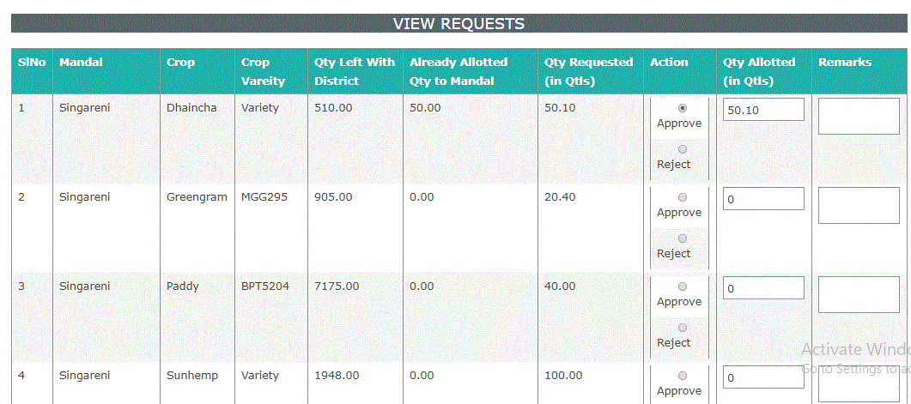

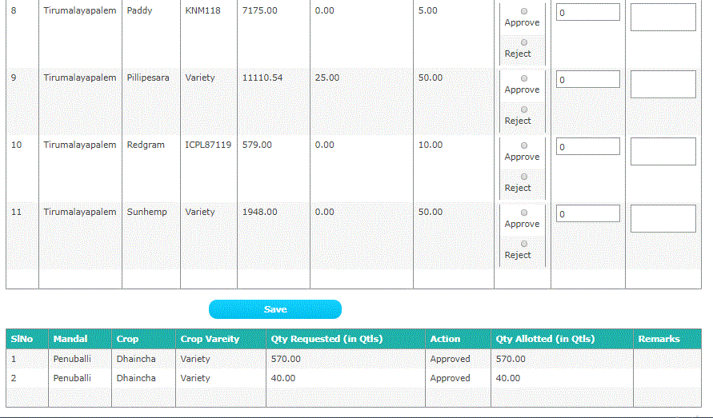

1. **Stock Transfer option in main menu**

With this option, INTER MANDAL STOCK TRANSFER can be done. That is, Seed Stock can be transferred from One mandal to another mandal. (See below screen). Here Select Year, Season, Mandal, Crop, Crop Variety and click on GET DATA button.

If Stock is there, data will be displayed as shown below

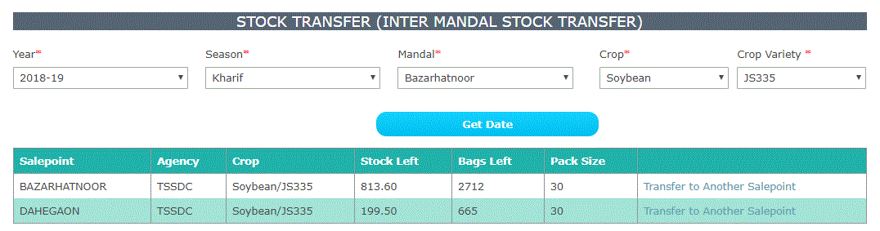

Click on TRANSFER TO ANOTHER SALEPOINT to transfer stock from Onemandal to another mandal.

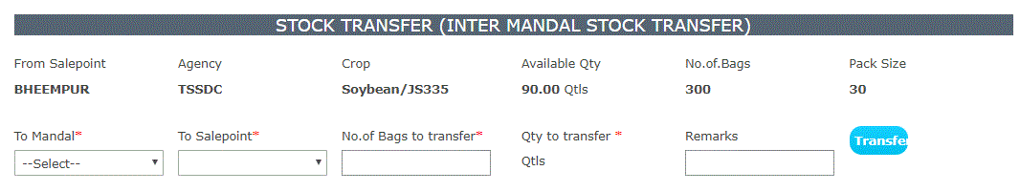

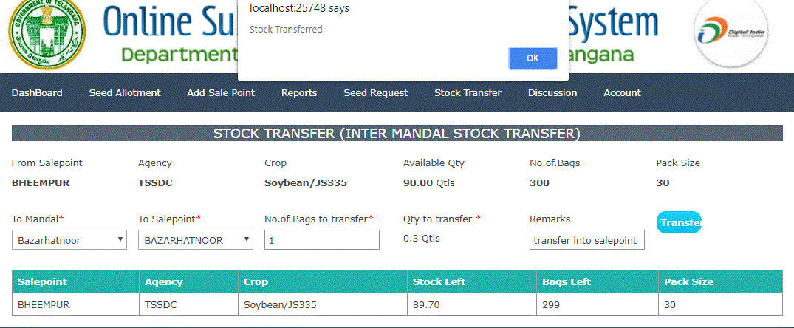

Select **To Mandal, To Sale Point** and enter **No.of bags** and **Remarks.** Click on **TRANSFER button.**

**Stock transferred** message seen above**.**

1. **Discussion Option in** **main menu:-**

For any query, on Seed allotment, Click on**Discussion** menu to post your query in DISCUSSION FORUM.

It will be replied by concerned person. Similarly,DAOs can reply the queries by using REPLY link in

DISCUSSION forum.

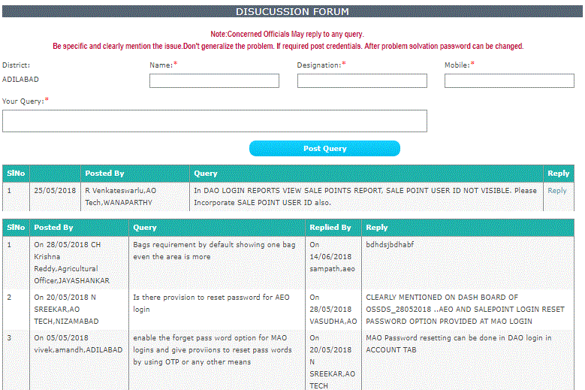

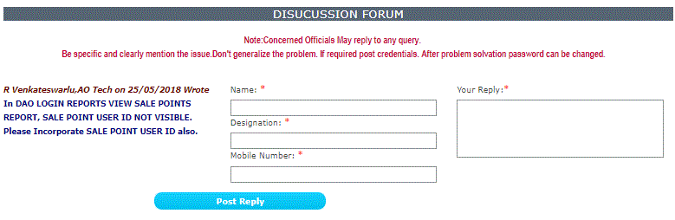

1. **ACCOUNT option in the main menu**

**ResetPassword of MAO from DAO Login: -**

To reset the password of MAO, Click on **Account🡪Password reset** menu and **select Mandal** as seen below.

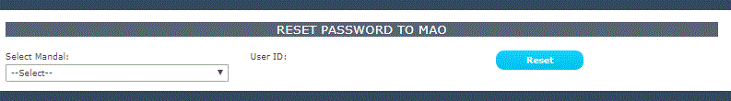

You have to select Select Mandal on click on Reset button. Herepassword reset to default password i.e. Sa@12345.

**Change Password of DAO Login: -**

Click on **Account**in the mainmenu **to Change Password**of DAO login.

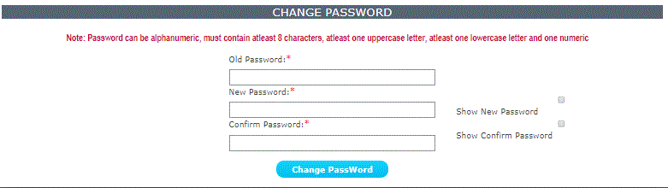

-----------END--------------