**Online Subsidy Seed Distribution System (OSSDS)**

URL is : <http://ossds.telangana.gov.in>

**Workflow of MAO Login – Screen Shots**

**INDEX**

|  |  |  |
| --- | --- | --- |
| **S.NO** | **ITEM NAME** | **PAGE NO.** |
| 1 | A. Check Dashboard and allotment to Sale Points done by MAO | 2 |
| 2 | B. Seed allotment to Sale point done by MAO | 3 |
| 3 | C. Delete/Update Seed allotment to Sale point by MAO | 5 |
| 3 | D. Freeze the seed allotment to Sale Point by MAO | 6 |
| 4 | E. View Seed Allotment | 7 |
| 5 | F. Add Representative to generate permit slip by MAO | 8 |
| 6 | G. Generate Permit Slip by MAO | 9 |
| 7 | H. Request Allotment of Seed by MAO to DAO | 12 |
| 8 | I. Stock Transfer by MAO from one Sale point to another Sale Point | 13 |
| 9 | J. Reports | 14 |
| 10 | K. Discussion | 16 |
| 11 | L. Account (Reset/Change Password) | 17 |

1. **Check Dashboard and allotment to Sale Points done by MAO**

After login as MAO, the DashBoard is seen as shown below.

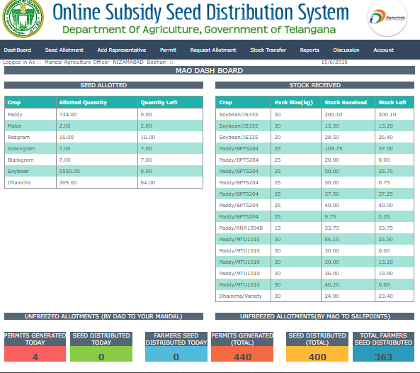

1. **Seed allotment to Sale Points done by MAO**

Click on menu, **Seed Allotment🡪View allotted** menu (see below screen)

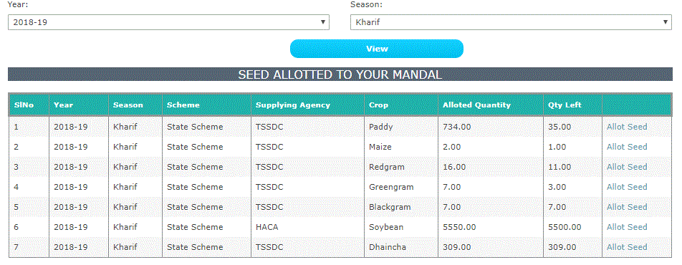

Click on **allot seed to** view seed allotment (see below screen)

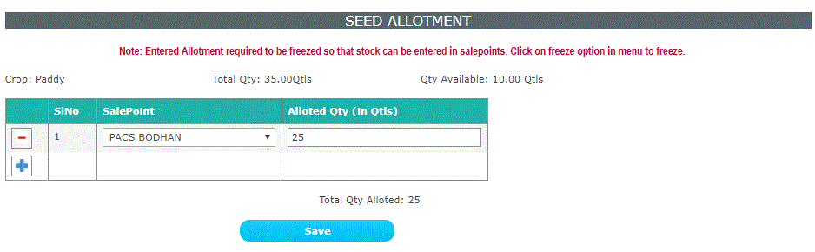

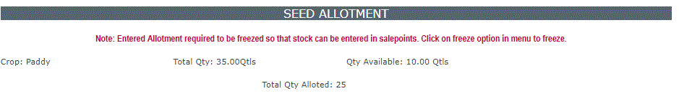

1. **Delete/Update Seed allotment to Sale point by MAO**

Click on **Seed Allotment🡪Delete/Update** menu to **edit/delete** the allotted seed

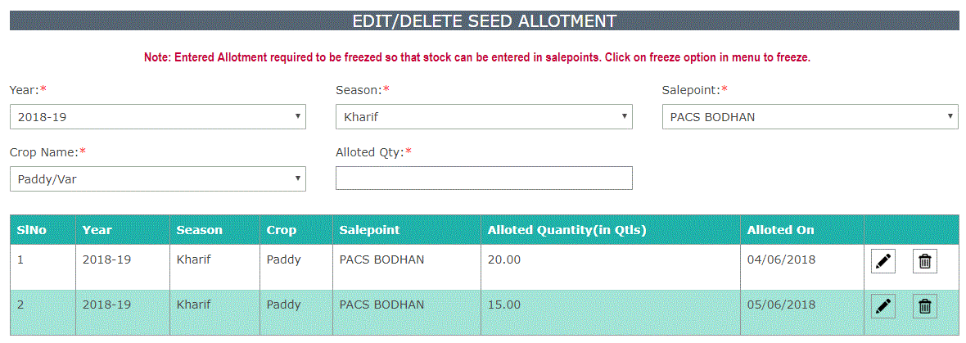

Click on delete button to delete the row

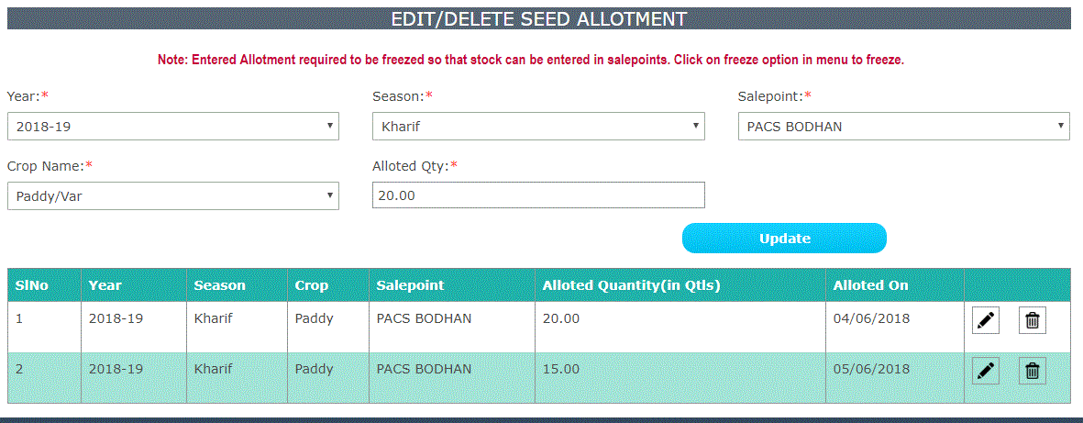

 edit Symbol to edit the data Delete symbol to delete data

1. **Freeze the seed allotment to Sale Point by MAO**

Click on**Seed Allotment**🡪**Freeze seed allotment**menu (see below screen)

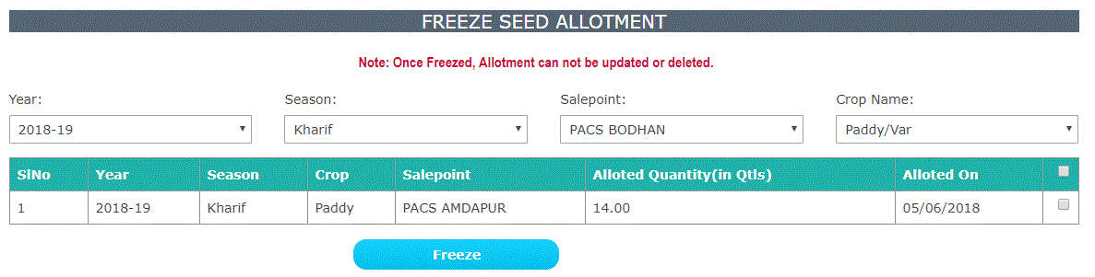

Selectcheckbox and click on **FREEZE** button data to freeze the data (see below screen)

**Note: Once Freezed, Allotment can’t be updated or deleted.**

1. **View Seed Allotment**

Click on **Seed Allotment** in main menu and select **View seed allotment** option (see below screen)

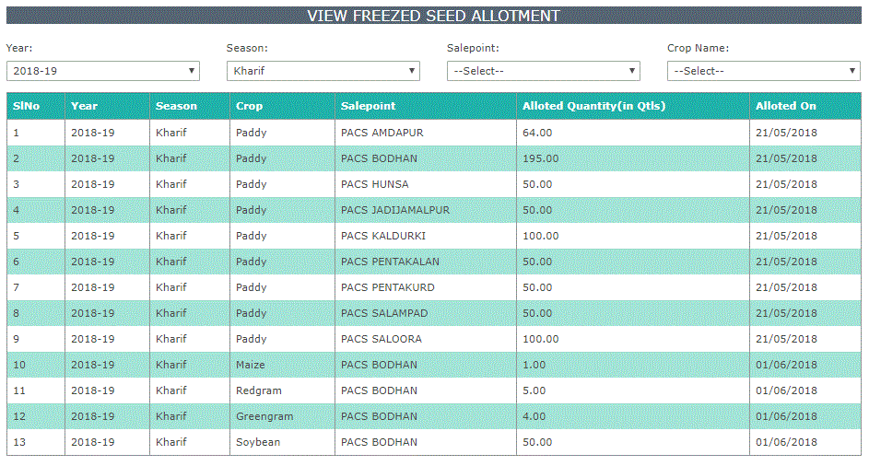

Select Year and Season then freeze data will be shown along with Sale point and Crop.

1. **Add Representative to generate permit slip by MAO**

Click on **Add Representative** in main menu. Here enter name of the person, designation, mobile number and select

Attached Sale point from the drop down menu. Enter username for login and select active/inactive. Select **YES**

button under **Active** Column. In case, if any salepoint is to be made as inactive, select **NO** under

Active Column. Click on **ADD to add representative(see below screens).**

**NOTE:- 1. Sale point incharge logins are created by DAOs.**

**2. MAOs can add AEOs as representatives to generate permitslip for seed allotment.**

**3. AEO(as representative) can login with his username to generate permit slip.**

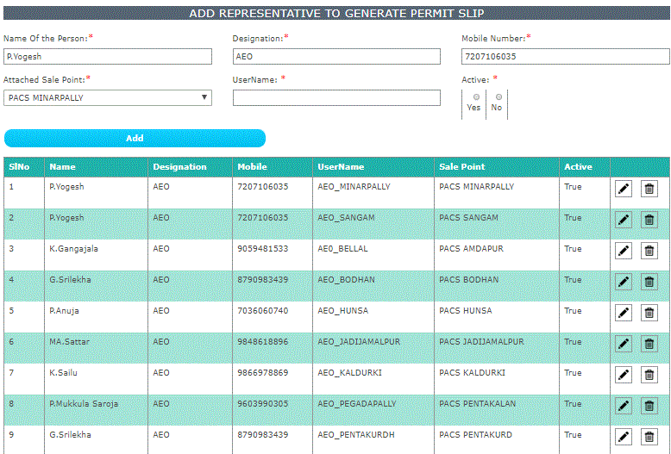

1. **Generate Permit Slip by MAO**

Click on **Permit🡪Generate Permit** menu.

**To Generate Permit Stock Should be entered and freezed in sale point login.**

Here Select/enter Village, Sale point, Khata number, Aadhaar Number, Farmer name, Gender, Category, Survey No, Father name, Mobile number, Total Land extent(as per PPB) and Person came for seed is to be entered. Here data will be shown in tabular form (see below). Here select Crop and Crop variety, if stock is available, no.of bags out of available bags will be shown. Enter extent. As per the extent the Seed rate and no.of required bags will be displayed. As per pattadar choice enter no. of bags and click on **SAVE**.

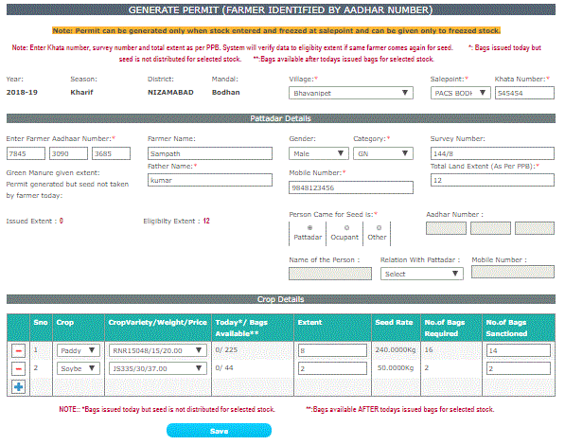

Now, system generated Permit slip(see below). It can be printed.

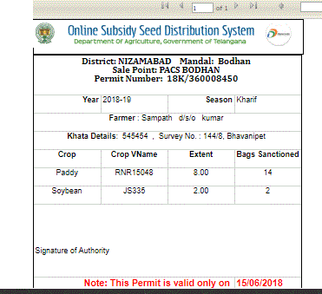

NOTE. In case of Green Manure, permit slips can be generated more than one time, to the pattadar till seed allotment done as per his eligibility of land extent.(see below screen)

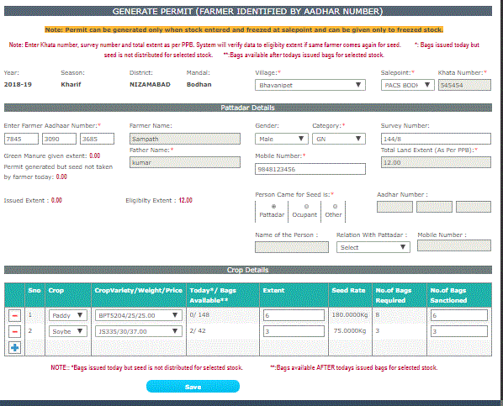



**The permit slip is valid for only one day. In PERMIT option in main menu, the other two options are DELETE PERMIT and PRINT PERMIT. Delete Permit is for deleting permits which are issued on current date and seed not yet sold, and PRINT PERMIT is to print a permit slip again.**

1. **Request Allotment of Seed by MAO to DAO**

Click on **Request Allotment**option in main menu.

Select year and season. System prompts data in tabular form.

Here select Crop and Crop variety and enter required allotment quatity in qunitals. Use – to delete row and + to add another crop/crop variety as per choice.

Click on SEND REQUEST button to send the request to DAO for required allotment(See below screen ).

The request is forwarded to Concerned DAO. After DAO Approval, the details will be intimated to Concerned DM.

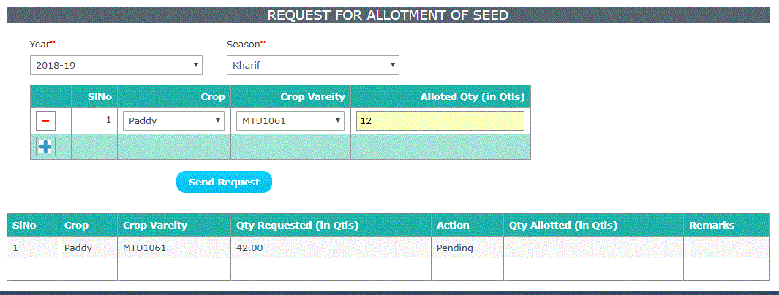

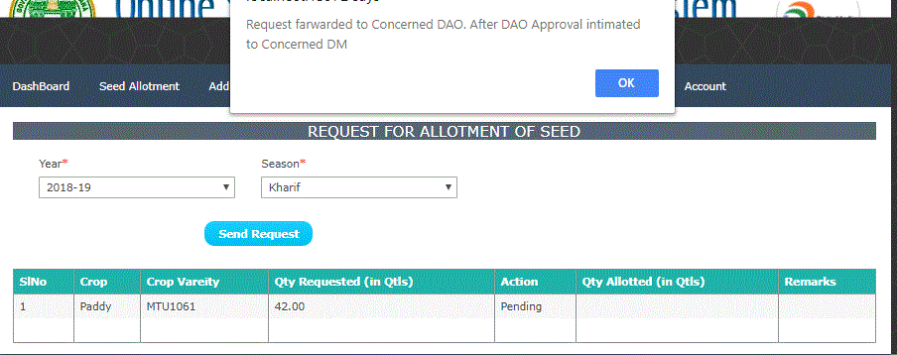

1. **Stock Transfer by MAO from one Sale point to another Sale Point**

Click on **Stock Transfer** option in main menu(see below screen). Select Year, season, crop and crop variety. Click on

GET DATA.

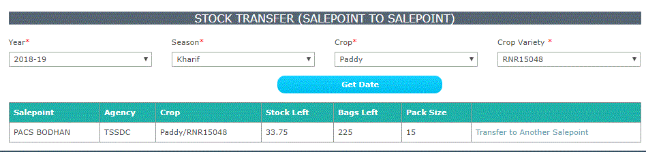

Click on **Transfer to Another Salepoint**to stock Transfer form (see below screen)

Here, Select Salepoint and enter no.of bags to transfer/remarks. Click on TRANSFER. The system show the transferred data in tabular form(see below screen).

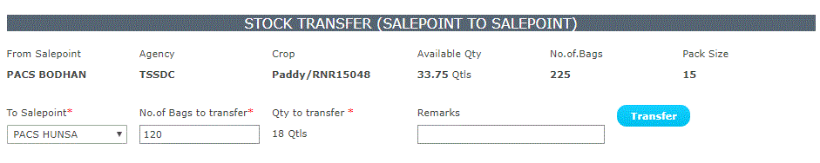

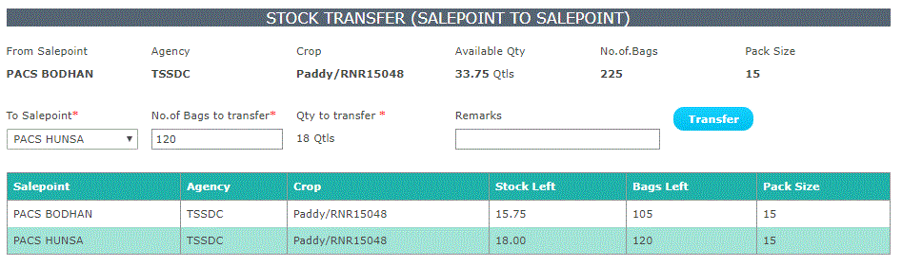

1. **Reports**

Click on **Reports** in Main menu to see **View Seed Allotment & Sales** option(see below screen)

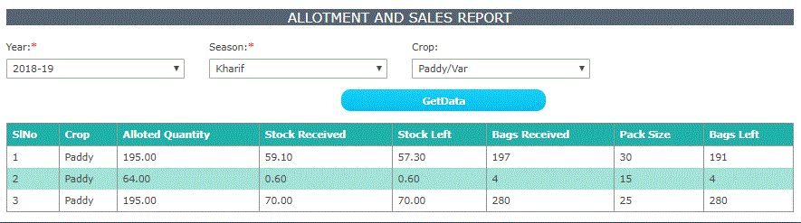

Click on **Reports** in main menu to see **View Permits** Option (see below screen)

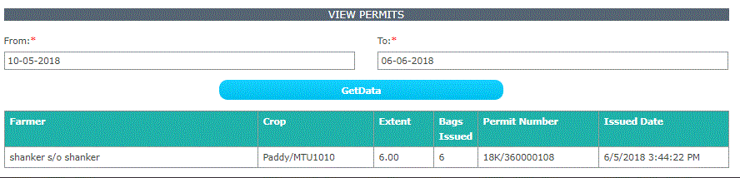

Click on **Reports** in main menu to see **Seed Distribution** option (see below screen)

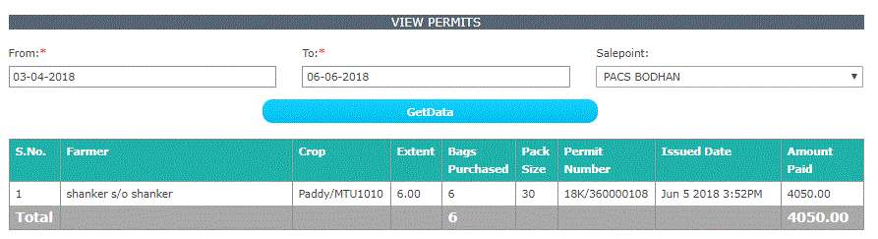

Click on **REPORTS** in main menu to see **DAILY REPORT** option(see below screen).

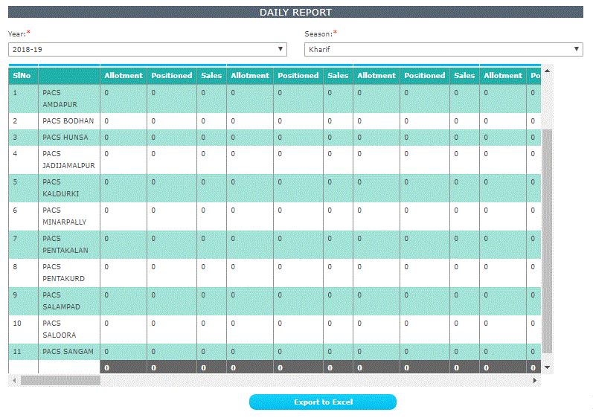

1. **Discussion**

Click on **Discussion** option in Mainmenu

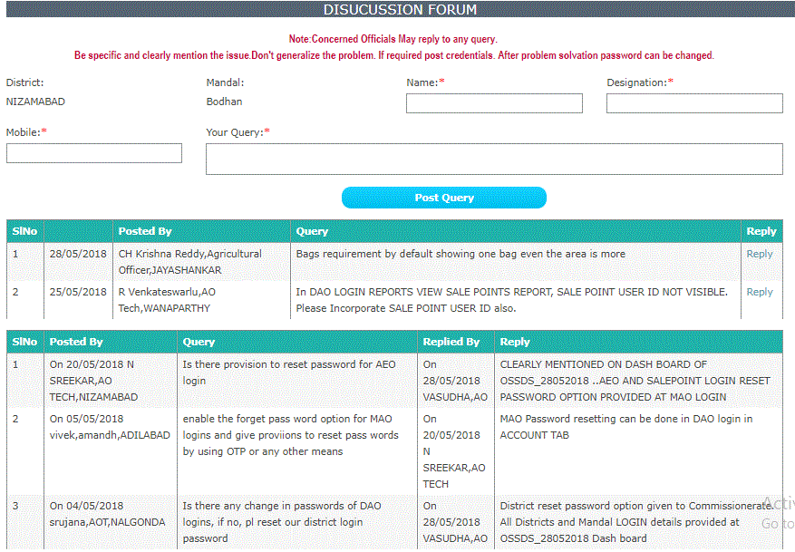

Click on **reply** button in above discussion forum form to reply for the queries by entering data as shown in below

Screen and click on **POST REPLY.**

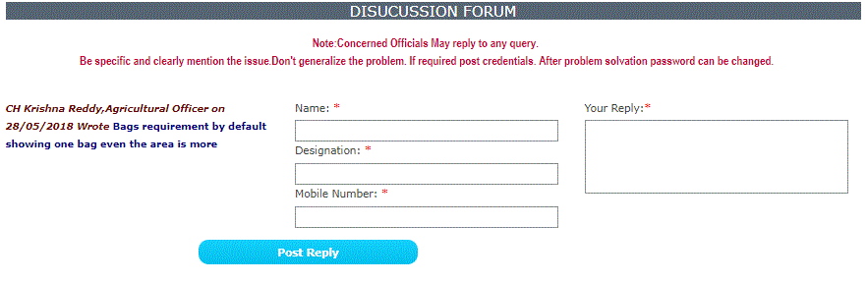

1. **Account (Reset/Change Password)**

Click on **ACCOUNT** option in main menu and select **Reset password** to salepoints/aeo (see below screen). Select

Level and Select Salepoint/AEO and Click on **RESET.**

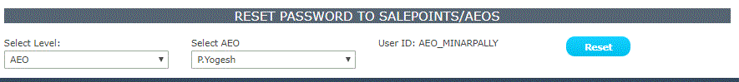

Click on **Reset** button to reset password to default password i.e. Sa@12345.

Click on **Account**option in Mainmenuand select**Change Password**to change the password of login MAO and

Click on **CHANGE PASSWORD**

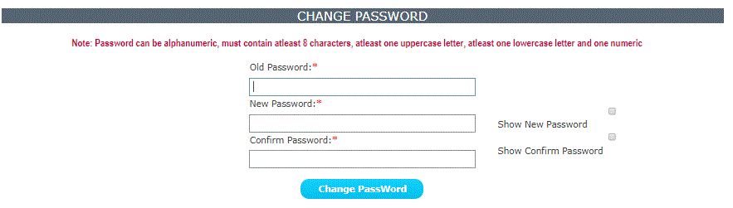

---- END----