**Online Subsidy Seed Distribution System (OSSDS)**

URL is :<http://ossds.telangana.gov.in>

**Workflow of Sale Point – Screen Shots**

**INDEX**

|  |  |  |
| --- | --- | --- |
| **S.NO** | **ITEM NAME** | **PAGE NO.** |
| 1 | A. Dashboard after login to Salepoint | 2 |
| 2 | B. Stock – (How to enter Stock Entry Details) | 3 |
| 3 | C. FREEZE – (How to freeze Stock Entered details) | 6 |
| 4 | D. Seed Distribution | 7 |
| 5 | E. PRINT RECEIPT | 8 |
| 6 | F. Reports | 9 |
| 7 | G. Discussion | 11 |
| 8 | H . Change password | 12 |

1. **Dashboard after login to Salepoint:-**

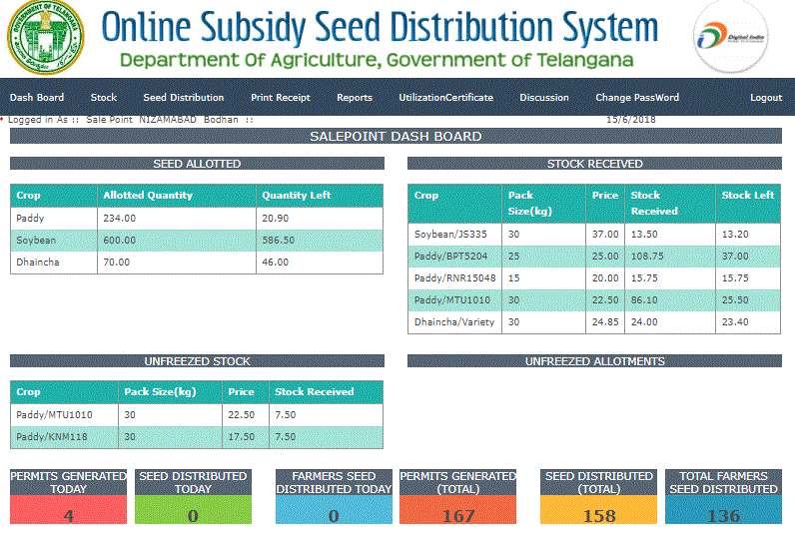

1. **STOCK – (How to enter Stock Entry Details)**

Stock entry is done in sale point login(PACS, ARKS, DCMS etc.). User Name and password for sale

point login is available at Dept.logins page (<http://ossds.telangana.gov.in/DeptLogins.aspx>).

* To enter the stock it is mandatory that Seed should be allotted to that sale point by MAO and freezed.
* If seed allotted and freezed than in dash board of sale point allotted details are displayed as shown below

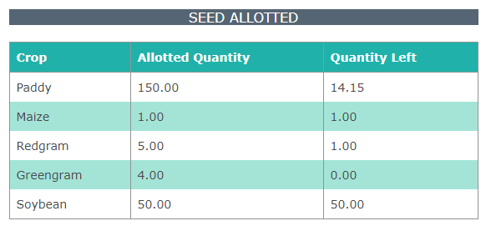

**NOTE :Stock can be entered only when seed allotment details are displayed**

**in dashboard**

To Enter Stock Details Click on Stock in menu and select Stock Entry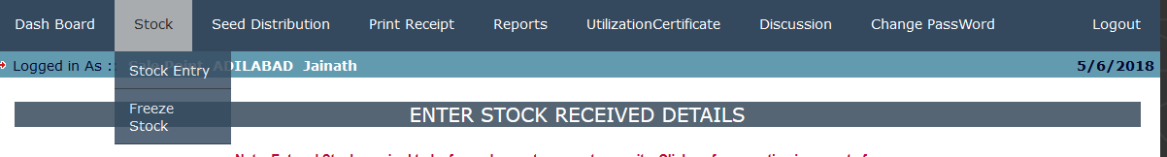

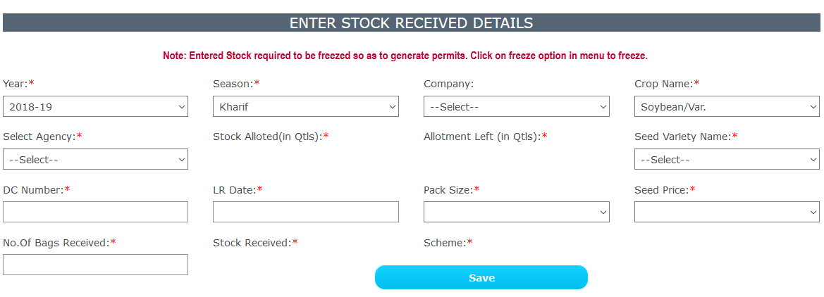

* Select Year, season, select Company is optional (only for Hybrids maize, jowar, bazra Etc..)
* After crop is selected, supplying agencies are displayed in drop down as per the allotment.
* Select agency, then Allotment details (Stock allotted and allotment left ) are displayed, Stock can be entered only within the left allotment.

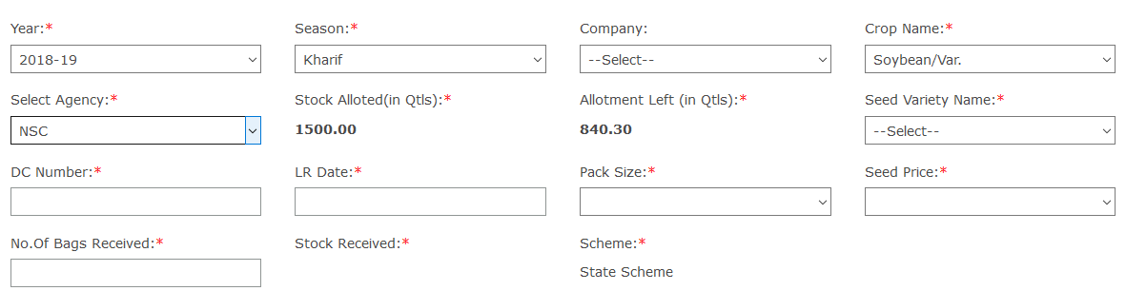

After agency selected, stock allotted and allotment left for the selected agency are displayed.

* Select crop variety, enter dc number, LR date, and select packing size and price.
* Once no. of bags entered system will calculate the stock received in quintals based on pack size.
* After stock received in quintals are displayed.
* Click on SAVE.

Details are saved.

If Pack Sizes or prices are not available for selected crop please inform to seed cell so that they can add details.

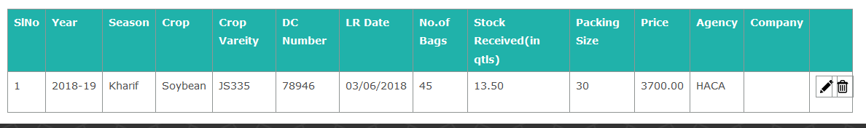

Update by clicking on , and delete by clicking on .

**NOTE: After stock entered, so as to generate permit stock need to be freezed.**

**Once freezed stock details can’t be changed, so make sure details are correct before freezing.**

1. **FREEZE – (How to freeze Stock Entered details)**

Click on Freeze option in the main menu(see below)

**Before freezing make sure that details** (price, pack size, no of bags, stock received in

quintals, agency, DC number and LR date) **of stock entered is correct.**

**After freezing stock details cannot be changed.**

Select Year, Season, Company, Crop and Seed Variety Name. System displays Unfreeze stock

details. Click on Check Box and Click on FREEZE button to freeze data (see below).

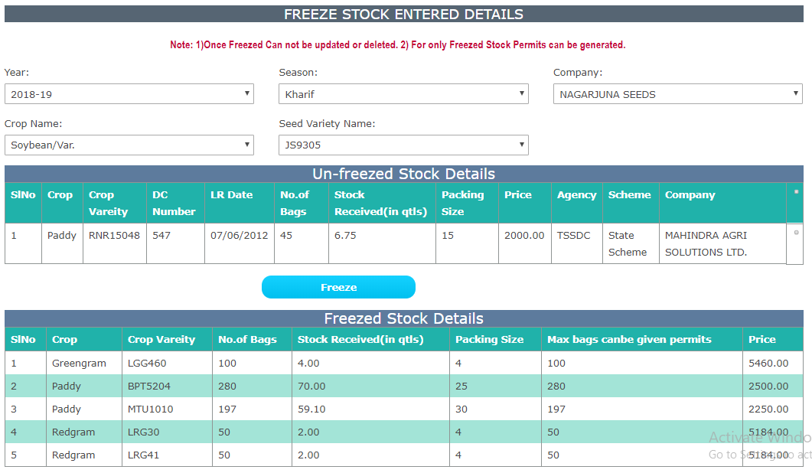

**NOTE:- For the freezed stock only, the permit slip can be**

**generated.**

1. **Seed Distribution:-**

Seed Distribution can be done to Generated PERMIT SLIP only by MAO of Representative.

Click on **Seed Distribution** option from main menu

Enter Permit number (which is generated by MAO/Representative) and

CLICK on GET DATA button. System displays the data as shown below.

Here, user has to enter NO.OF BAGS PURCHASED. Accordingly amount will be calculated by

system and Total amount is also displayed.

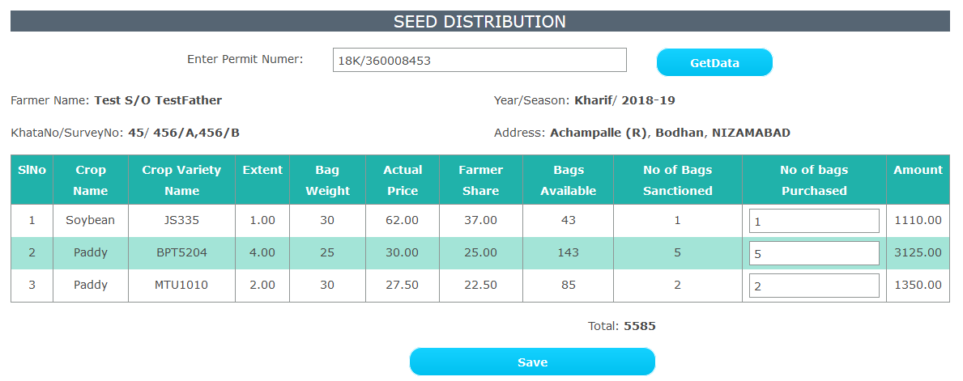 Click on SAVE.

1. **PRINT RECEIPT:-**

Click on PRINT RECEIPT option in main menu.

Enter Permit number and GET DATA Button. A report is generated with the following details. Click on PRINT button to print this receipt for farmer.

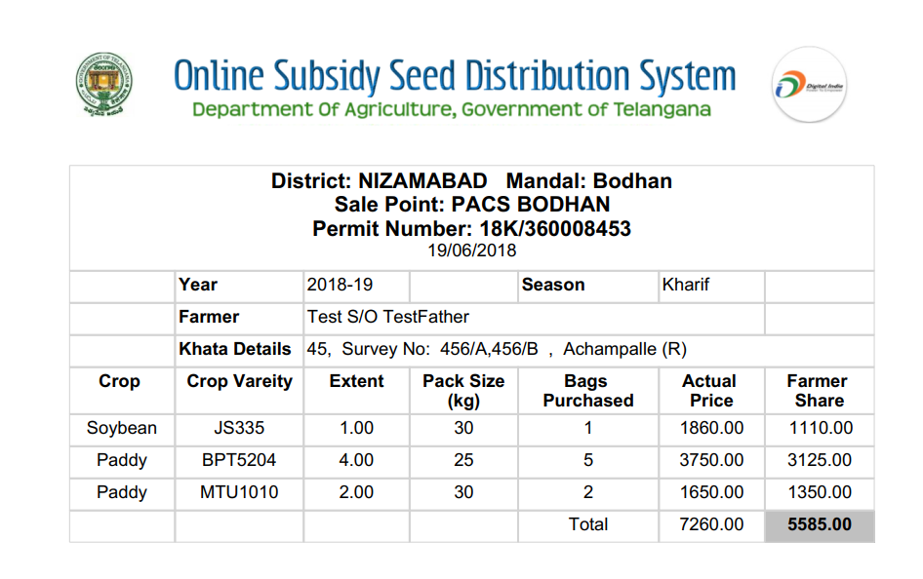

1. **Reports:-**

Click on **Reports**option in main menu. Three options are available.

1.Click on **View Permits**

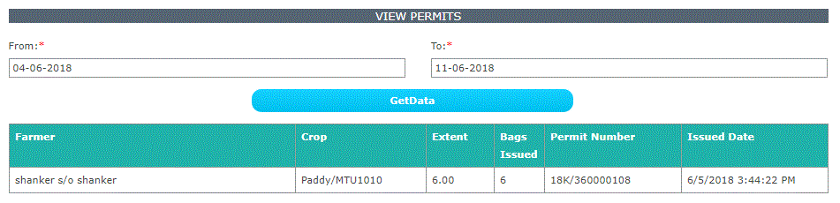

Select FROM DATE and TO DATE and click on GET DATA to see the permits.

2. Click on **VIEW DISTRIBUTION**(see below screen)

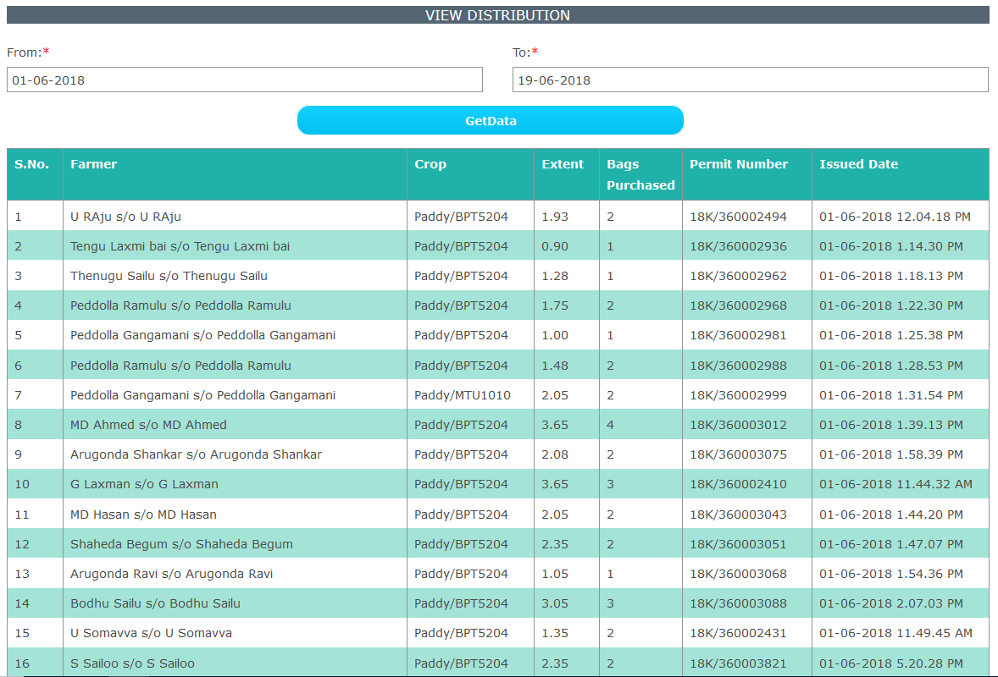

3. Click on **Allotment and Sales**(see below screen) 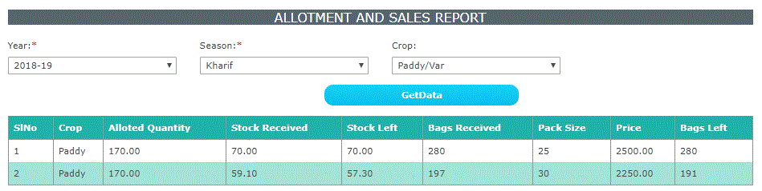

1. **Discussion:-**

Click on **Discussion** option in main menu

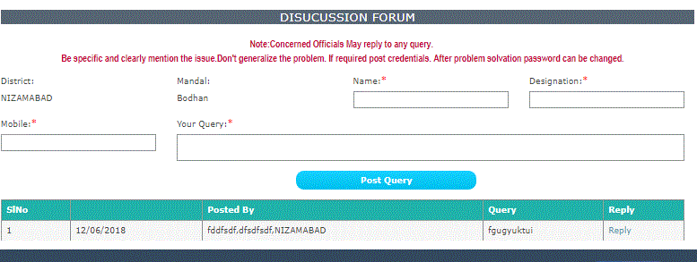

Click on **Reply** button and enter your details and **YOUR REPLY** and Click on **POST REPLY BUTTON** (see below screen) to participate in discussion forum

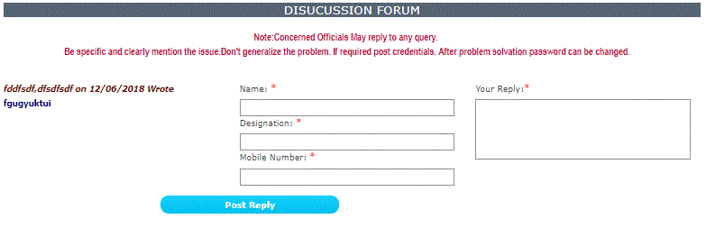

1. **Change Password**

Click on CHANGE PASSWORD in main menu to change the password.

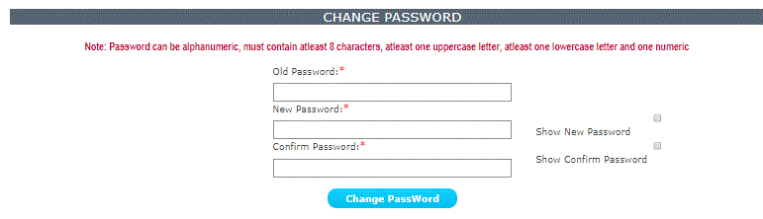

---- END -----