# SMART AIR QUALITY MONITORING SYSEM

* HARSHITHA N

# Table of content

1. About the Smart Air quality System
   1. Description
   2. Identifying features
   3. State of art
   4. 5W’s & 1H
   5. S.W.O.T analysis
2. Requirements
   1. High level requirements
   2. Low level requirements
3. Block Diagram and Blocks explanation
   1. Block Diagram
   2. Microcontroller
   3. Sensors
   4. Actuators
   5. Other

1. Architecture
   1. Flow Chart
   2. Structural Diagram
2. Test plan and output
   1. High level test plan
   2. Low level test plan
3. Application
4. Assumptions
5. Output
6. Future Scope
7. References

Conclusion

# 1 Smart Air Quality Monitoring System

## 1.1 Abstract

## This project is an Smart Air quality Monitoring System , which will be detect the amount of pollutants present in the air of the environment. If we know the amount of pollutants present in the air, then precaution can be taken to minimize the level of pollution in the air

## 1.2 Identifying features

* The main feature of this project is:
* The LCD will display the percentage of Carbon dioxide and oxygen in the air
* The LED will glow to indicate when air quality is pure.
* The user will get to know easily about the quality of air they are surrounded by and take precautions for there safety.
* The cost of sensor used in project is low..

## 1.3 State of art

## This project makes use of Potentiometer assumed as gas sensors, switch 2 as lambda sensors for sensing oxygen. The LCD displays the percentage of CO2 and O2 present in the gas. By combining all these components a final system is made called as S.A.M.S. As the technology is increasing rapidly these kind of system are very useful in our daily lives.

## 1.4 5W’s 1H

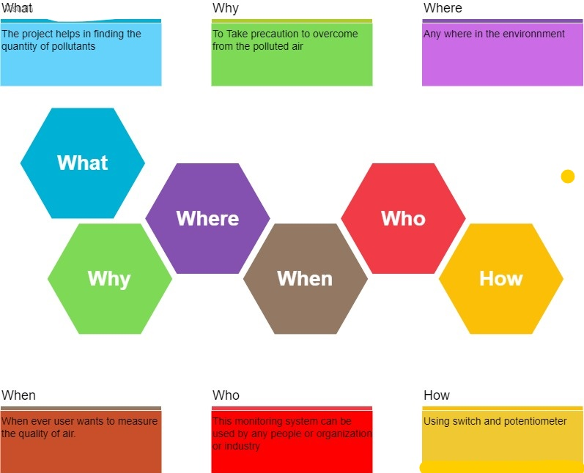

## Swot Analysis

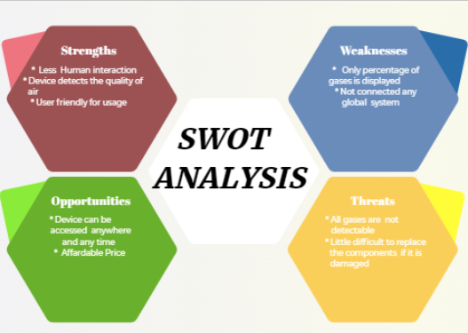

# 2 Requirements

## 2.1 High Level Requirements

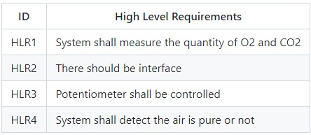

**2.2 Low Level Requirements**

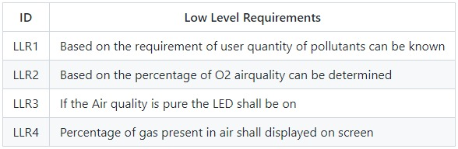

## 3 Block Diagram and Blocks explination

## 3.1 BLOCK DIAGRAM

1.2 Microcontroller(ATmega328)

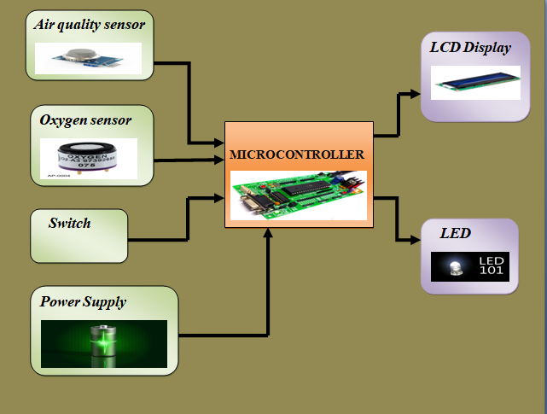

# ATmega328 is an 8-bit, 28-Pin AVR Microcontroller, manufactured by Microchip, follows RISC Architecture and has a flash-type program memory of 32KB.It has an EEPROM memory of 1KB and its SRAM memory is 2KB. Its excellent features include cost-efficiency, low power dissipation, programming lock for security purposes, real timer counter with separate oscillator.

# 1.3 Sensors

# Potentiometer (Air Sensor-MQ135) - A potentiometer assumed as air quality sensor measures the quality of the air quality in percentage Air quality sensors are devices used to detect contaminants in the air. This includes particulates, pollutants and noxious gases that may be harmful to human health. It detect gases like carbon monoxide and carbon dioxide by measuring the absorption of infrared light.

# Switch(Oxygen sensor):A Switch assumed as oxygen sensor measures the percentage of O2An oxygen sensor is an electronic device that measures the proportion of oxygen (O2) in the gas or liquid being analysed.

# 1.4 Actuators

# LCD Display :A liquid-crystal display (LCD) is a flat-panel display or other electronically modulated optical device. It uses the light-modulating properties of liquid crystals combined with polarizer’s. Liquid crystals do not emit light directly, instead using a backlight or reflector to produce images in color or monochrome.

# LED: A light-emitting diode (LED) is a semiconductor light source that emits light when current flows through it. Electrons in the semiconductor recombine with electron holes, releasing energy in the form of photons.

# Resister :A resistor is a passive two-terminal electrical component that implements electrical resistance as a circuit element.In electronic circuits, resistors are used to reduce current flow, adjust signal levels, to divide voltages, bias active elements, and terminate transmission lines, among other uses.

# 1.5 Other

# Voltage Source: A voltage source is a two-terminal device which can maintain a fixed voltage. An ideal voltage source can maintain the fixed voltage independent of the load resistance or the output current

**4. Architecture**

**4.1 Flow chart**

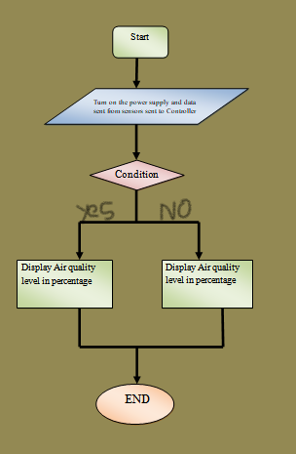

**4.2 Structural Diagram**

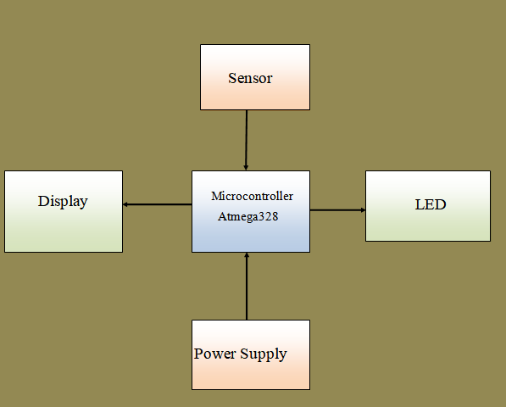

**5 Test plan and output**

# 5.1 HIGH LEVEL TEST PLAN

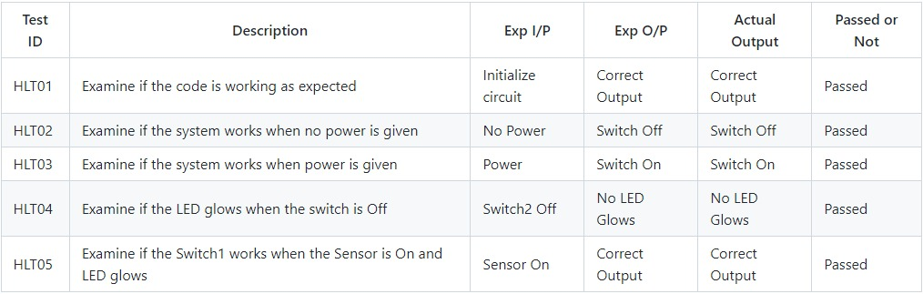

# 5.2 LOW LEVEL TEST PLAN

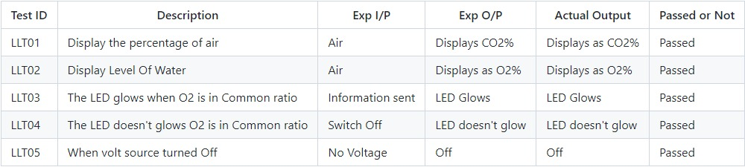

# 6 Application

1. This system shall be used as Indoor Air Quality Monitoring System
2. This system shall be used as Particulate Matter Monitoring
3. This system shall be used as Gas Detection System
4. This system shall be used as Outdoor Air Quality Monitoring System

# 7 Assumptions

* Potentiometer as gas sensor.
* Switch-2 as Lamda sensor

# 8 Output

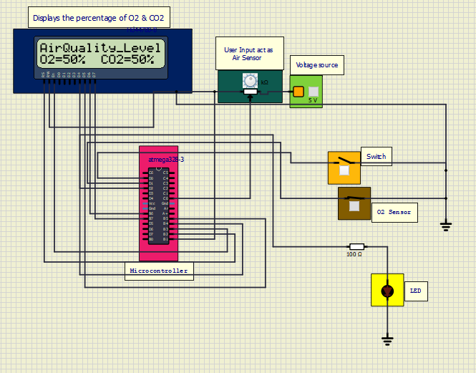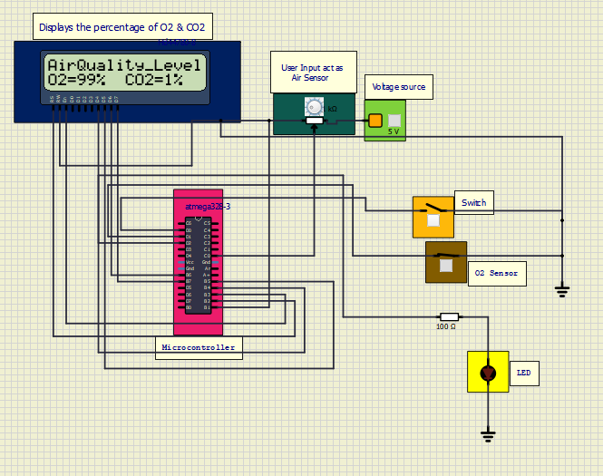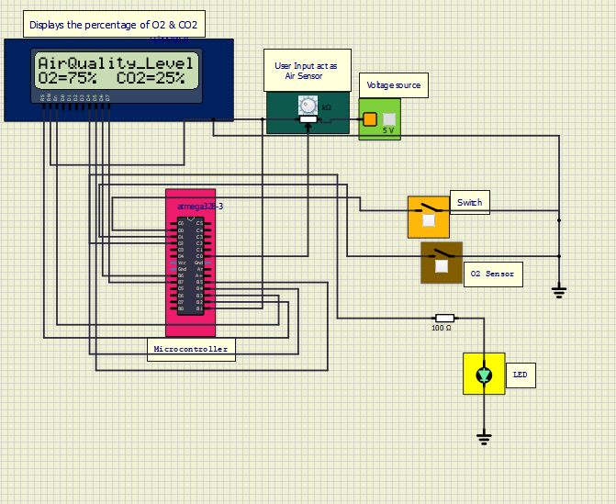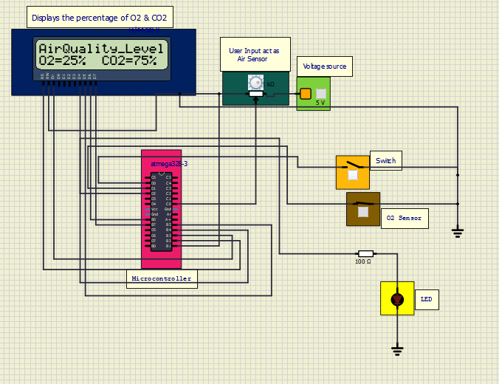

Hex Files Created.

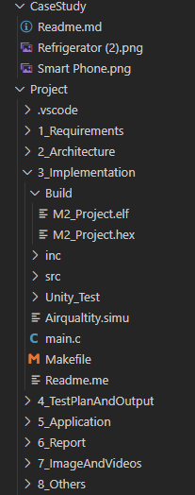

Simulation Circuit

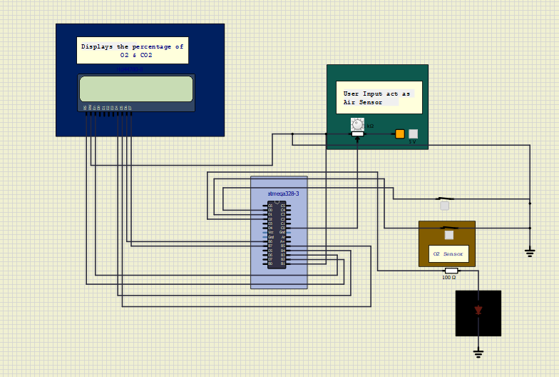

# 9 Future Scope

* Percentage of all gases are implemented

# 10 References

<https://www.rcciit.org/students_projects/projects/aeie/2018/GR1.pdf>

**Conclusion**

* Therefore, improving air quality can deliver substantial health benefits; reducing air pollution levels means reducing premature deaths and diseases from stroke, heart disease, lung cancer, and both chronic and acute respiratory diseases, including asthma. the most harmful air pollutant.