|  |  |
| --- | --- |
| DEPARTMENT OF MECHANICAL ENGINEERING  INDIAN INSTITUTE OF TECHNOLOGY ROPAR  RUPNAGAR-140001, INDIA | **IIT Ropar**E:\departmental work\2012.07.20-IITRPR-LOGO\2012.07.20-IITRPR-LOGO\2012.07.20-IITRPR-NEW LOGO.jpg |

*DESIGN LAB-II (ME306) LABORATORY REPORT*

For

**Balancing of Inverted Pendullum**

*Submitted by*

**Lab-Group E(Wed)**

**Darius Johanan (2022MEB1305)**

**Dharmansh Vyas (2022MEB1306)**

**Dhruv Agarwal (2022MEB1307)**

**Gandhe Harshitha (2022MEB1308)**

*Submitted to*

***Dr. Jitendra Prasad***

***Dr. Srikant Shekhar Padhee***

**Title:** Balancing of Inverted Pendulum

**Objective:** The objective of this project is to design, model, and simulate the balancing of an inverted pendulum mounted on a moving cart using MATLAB. The system is developed and analyzed through four integrated modules:

* **Simulink**
* **Simscape**
* **Control System** **Toolbox**
* **Simscape**

The project aims to achieve stable balancing of the pendulum by applying feedback control strategies that regulate the cart’s motion, ensuring the pendulum maintains its upright position despite disturbances and initial offsets.

**Introduction:** Balancing an inverted pendulum on a moving cart is a classical control problem that demonstrates key concepts of dynamic modeling, control design, and system stabilization. The system is inherently unstable and requires continuous corrective action to maintain the pendulum in the upright position.

In this project, the inverted pendulum-cart system is modeled and simulated using MATLAB’s integrated environment. The simulation leverages **Simulink** for dynamic system modeling and control implementation, **Simscape** for incorporating realistic physical behavior, **Control System Toolbox** for designing and tuning controllers, and **Simscape Multibody** for 3D visualization and validation of the mechanical system.

The goal is to design a feedback controller capable of stabilizing the pendulum by controlling the cart’s motion, demonstrating the practical application of control theory in complex, real-world-like systems.

This problem finds relevance in several real-world applications, including self-balancing robots, rocket attitude control, and human posture stabilization.

**System Modelling using simscape, Multibody**

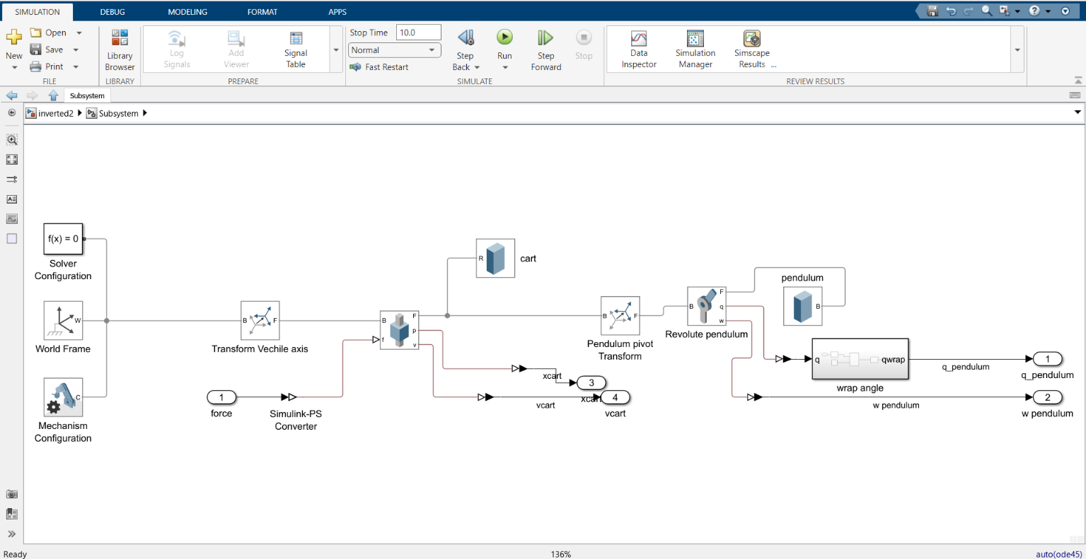

*Fig1: Block Diagram for the inverted Pendulum*

The subsystem shown above is modeled in **Simscape Multibody** within Simulink to represent the physical dynamics of an inverted pendulum mounted on a cart. The following components are used to construct the mechanical system and interface it with control inputs and measurement outputs:

1. **Solver Configuration Block:**  
   This block provides the necessary solver settings to compute the physical simulation. It is mandatory for any physical network in Simscape and ensures consistent initialization and solution of the system's differential equations.
2. **World Frame Block:**  
   Defines the global reference frame for the system. All bodies and joints in the model are positioned and oriented relative to this frame.
3. **Mechanism Configuration Block:**  
   Configures parameters for the entire mechanism, such as gravity direction and magnitude. This block ensures the system follows the correct physical environment.
4. **Transform (Vehicle Axis) Block:**  
   This block applies a translational transform along a specified axis to the cart, enabling it to move along the horizontal axis under the influence of the applied force.
5. **Simulink-PS Converter Block:**  
   Converts the force signal generated in Simulink (SI units) into a physical signal compatible with Simscape, allowing the force to be applied to the cart body.
6. **Prismatic Joint Block (B - F):**  
   Represents a linear sliding joint allowing the cart to move only along the defined translational axis, restricting any rotational or lateral movement.
7. **Rigid Solid Block (Cart):**  
   Models the cart body as a rigid body with defined mass and geometry, allowing it to respond to forces and constraints in the system.
8. **Transform (Pendulum Pivot) Block:**  
   Defines the pivot point where the pendulum is attached to the cart. It creates the correct position and orientation of the pendulum relative to the cart.
9. **Revolute Joint Block:**  
   Allows the pendulum to rotate about its pivot point, providing one degree of freedom for angular motion around the joint axis.
10. **Rigid Solid Block (Pendulum):**  
    Models the pendulum as a rigid body with specified mass and dimensions. It is connected to the cart through the revolute joint.
11. **Wrap Angle Block:**  
    Ensures the pendulum’s angular position output remains within a continuous range by wrapping angles appropriately, preventing discontinuities during simulation.
12. **Output Ports (q_pendulum, w_pendulum, xcart, vcart):**  
    These ports output the pendulum’s angle and angular velocity (q_pendulum, w_pendulum), and the cart’s position and velocity (xcart, vcart) respectively. These signals are used for observation and for feedback to the control system.

*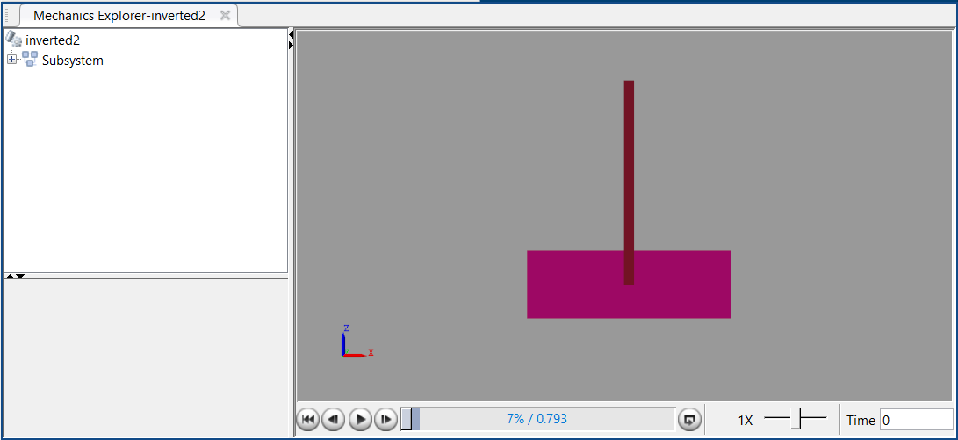Fig2: Physical Model of Cart-Pendulum Assembly*

**Workflow of the Subsystem**

1. **Force Input Application:**
   * An external force signal is generated in **Simulink** and converted to a physical signal using the **Simulink-PS Converter**.
   * This force acts as the input to move the cart along the horizontal axis.
2. **Cart Motion along Prismatic Joint:**
   * The applied force drives the **cart**, which is allowed to move only along a linear axis defined by the **Prismatic Joint**.
   * The **Transform (Vehicle Axis)** block ensures the correct axis alignment for cart motion.
3. **Pendulum Mounting and Rotation:**
   * The **Pendulum Pivot Transform** positions the **pendulum** on the cart at the pivot point.
   * The **Revolute Joint** allows the pendulum to rotate freely around the pivot as the cart moves.
4. **Dynamic Interaction Between Cart and Pendulum:**
   * As the cart moves, it affects the pendulum’s dynamics, causing it to swing.
   * The gravitational force, along with the cart's motion, determines the pendulum’s angular position and velocity.
5. **Signal Measurement and Wrapping:**
   * The **Wrap Angle** block ensures the pendulum angle remains within a continuous and bounded range (typically -π to π).
   * Measurement blocks output the following signals:
     + **q_pendulum**: Pendulum angle.
     + **w_pendulum**: Pendulum angular velocity.
     + **xcart**: Cart position.
     + **vcart**: Cart velocity.
6. **Feedback to Control System (Outside Subsystem):**
   * These output signals are used in the external control system implemented in Simulink to compute the corrective force necessary to stabilize the pendulum.

**Closed Loop control setup**

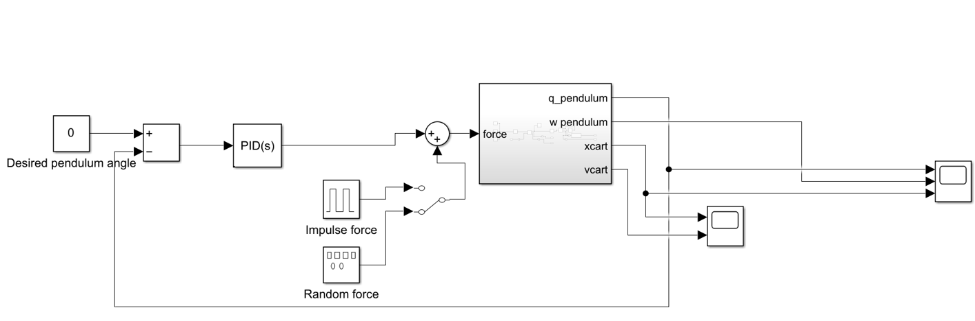

*Fig3: Control system*

**Subsystem Description: Control System of Inverted Pendulum on Cart**

The figure shows the control system implemented in Simulink to balance the inverted pendulum mounted on a cart. The system uses PID control to compute the necessary force applied to the cart based on the pendulum's angular error. The key components and their functions are as follows:

1. Desired Pendulum Angle (Setpoint):
   * Provides the reference input for the pendulum angle, typically set to 0 radians, indicating the upright vertical position.
2. Error Calculation Block:
   * Computes the difference between the desired pendulum angle and the actual angle measured from the system.
   * This error signal becomes the input for the PID controller.
3. PID Controller Block (PID(s)):
   * A PID (Proportional-Integral-Derivative) controller is used to generate the control force based on the error.
   * The controller aims to minimize the error by adjusting the cart's position to balance the pendulum.
4. Switch Block (Manual/Automatic Control):
   * Enables switching between manual input (No force) and automatic control via PID.
   * Useful for testing the system both with and without active control.
5. Disturbance Input Block:
   * Adds an external disturbance force to the system to test the robustness of the controller.
   * This allows evaluating the system’s performance under unexpected forces or shocks.
6. Sum Block:
   * Combines the control force from the PID controller (or manual input) and the disturbance force to create the total force applied to the cart.
7. Physical Subsystem Block (Simscape Multibody):
   * Represents the physical model of the cart-pendulum system.
   * Accepts the total force input and provides measured outputs including:
     + q_pendulum: Pendulum angle.
     + w_pendulum: Pendulum angular velocity.
     + xcart: Cart position.
     + vcart: Cart velocity.
8. Feedback Loop and Display:
   * The system outputs are routed back into the controller for closed-loop operation.
   * Outputs are also sent to display blocks for visualization of system states during simulation.

**Workflow of the Control Subsystem**

1. Set Desired Pendulum Angle (Reference Input):
   * The desired upright position is set (usually 0 radians).
2. Error Computation:
   * The current pendulum angle is subtracted from the desired angle to generate the control error.
3. Force Calculation through PID Control:
   * The PID controller computes the required corrective force to reduce the error.
   * A switch allows the user to bypass the controller and apply a manual force if desired.
4. Disturbance Addition (If Enabled):
   * An optional disturbance force is added to test system robustness.
5. Force Application to Physical System:
   * The computed total force is applied to the physical system (cart-pendulum model).
6. System Response and Feedback:
   * The physical system responds to the applied force.
   * System outputs (angles, velocities, positions) are fed back to the control system and displayed for analysis.

**Results**

**Without Control**

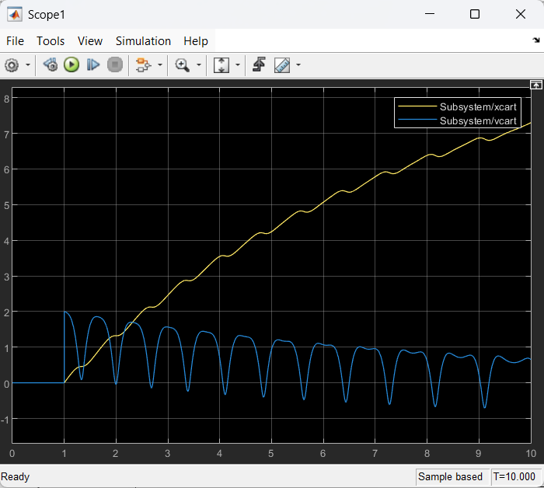

*Fig4:Plot for position and velocity of cart*

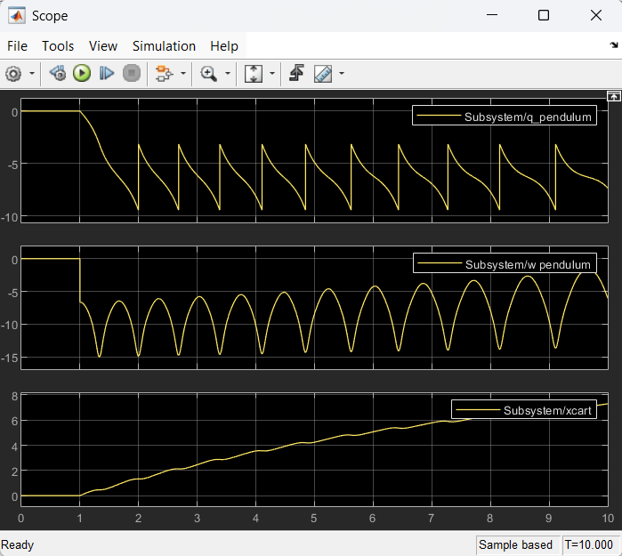

*Fig5: Plot for Angle,Angular Velocity, Position of cart*

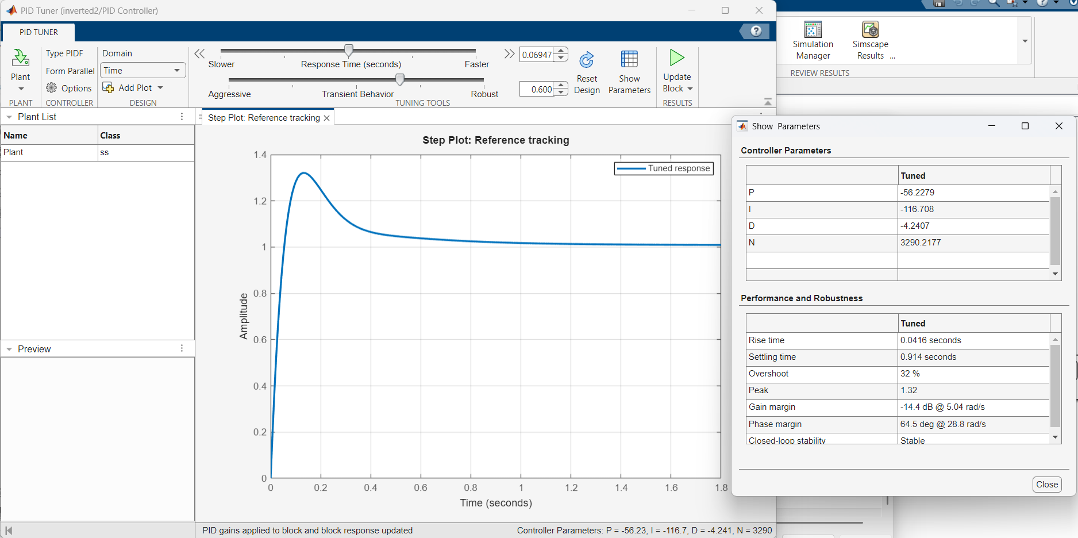

*Fig6: PID Tuning Parameters*

**Impulse Disturbance with Control**

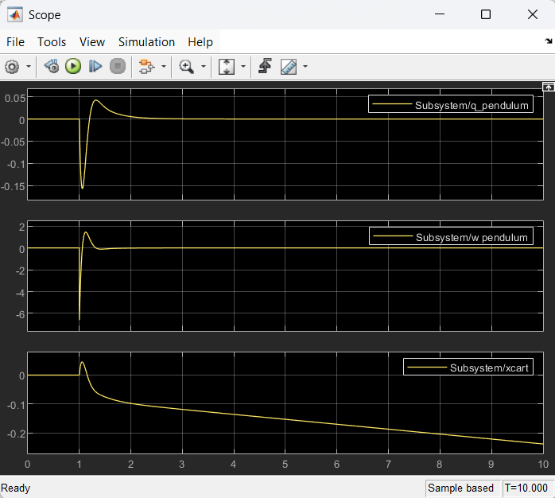

*Fig7: Plot for Angle,Angular velocity and Position of cart*

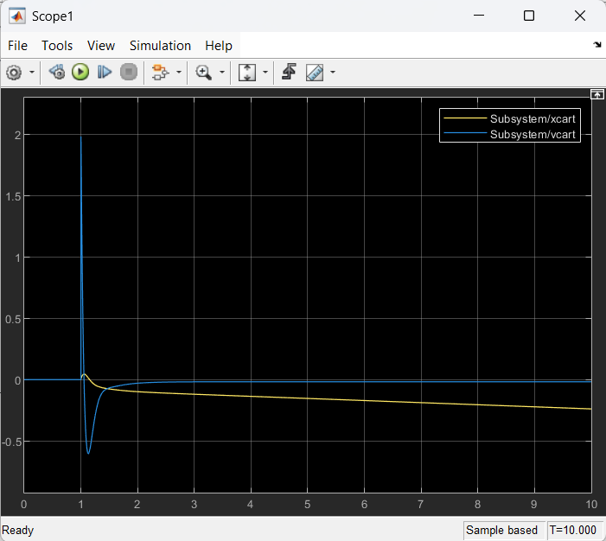

*Fig8:Plot for Position and Velocity of cart*

**Random Disturbance with Contr**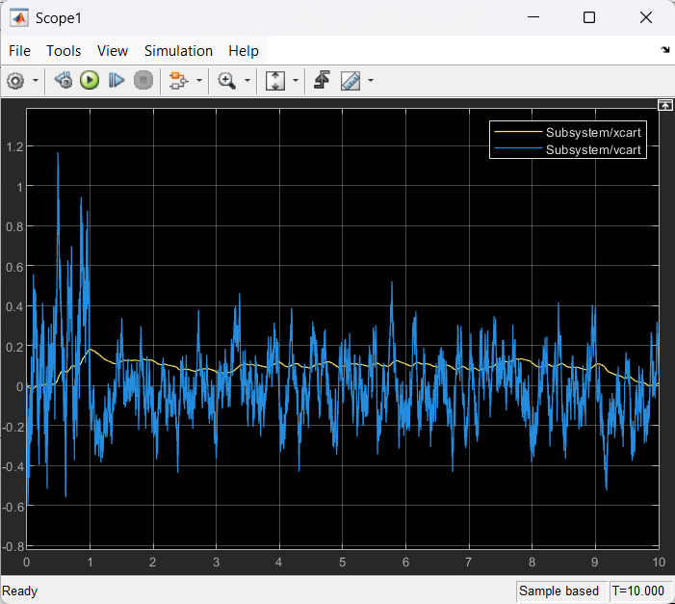

*Fig9: Plot for position and velocity of cart*

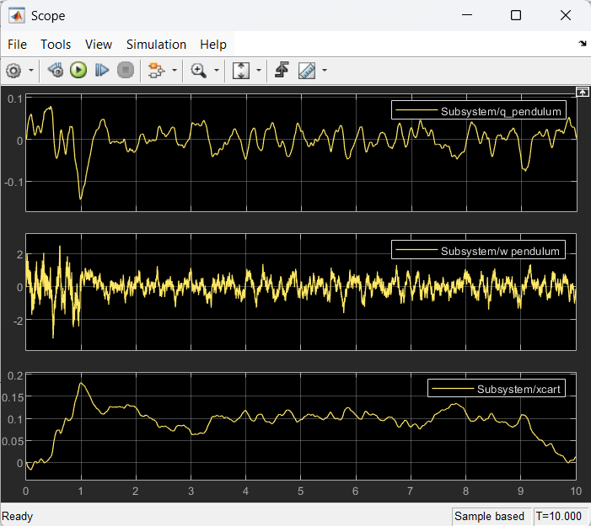

*Fig10: Plot for Angle, Angular Velocity and position of cart*

**Conclusion and Discussion**