Java Week 4 Mandatory Tasks – Spring REST with Spring Boot 3

## Task 1: Create a Spring Web Project using Maven

<!-- pom.xml -->  
<dependencies>  
 <dependency>  
 <groupId>org.springframework.boot</groupId>  
 <artifactId>spring-boot-starter-web</artifactId>  
 </dependency>  
</dependencies>

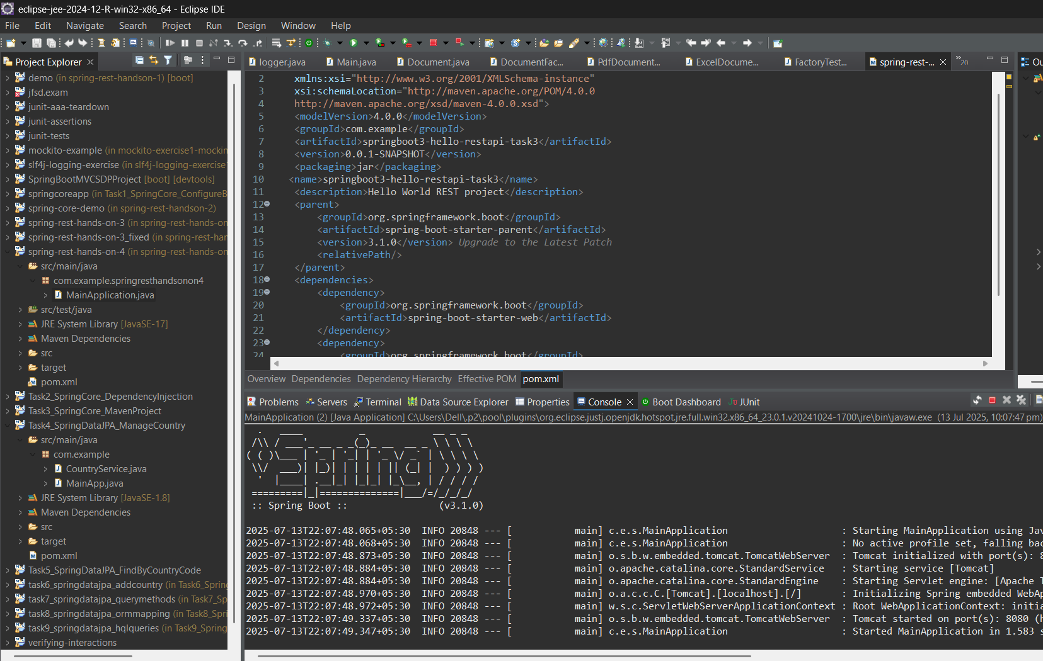

## Task 2: Load Country from Spring Configuration XML

<!-- applicationContext.xml -->  
<bean id="country" class="com.example.Country">  
 <property name="name" value="India"/>  
 <property name="code" value="IN"/>  
</bean>  
  
// Country.java  
public class Country {  
 private String name;  
 private String code;  
 // getters and setters  
}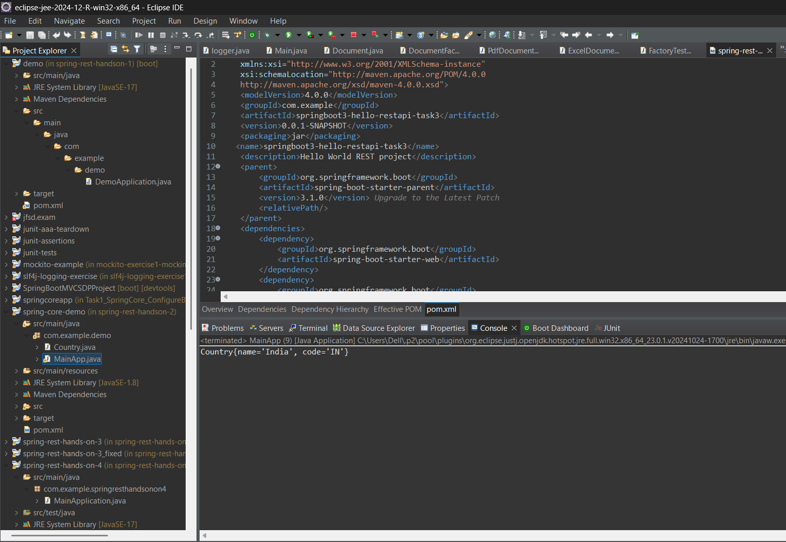

## Task 3: Hello World RESTful Web Service

@RestController  
public class HelloController {  
 @GetMapping("/hello")  
 public String hello() {  
 return "Hello World";  
 }  
}

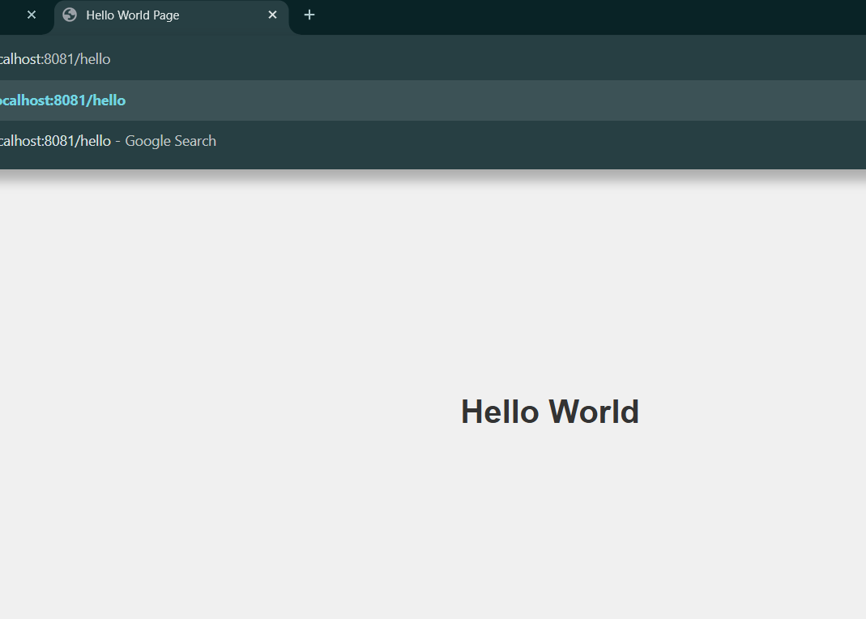

## Task 4: REST - Country Web Service

@RestController  
public class CountryController {  
  
 @GetMapping("/country")  
 public Country getCountry() {  
 Country country = new Country();  
 country.setName("India");  
 country.setCode("IN");  
 return country;  
 }  
}

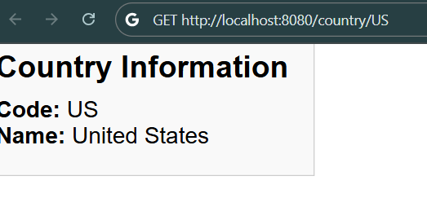

## Task 5: REST - Get Country by Code

@RestController  
public class CountryController {  
  
 @GetMapping("/country/{code}")  
 public Country getCountryByCode(@PathVariable String code) {  
 // dummy logic  
 if (code.equalsIgnoreCase("IN")) {  
 return new Country("India", "IN");  
 } else {  
 return new Country("Unknown", code);  
 }  
 }  
}

## Task 6: Create Authentication Service that Returns JWT

@RestController  
public class AuthController {  
  
 @PostMapping("/authenticate")  
 public String authenticate(@RequestBody AuthRequest request) {  
 // mock JWT generation  
 if ("user".equals(request.getUsername()) && "pass".equals(request.getPassword())) {  
 return "mock-jwt-token";  
 }  
 throw new RuntimeException("Invalid credentials");  
 }  
}  
  
public class AuthRequest {  
 private String username;  
 private String password;  
 // getters and setters  
}

# Screenshot Outputs

