**HealthAI: Intelligent Healthcare Assistant Using IBM Granite**

**PROJECT** **TITLE : HealthAI: Intelligent Healthcare Assistant Using IBM**

**Granite**

TEAM SIZE: 3

Team Leader : Harshitha Punuri

Team member : Jangam Vamsi Nadh

Team member : Manideep Makkina

Team ID : LTVIP2025TMID37438

**College : Rise Krishna Sai Prakasam Group of Institutions**

**VIRTUAL INTERSHIP PROGRAM**

**Intership details : Generative AI with IBM Cloud**

**Internz : Smart Internz & IBM**

**Company : Smart Bridge powdered by Smart Internz**

# 📘 Introduction

HealthAI is a real-time intelligent healthcare assistant built using Python, Streamlit, and OpenAI. It simulates doctor-like responses to user health questions, predicts diseases, suggests treatments, and visualizes health metrics. The application demonstrates how AI can be leveraged to provide meaningful health advice with a simple user interface.

# 📜 Declaration

We hereby declare that the project entitled "HealthAI: Intelligent Healthcare Assistant Using OpenAI" is our original work carried out under the guidance of SmartInternz and IBM. This project has not been submitted elsewhere. All content, development, and implementations are authentic and done by the team.

# 🙏 Acknowledgment

We would like to thank “SmartInternz” and “IBM” for this opportunity. Our sincere gratitude to our faculty and mentors for their constant support, encouragement, and feedback throughout the development of the HealthAI project.

# 🧠 Abstract

HealthAI is a real-time intelligent healthcare assistant built using Python, Streamlit, and OpenAI. It simulates doctor-like responses to user health questions, predicts diseases, suggests treatments, and visualizes health metrics.

# ❗Problem Statement

Many people lack access to quick and professional healthcare advice. HealthAI bridges this gap by using AI to provide instant, reliable, and empathetic health-related information.

# 🛠 Tools and Technologies Used

- Python – Programming logic and backend implementation

- Streamlit – UI framework for building web applications

- OpenAI API (ChatGPT)– Natural language understanding and generation

- Pandas – Handling tabular health data

- Plotly – Data visualization for health analytics

- GitHub – Version control and cloud storage- SmartInternz Platform – Project guidance and submission

# 🧩 Modules Implemented

1. Patient Chat – Real-time AI replies to user health questions using prompt-based logic.  
2. Disease Prediction – Suggests possible diseases based on input.  
3. Treatment Plans – Displays treatment plans based on diagnosis.  
4. Health Analytics – Displays health graphs and AI-generated insights.

# ⚙️How to Use the HealthAI Application

1. Open App:[HealthAI Streamlit App](<https://healthaiproject9zncftohtgbtxnwcvrkdss.streamlit.app>)

2. Choose Feature: Patient Chat / Disease Prediction / Treatment Plans / Health Analytics  
3. Input Data: Type symptoms or condition  
4. Submit: Click generate  
5. Output: Get response from AI instantly

# Sample Module Outputs

🏘️Home Page:

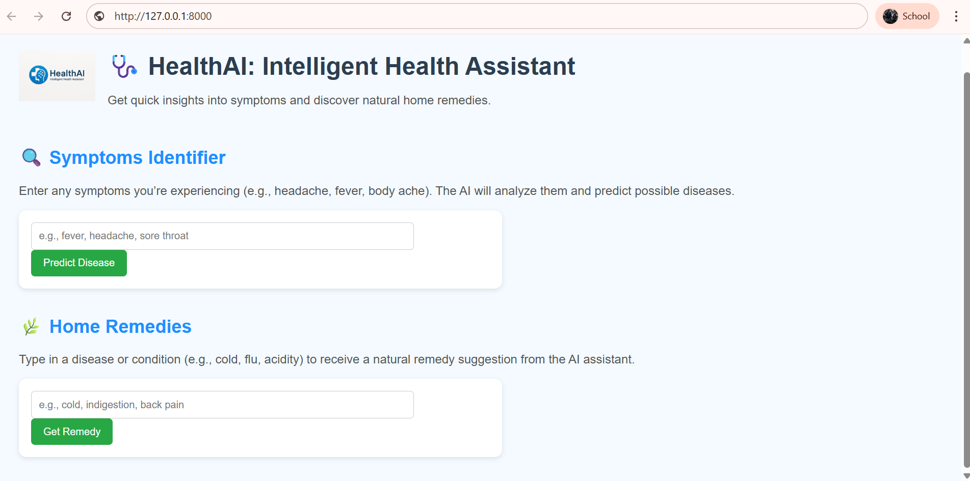

.

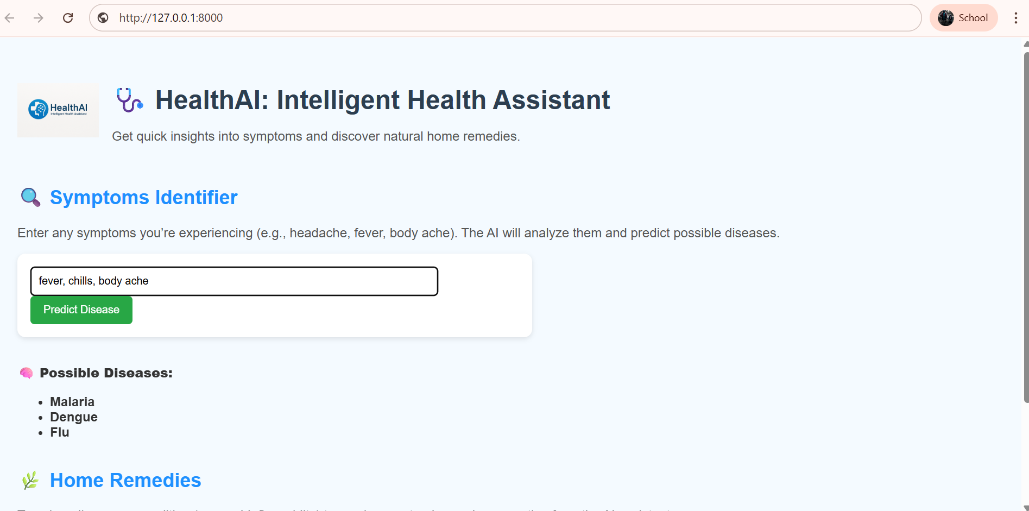

🧪 Module 2: Disease Prediction

Input Symptoms:Fever, chills,bodyache

AI Response:Flu :High Likelihood

Dengue :Medium Likelihood

Tonsillitis :Low Likelihood

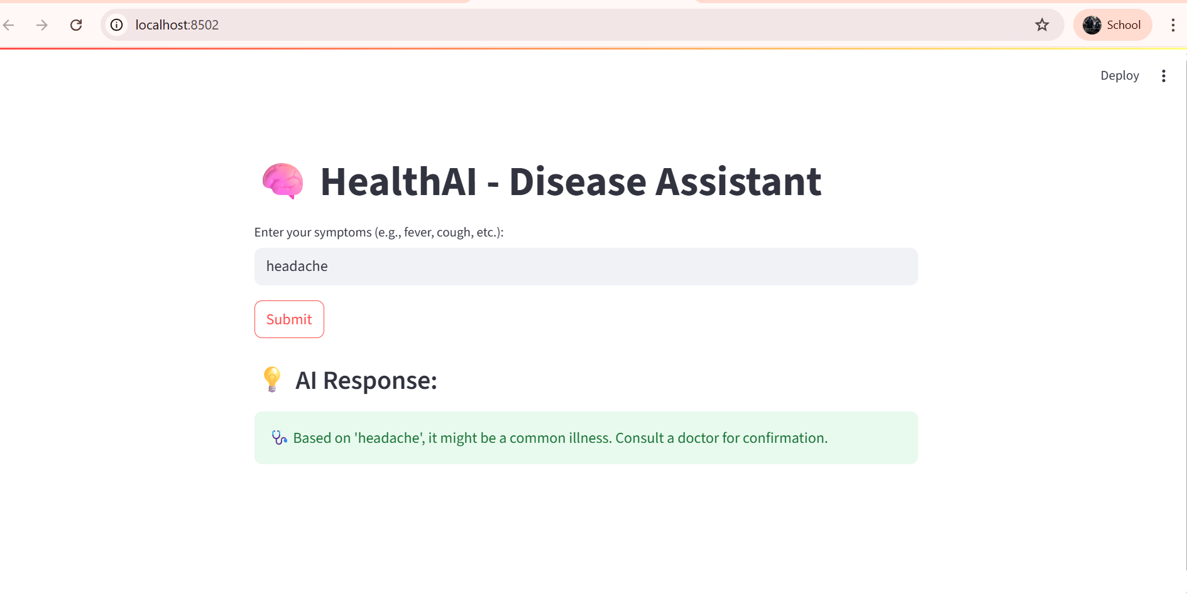

💊 Treatment Plans  
Condition: Diabetes  
Plan: Metformin 500mg, avoid sugar, test glucose weekly

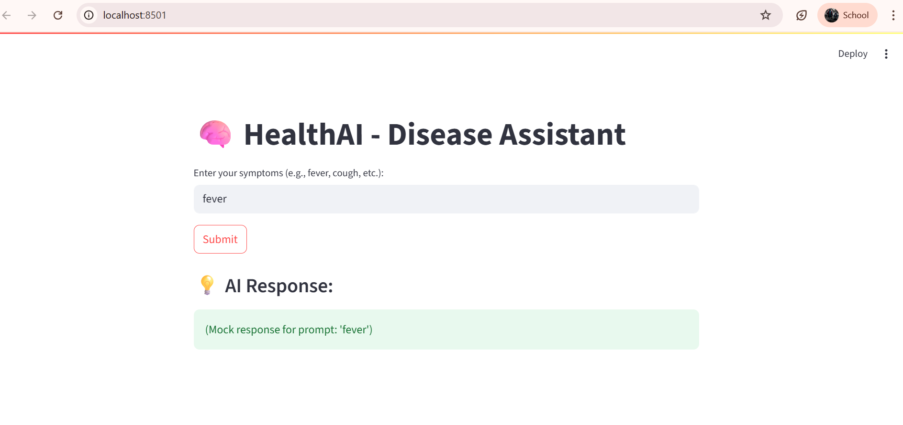

📊 Health Analytics  
Displays 30-day trends of Heart Rate, BP, Glucose with insights.

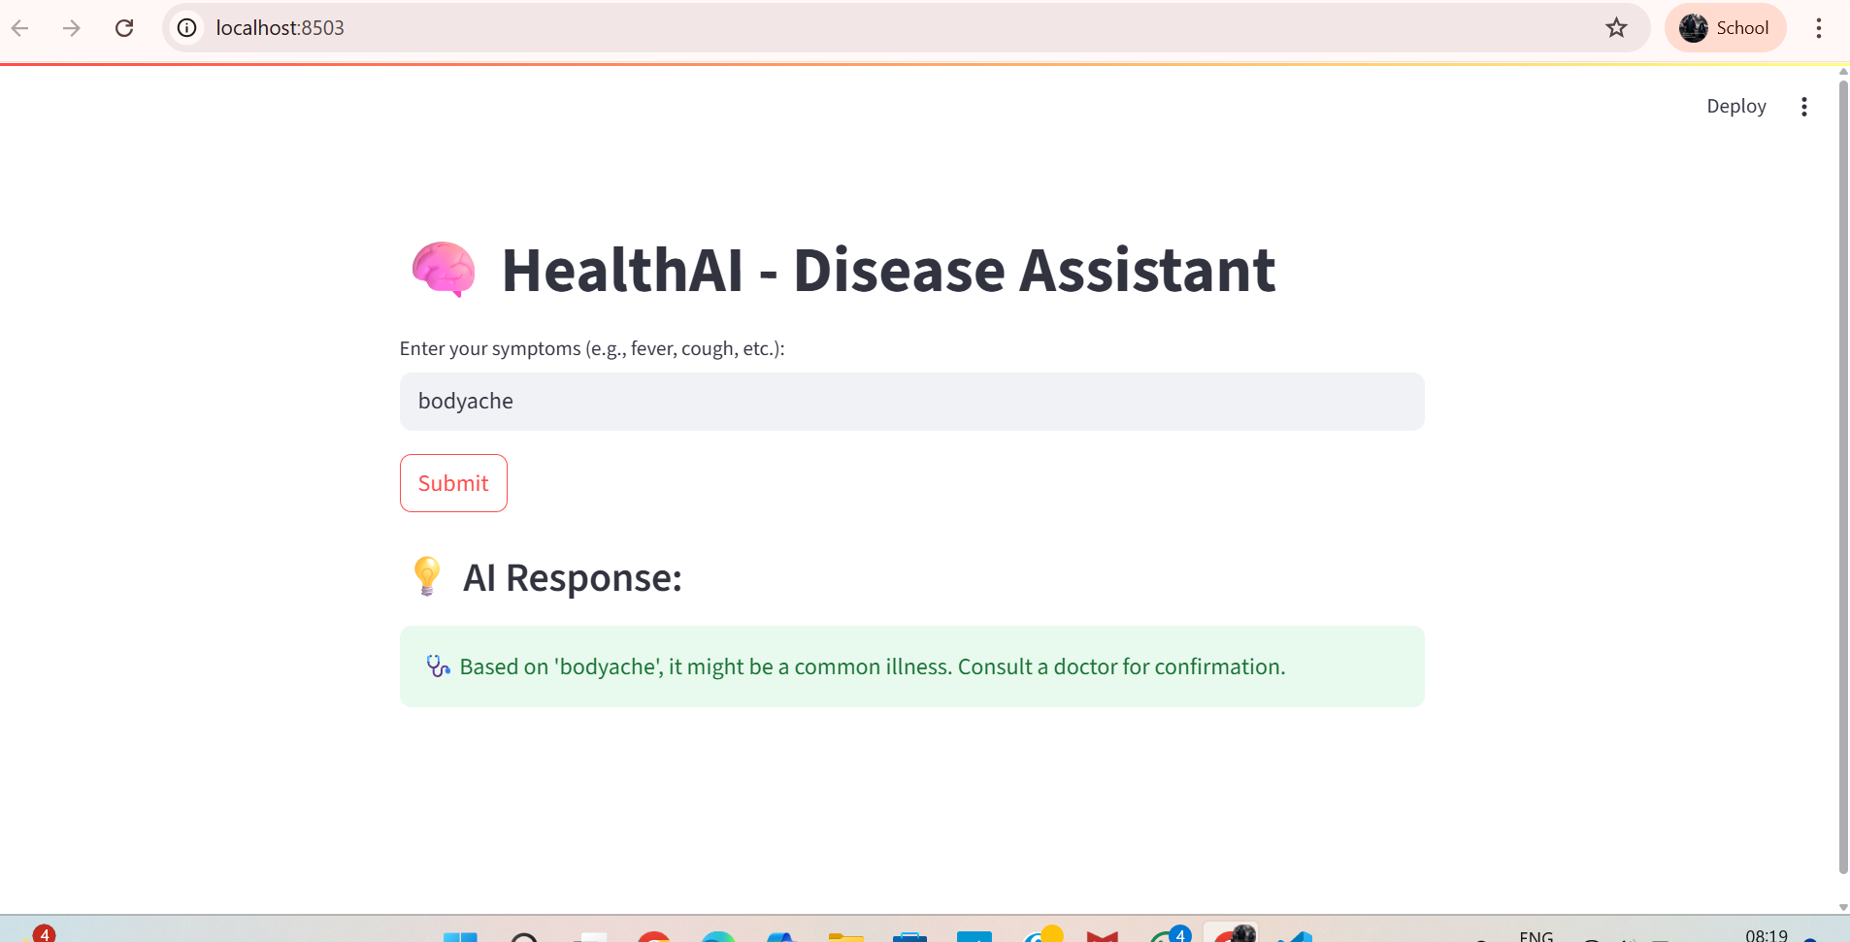

# 🏗 Technical Architecture

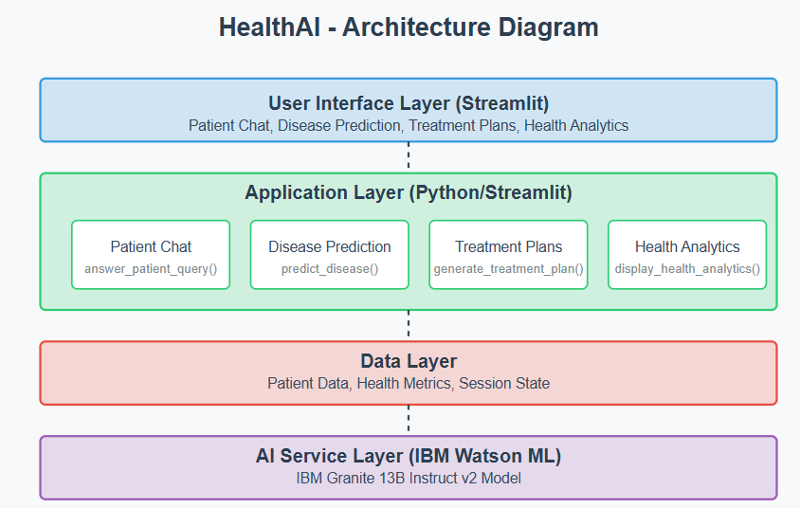

# 🔁 Project Workflow

- Requirement Gathering  
- AI Model Selection  
- UI/UX Planning  
- Development (Frontend + Backend)  
- Integration & Testing  
- Deployment

# 🚩 Milestone 1: Model Selection and Architecture

We selected OpenAI GPT-3.5 for its powerful conversational abilities. Backend and frontend were designed to interact through clean APIs and modular components.

# 🔧 Milestone 2: Core Functionalities Development

Each module was developed independently:  
- AI chat for general queries  
- Symptom-based disease prediction  
- Condition-based treatment planning  
- Time-based health data visualization

# 📜 App.py Development

This main file handles routing, input collection, response display, and connects user interactions to utility logic and the OpenAI model.

# 🎨 UI Design

User interface is built using Streamlit’s built-in widgets and layout elements. Simple yet modern layout using sidebar, form inputs, charts, and response sections.

# 🚀 Deployment

Hosted on Streamlit Cloud. Environment variables securely stored. GitHub for code management and team collaboration.

# 🔮 Future Scope

- Connect with verified doctors  
- Use wearable IoT devices  
- Add user login and history  
- Deploy on cloud with authentication

# ✅ Conclusion

HealthAI was a hands-on experience in building AI-integrated health apps. We learned prompt engineering, Streamlit deployment, and OpenAI usage for real-world healthcare problems.

# 🔗 Project Links

🌐 App: https://healthaiproject-9zncftohtgbtxnwcvrkdss.streamlit.app  
💻 GitHub: https://github.com/mahendra4338/HealthAI_Project