echo &quot;Enter the year&quot; read y
b=`expr $y % 4` if [ $b -eq 0 ] then
echo &quot;$y is a leap year&quot; else
echo &quot;$y is not a leap year&quot; fi
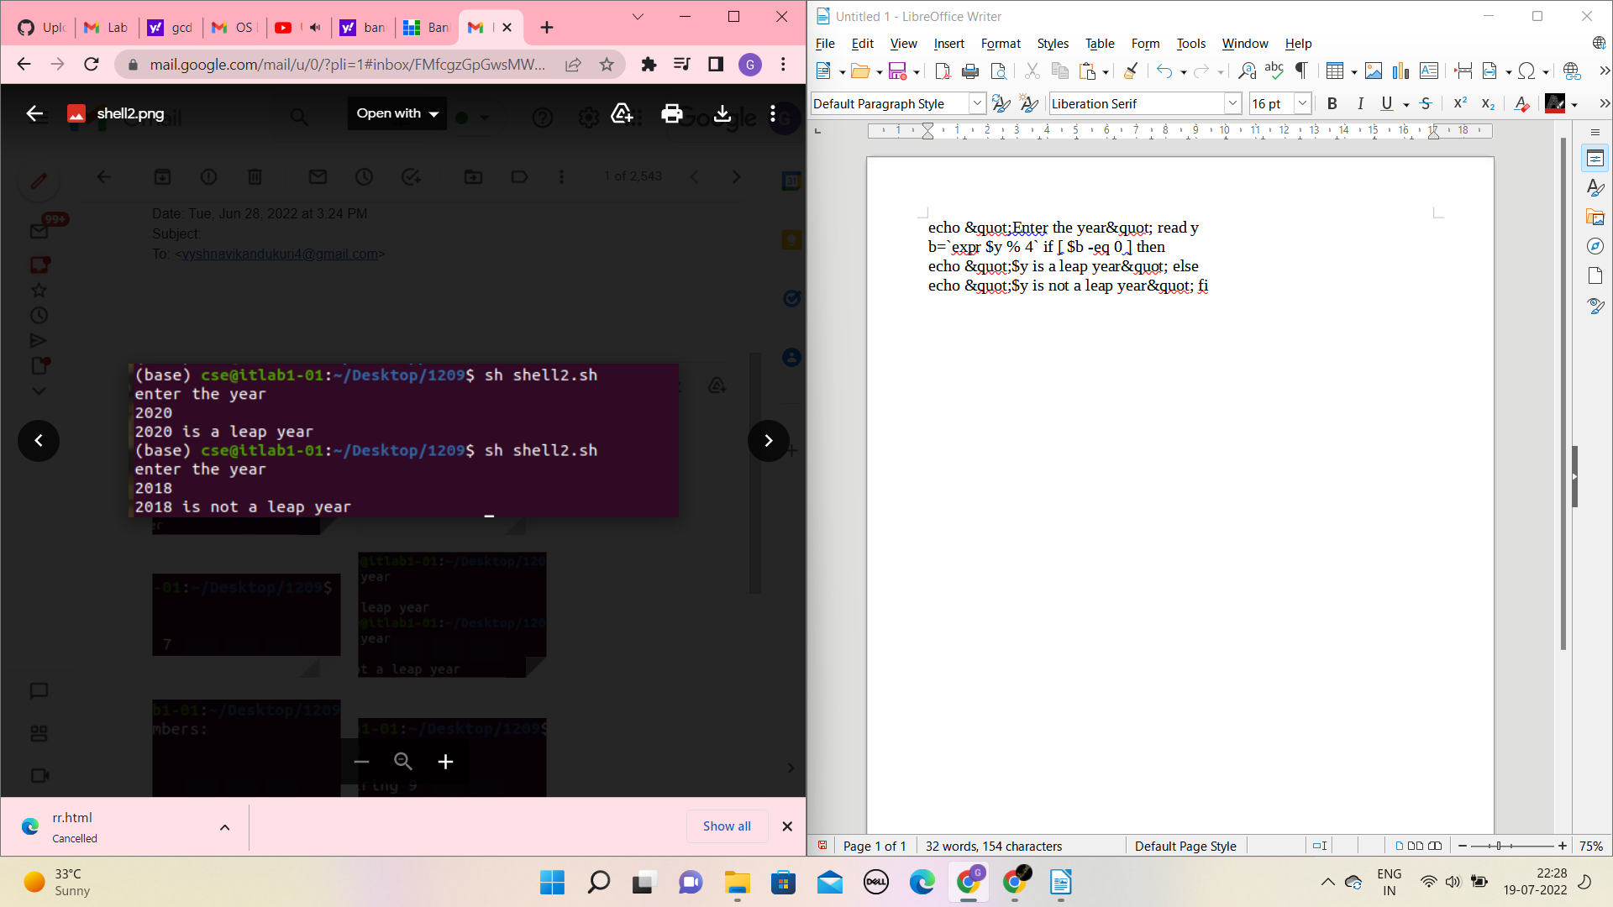

echo &quot;Enter a Number&quot; read n
i=`expr $n - 1` p=1
while [ $i -ge 1 ] do
n=`expr $n \* $i` i=`expr $i - 1` done
echo &quot;The Factorial of the given Number is $n&quot;
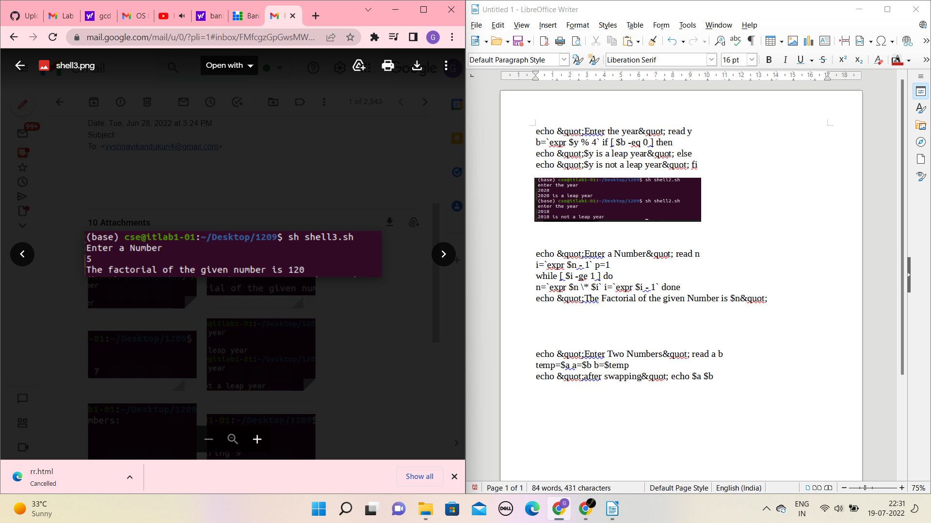

echo &quot;Enter Two Numbers&quot; read a b
temp=$a a=$b b=$temp
echo &quot;after swapping&quot; echo $a $b
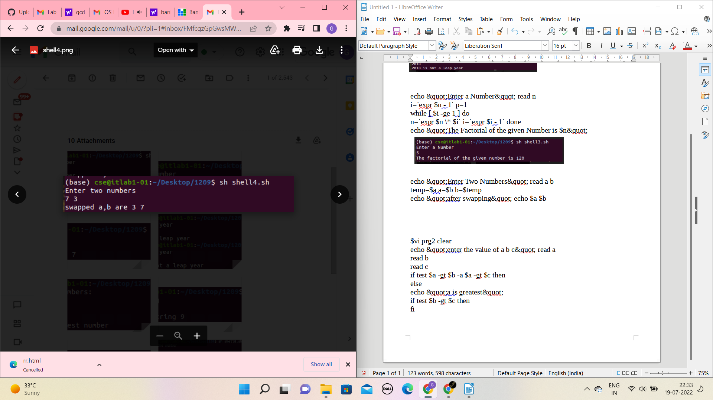

$vi prg2 clear
echo &quot;enter the value of a b c&quot; read a
read b
read c
if test $a -gt $b -a $a -gt $c then
else
echo &quot;a is greatest&quot;
if test $b -gt $c then
fi

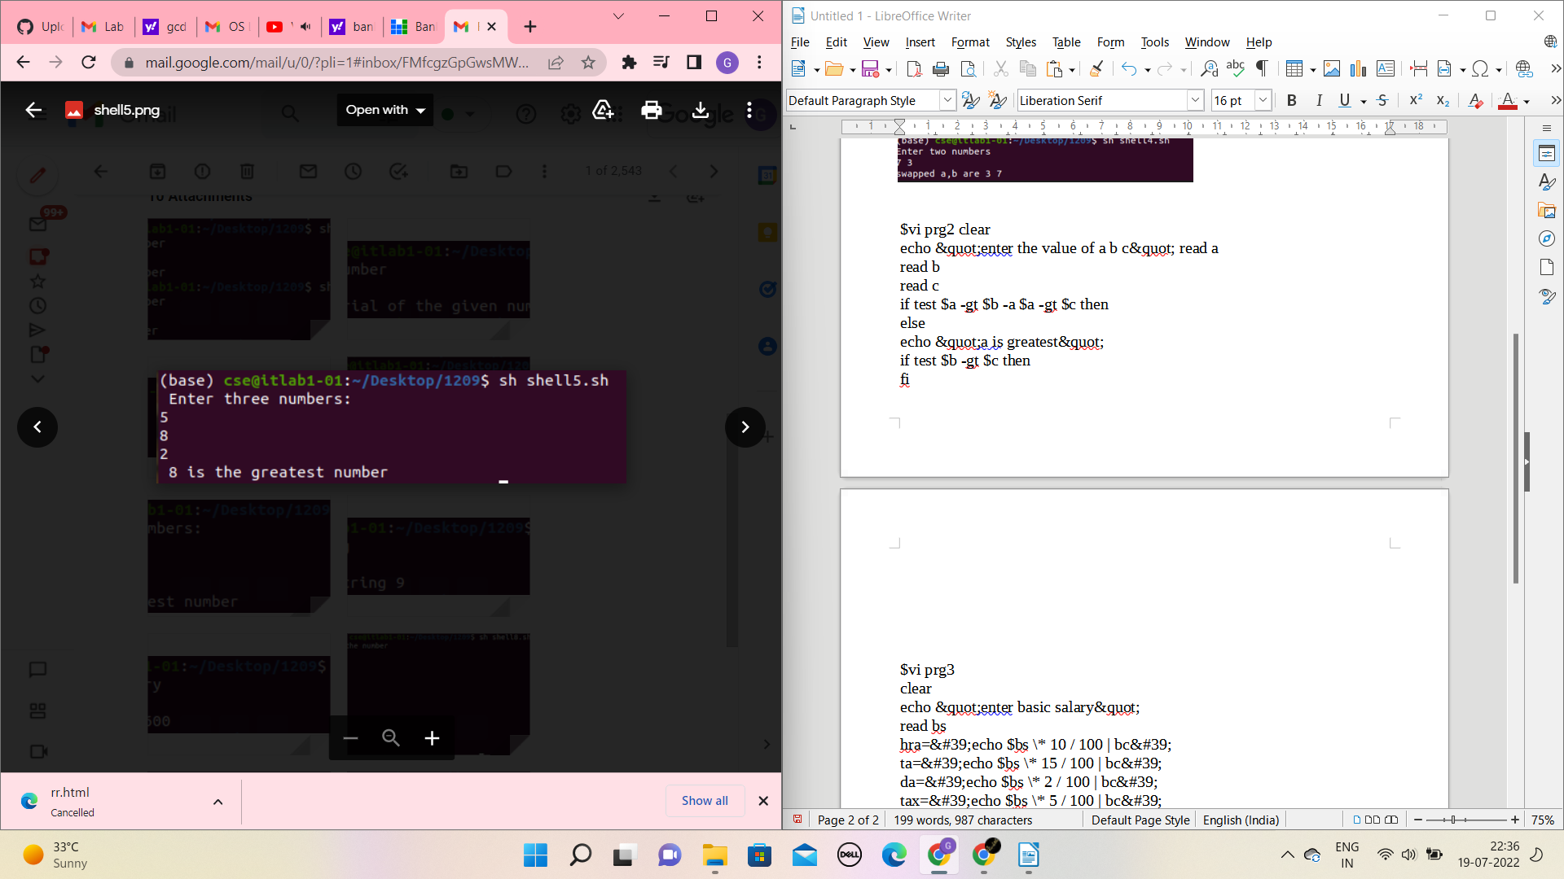

clear
echo &quot;enter basic salary&quot;
read bs
hra=&#39;echo $bs \* 10 / 100 | bc&#39;
ta=&#39;echo $bs \* 15 / 100 | bc&#39;
da=&#39;echo $bs \* 2 / 100 | bc&#39;
tax=&#39;echo $bs \* 5 / 100 | bc&#39;
pf=&#39;echo $bs \* 10 / 100 | bc&#39;
add=&#39;echo $hra + $ta + $da | bc&#39;
ded=&#39;echo $tax + $pf | bc&#39;
netsal=&#39;echo $bs + $add - $ded | bc&#39;
echo net salary is $netsal
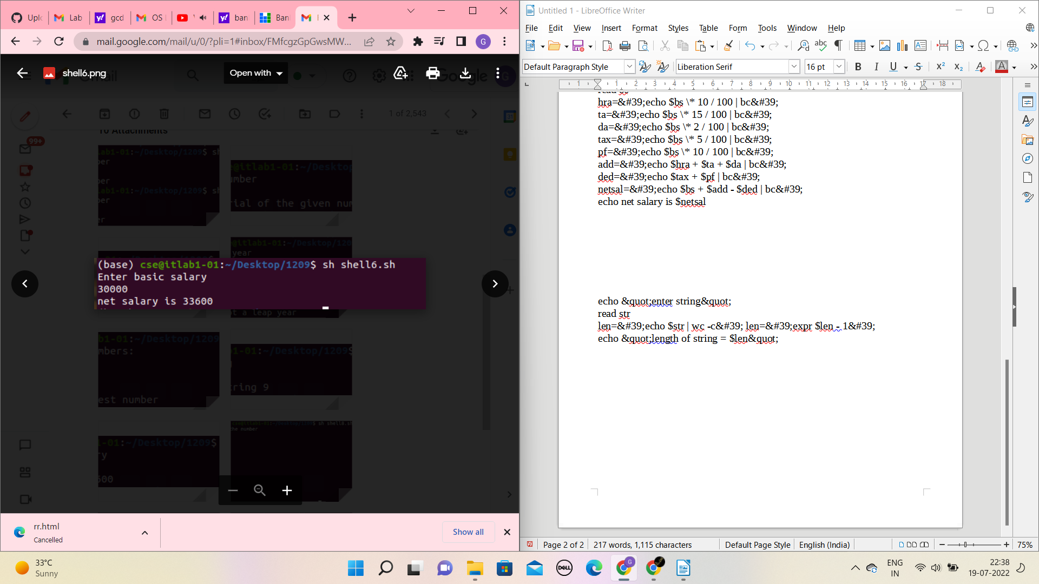

echo &quot;enter string&quot;
read str
len=&#39;echo $str | wc -c&#39; len=&#39;expr $len - 1&#39;
echo &quot;length of string = $len&quot;
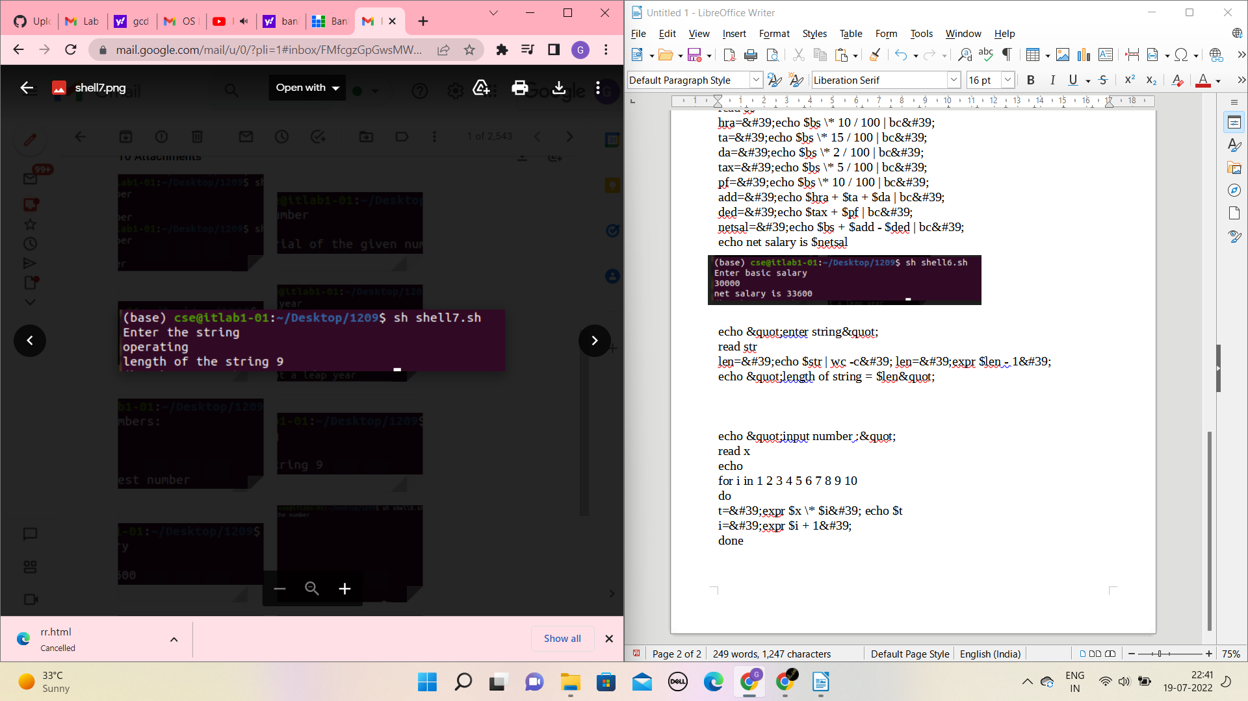

echo &quot;input number :&quot;
read x
echo
for i in 1 2 3 4 5 6 7 8 9 10
do
t=&#39;expr $x \* $i&#39; echo $t
i=&#39;expr $i + 1&#39;
done
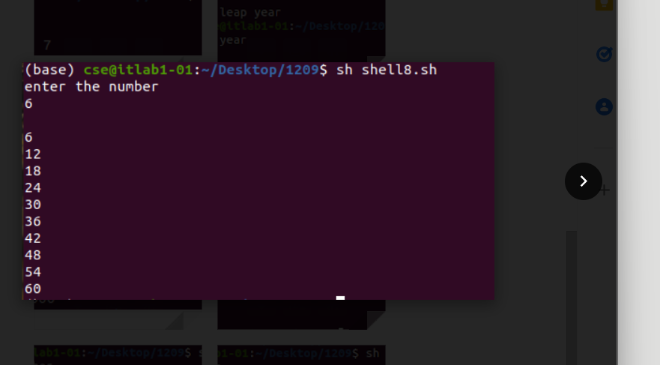

echo &quot;enter value of n&quot; read n
i=0
while test $i -le $n do
done echo
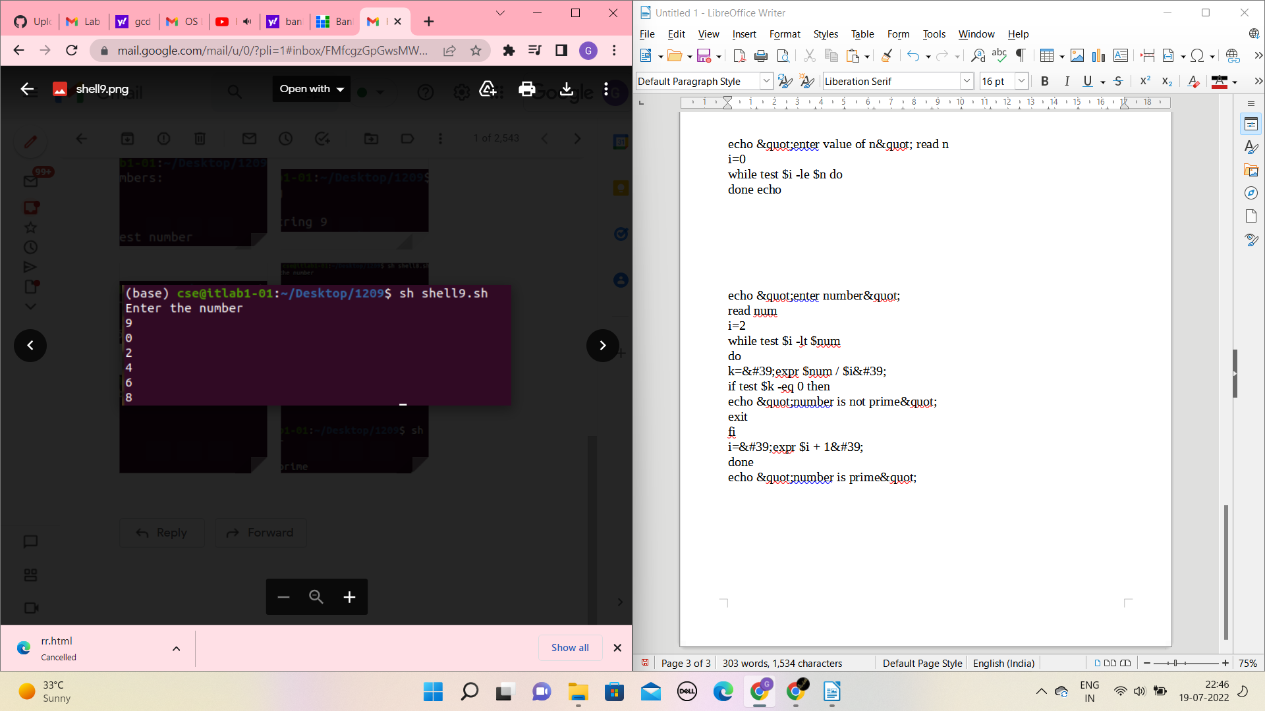

echo &quot;enter number&quot;
read num
i=2
while test $i -lt $num
do
k=&#39;expr $num / $i&#39;
if test $k -eq 0 then
echo &quot;number is not prime&quot;
exit
fi
i=&#39;expr $i + 1&#39;
done
echo &quot;number is prime&quot;
