**RESULTS FOR VGG 16 MODEL**

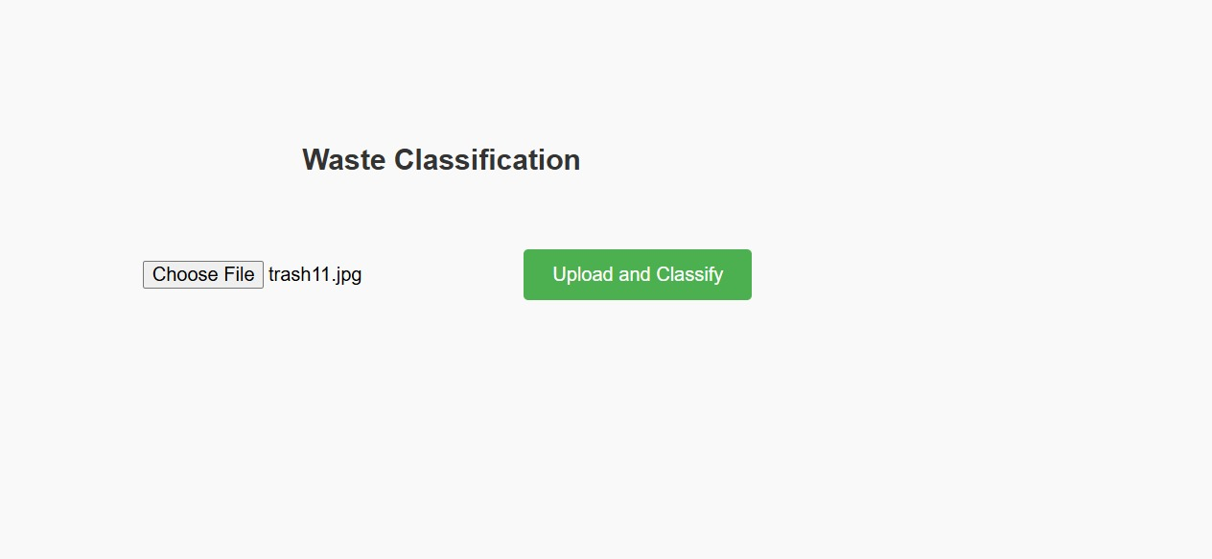

To upload image

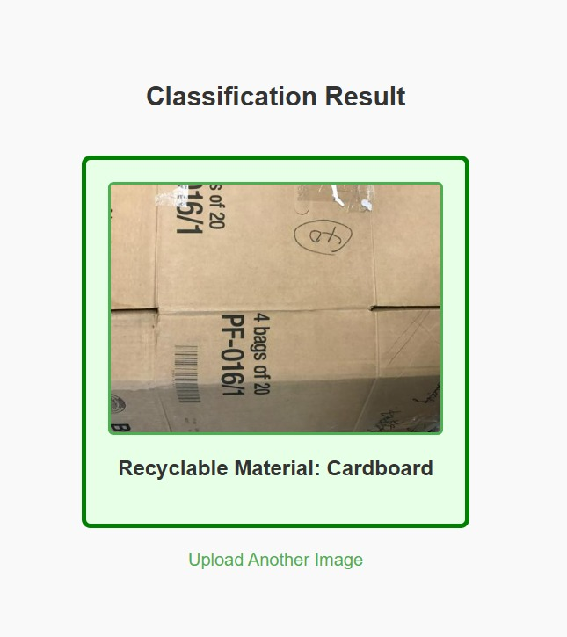

Prediction for recyclable

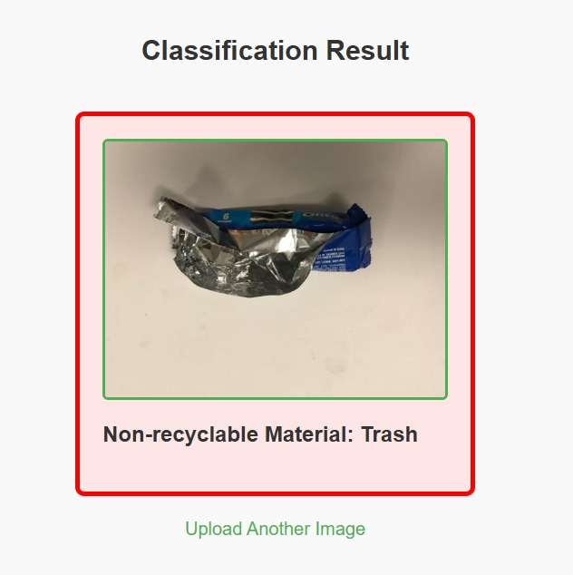

Prediction for non recyclable