FML ASSIGNMENT-5

Sai Harshitha Akula

2023-12-02

#Installing the required packages.

#install.packages("purr")   
#It provides a functional programming approach to iterating, mapping, and manipulating data structures.  
  
#install.packages("GGally")  
#It provides enhanced functionalities for exploring and visualizing relationships within multivariate datasets.  
  
#install.packages("pvclust")  
#The pvclust package is particularly useful when we want to assess the reliability of the clusters obtained through hierarchical clustering by incorporating bootstrap resampling techniques.  
  
#install.packages("fpc")  
# It provides a range of functions and tools that are particularly useful for working with clustering algorithms and evaluating clustering results.

#Loading the required libraries.

library(dplyr)

##   
## Attaching package: 'dplyr'

## The following objects are masked from 'package:stats':  
##   
## filter, lag

## The following objects are masked from 'package:base':  
##   
## intersect, setdiff, setequal, union

library(purrr)  
library(GGally)

## Warning: package 'GGally' was built under R version 4.3.2

## Loading required package: ggplot2

## Warning: package 'ggplot2' was built under R version 4.3.2

## Registered S3 method overwritten by 'GGally':  
## method from   
## +.gg ggplot2

library(pvclust)

## Warning: package 'pvclust' was built under R version 4.3.2

library(fpc)

## Warning: package 'fpc' was built under R version 4.3.2

library(cluster)

## Warning: package 'cluster' was built under R version 4.3.2

#Importing the dataset.

Cereals <- read.csv("C:/Users/saiha/OneDrive/Documents/R PROGRAMMING/Cereals.csv")  
Cereals1<-read.csv("C:/Users/saiha/OneDrive/Documents/R PROGRAMMING/Cereals.csv")

#Structure of the dataset.

str(Cereals)

## 'data.frame': 77 obs. of 16 variables:  
## $ name : chr "100%_Bran" "100%_Natural_Bran" "All-Bran" "All-Bran_with_Extra_Fiber" ...  
## $ mfr : chr "N" "Q" "K" "K" ...  
## $ type : chr "C" "C" "C" "C" ...  
## $ calories: int 70 120 70 50 110 110 110 130 90 90 ...  
## $ protein : int 4 3 4 4 2 2 2 3 2 3 ...  
## $ fat : int 1 5 1 0 2 2 0 2 1 0 ...  
## $ sodium : int 130 15 260 140 200 180 125 210 200 210 ...  
## $ fiber : num 10 2 9 14 1 1.5 1 2 4 5 ...  
## $ carbo : num 5 8 7 8 14 10.5 11 18 15 13 ...  
## $ sugars : int 6 8 5 0 8 10 14 8 6 5 ...  
## $ potass : int 280 135 320 330 NA 70 30 100 125 190 ...  
## $ vitamins: int 25 0 25 25 25 25 25 25 25 25 ...  
## $ shelf : int 3 3 3 3 3 1 2 3 1 3 ...  
## $ weight : num 1 1 1 1 1 1 1 1.33 1 1 ...  
## $ cups : num 0.33 1 0.33 0.5 0.75 0.75 1 0.75 0.67 0.67 ...  
## $ rating : num 68.4 34 59.4 93.7 34.4 ...

sum(is.na(Cereals))

## [1] 4

#Removing any instances of missing values within the dataset.

Cereals <- na.omit(Cereals)  
Cereals1<-na.omit(Cereals1)  
sum(is.na(Cereals))

## [1] 0

#Transforming the cereal names into row names to facilitate the subsequent visualization of clusters.

rownames(Cereals) <- Cereals$name  
rownames(Cereals1) <- Cereals1$name

#Excluding the “name” column as it no longer contributes any meaningful information.

Cereals$name = NULL  
Cereals1$name = NULL

#Before applying any distance measure, it is essential to normalize the data as variables with broader ranges can disproportionately impact the distance calculation.

Cereals <- scale(Cereals[,3:15])

#Intending to employ the Euclidean distance metric for conducting hierarchical clustering on the dataset.

# computing the Euclidean distance matrix for the dataset using the "euclidean" method for distance calculation.  
d <- dist(Cereals, method = "euclidean")  
# initiating hierarchical clustering using the "complete" linkage method based on the dissimilarity matrix D.   
HC_complete <- hclust(d, method = "complete" )  
# Plotting the obtained dendrogram.  
plot(HC_complete, cex = 0.6, hang = -1)

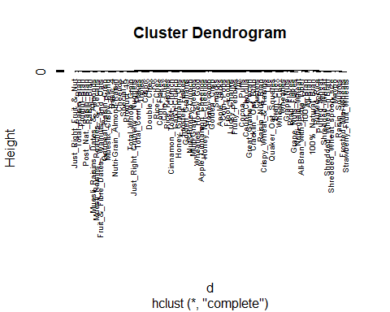

#Using the agnes function from the cluster package to perform agglomerative hierarchical clustering with the "single" linkage method on a dataset.  
library(cluster)  
HC_single <- agnes(Cereals, method = "single")  
  
#Generating a dendrogram plot for the hierarchical clustering result obtained from the agnes function.  
pltree(HC_single, cex = 0.6, hang = -1, main = "Dendrogram of agnes")

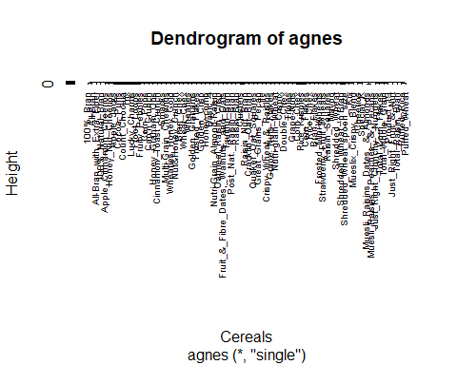

#Using the agnes function from the cluster package to perform agglomerative hierarchical clustering with the "average" linkage method on a dataset.  
HC_average <- agnes(Cereals, method = "average")  
  
#Generating a dendrogram plot.  
pltree(HC_average, cex = 0.6, hang = -1, main = "Dendrogram of agnes")

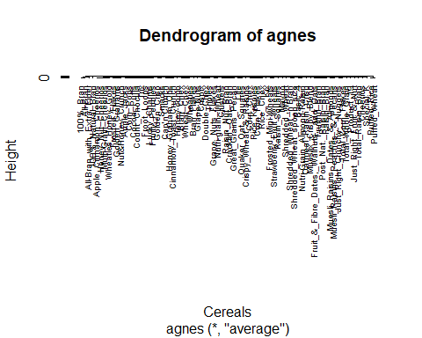

#Using the agnes function from the cluster package to perform agglomerative hierarchical clustering with the "ward" linkage method on a dataset.  
HC_Ward <- agnes(Cereals, method = "ward")  
  
#Generating a dendrogram plot.  
pltree(HC_Ward, cex = 0.6, hang = -1, main = "Dendrogram of agnes")

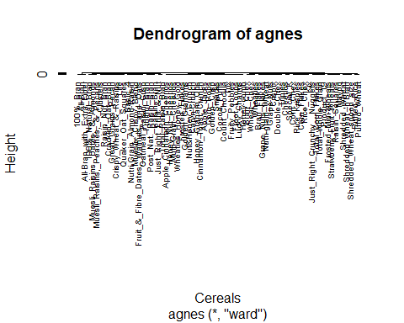 #Computing the Agnes coefficient for each methodology.

library(purrr)  
# Representing different linkage methods used in hierarchical clustering.   
m <- c( "average", "single", "complete", "ward")  
names(m) <- c( "average", "single", "complete", "ward")  
# Function for computing the coefficient  
ac <- function(x) {  
 agnes(Cereals, method = x)$ac  
}  
map_dbl(m, ac)

## average single complete ward   
## 0.7766075 0.6067859 0.8353712 0.9046042

#So, from the above values we can see that “Ward” emerges as the most favorable linkage method, exhibiting a compelling agglomerative coefficient of 0.9046042.

#Segment the dendrogram using the “cutree()” function to identify distinct sub-groups, commonly referred to as clusters.

#Creating the distance matrix  
D <- dist(Cereals, method = "euclidean")  
  
# Using Ward method for Hierarchical clustering  
HC_Ward_cluster <- hclust(D, method = "ward.D2" )  
  
#Creating a plot to visualize hierarchical clustering.  
plot(HC_Ward_cluster, cex=0.6 )  
  
#Drawing rectangles around clusters in a hierarchical clustering dendrogram.   
rect.hclust(HC_Ward_cluster,k=6,border = 1:6)

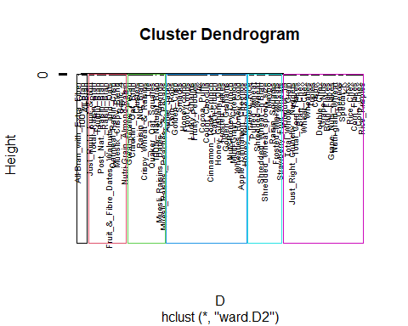

#Let’s explore the distribution of data records across various clusters and understand the allocation patterns.

# Cutting the tree into 6 groups.  
sub_group <- cutree(HC_Ward_cluster, k = 6)  
# Creating a frequency table, summarizing the counts of unique values.  
table(sub_group)

## sub_group  
## 1 2 3 4 5 6   
## 3 10 21 10 21 9

#install.packages("GGally")  
library(GGally)  
library(dplyr)  
Cereals1 %>%   
select(calories, protein, fat, sodium, fiber, carbo, sugars, potass,vitamins,rating) %>%   
ggcorr(palette = "RdBu", label = TRUE, label_round = 2)

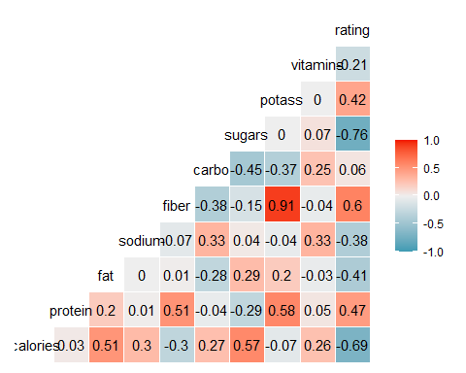

#The pvclust() function from the pvclust package is designed for assessing the statistical significance of clusters generated through hierarchical clustering using multiscale bootstrap resampling. In this method, clusters with strong support from the data are assigned larger p-values. It’s important to note that when using pvclust, the grouping is applied to columns rather than rows. Therefore, we have to transpose the data before employing this method for more accurate results.

# Using Ward Hierarchical Clustering with Bootstrapped p values  
library(pvclust)

fit.pv <- pvclust(Cereals, method.hclust="ward.D2",  
 method.dist="euclidean")

## Bootstrap (r = 0.5)... Done.  
## Bootstrap (r = 0.59)... Done.  
## Bootstrap (r = 0.69)... Done.  
## Bootstrap (r = 0.8)... Done.  
## Bootstrap (r = 0.89)... Done.  
## Bootstrap (r = 1.0)... Done.  
## Bootstrap (r = 1.09)... Done.  
## Bootstrap (r = 1.19)... Done.  
## Bootstrap (r = 1.3)... Done.  
## Bootstrap (r = 1.39)... Done.

#Creating a dendogram with p values  
plot(fit.pv)   
# Adding rectangles around groups highly supported by the data  
pvrect(fit.pv, alpha=.95)

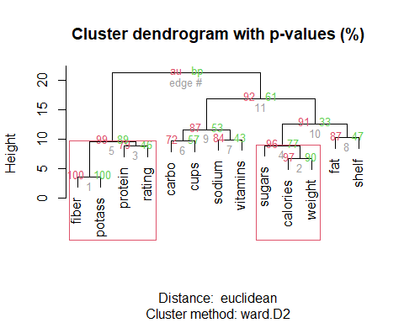 #The stability of each cluster in the original clustering is expressed through the average Jaccard coefficient across all bootstrap iterations. Clusters with a stability rating below 0.6 should be deemed unstable. When stability ratings fall between 0.6 and 0.75, the cluster can discern a pattern in the data, but there is not a robust consensus on the grouping of points. Notably stable clusters exhibit exceptional stability when their ratings surpass 0.85.

#1.The optimal strategy involves maximizing the Jaccard bootstrap for each cluster, emphasizing robustness in cluster-wise assessments.

#2.Minimizing the dissolution of clusters is advised to uphold their integrity effectively.

#3.Striving to augment the number of recovered clusters while maintaining proximity to the original configuration as closely as feasible.

#Running clusterboot() function

#install.packages("fpc")  
library(fpc)  
library(cluster)  
Kbestp<-6  
clusterb_hclust <- clusterboot(Cereals,clustermethod=hclustCBI,method="ward.D2", k=Kbestp)

## boot 1   
## boot 2   
## boot 3   
## boot 4   
## boot 5   
## boot 6   
## boot 7   
## boot 8   
## boot 9   
## boot 10   
## boot 11   
## boot 12   
## boot 13   
## boot 14   
## boot 15   
## boot 16   
## boot 17   
## boot 18   
## boot 19   
## boot 20   
## boot 21   
## boot 22   
## boot 23   
## boot 24   
## boot 25   
## boot 26   
## boot 27   
## boot 28   
## boot 29   
## boot 30   
## boot 31   
## boot 32   
## boot 33   
## boot 34   
## boot 35   
## boot 36   
## boot 37   
## boot 38   
## boot 39   
## boot 40   
## boot 41   
## boot 42   
## boot 43   
## boot 44   
## boot 45   
## boot 46   
## boot 47   
## boot 48   
## boot 49   
## boot 50   
## boot 51   
## boot 52   
## boot 53   
## boot 54   
## boot 55   
## boot 56   
## boot 57   
## boot 58   
## boot 59   
## boot 60   
## boot 61   
## boot 62   
## boot 63   
## boot 64   
## boot 65   
## boot 66   
## boot 67   
## boot 68   
## boot 69   
## boot 70   
## boot 71   
## boot 72   
## boot 73   
## boot 74   
## boot 75   
## boot 76   
## boot 77   
## boot 78   
## boot 79   
## boot 80   
## boot 81   
## boot 82   
## boot 83   
## boot 84   
## boot 85   
## boot 86   
## boot 87   
## boot 88   
## boot 89   
## boot 90   
## boot 91   
## boot 92   
## boot 93   
## boot 94   
## boot 95   
## boot 96   
## boot 97   
## boot 98   
## boot 99   
## boot 100

summary(clusterb_hclust$result)

## Length Class Mode   
## result 7 hclust list   
## noise 1 -none- logical   
## nc 1 -none- numeric   
## clusterlist 6 -none- list   
## partition 74 -none- numeric   
## clustermethod 1 -none- character  
## nccl 1 -none- numeric

groups<-clusterb_hclust$result$partition  
head(data.frame(groups))

## groups  
## 100%_Bran 1  
## 100%_Natural_Bran 2  
## All-Bran 1  
## All-Bran_with_Extra_Fiber 1  
## Apple_Cinnamon_Cheerios 3  
## Apple_Jacks 3

#Representing the mean values obtained through bootstrapping.

clusterb_hclust$bootmean

## [1] 0.8903215 0.5140321 0.9236450 0.6360336 0.6198769 0.6914729

#Determining the frequency with which each cluster is disassembled by default during the execution of clusterboot(), which, by default, conducts 100 bootstrap iterations.

clusterb_hclust$bootbrd

## [1] 12 59 0 41 30 38

#Retrieving the identified clusters from the results generated by the hclust() function.

groups <- cutree(HC_Ward_cluster, k = 6)  
print_cluster <- function(labels, k) {  
for(i in 1:k) {  
print(paste("cluster", i))  
print(Cereals1[labels==i,c("mfr","calories","protein","fat","sodium","fiber","carbo","sugars","potass",  
 "vitamins","rating")])  
}  
}  
print_cluster(groups, 6)

## [1] "cluster 1"  
## mfr calories protein fat sodium fiber carbo sugars  
## 100%_Bran N 70 4 1 130 10 5 6  
## All-Bran K 70 4 1 260 9 7 5  
## All-Bran_with_Extra_Fiber K 50 4 0 140 14 8 0  
## potass vitamins rating  
## 100%_Bran 280 25 68.40297  
## All-Bran 320 25 59.42551  
## All-Bran_with_Extra_Fiber 330 25 93.70491  
## [1] "cluster 2"  
## mfr calories protein fat sodium fiber carbo  
## 100%_Natural_Bran Q 120 3 5 15 2.0 8.0  
## Clusters G 110 3 2 140 2.0 13.0  
## Cracklin'_Oat_Bran K 110 3 3 140 4.0 10.0  
## Crispy_Wheat_&_Raisins G 100 2 1 140 2.0 11.0  
## Great_Grains_Pecan P 120 3 3 75 3.0 13.0  
## Life Q 100 4 2 150 2.0 12.0  
## Muesli_Raisins,_Dates,_&_Almonds R 150 4 3 95 3.0 16.0  
## Muesli_Raisins,_Peaches,_&_Pecans R 150 4 3 150 3.0 16.0  
## Quaker_Oat_Squares Q 100 4 1 135 2.0 14.0  
## Raisin_Nut_Bran G 100 3 2 140 2.5 10.5  
## sugars potass vitamins rating  
## 100%_Natural_Bran 8 135 0 33.98368  
## Clusters 7 105 25 40.40021  
## Cracklin'_Oat_Bran 7 160 25 40.44877  
## Crispy_Wheat_&_Raisins 10 120 25 36.17620  
## Great_Grains_Pecan 4 100 25 45.81172  
## Life 6 95 25 45.32807  
## Muesli_Raisins,_Dates,_&_Almonds 11 170 25 37.13686  
## Muesli_Raisins,_Peaches,_&_Pecans 11 170 25 34.13976  
## Quaker_Oat_Squares 6 110 25 49.51187  
## Raisin_Nut_Bran 8 140 25 39.70340  
## [1] "cluster 3"  
## mfr calories protein fat sodium fiber carbo sugars  
## Apple_Cinnamon_Cheerios G 110 2 2 180 1.5 10.5 10  
## Apple_Jacks K 110 2 0 125 1.0 11.0 14  
## Cap'n'Crunch Q 120 1 2 220 0.0 12.0 12  
## Cinnamon_Toast_Crunch G 120 1 3 210 0.0 13.0 9  
## Cocoa_Puffs G 110 1 1 180 0.0 12.0 13  
## Corn_Pops K 110 1 0 90 1.0 13.0 12  
## Count_Chocula G 110 1 1 180 0.0 12.0 13  
## Froot_Loops K 110 2 1 125 1.0 11.0 13  
## Frosted_Flakes K 110 1 0 200 1.0 14.0 11  
## Fruity_Pebbles P 110 1 1 135 0.0 13.0 12  
## Golden_Crisp P 100 2 0 45 0.0 11.0 15  
## Golden_Grahams G 110 1 1 280 0.0 15.0 9  
## Honey_Graham_Ohs Q 120 1 2 220 1.0 12.0 11  
## Honey_Nut_Cheerios G 110 3 1 250 1.5 11.5 10  
## Honey-comb P 110 1 0 180 0.0 14.0 11  
## Lucky_Charms G 110 2 1 180 0.0 12.0 12  
## Multi-Grain_Cheerios G 100 2 1 220 2.0 15.0 6  
## Nut&Honey_Crunch K 120 2 1 190 0.0 15.0 9  
## Smacks K 110 2 1 70 1.0 9.0 15  
## Trix G 110 1 1 140 0.0 13.0 12  
## Wheaties_Honey_Gold G 110 2 1 200 1.0 16.0 8  
## potass vitamins rating  
## Apple_Cinnamon_Cheerios 70 25 29.50954  
## Apple_Jacks 30 25 33.17409  
## Cap'n'Crunch 35 25 18.04285  
## Cinnamon_Toast_Crunch 45 25 19.82357  
## Cocoa_Puffs 55 25 22.73645  
## Corn_Pops 20 25 35.78279  
## Count_Chocula 65 25 22.39651  
## Froot_Loops 30 25 32.20758  
## Frosted_Flakes 25 25 31.43597  
## Fruity_Pebbles 25 25 28.02576  
## Golden_Crisp 40 25 35.25244  
## Golden_Grahams 45 25 23.80404  
## Honey_Graham_Ohs 45 25 21.87129  
## Honey_Nut_Cheerios 90 25 31.07222  
## Honey-comb 35 25 28.74241  
## Lucky_Charms 55 25 26.73451  
## Multi-Grain_Cheerios 90 25 40.10596  
## Nut&Honey_Crunch 40 25 29.92429  
## Smacks 40 25 31.23005  
## Trix 25 25 27.75330  
## Wheaties_Honey_Gold 60 25 36.18756  
## [1] "cluster 4"  
## mfr calories protein fat sodium fiber  
## Basic_4 G 130 3 2 210 2.0  
## Fruit_&_Fibre_Dates,_Walnuts,_and_Oats P 120 3 2 160 5.0  
## Fruitful_Bran K 120 3 0 240 5.0  
## Just_Right_Fruit_&_Nut K 140 3 1 170 2.0  
## Mueslix_Crispy_Blend K 160 3 2 150 3.0  
## Nutri-Grain_Almond-Raisin K 140 3 2 220 3.0  
## Oatmeal_Raisin_Crisp G 130 3 2 170 1.5  
## Post_Nat._Raisin_Bran P 120 3 1 200 6.0  
## Raisin_Bran K 120 3 1 210 5.0  
## Total_Raisin_Bran G 140 3 1 190 4.0  
## carbo sugars potass vitamins rating  
## Basic_4 18.0 8 100 25 37.03856  
## Fruit_&_Fibre_Dates,_Walnuts,_and_Oats 12.0 10 200 25 40.91705  
## Fruitful_Bran 14.0 12 190 25 41.01549  
## Just_Right_Fruit_&_Nut 20.0 9 95 100 36.47151  
## Mueslix_Crispy_Blend 17.0 13 160 25 30.31335  
## Nutri-Grain_Almond-Raisin 21.0 7 130 25 40.69232  
## Oatmeal_Raisin_Crisp 13.5 10 120 25 30.45084  
## Post_Nat._Raisin_Bran 11.0 14 260 25 37.84059  
## Raisin_Bran 14.0 12 240 25 39.25920  
## Total_Raisin_Bran 15.0 14 230 100 28.59278  
## [1] "cluster 5"  
## mfr calories protein fat sodium fiber carbo sugars  
## Bran_Chex R 90 2 1 200 4 15 6  
## Bran_Flakes P 90 3 0 210 5 13 5  
## Cheerios G 110 6 2 290 2 17 1  
## Corn_Chex R 110 2 0 280 0 22 3  
## Corn_Flakes K 100 2 0 290 1 21 2  
## Crispix K 110 2 0 220 1 21 3  
## Double_Chex R 100 2 0 190 1 18 5  
## Grape_Nuts_Flakes P 100 3 1 140 3 15 5  
## Grape-Nuts P 110 3 0 170 3 17 3  
## Just_Right_Crunchy__Nuggets K 110 2 1 170 1 17 6  
## Kix G 110 2 1 260 0 21 3  
## Nutri-grain_Wheat K 90 3 0 170 3 18 2  
## Product_19 K 100 3 0 320 1 20 3  
## Rice_Chex R 110 1 0 240 0 23 2  
## Rice_Krispies K 110 2 0 290 0 22 3  
## Special_K K 110 6 0 230 1 16 3  
## Total_Corn_Flakes G 110 2 1 200 0 21 3  
## Total_Whole_Grain G 100 3 1 200 3 16 3  
## Triples G 110 2 1 250 0 21 3  
## Wheat_Chex R 100 3 1 230 3 17 3  
## Wheaties G 100 3 1 200 3 17 3  
## potass vitamins rating  
## Bran_Chex 125 25 49.12025  
## Bran_Flakes 190 25 53.31381  
## Cheerios 105 25 50.76500  
## Corn_Chex 25 25 41.44502  
## Corn_Flakes 35 25 45.86332  
## Crispix 30 25 46.89564  
## Double_Chex 80 25 44.33086  
## Grape_Nuts_Flakes 85 25 52.07690  
## Grape-Nuts 90 25 53.37101  
## Just_Right_Crunchy__Nuggets 60 100 36.52368  
## Kix 40 25 39.24111  
## Nutri-grain_Wheat 90 25 59.64284  
## Product_19 45 100 41.50354  
## Rice_Chex 30 25 41.99893  
## Rice_Krispies 35 25 40.56016  
## Special_K 55 25 53.13132  
## Total_Corn_Flakes 35 100 38.83975  
## Total_Whole_Grain 110 100 46.65884  
## Triples 60 25 39.10617  
## Wheat_Chex 115 25 49.78744  
## Wheaties 110 25 51.59219  
## [1] "cluster 6"  
## mfr calories protein fat sodium fiber carbo sugars  
## Frosted_Mini-Wheats K 100 3 0 0 3 14 7  
## Maypo A 100 4 1 0 0 16 3  
## Puffed_Rice Q 50 1 0 0 0 13 0  
## Puffed_Wheat Q 50 2 0 0 1 10 0  
## Raisin_Squares K 90 2 0 0 2 15 6  
## Shredded_Wheat N 80 2 0 0 3 16 0  
## Shredded_Wheat_'n'Bran N 90 3 0 0 4 19 0  
## Shredded_Wheat_spoon_size N 90 3 0 0 3 20 0  
## Strawberry_Fruit_Wheats N 90 2 0 15 3 15 5  
## potass vitamins rating  
## Frosted_Mini-Wheats 100 25 58.34514  
## Maypo 95 25 54.85092  
## Puffed_Rice 15 0 60.75611  
## Puffed_Wheat 50 0 63.00565  
## Raisin_Squares 110 25 55.33314  
## Shredded_Wheat 95 0 68.23588  
## Shredded_Wheat_'n'Bran 140 0 74.47295  
## Shredded_Wheat_spoon_size 120 0 72.80179  
## Strawberry_Fruit_Wheats 90 25 59.36399

– I have opted to select clusters based on both statistical values and nutritional richness to formulate a health-conscious diet. It’s crucial to note that this approach is entirely subjective, as there is no explicit mention of a defined metric or scale for constructing a healthy diet.

– Regarding the necessity of normalization, my stance is negative. Normalizing the data tends to diminish its magnitude, posing significant challenges for comprehensive analysis and decision-making.

– The clusters representing different levels of cereal diets showcase varying degrees of richness, adequacy, and deficiencies in nutrients. After segregating the data into six distinct groups, a thorough examination of these clusters is conducted, taking into account all relevant factors and variables.

– Despite Cluster 1 offering nutritionally sound guidelines for crafting a balanced diet, it does present limitations due to its relatively constrained options. On the contrary, Clusters 2 and 3 are discouraged for inclusion in a health-conscious meal plan due to their subpar ratings and elevated levels of fat and sugar content.

– Clusters 4 and 5 stand out for maintaining a well-balanced nutritional profile and receiving favorable ratings for consumer satisfaction. Consequently, these clusters emerge as optimal choices, particularly suitable for implementation in primary public schools’ cafeterias.