**In class Programming Assignment - 5**

**GitHub Link:** [**https://github.com/HarshithaBoyapati2002/nn_icp5**](https://github.com/HarshithaBoyapati2002/nn_icp5)

**Videolink:**[**https://drive.google.com/file/d/1x_Lh0JaJZgok-f20-HrBUiDYzH_j6mg8/view?usp=sharing**](https://drive.google.com/file/d/1x_Lh0JaJZgok-f20-HrBUiDYzH_j6mg8/view?usp=sharing)

**Problem 1:** Image classification with CNN

**Solution:**

1. Tuning hyperparameter and make necessary addition to the baseline model to improve validation accuracy and reduce validation loss.

1. The crucial aspect that influences the performance of the network is the number of layers in the network. Deep neural networks with multiple layers, also known as deep learning models, are capable of learning complex patterns and extracting higher-level features. This depth enables them to handle more sophisticated tasks and achieve higher accuracy.
2. Creating at least two more visualizations using matplotlib

1. Using cifer10 dataset and implementing baseline models provided.

1. Applying modified architecture to the dataset and training it.

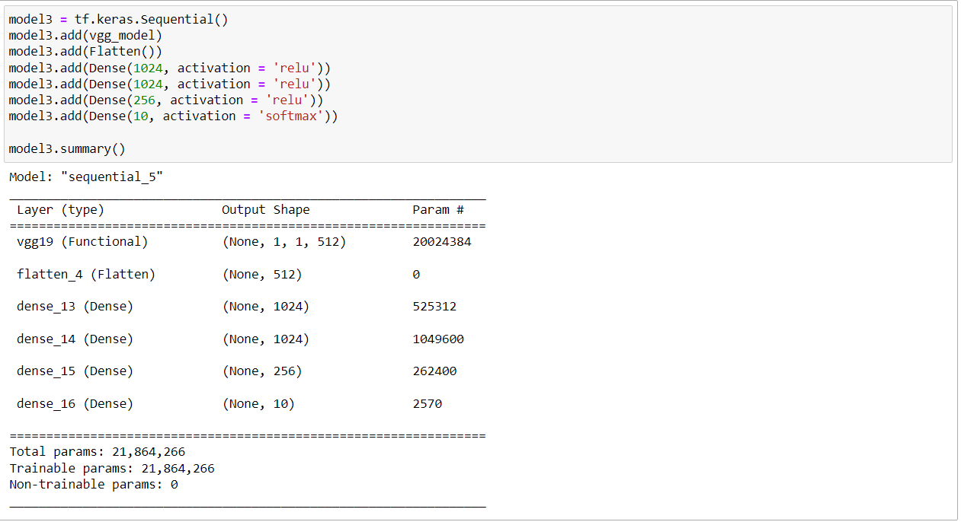

1. Save the improved model and use it for prediction on testing data.

1. Provide plot of confusion matric.

1. Provide Training and testing Loss and accuracy plots in one plot using subplot command and history object.

