**In class Programming Assignment - 6**

**GitHub Link:** [**https://github.com/HarshithaBoyapati2002/nn_icp6**](https://github.com/HarshithaBoyapati2002/nn_icp6)

**Video:**[**https://drive.google.com/file/d/1j11Rmgf_Z3K6waK-WDeDcP3CdytPQ5DT/view?usp=drive_link**](https://drive.google.com/file/d/1j11Rmgf_Z3K6waK-WDeDcP3CdytPQ5DT/view?usp=drive_link)

1. Adding one more hidden layer to autoencoder.

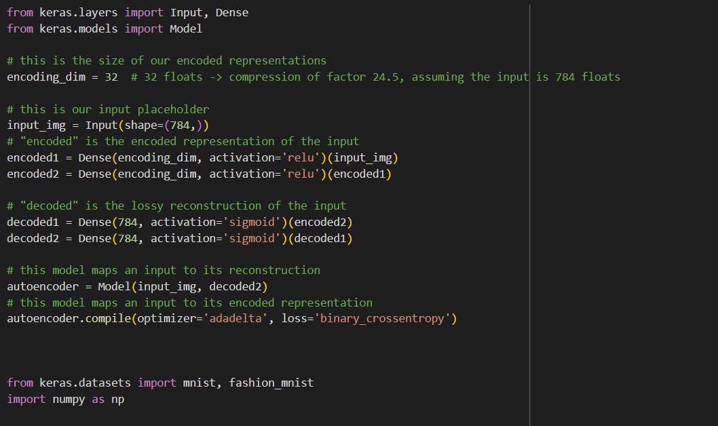 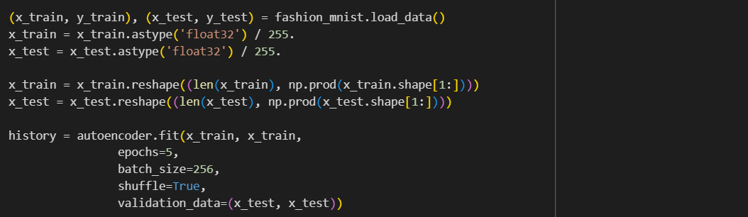

1. Predicting the test data and then visualizing one of the reconstructed version of that test data. Also, visualizing the same test data before reconstruction using Matplotlib.

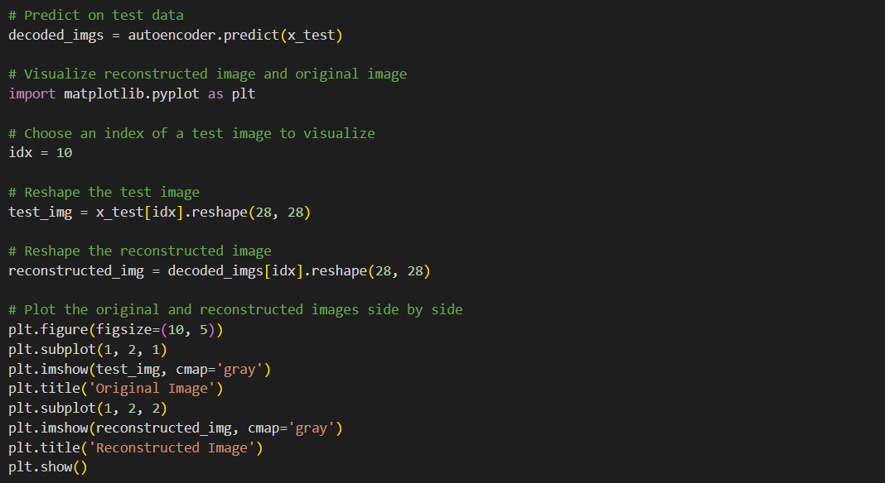 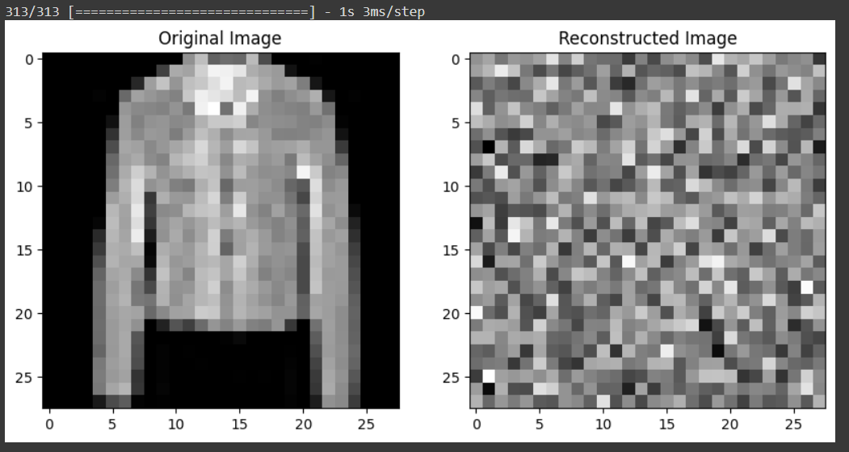

1. Repeating the above code on the denoisening autoencoder.

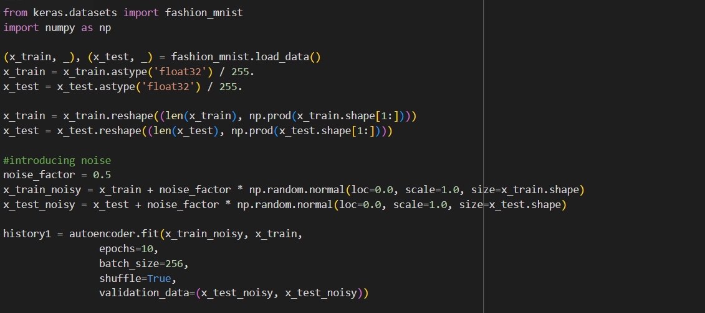 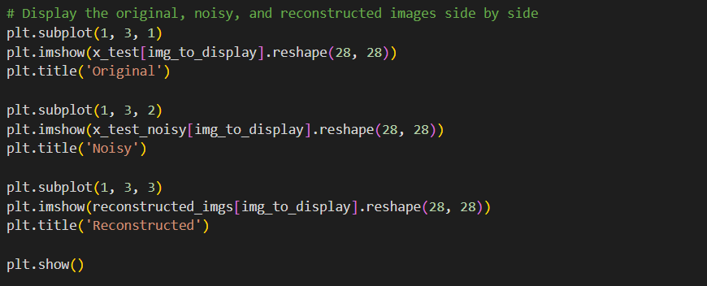 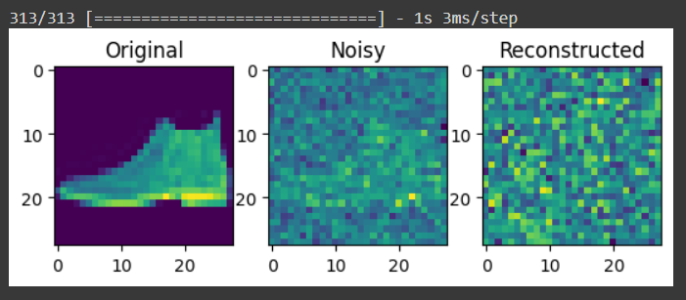

1. Plotting loss and accuracy using the history object.

