Your supermarket company is working on expanding their Docker infrastructure. They have an existing service that provides a list of fruit sold in their stores. After measuring the amount of load on this service, they have asked you to scale this service up to a higher number of replicas.

In addition, there is a new service that provides a list of vegetables. This new service needs to be created in the cluster. Set up the swarm cluster to complete the lab, ensure that the swarm meets the following specifications:

1. Scale the service called products-fruit to 5 replicas.

docker run --publish 8080:8080 -detach --name fruit-list fruit-list:1.0.0

2. Create a new service called products-vegetables running the linuxacademycontent/vegetable-service:1.0.0 image.

docker service create --replicas 3 --name products-vegetables linuxacademycontent/vegetable-service:1.0.0

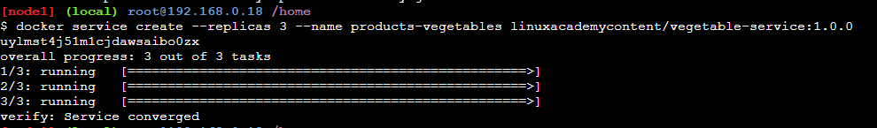

3. Publish products-vegetables on port 8081. The application listens on port 80.

docker service create --replicas 3 -p 8081:80 --name products-vegetables1 linuxacademycontent/vegetable-service:1.0.0

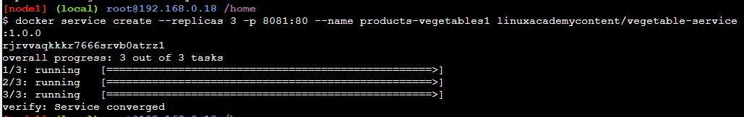

4. Run products-vegetables with 3 replicas.

docker service scale products-vegetables1=3

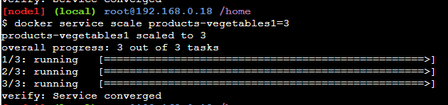

You can test the products-fruit service from any swarm node (including the manager) with curl localhost:8080.

curl ‘<ip-address>:8080’

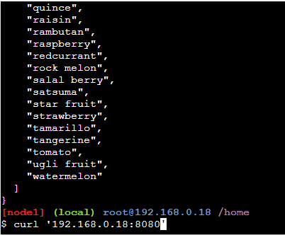

Once products-vegetables is running, you should be able to test it from any swarm node (including the manager) with curl localhost:8081.

curl ‘<ip address>:8081’

