Your company is ready to start using Docker on some of their servers. In order to get started, they want you to set up and configure Docker CE on a server that has already been set up. You will need to make sure that the server meets the following specifications:

Docker CE is installed and running on the server.
Use Docker CE version 5:18.09.5~3-0~ubuntu-bionic.
Any non-root user has permission to run docker commands.
The default logging driver is set to syslog.

[NOTE: Write the series of commands to achieve above in this file below the question scenario with documentation]

Running ubuntu server

apt-get update
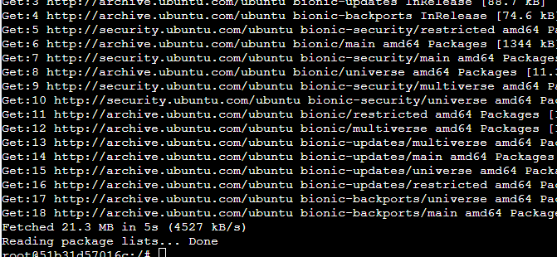
apt-get upgrade
