Assignment-13
Batch-7
2303A51463

Task 1: Refactoring – Removing Code Duplication
Objective
To eliminate repeated logic by extracting reusable functions.
Task Description
Use AI assistance to refactor a legacy Python script that contains repeated
blocks of code calculating the area and perimeter of rectangles.
Starter (Legacy) Code
# Legacy script with repeated logic
print("Area of Rectangle:", 5 * 10)
print("Perimeter of Rectangle:", 2 * (5 + 10))
print("Area of Rectangle:", 7 * 12)
print("Perimeter of Rectangle:", 2 * (7 + 12))
print("Area of Rectangle:", 10 * 15)
print("Perimeter of Rectangle:", 2 * (10 + 15))
Expected Outcome
• A reusable function to calculate area and perimeter
• No duplicated code blocks
• Proper docstrings for all functions
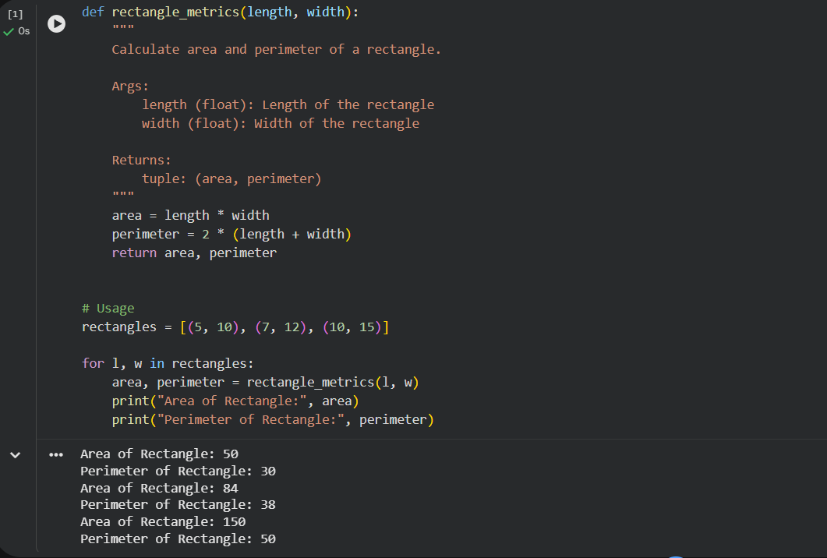
Observation:
Before Refactoring
- Same area and perimeter logic repeated multiple times.
- Difficult to maintain — any formula change must be updated in many places.
- Code length was unnecessarily large.
- Higher risk of human error.
After Refactoring
- Logic extracted into a single reusable function.
- Code became shorter and cleaner.
- Easy to maintain and extend.
- Improved modularity and scalability.

Task 2: Refactoring – Optimizing Loops and Conditionals
Objective
To improve performance by replacing inefficient nested loops with optimized
structures.
Task Description
Use AI to analyze and refactor a script that checks the presence of elements
using nested loops.
Starter (Legacy) Code
names = ["Alice", "Bob", "Charlie", "David"]
search_names = ["Charlie", "Eve", "Bob"]
for s in search_names:
found = False
for n in names:
if s == n:
found = True
if found:
print(f"{s} is in the list")
else:
print(f"{s} is not in the list")
Expected Outcome
• Optimized solution using set lookups or comprehensions
• Performance comparison before and after refactoring
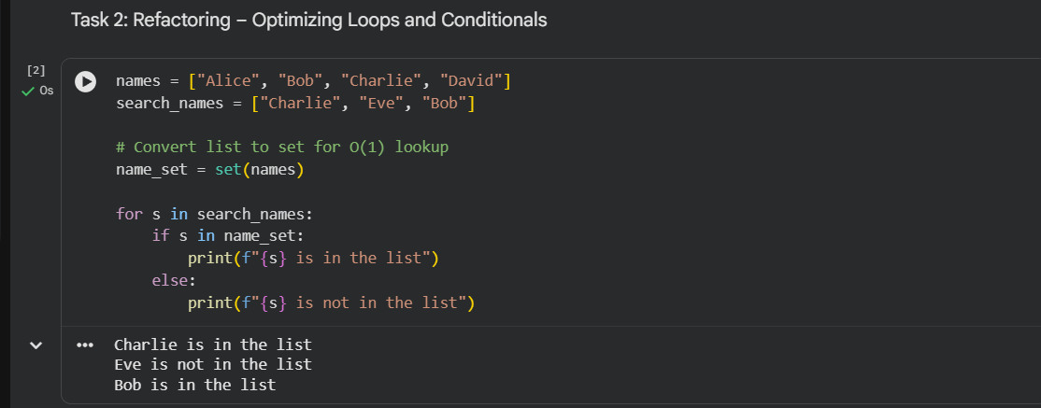
Comparison:
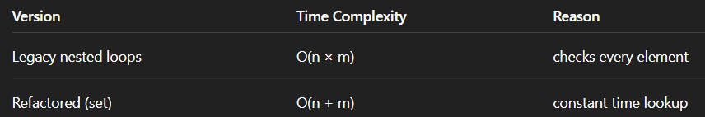
Observation:
Before Refactoring
- Used nested loops.
- Time complexity was O(n × m).
- Inefficient for large datasets.
- More comparisons performed than necessary.
After Refactoring
- Used a set for membership lookup.
- Time complexity improved to O(n + m).
- Code became more Pythonic and readable.
- Performance improved significantly for large inputs.

Task 3: Refactoring – Extracting Reusable Functions
Objective
To modularize code by extracting calculations into reusable functions.
Task Description
Refactor a legacy script where price and tax calculations are written inline.
Starter (Legacy) Code
price = 250
tax = price * 0.18
total = price + tax
print("Total Price:", total)
price = 500
tax = price * 0.18
total = price + tax
print("Total Price:", total)
Expected Outcome
• A function calculate_total(price)
• Cleaner and reusable code structure
• Proper documentation
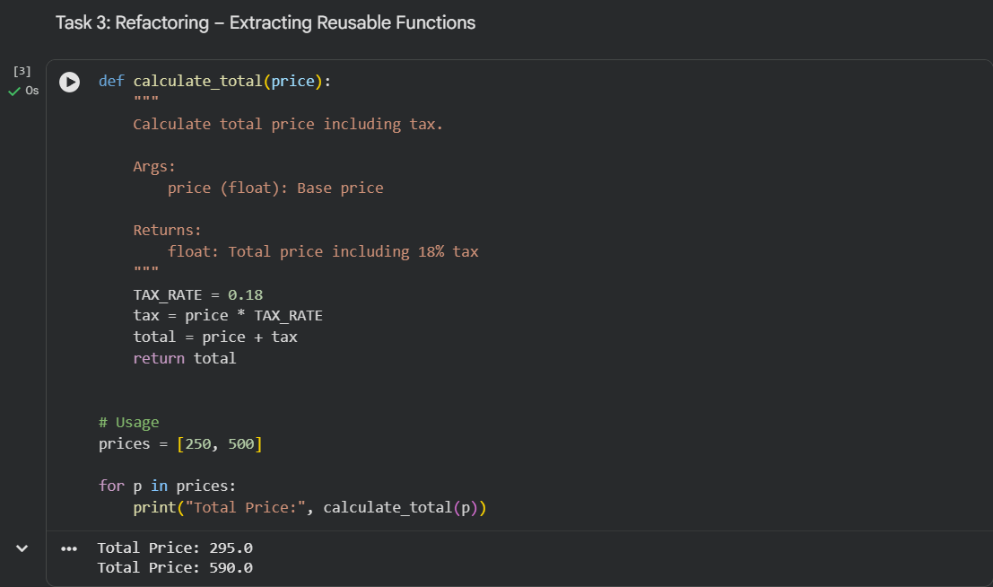
Observation:
Before Refactoring
- Tax calculation logic duplicated.
- Hard to update tax rate in multiple places.
- Poor modularity.
- Violates DRY principle.
After Refactoring
- Created reusable function calculate_total(price).
- Centralized tax logic.
- Easier updates and testing.
- Cleaner program structure.

Task 4: Refactoring – Replacing Hardcoded Values with Constants
Objective
To improve maintainability by replacing magic numbers with named constants.
Task Description
Use AI to identify hardcoded values and replace them with constants.
Starter (Legacy) Code
print("Area of Circle:", 3.14159 * (7 ** 2))
print("Circumference of Circle:", 2 * 3.14159 * 7)
Expected Outcome
• Constants such as PI and RADIUS
• Cleaner, maintainable code
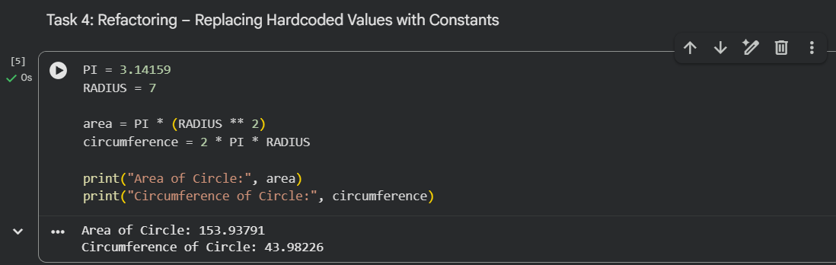
Observation:
Before Refactoring
- Magic numbers (3.14159 and 7) used directly.
- Poor readability.
- Difficult to update values.
- Risk of inconsistency.
After Refactoring
- Introduced named constants (PI, RADIUS).
- Code became self-explanatory.
- Easier future modifications.
- Improved maintainability.

Task 5: Refactoring – Improving Variable Naming and Readability
Objective
To enhance readability using descriptive variable names and comments.
Task Description
Refactor a script with unclear variable names.
Starter (Legacy) Code
a = 10
b = 20
c = a * b / 2
print(c)
Expected Outcome
• Descriptive variable names
• Inline comments explaining logic
• Identical output
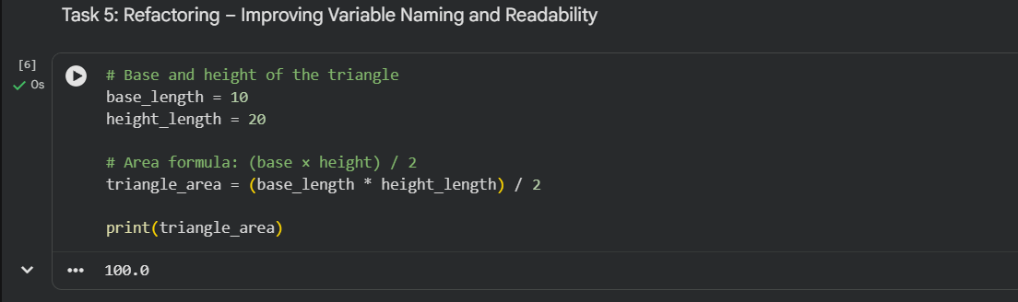
Observation:
Before Refactoring
- Variables a, b, c were unclear.
- Hard to understand program purpose.
- Poor code readability.
- Not suitable for team development.
After Refactoring
- Used descriptive names (base_length, height_length, triangle_area).
- Added inline comments.
- Logic became self-documenting.
- Output remained identical.

