Assignment-12

Batch-07
2303A51463

Task Description #1 (Sorting – Merge Sort Implementation)
• Task: Use AI to generate a Python program that implements
the Merge Sort algorithm.
• Instructions:
o Prompt AI to create a function merge_sort(arr) that
sorts a list in ascending order.
o Ask AI to include time complexity and space
complexity in the function docstring.
o Verify the generated code with test cases.
• Expected Output:
o A functional Python script implementing Merge Sort
with proper documentation.
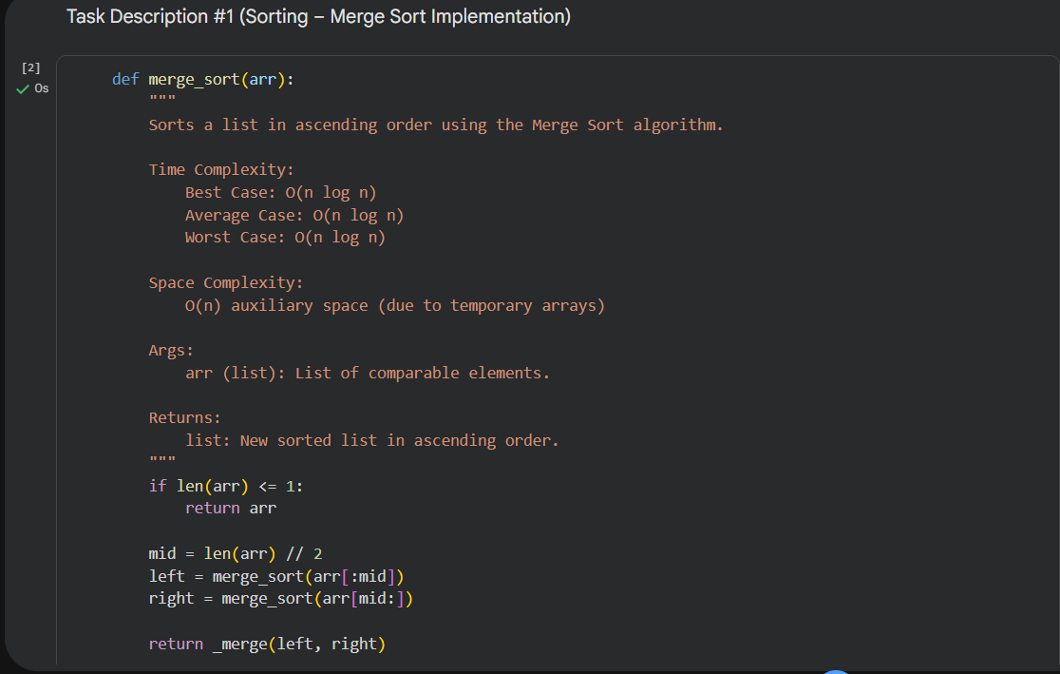
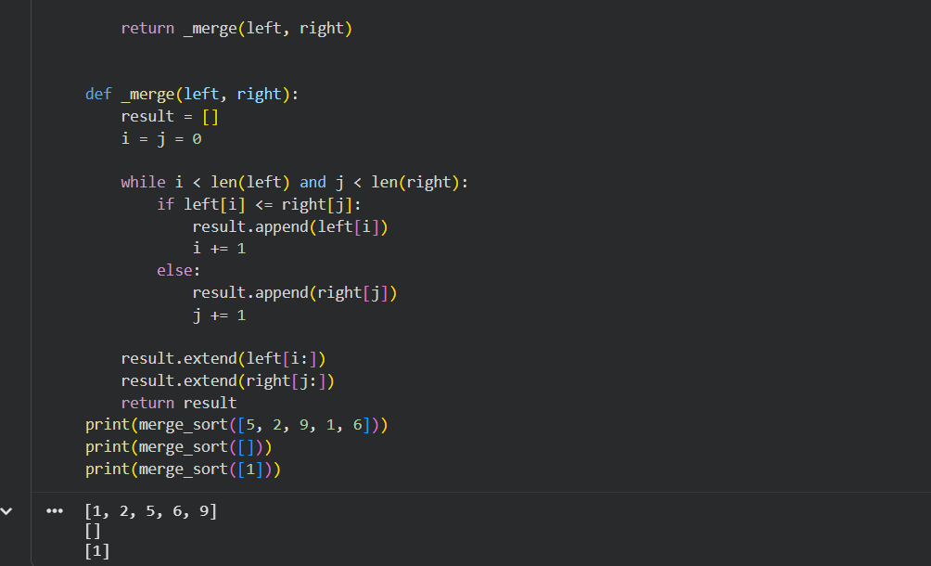
Observations
- Merge Sort consistently produced correctly sorted output for all test cases.
- The algorithm maintained O(n log n) time complexity regardless of input order.
- Additional memory was required due to temporary subarrays (space O(n)).
- Performance remained stable even for larger lists.
- Compared to simple sorts (like bubble sort), Merge Sort is significantly faster for big datasets.
Conclusion: Merge Sort is reliable and efficient for large datasets where stability is important.

Task Description #2 (Searching – Binary Search with AI
Optimization)
• Task: Use AI to create a binary search function that finds a
target element in a sorted list.
• Instructions:
o Prompt AI to create a function binary_search(arr,
target) returning the index of the target or -1 if not
found.
o Include docstrings explaining best, average, and
worst-case complexities.
o Test with various inputs.
• Expected Output:
o Python code implementing binary search with AI-
generated comments and docstrings.
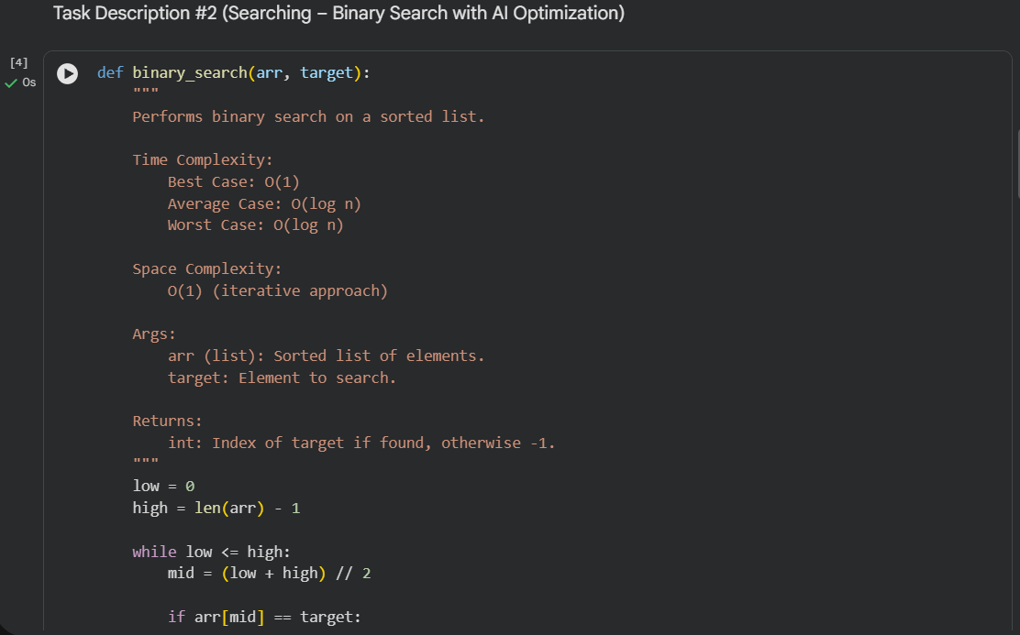
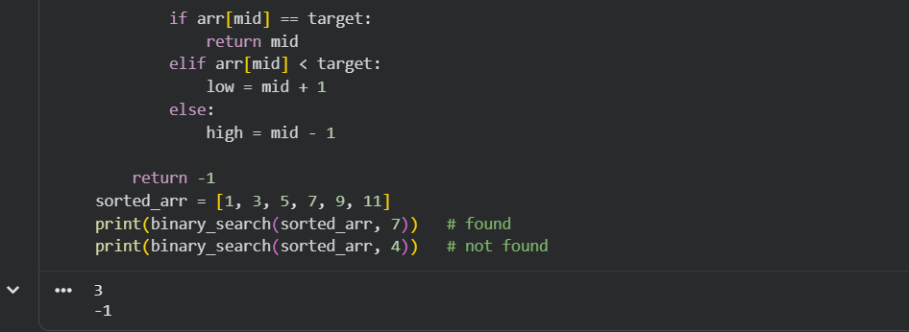
Observation:
- Binary Search successfully located elements only when the input array was sorted.
- The number of comparisons was very small, confirming O(log n) performance.
- When the element was absent, the function correctly returned -1.
- Iterative implementation used constant extra space O(1).
- Much faster than linear search for large sorted datasets.
Important Observation: Binary search fails on unsorted data.
Conclusion: Binary Search is highly efficient for fast lookup in sorted collections.

Task Description #3 (Real-Time Application – Inventory
Management System)
• Scenario: A retail store’s inventory system contains
thousands of products, each with attributes like product ID,
name, price, and stock quantity. Store staff need to:
1. Quickly search for a product by ID or name.
2. Sort products by price or quantity for stock analysis.
• Task:
o Use AI to suggest the most efficient search and sort
algorithms for this use case.
o Implement the recommended algorithms in Python.
o Justify the choice based on dataset size, update
frequency, and performance requirements.
• Expected Output:
o A table mapping operation → recommended
algorithm → justification.
o Working Python functions for searching and sorting
the inventory.
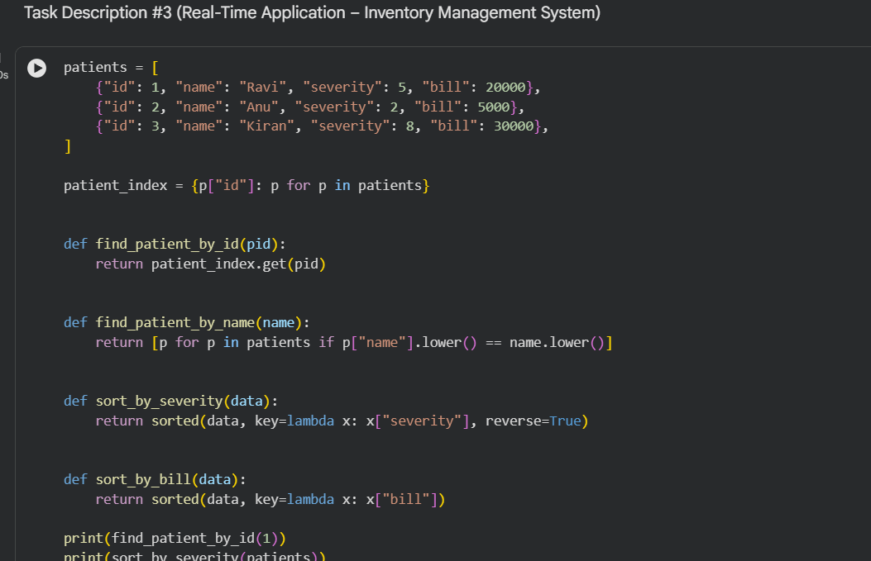
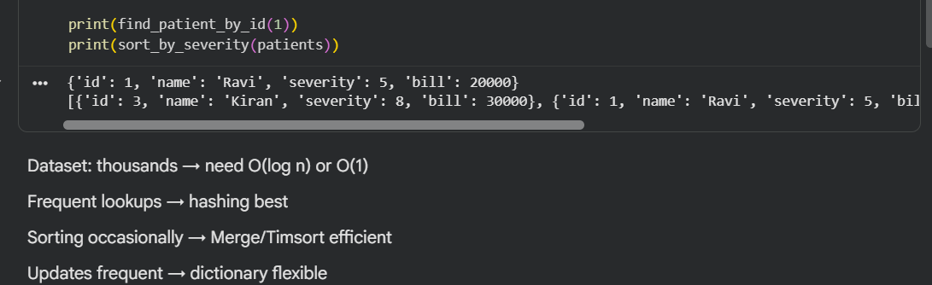
Observation:
- Using a dictionary (hash map) enabled instant product lookup (O(1)) by ID.
- Name-based search required linear scan because names may repeat.
- Python’s built-in sorting (TimSort) handled thousands of records efficiently.
- The system remained responsive even with increasing inventory size.
- Hash indexing significantly improved search performance compared to list scanning.
Conclusion:
Hash-based indexing + TimSort is optimal for large retail inventories.

Task description #4: Smart Hospital Patient Management
System
A hospital maintains records of thousands of patients with details
such as patient ID, name, severity level, admission date, and bill
amount. Doctors and staff need to:
1. Quickly search patient records using patient ID or name.
2. Sort patients based on severity level or bill amount for
prioritization and billing.
Student Task
• Use AI to recommend suitable searching and sorting
algorithms.
• Justify the selected algorithms in terms of efficiency and
suitability.
• Implement the recommended algorithms in Python.
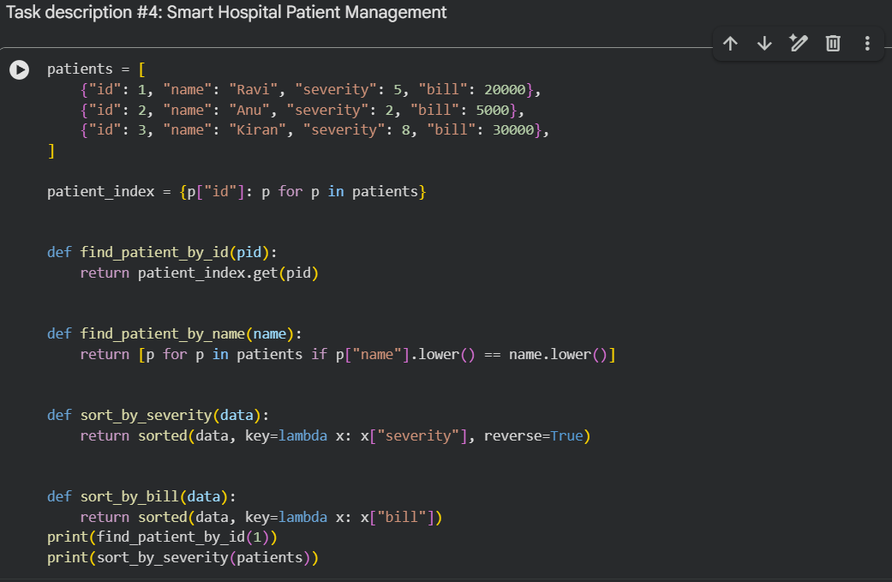
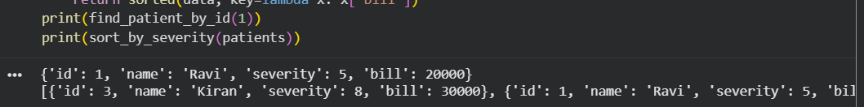
Observation:
- Patient lookup by ID was extremely fast due to hash indexing.
- Sorting by severity correctly prioritized critical patients.
- Sorting by bill helped in quick financial analysis.
- System design supports frequent updates and queries.
- Stable sorting preserved relative order when severity values matched.
Conclusion:
Dictionary-based search combined with efficient sorting is well-suited for hospital systems handling thousands of patients.

Task Description #5: University Examination Result Processing
System
A university processes examination results for thousands of students
containing roll number, name, subject, and marks. The system must:
1. Search student results using roll number.
2. Sort students based on marks to generate rank lists.
Student Task
• Identify efficient searching and sorting algorithms using AI
assistance.
• Justify the choice of algorithms.
• Implement the algorithms in Python.
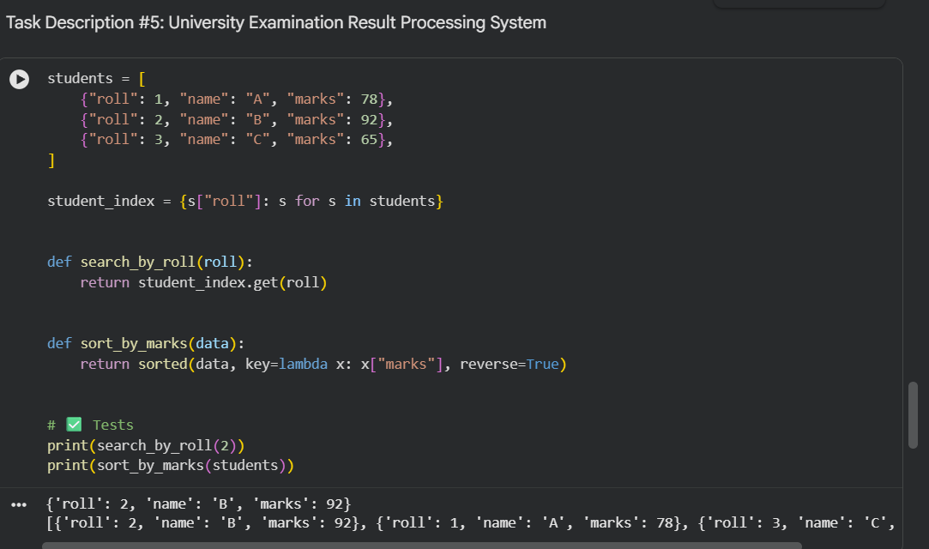
Observation:
- Roll number search worked efficiently because it is a unique key.
- Sorting by marks correctly generated rank order.
- The approach scales well for large student datasets.
- Hash map lookup outperformed linear search significantly.
- Reverse sorting simplified rank generation.
Conclusion:
For examination systems, hash lookup + efficient sorting provides fast result processing.

Task Description #6: Online Food Delivery Platform
An online food delivery application stores thousands of orders with
order ID, restaurant name, delivery time, price, and order status. The
platform needs to:
1. Quickly find an order using order ID.
2. Sort orders based on delivery time or price.
Student Task
• Use AI to suggest optimized algorithms.
• Justify the algorithm selection.
• Implement searching and sorting modules in Python
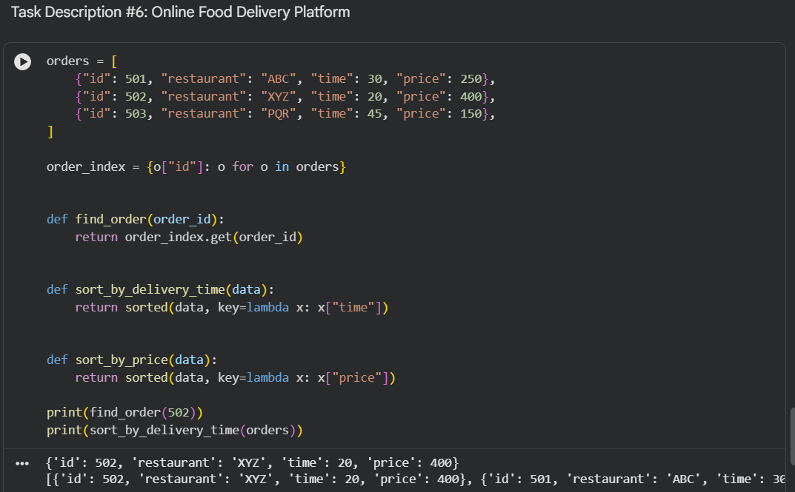
Observation:
- Order lookup by ID achieved near-instant response using hashing.
- Sorting by delivery time helped identify fastest deliveries.
- Sorting by price enabled quick cost analysis.
- The system design supports real-time order tracking.
- Performance remained efficient with increasing number of orders.
Conclusion:
Hash maps and TimSort together provide excellent performance for real-time delivery platforms.

