# 19-03-25

## What is DAM and Why Do We Use It?

DAM (Digital Asset Management) in AEM is used to store and manage digital assets such as images, videos, and documents. It provides versioning, metadata management, and easy retrieval for content authors.

## Create a Folder and Upload Images

1. Navigate to `/content/dam/myTraining/us/en-us` in AEM.  
2. Create a folder inside this path.  
3. Upload two images.  
4. Use the Image component to add these images to a page.

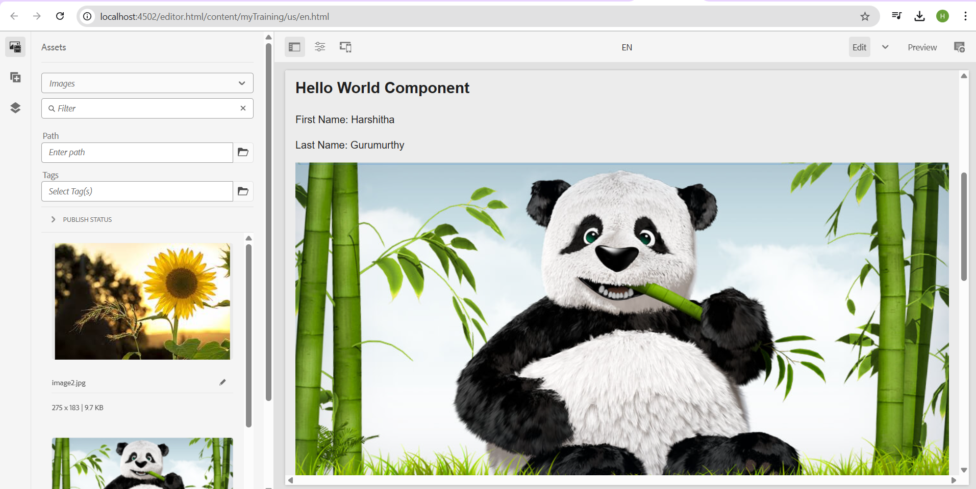

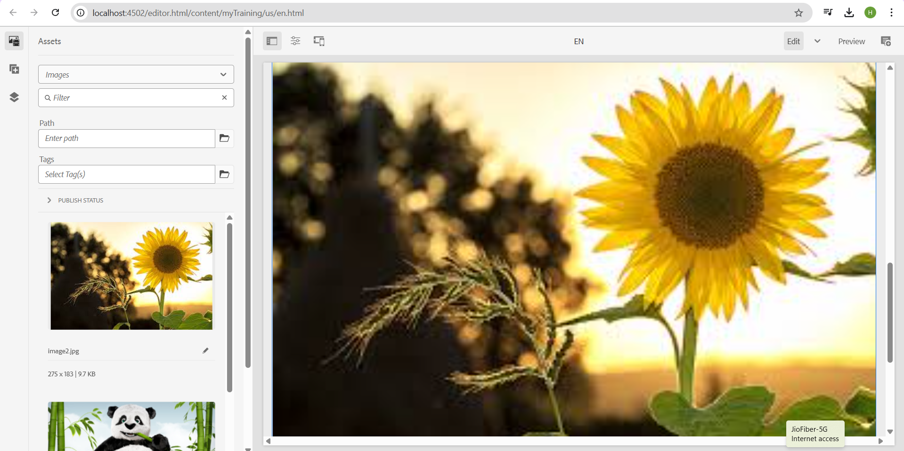

## What is Renditions?

Renditions in AEM are different variations of an image generated automatically when an image is uploaded to DAM. They help optimize image delivery for different screen sizes and devices.

## Check Renditions for Uploaded Images

1. Go to the uploaded image in DAM.  
2. Click on the image and navigate to the 'Renditions' tab to see available versions.

## Add Fields in HelloWorld Component

Modify the HelloWorld component to include two new fields:  
- `FirstName`  
- `LastName`  
Display these values in “HelloWorld.html” using properties.

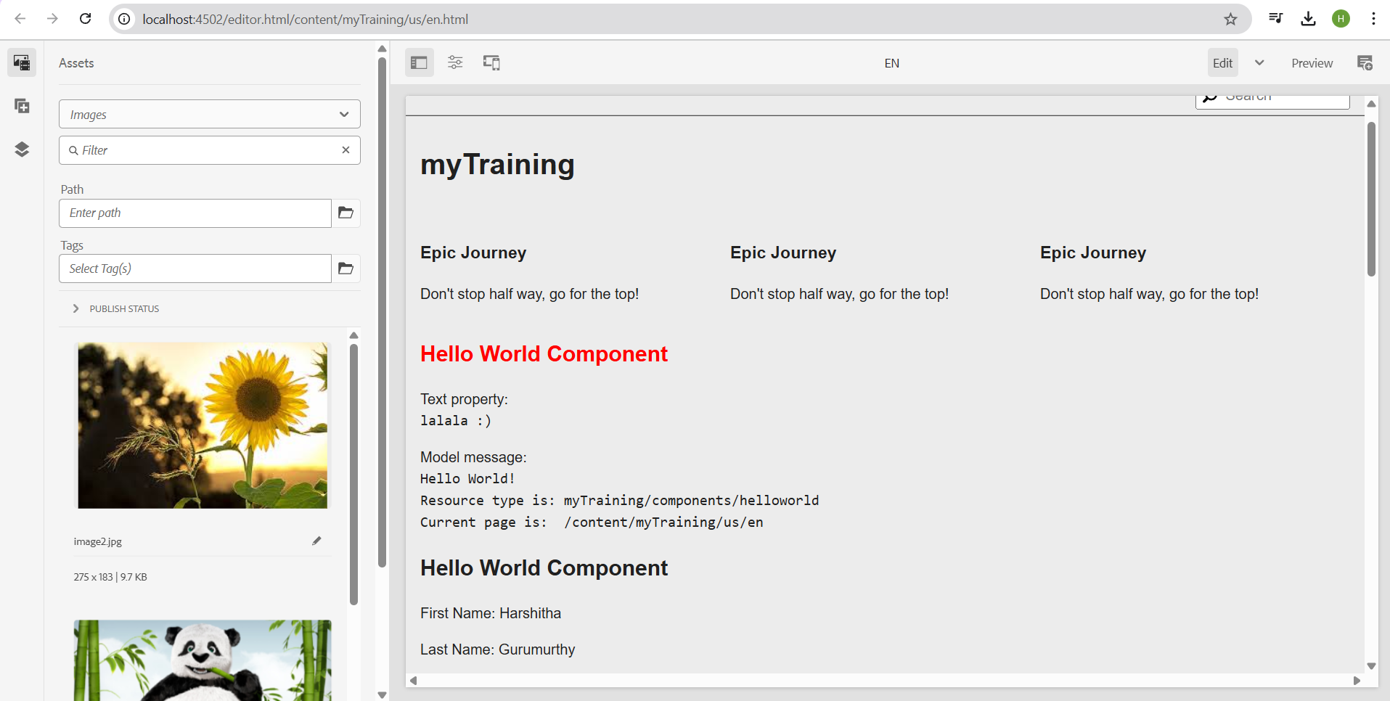

## Use @ValueMapValue in HelloWorldModel

Modify the Sling Model `com.myTraining.core.models.HelloWorldModel` to use `@ValueMapValue` for fetching the FirstName and LastName values.

## Why Use Package Manager?

The Package Manager in AEM is used to create, install, and distribute content packages. It helps in deploying components, assets, and configurations across environments.

## Create Packages

1. Create two packages:  
- One package for DAM (including the two uploaded images).  
- One package for the HelloWorld component.

## Configure Replication Agent & Publish Page

1. Configure the replication agent in AEM.  
2. Publish the page from the Author instance (`4502`) to the Publish instance (`4503`).