# Implementing AEM Servlets for Page Creation and Search

## 1. Introduction

This document provides a step-by-step guide for implementing three servlets in Adobe Experience Manager (AEM):

- `SampleServlet` using `SlingAllMethodsServlet` registered via `resourceType`

- `CreatePageServlet` using `SlingSafeMethodsServlet` registered via `path`

- `SearchServlet` utilizing `PredicateMap` for searching content

## 2. Prerequisites

- AEM instance running

- Knowledge of Java and AEM development

- AEM Project setup using Maven

- Access to CRXDE and AEM’s OSGi configuration

## 3. Creating SampleServlet

This servlet extends `SlingAllMethodsServlet` and is registered using `resourceType`.

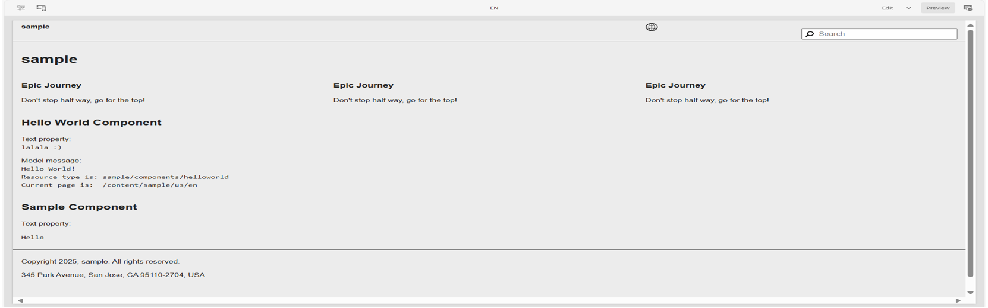

### 3.1 Code Implementation

@Component(  
 service = Servlet.class,  
 property = {  
 "sling.servlet.resourceTypes=myproject/components/sample",  
 "sling.servlet.methods=GET"  
 }  
)  
public class SampleServlet extends SlingAllMethodsServlet {  
 @Override  
 protected void doGet(SlingHttpServletRequest request, SlingHttpServletResponse response)  
 throws ServletException, IOException {  
 response.getWriter().write("Sample Servlet Executed");  
 }  
}

## 4. Creating CreatePageServlet

This servlet extends `SlingSafeMethodsServlet` and creates pages dynamically.

### 4.1 Code Implementation

@Component(  
 service = Servlet.class,  
 property = {  
 "sling.servlet.paths=/bin/createpage",  
 "sling.servlet.methods=GET"  
 }  
)  
public class CreatePageServlet extends SlingSafeMethodsServlet {  
 @Override  
 protected void doGet(SlingHttpServletRequest request, SlingHttpServletResponse response)  
 throws ServletException, IOException {  
 String pageName = request.getParameter("name");  
 if (pageName == null || pageName.isEmpty()) {  
 response.getWriter().write("Invalid page name");  
 return;  
 }  
 PageManager pageManager = request.getResourceResolver().adaptTo(PageManager.class);  
 if (pageManager != null) {  
 try {  
 Page newPage = pageManager.create("/content/myproject", pageName, "myproject/templates/basic", pageName);  
 response.getWriter().write("Page Created: " + newPage.getPath());  
 } catch (WCMException e) {  
 response.getWriter().write("Error creating page: " + e.getMessage());  
 }  
 }  
 }  
}

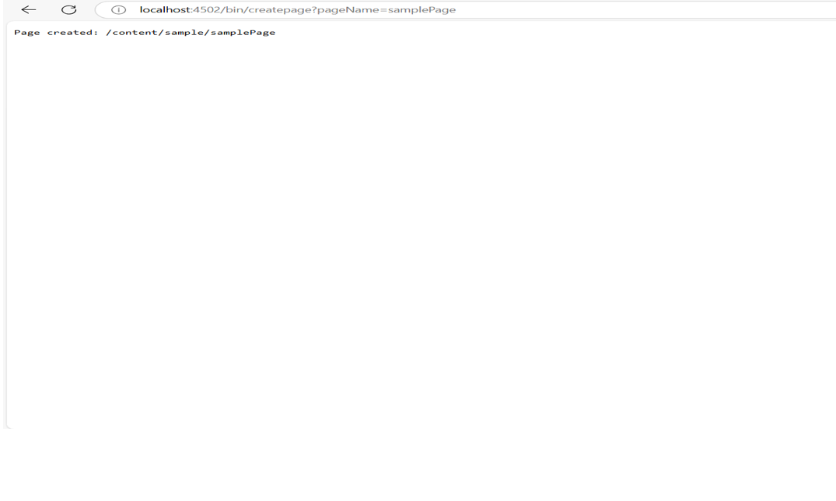

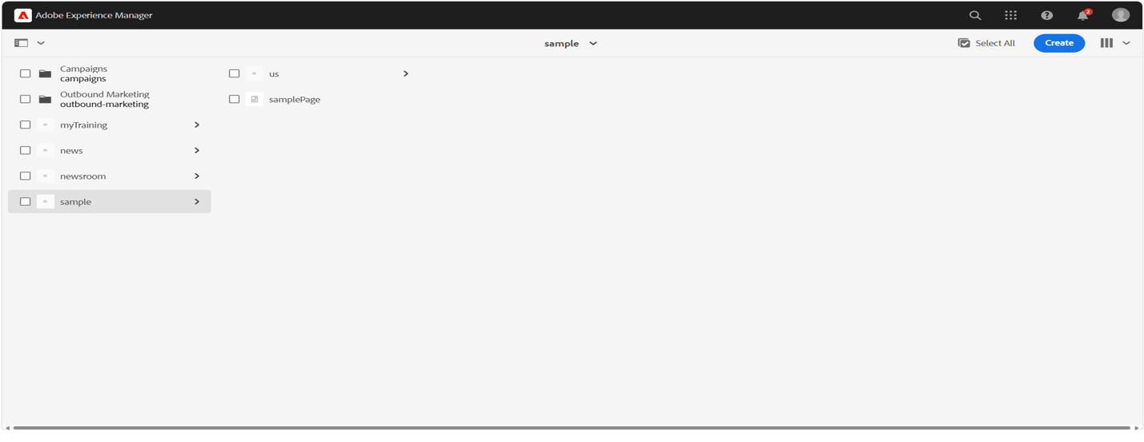

## 5. Creating SearchServlet

This servlet uses `PredicateMap` to search content.

### 5.1 Code Implementation

@Component(  
 service = Servlet.class,  
 property = {  
 "sling.servlet.paths=/bin/searchcontent",  
 "sling.servlet.methods=GET"  
 }  
)  
public class SearchServlet extends SlingSafeMethodsServlet {  
 @Reference  
 private QueryBuilder queryBuilder;  
  
 @Override  
 protected void doGet(SlingHttpServletRequest request, SlingHttpServletResponse response) throws IOException {  
 String searchText = request.getParameter("query");  
 if (searchText == null || searchText.isEmpty()) {  
 response.getWriter().write("Invalid search query");  
 return;  
 }  
 Map<String, String> predicates = new HashMap<>();  
 predicates.put("path", "/content");  
 predicates.put("type", "cq:Page");  
 predicates.put("fulltext", searchText);  
 Query query = queryBuilder.createQuery(PredicateGroup.create(predicates), request.getResourceResolver().adaptTo(Session.class));  
 Result result = query.getResult();  
 response.getWriter().write("Found " + result.getHits().size() + " results");  
 }  
}

