E-Commerce-Performance-Analysis

QUERY AND SCREENSHOTS OF ANALYSIS

1. Top 10 best-selling product categories by number of orders
SELECT product_category_name, COUNT(DISTINCT order_id) AS Total_orders
FROM df_OrderItems
JOIN df_Products ON df_Products.product_id = df_OrderItems.product_id
GROUP BY product_category_name
ORDER BY Total_orders DESC
LIMIT 10;
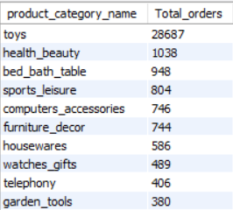

2. Top 10 categories by total revenue
SELECT product_category_name, ROUND(SUM(payment_value),2) AS total_revenue FROM df_Payments
INNER JOIN df_OrderItems ON df_OrderItems.order_id = df_Payments.order_id
INNER JOIN df_Products ON df_Products.product_id = df_OrderItems.product_id
GROUP BY product_category_name
ORDER BY total_revenue DESC
LIMIT 10;
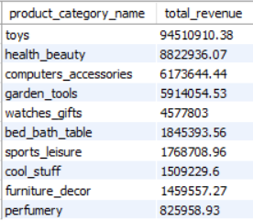

3. Which categories have high order count but low revenue (or vice versa)?
SELECT product_category_name,
COUNT(DISTINCT df_OrderItems.order_id) AS total_orders,
ROUND(SUM(payment_value), 2) AS total_revenue,
ROUND(SUM(payment_value)/COUNT(DISTINCT df_OrderItems.order_id), 2) AS avg_revenue_per_order
FROM df_Payments
INNER JOIN df_OrderItems ON df_OrderItems.order_id = df_Payments.order_id
INNER JOIN df_Products ON df_Products.product_id = df_OrderItems.product_id
GROUP BY product_category_name
ORDER BY avg_revenue_per_order ASC
LIMIT 10;
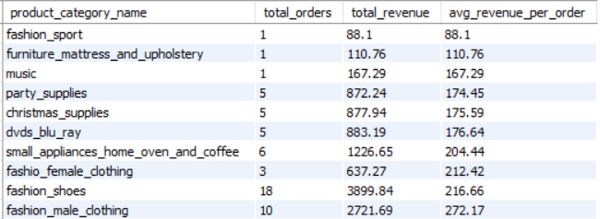
4. Which product categories have the highest average shipping cost?
SELECT product_category_name,
ROUND(AVG(shipping_charges), 2) AS avg_shipping_cost
FROM df_OrderItems
JOIN df_Products ON df_Products.product_id = df_OrderItems.product_id
GROUP By product_category_name
ORDER BY avg_shipping_cost DESC
LIMIT 10;
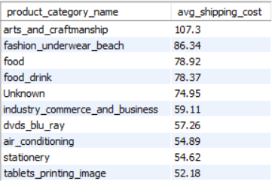

5. For which categories does shipping cost exceed 50% of product price?
SELECT product_category_name,
ROUND(AVG(shipping_charges),2) AS avg_shipping_cost,
ROUND(AVG(price),2) AS avg_price
FROM df_OrderItems
JOIN df_Products ON df_Products.product_id = df_OrderItems.product_id
GROUP BY product_category_name
HAVING AVG(shipping_charges) > AVG(price) * 0.5;

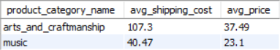
6. Revenue breakdown by payment type
SELECT payment_type, ROUND(SUM(payment_value),2) AS total_revenue
FROM df_Payments
GROUP BY payment_type;
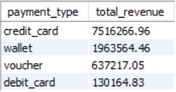

7. Average order value by payment type
SELECT payment_type, ROUND(SUM(payment_value)/COUNT(DISTINCT order_id),2) AS avg_order_value
FROM df_Payments
GROUP BY payment_type;
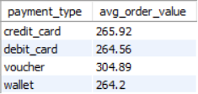

8. Credit card users: distribution of installment counts — are people mostly paying in 1 instalment or splitting into 6+?
SELECT payment_type, payment_installments, COUNT(df_Payments.order_id) AS total_orders
FROM df_Payments
WHERE payment_type = 'credit_card'
GROUP BY payment_installments
ORDER BY payment_installments ASC;

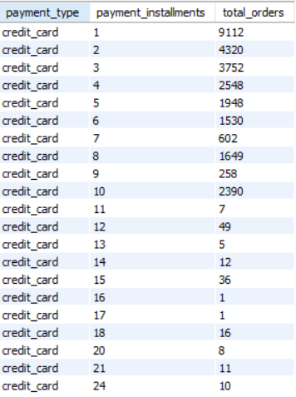

9. Do repeat customers (same customer_id appearing in multiple orders) spend more per order than one-time buyers?

SELECT
CASE
WHEN total_orders = 1 THEN 'One-time buyer'
ELSE 'Repeat customer'
END AS customer_type,
ROUND(AVG(avg_order_value), 2) AS avg_spending,
COUNT(customer_id) AS total_customers
FROM (SELECT df_Customers.customer_id,
COUNT(df_Orders.order_id) as total_orders,
ROUND(AVG(price),2) AS avg_order_value
FROM df_Customers
INNER JOIN df_Orders ON df_Orders.customer_id = df_Customers.customer_id
INNER JOIN df_OrderItems ON df_Orders.order_id = df_OrderItems.order_id
GROUP BY df_Customers.customer_id
) AS customer_summary
GROUP BY customer_type;

