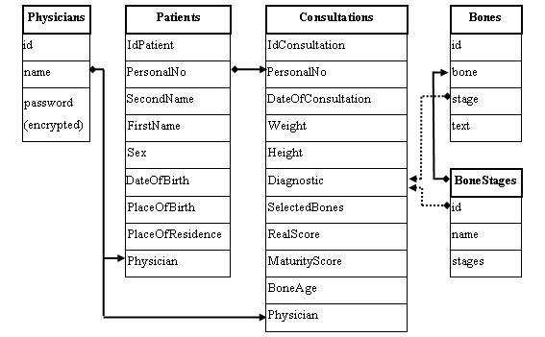

Queries to create Database and Tables.

Create Database HarshithaCARE;
Use Database HarshithaCARE;

Create table Physicians(Id int(10) NOT NULL, Name varchar(30) , Password varchar(20),Primary key(Name));

Create table Patients(IdPatient int(10) NOT NULL, PersonalNo int(10)NOT NULL, SecondName varchar(20),FirstName varchar(20) NOT NULL,Sex varchar(6),DateOfBirth DATE,PlaceOfBirth varchar(40),PlaceOfResidence varchar(50),Physician varchar(30),primary key(PersonalNo),Foreign key(Physician) references Physicians(Name));

Creteate table Consultations(IdConsultation int(10) NOT NULL,PersonalNo int(10),DateOfConsultation DATE,Weight int(4),Height int(4),Diagnostic varchar(40),Selected Bones varchar(40),RealScore int(11),MaturityScore int(11),BoneAge varchar(10),Physician varchar(30),primary key(IdConsultation),foreign key(PersonalNo) references Patients(PersonalNo),Foreign key(Physician) references Physicians(Name));

Create table Bonestages(Id int(10), Name varchar(30),Stages varchar(30),primary key(Id));

Create table Bones(Id int(10),Bone int(10),Stage varchar(20),Text varchar(50),Primary key(Id),Foreign key(Bone) references Bonestages(Id));

