**Project Title**

**Dior Fashion Brand Stock data Visualization**

**Team Members**

1. **Name :** Harshitha Kolli

**St id :** 11521716

**Mail id:** [harshithakolli@my.unt.edu](mailto:harshithakolli@my.unt.edu)

1. **Name :** Gowthami Mulpuri

**St id :** 11600593

**Mail id:** [gowthamimulpuri@my.unt.edu](mailto:gowthamimulpuri@my.unt.edu)

1. **Name :** Naga Tulasi Parvathi Veerla

**St id :** 11626471

**Mail id:** [NagaTulasiParvathiVeerla@my.unt.edu](mailto:NagaTulasiParvathiVeerla@my.unt.edu)

**Goals and Objectives:**

"Others' thought process" has forever been a significant snippet of data for the vast majority of us while deciding. The Web and the Internet have out of nowhere made it conceivable to find out about the viewpoints and encounters of people who are neither our own associates nor notable expert pundits that is, individuals we have never known about. Thusly, a rising number of individuals are spreading the word about their perspectives for outsiders over the Web. Individual shoppers' advantage in web-based suppositions with respect to items and administrations, as well as the potential impact such conclusions have, is a main impetus behind this field of study. What's more, there are different issues engaged with this cycle that should be survived. to be stomped on to accomplish the ideal outcomes We directed this study to essential philosophy that ordinarily happens in this system and activities that are to be taken be taken to address the troubles experienced

**Motivation**

**Objective**

Organizations are basically worried about client fulfillment and item surveys. Changes in web-based entertainment temperament have been exhibited to compare with changes in securities exchanges. Distinguishing and settling client protests increments client bliss and an association's reliability. Thus, an unprejudiced mechanized technique is expected to characterize client surveys about any worry. In the current climate, when we are generally experiencing information over-burden (albeit this does not imply better or more significant bits of knowledge), organizations may have accumulated mountains of customer feedback. yet it is still difficult for typical people to break down it physically without mistake or predisposition. Organizations with the best goals are habitually caught in a data vacuum. You know that you expect experiences to direct your navigation, and while you are aware of your lack of them, you are unsure of how to remedy the situation. Opinion research gives some understanding into the main worries, basically from the stance of clients. Since opinion examination might be mechanized, decisions can be founded on a lot of information as opposed to unadulterated instinct.

**objective**

Time Series estimating and displaying is basic in information examination. Time series examination is a subset of measurements that is broadly utilized in subjects, for example, econometrics and tasks research. Time series are generally used in examination and information science. Stock costs are variable, and their still up in the air by various elements. This undertaking's primary objective is to estimate stock qualities using long transient memory (LSTM).

**Related Work (Background)**

**Using machine learning, predict stock market movements**

The exam work was completed by V Kranthi Sai Reddy, a student at the Sreenidhi Foundation for Science and Innovation and an ECM.

Hyderabad is a city in India. Global stock trading is one of the most important financial developments. Securities exchange estimating is the practice of trying to project the future value of a company's stock or other financial product traded inside a transaction involving money. This paper explains how to use AI to forecast a stock. When making stock forecasts, the majority of stockbrokers use specialized, major, or time assortment investigation. Python is the programming language that will be utilized to implement the framework that will rule the stock commercial center. We suggest an AI (ML) approach in this investigation. The precise projection is then made using the readily available offers data and benefit knowledge. This quick look makes use of a framework in this circumstance. Utilizing costs with daily and modern frequencies, the Help Vector Machine (SVM) method is used to calculate stock costs for large and small capitalizations within the three specific business sectors.

**Stock Market Index Prediction Using Artificial Intelligence Methods**

Ronald Lufuno Marwala oversaw the study. a paper submitted to the Personnel of Designing and the Constructed Climate at the College of the Witwatersrand in Johannesburg in fulfillment of the requirements for the Expert of Science in Science certificate. The frail type of the Proficient Market Speculation (EMH) attests that estimating the future cost of a resource in light of information contained in authentic costs of a resource is unthinkable. This demonstrates that the market performs like an irregular walk, making estimating inconceivable. Besides, because of the intrinsic intricacy of the monetary framework, monetary determining is a difficult endeavor. The objective of this work was to demonstrate and expect the future cost of utilizing man-made consciousness (computer based intelligence) innovation. a statement of the transaction Three artificial reasoning methods—brain networks (NN), fully convolutional machines, and central nervous system frameworks—are used to forecast the future cost of a capital market file based on past cost data. Man-made reasoning procedures are used as tools for forecasting financial time series and can depict the complexities of financial frameworks.

**Dataset**

Dior Stock Information Xls file

Parameters Like Open, Close, High, Low,BrandName,Volume

**Detail design of Features**

**Component Of System**

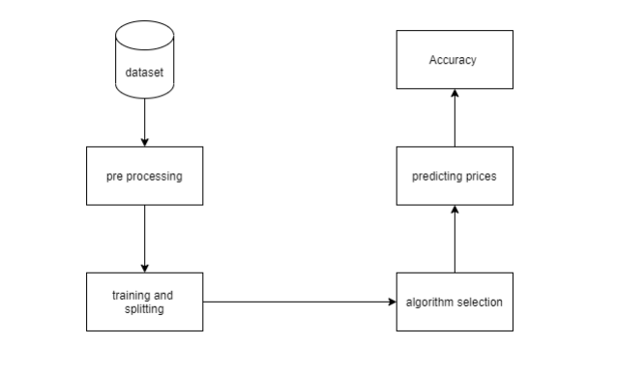

A part graph is a sort of chart in UML. The objective is likewise particular from the past charts talked about. It doesn't characterize the framework's usefulness, however it portrays the parts that empower such capabilities.

Part graphs are utilized for picturing, portraying, and archiving part based frameworks, as well as creating executable frameworks through forward and picking apart. Part graphs are basically class charts that emphasis on a framework's parts and are regularly used to portray a framework's static execution viewpoint.

**Architecture**

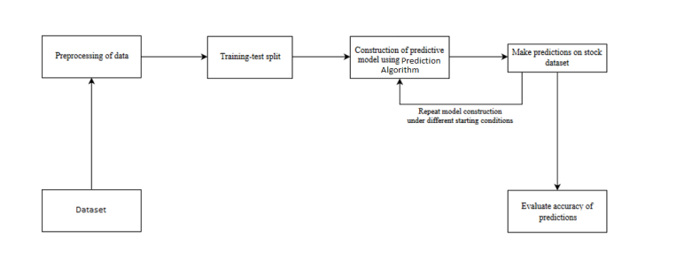

**Analysis**

The monetary market is a dynamic and complex framework where anybody can trade monetary forms, stocks, offers, and subsidiaries through virtual stages worked with by merchants. The securities exchange permits financial backers to buy portions of public firms through trade or over-the-counter exchanging. This market has furnished financial backers with the potential chance to bring in cash and carry on with a prosperous life by putting away little amounts of cash at an okay contrasted with the gamble of beginning another business or the need for a lucrative work. Many variables impact securities exchanges, bringing about market vulnerability and extreme instability. Robotized trading systems (ATS) run on computer programming, despite the fact that individuals can accept orders and send them to the market. Projects can handle orders quicker and more precisely than individuals. Nonetheless, to assess and deal with the presentation of ATSs, risk the board frameworks, and human-based wellbeing measures are undeniably required. Many variables are integrated and thought about while fostering an ATS, for example, the exchanging methodology to be utilized, complex numerical capabilities that mirror the condition of a particular stock, AI calculations that empower future stock worth expectation, and explicit news connected with the stock being broke down.

**System configuration**

This task might be run on standard equipment. We ran the whole task on an Intel I5 processor with 8 GB Slam and a 2 GB Nvidia Realistic Processor. It likewise has two centers that run at 1.7 GHz and 2.1 GHz. The main portion of the interaction is the preparation stage, which requires around 10-15 minutes, and the subsequent part is the trying stage, which simply requires a couple of moments to create expectations and compute exactness.

**Hardware Requirements:**

• Slam: 4 GB

• Capacity: 500 GB

• Computer processor: 2 GHz or quicker

• Engineering: 32-cycle or 64-bit

Programming prerequisites

• Python 3.5 in Google Collab is utilized for information pre-handling, model preparation and expectation.

**Software requirements**

Python 3.5 in Google Collab is utilized for information pre-handling, model preparation and expectation.

• Working Framework: windows 7 or more or Linux based operating system or Macintosh operating system.

**Implementation**

Information perception is the discipline of endeavoring to comprehend information by showing it in a visual setting to feature examples, patterns, and associations that could somehow go undetected.

Python has various incredible charting bundles that are jam-loaded with valuable usefulness. Python gives an incredible library to making dynamic or profoundly adaptable diagrams.

To get a little outline, the following are a couple of famous plotting libraries:

* **Matplotlib** easy to use and offers loads of flexibility
* **Seaborn** has a high-level interface and excellent preset styles.
* **Pandas Visualization** has an intuitive interface and is based on Matplotlib.
* **Plotnine** built on ggplot2 in R and employs Grammar of Graphics
* **Plotly** enables the creation of interactive plots

**Scatter Plot**

The dissipate strategy in Matplotlib can be utilized to make a disperse plot. We will likewise utilize plt.subplots to construct a figure and a pivot to give our plot a title and marks.

**Histogram**

Involving the hist strategy in Matplotlib, we can produce a Histogram. On the off chance that we supply absolute information, for example, the wine-survey dataset's focuses section, it will consequently ascertain how often each class shows up.

**Graph with Bars**

The bar strategy can be utilized to produce a bar diagram. Since the bar outline doesn't work out the recurrence of a classification naturally, we will use the pandas esteem counts technique to achieve so. The bar outline is helpful for unmitigated information with less than 30 distinct classifications, however it can turn out to be genuinely muddled in any case.

**Box and whisker plots of time series by interval**

Histograms and thickness plots uncover the conveyance of all information, however we could be more intrigued by the appropriation of values per time stretch.

The case and stubble plot is one more type of figure that can be utilized to sum up the appropriation of perceptions. This realistic structures a container around the information's 25th and 75th percentiles, catching the center half of perceptions. To address the wide degrees of the information, a line is drawn at the 50th percentile (the middle), and hairs are drawn above and beneath the container. Exceptions outside the information's hairs or degrees are set apart with specks.

For every span, box and stubble plots can be made and differentiated. in a period series, like years, months, or days.

**Python Heatmaps Practical Python Data Science**

For each worth to be plotted, a heatmap has values demonstrating a few shades of a similar variety. The hazier tones of the graph ordinarily address higher qualities than the lighter shades. Something else entirely can moreover be used for an essentially unique worth.

**Violin plot**

A violin plot works much the same way to a case and stubble plot. It portrays the dispersion of quantitative information across many degrees of (at least one) class variable, permitting those appropriations can measure up.

**Preliminary Results**

Using the.plot extension from Pandas dataframes is the first way we can plot data. This will be used to create a scatterplot of the features of the Dior stock.

The Seaborn Library can be used to create a similar narrative as well.

Bivariate scatterplots and univariate histograms for High and Low are displayed in the same figure by a seaborn jointplot.

We can also use the heatmap for co-relation matrix

The Seaborn Library can be used to create a similar narrative as well.

Bivariate scatterplots and univariate histograms for open and close are displayed in the same figure by a seaborn jointplot.

To color the scatterplot according to Symbol, we'll use Seaborn's FacetGrid.

We can look at the histogram subplots

We can look at an individual feature in Seaborn through a boxplot

In Seaborn's striplot, we can add a layer of distinct points on top of this plot to make it longer. To prevent all of the points from falling into a single vertical line, we'll use jitter=True. The plot is displayed on top of the previous axes when the resultant axes are saved as ax each time.

The advantages of the previous two plots are combined and simplified in a violin plot. In a violin plot, denser regions of the data are fatter and more sparse regions are thinner.

The kdeplot, which constructs and visualizes a kernel density estimate of the underlying feature, is a final Seaborn plot that is helpful for examining univariate relations.

The pairplot, which displays the bivariate relationship between each pair of features, is another helpful seaborn plot.

In a pairplot, the diagonal elements by default display the histogram; however, by updating the elements, we can display other things, like a kde.

Here we have enumerated the columns present in the list with scatter subplots

Let's return to some of the ones we can with Pandas now that we've discussed seaborn. On each feature divided up by Symbol, we can quickly create a boxplot using pandas.

**Project Management**

**Implementation status report**

**Work completed:**

|  |  |  |
| --- | --- | --- |
| **Description/Task** | **Responsibility - Person** | **Contributions - percentage** |
| Data Read and Preprocessing | Harshitha Kolli | 34% |
| Data Analysis | Gowthami Mulpuri | 33% |
| Analysis | Naga Tulasi Parvathi Veerla | 33% |

**Work to be completed:**

|  |  |  |  |
| --- | --- | --- | --- |
| **Description** | **Responsibility - Task** | **Responsibility - Person** | **Issues/ Concerns** |
| LSTM | Implementation of the Long short-term memory algorithm | Harshitha Kolli  Gowthami Mulpuri | Implementing is harder |
| Result Analysis | Analyzing the outcomes | Naga Tulasi Parvathi Veerla | No concerns |
|  |  |  |  |

**Github Link**

[**https://github.com/HarshithaKolli98/DIOR**](https://github.com/HarshithaKolli98/DIOR)

**References/Bibliography**

[1] Achyut Ghosh, Soumik Bose1, GiridharMaji, Narayan C. Debnath, Soumya Sen, Stock Price Prediction Using LSTM on Indian Share Market

<https://easychair.org/publications/paper/LKgn>

[2] S. Selvin, R. Vinayakumar, E. A. Gopalkrishnan, V. K. Menon, and K. P. Soman - Stock price prediction based on LSTM, RNN, and CNN-sliding window models - 2017.

<https://www.researchgate.net/publication/321503983_Stock_price_prediction_using_LSTM_RNN_and_CNN-sliding_window_model>

[3] Murtaza Roondiwala, Harshal Patel, and Shraddha Varma, "Predicting Stock Prices Using LSTM," Department of Information Technology, Mumbai University, 2015.

<https://www.researchgate.net/publication/327967988_Predicting_Stock_Prices_Using_LSTM>

[4] Xiongwen Pang, Yanqiang Zhou, Pan Wang, and Weiwei Lin, "A novel neural network technique for stock market forecasting," 2018.

<https://www.researchgate.net/publication/221543550_A_Novel_Adaptive_Learning_Algorithm_for_Stock_Market_Prediction>

[5] Navanshu Agarwal, Sheirsh Saxena, Ridam Arora, Shikhin Gupta, Himanshu Dhiman, Lokesh Chouhan, Ishita Parmar National Institute of Technology, Hamirpur - 177005, INDIA, Department of Computer Science and Engineering - Machine Learning for Stock Market Prediction

<https://www.researchgate.net/profile/Lokesh-Chouhan/publication/331345883_Stock_Market_Prediction_Using_Machine_Learning/links/5cb4487a299bf120976663be/Stock-Market-Prediction-Using-Machine-Learning.pdf>