1.Report View:

A Power BI report view is a multi-perspective view into a dataset with visuals that represent different findings and insights from that dataset. A report can have a single visual or pages full of visuals.

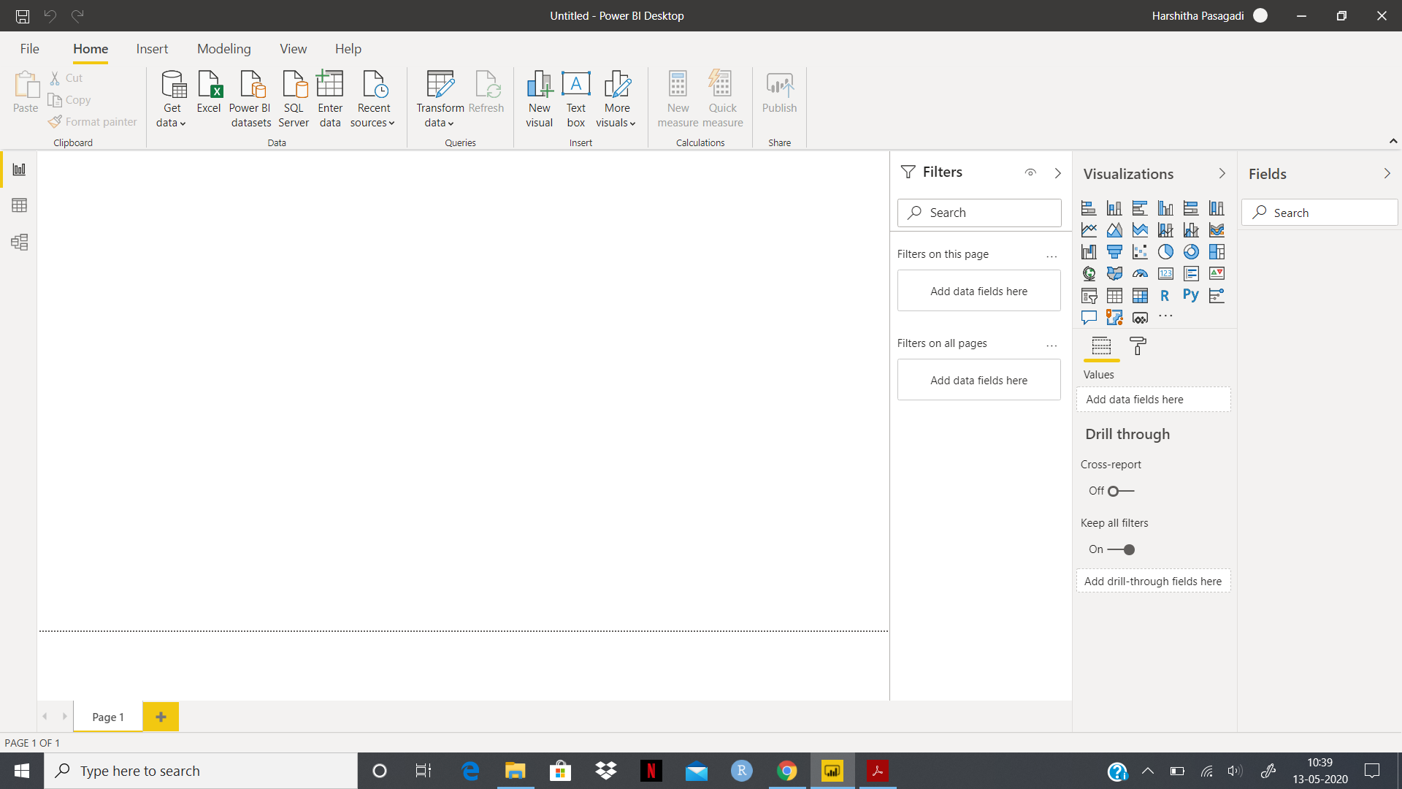

2. Data View:

Data View helps inspect, explore and understand the data in the Power BI Desktop. In Data view, the data is visible afterit has been loaded into the model.

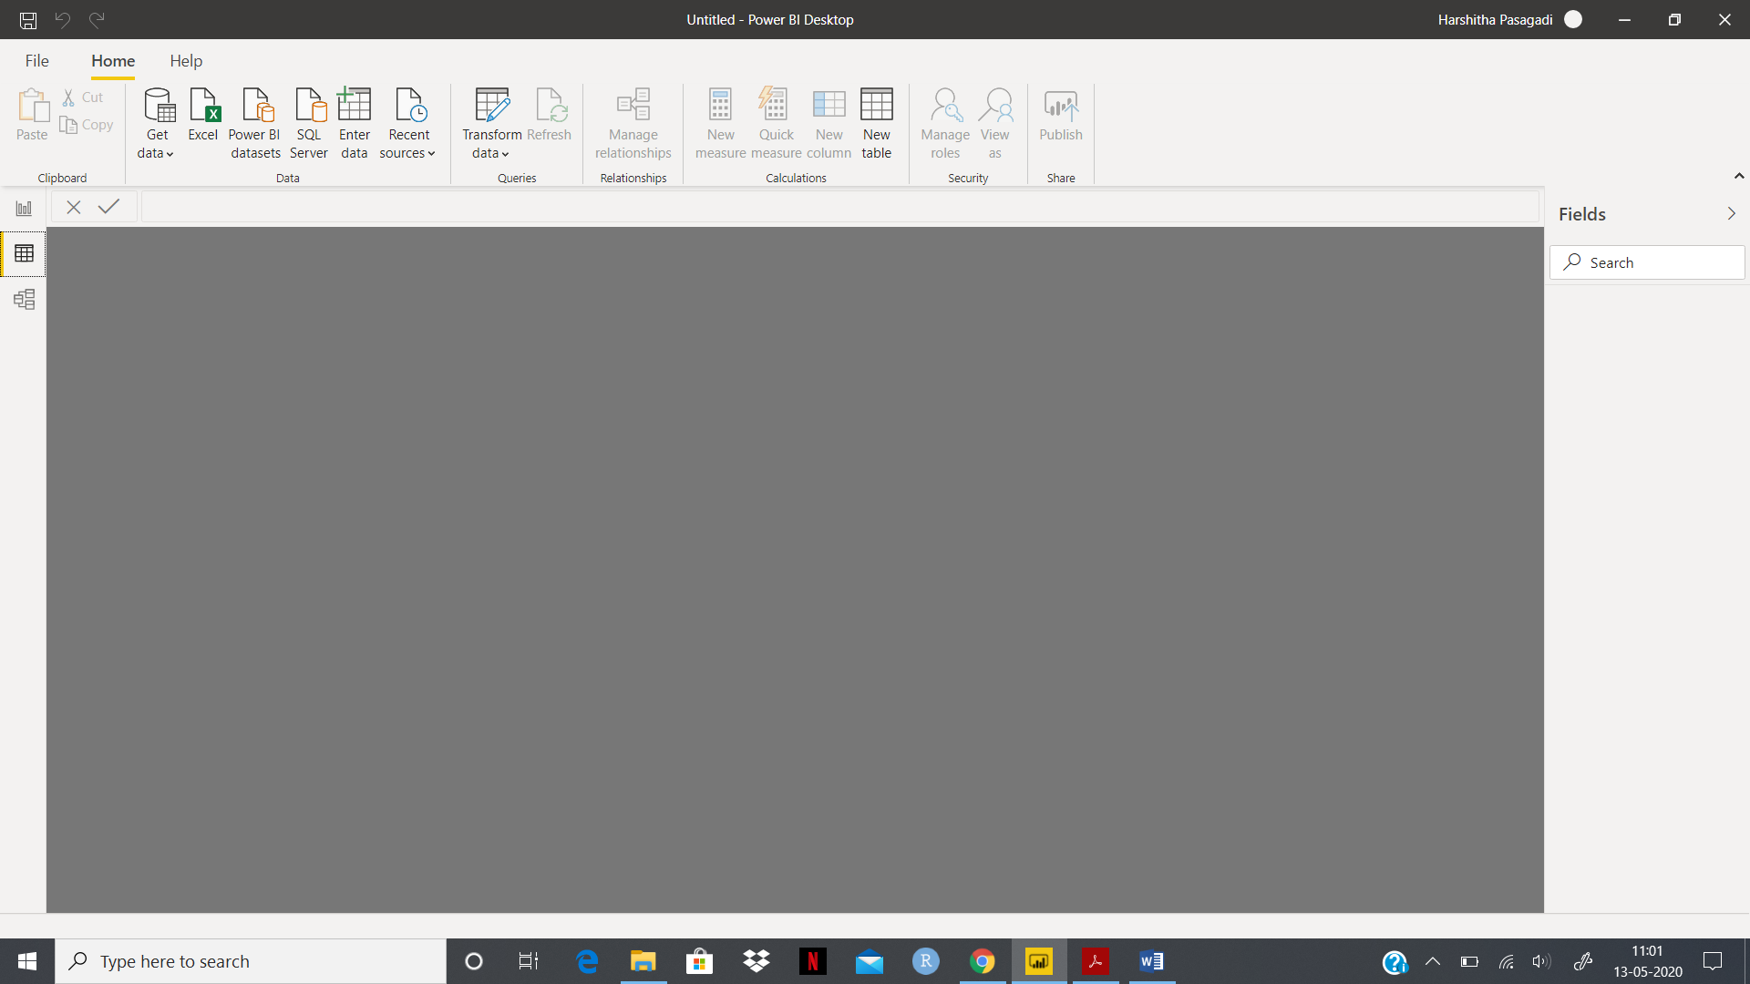

3. Model View:

Model view shows all of the tables, columns, and relationships in the model. This view is very helpful when your model has complex relationships between many tables.

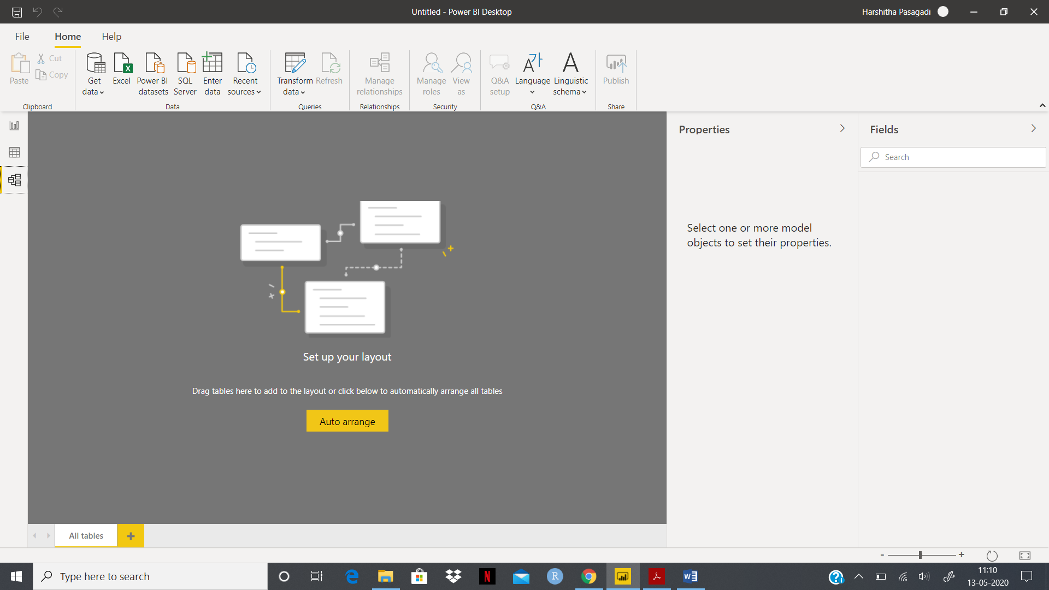

4. Power Query Editor:

The Power Query Editor plays the role of an intermediate data container where the data can be modified by selecting rows and columns, splitting rows and columns, pivoting and unpivoting columns etc. The changes made by the Power Query Editor are not reflected in the actual dataset. Once the data is pre-processed and transformed into the required format, the data can be loaded into the Power BI environment.

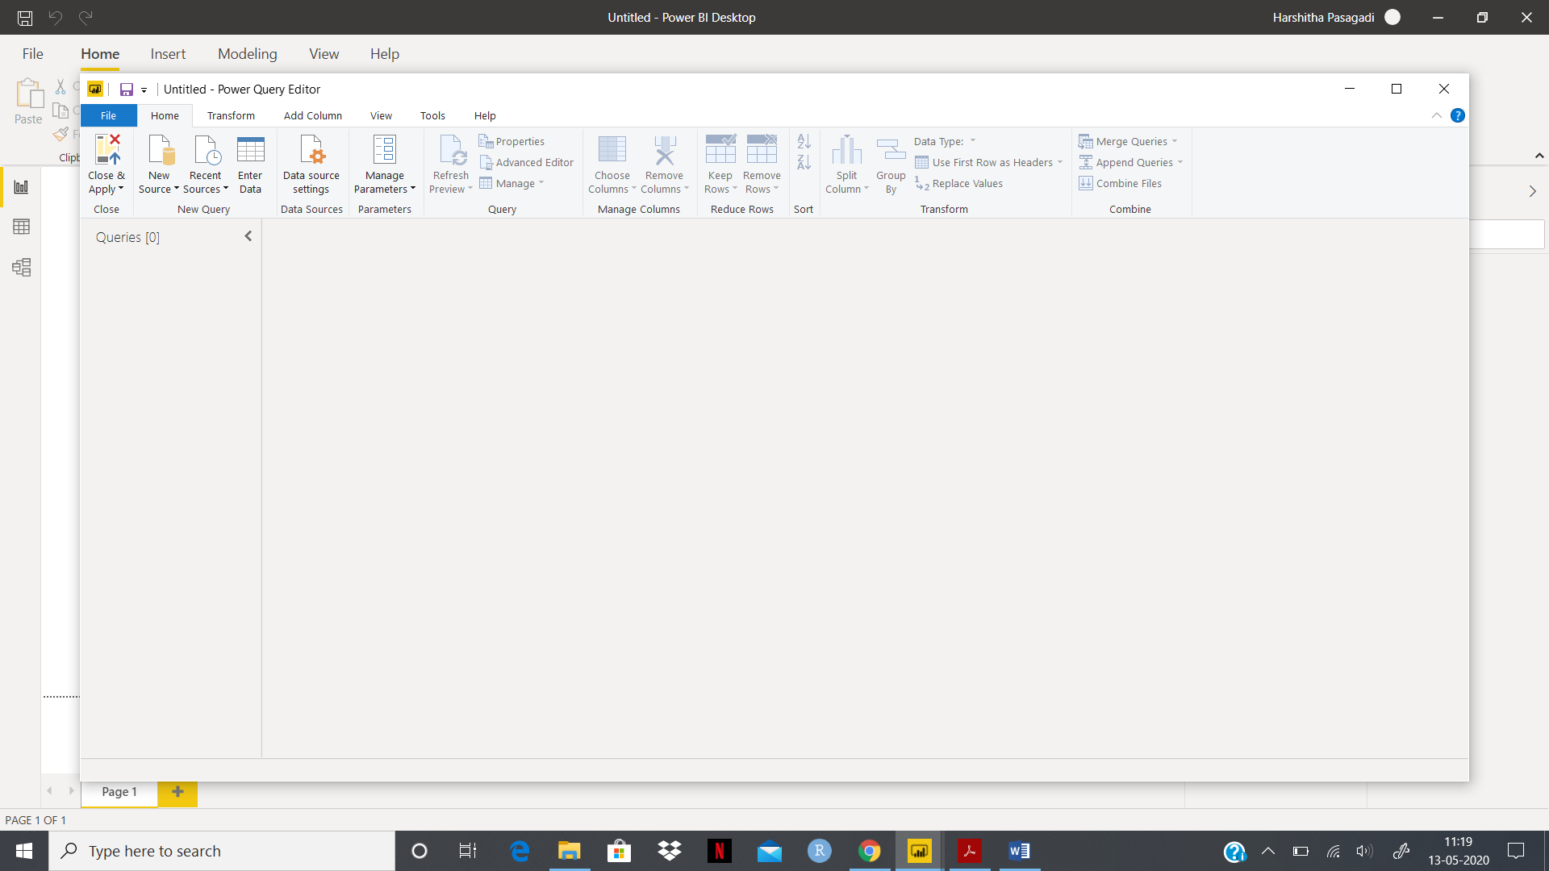

5. Advance Editor:

The **Advanced Editor** helps to see the code that Power Query Editor is creating with each step. It also allows to create our own shaping code.

