**REVISION HISTORY**

|  |  |  |
| --- | --- | --- |
|  | **DATE** | **MODIFIED BY** |
| 1 | Oct 2016 | SAHANA |
|  |  |  |
|  |  |  |
|  |  |  |
|  |  |  |
|  |  |  |

Creating Universal Distribution Certificate

A distribution certificate allows you to create an app for distribution. Before an app can be distributed, your must have a valid distribution certificate linked to a distribution provisioning profile. Each team can have only one active distribution certificate.

To create a distribution certificate, you will first need to generate a certificate request from your computer. On a Mac, you should do this by opening the Keychain Access application found in the Utilities.

**Step 1. Generate a Certificate Request**

Go to Keychain Access - Choose Keychain Access -> Certificate Assistant -> Request a Certificate from a Certificate Authority.

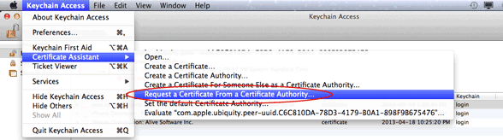

Enter your user email address and common name. Use the same address and name as you used to register in the iOS Developer Program. Select the options "saved to disk" and "let me specify key pair information" and click Continue. Specify a filename and click Save to save the file CertificateSigningRequest.certSigningRequest to your desktop.

**Step 2. Request Certificate**

Now go back to Apple Developer Center and click "Certificates, Identifiers & Profiles".

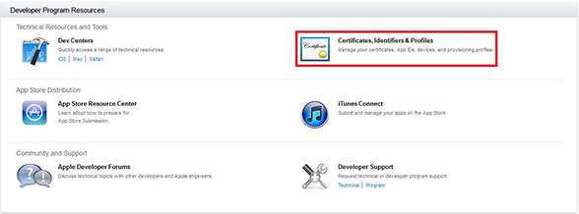

Next click on "Certificates" under iOS Apps

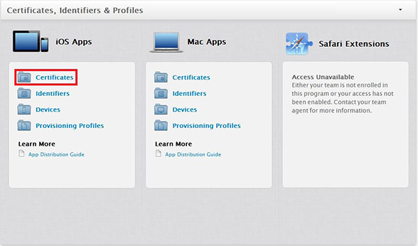

Click on the "+" sign near the top right corner to create a new certificate.

In the next screen you will need to select what type of certificate you are going to create, in this example we will be choosing the option "In-House and Ad Hoc"

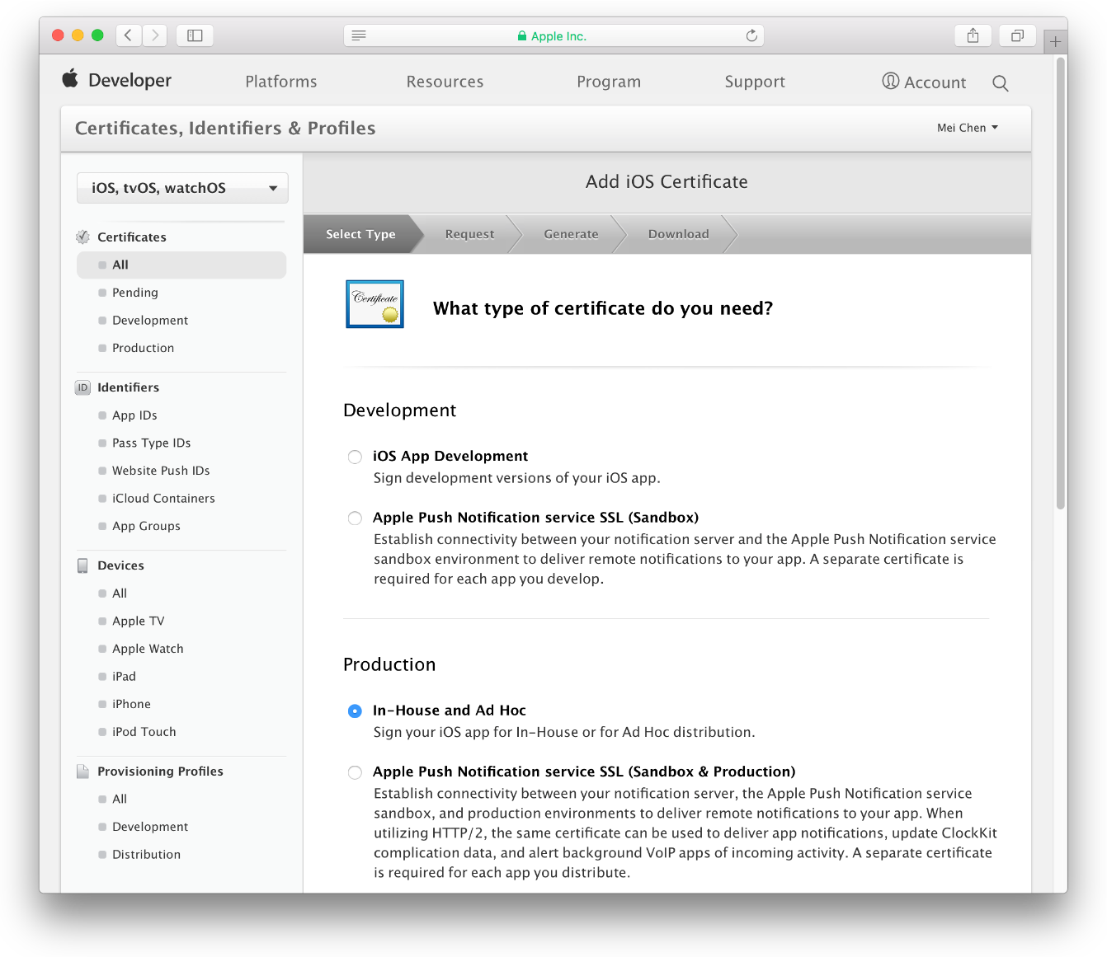

After that you will see a different screen depending on the otion you chose. In this case we see a screen letting us know that in order to create the certificate we will need a certificate signing request. You have already created that in step 1.

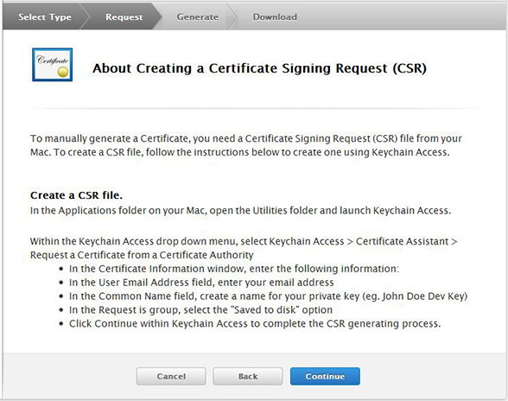

After you click Continue, you will be asked to upload the Certificate Signing Request you generate from the first step of this tutorial. Simply upload it and click generate.

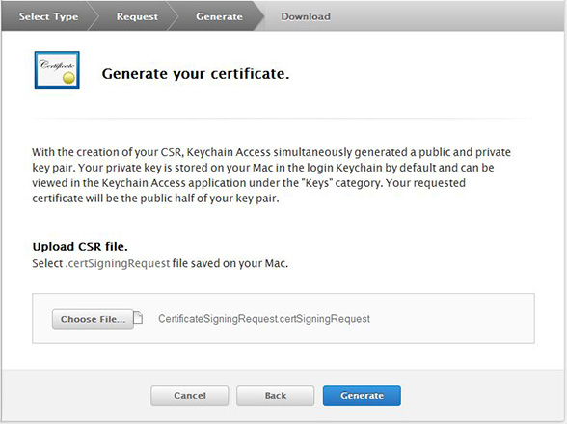

**Step 3. Download Certificate**

After your certificate is generated it will bring you to the download page. Click Download to save it on your computer.

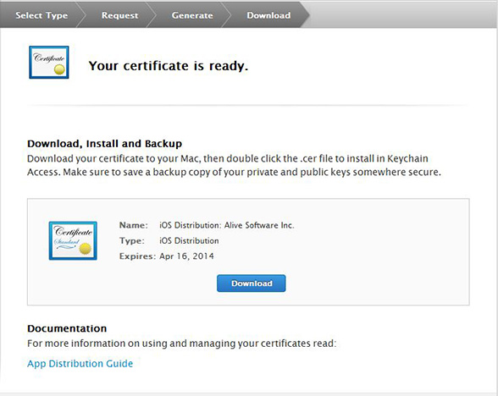

After the file downloads, locate the distribution_identity.cer file in your downloads directory, and double-click it to import it to Keychain Access.

Registering App IDs

1. Sign in to [developer.apple.com/account](http://developer.apple.com/account), and click Certificates, IDs & Profiles.
2. Under Identifiers, select App IDs.
3. Click the Add button (+) in the upper-right corner.
4. Enter a name or description for the App ID in the Description field.

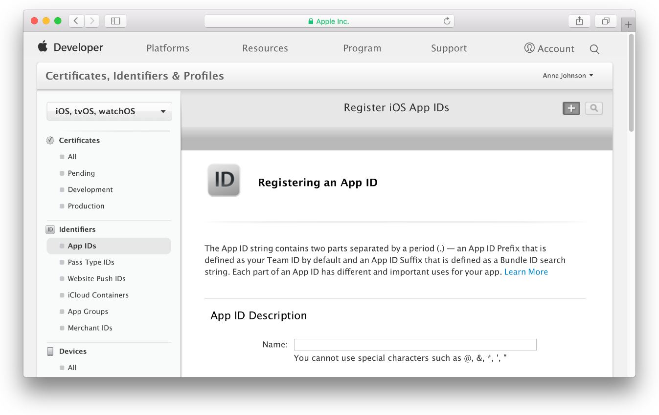

1. To create an explicit App ID, select Explicit App ID and enter the app’s bundle ID in the Bundle ID field. An explicit App ID exactly matches the bundle ID of an app you’re building—for example, com.example.ajohnson.adventure. An explicit App ID can’t contain an asterisk (*).

If you entered a bundle ID in the target’s Summary pane in Xcode, the App ID you enter here should match your bundle ID. 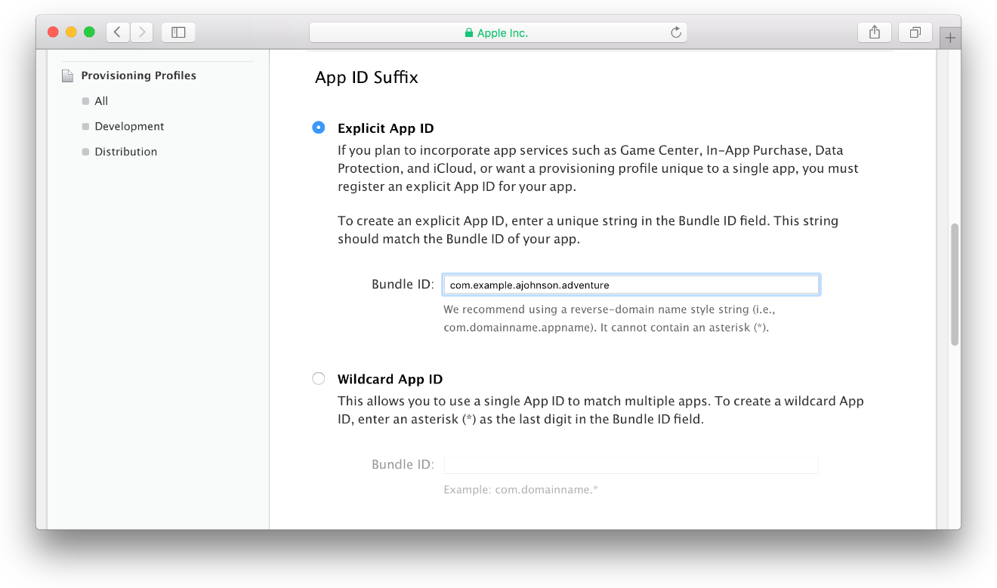

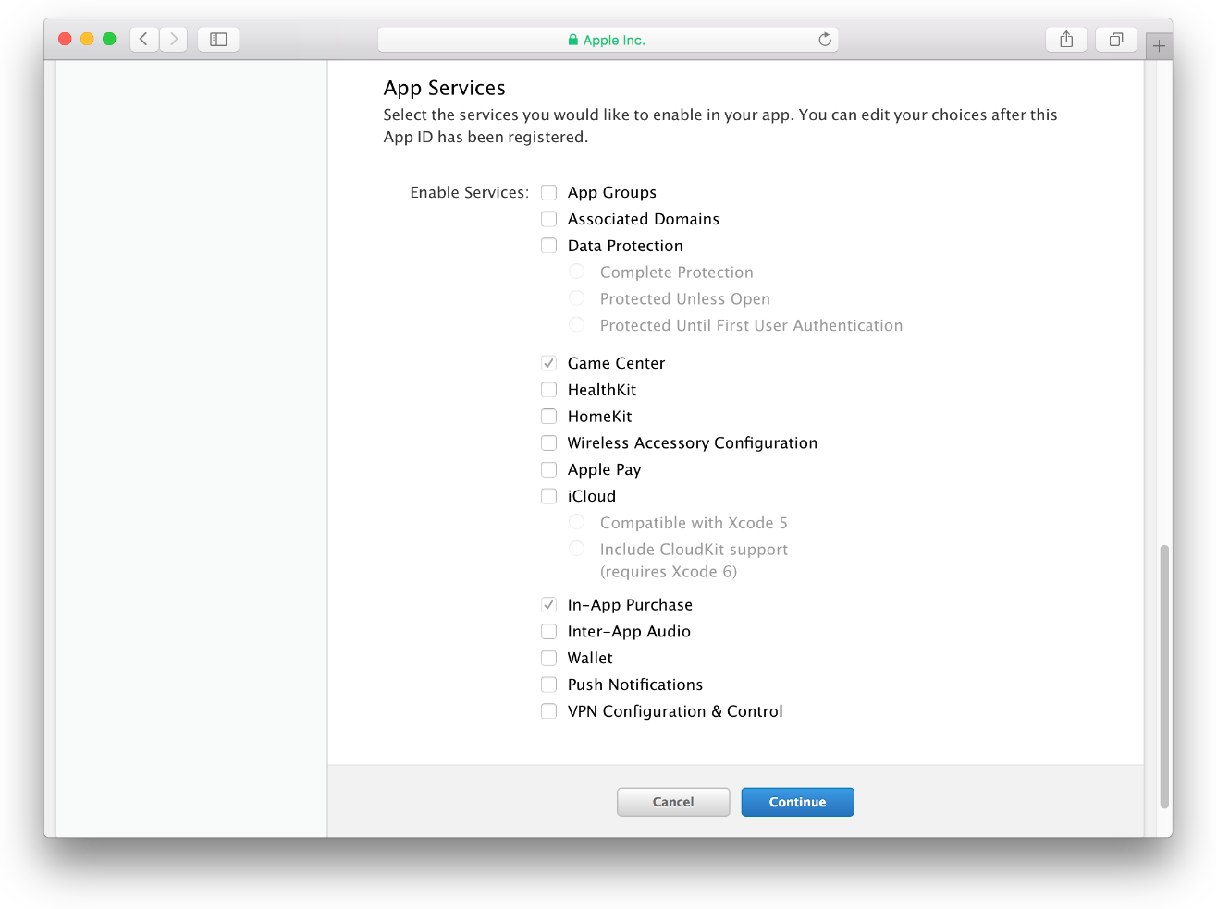

1. Click Continue.
2. Review the registration information, and click Register.
3. Click Done.

Creating Ad Hoc Provisioning Profiles

An ad hoc provisioning profile allows testers to run your app on their device without needing Xcode. To create an ad hoc provisioning profile, you select an App ID, a single distribution certificate, and multiple test devices.

**To create an ad hoc provisioning profile**

1. Sign in to [developer.apple.com/account](http://developer.apple.com/account), and click Certificates, IDs & Profiles.
2. Under Provisioning Profiles, select All.
3. Click the Add button (+) in the upper-right corner.
4. Select Ad Hoc as the distribution method, and click Continue.

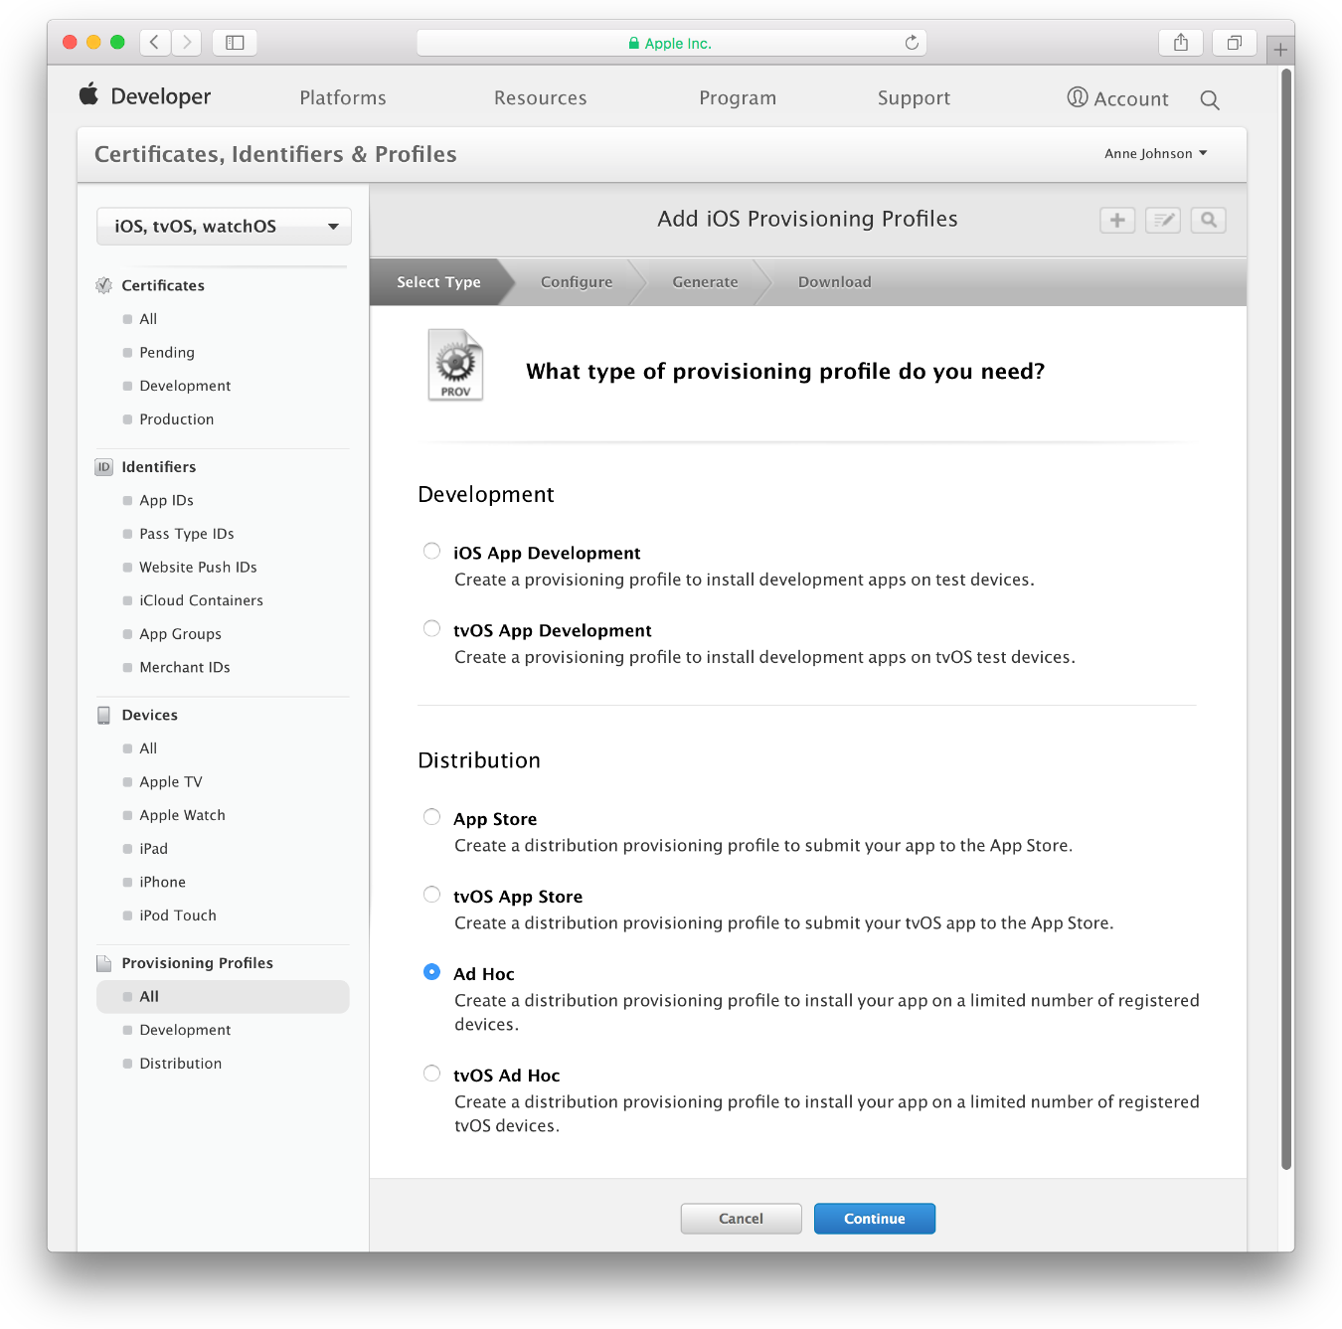

1. Choose the App ID you used for development, which matches your bundle ID, from the App ID pop-up menu and click Continue.

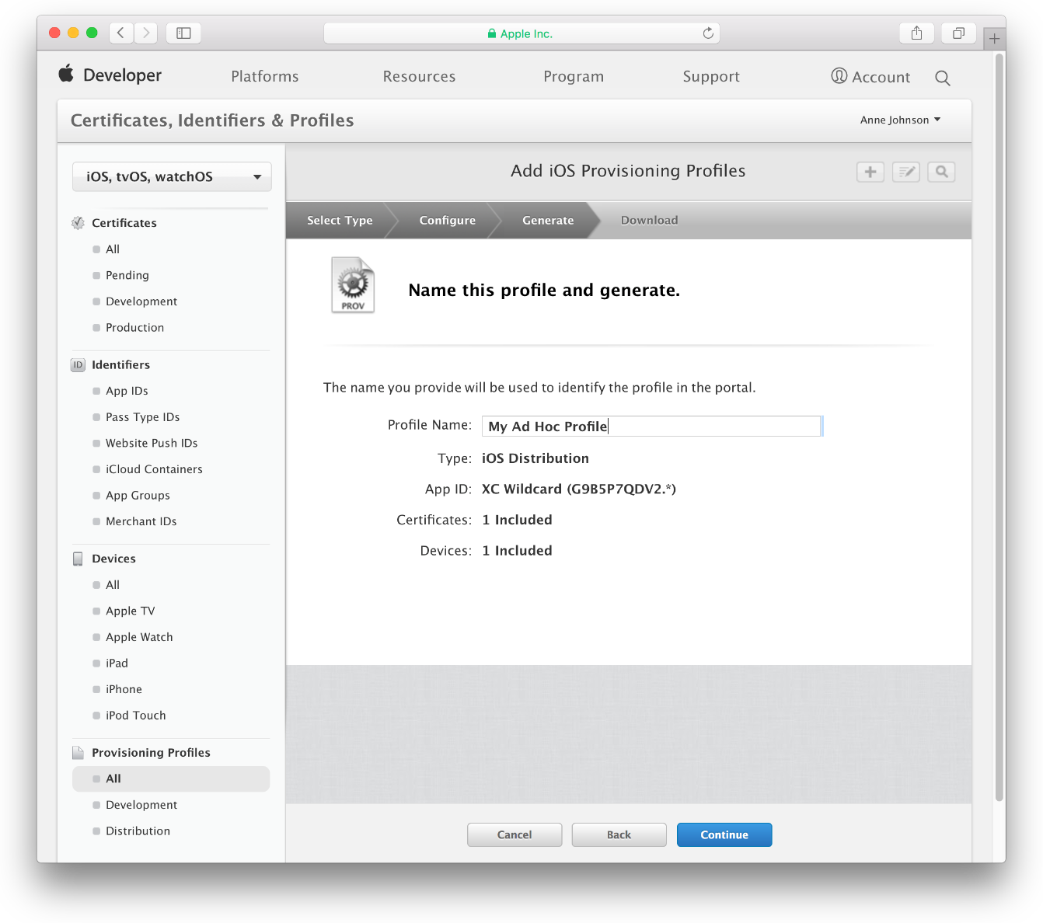

1. Select the distribution certificate you want to use, and click Continue.If you don’t have a distribution certificate, create one using Xcode, as described in [Creating Signing Identities](https://developer.apple.com/library/content/documentation/IDEs/Conceptual/AppDistributionGuide/MaintainingCertificates/MaintainingCertificates.html#//apple_ref/doc/uid/TP40012582-CH31-SW6), before continuing.
2. Select the devices you want to use for testing, and click Continue.
3. Enter a profile name, and click Continue.  Wait while your developer account generates the provisioning profile.
4. At the bottom of the page, Click Done.