***Installing Enterprise apps on devices with iOS version above 9.0***

| **Document Revision History** | | |
| --- | --- | --- |
| Date | Details | Updated By |
| Oct 2016 | First documentation | Harshitha |
|  |  |  |
|  |  |  |
|  |  |  |

Apple provides Enterprise Distribution as a way for companies to create and share internal apps without having to go through the App Store. Unfortunately, bad actors have been using the associated process as a way to try and trick people into installing malicious apps. With iOS 9 that's now a lot harder to do.

Previously, all that was required to install an Enterprise app was to tap the Trust button on the popup ( As seen in the image below).

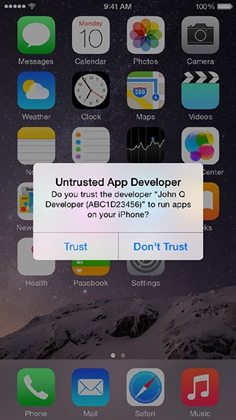Now there is no Trust button on the popup. There are no buttons at all. Or instructions of any kind. So, unless you know what to do, you can't install an enterprise app either accidentally or obliviously.

As ServicePro-TCW version is also an enterprise application built using “In-House and Ad Hoc” certificate, it has to be installed following the process explained below.

When trying to install an app from an unknown developer on iOS 9 and 10, an alert dialog that the developer is not trusted will be seen. To solve this, launch Settings from home screen, then go to General > Profiles (or General > Device Management, or General > Profiles & Device Management), tap on the row with the developer's name, and then on Trust "<name>". After this, you should be able to launch the app.