

CASE STUDY 15:

**Work Experience**

TEAM MEMBERS:

1. 2100031262

2. **2100031345**

3. **2100031364**

### ABSTRACT:

In this work, to show that real life cases scenario when tested satisfied queuing theory, we obtain data from Kalinga restaurant, Jodhpur. We then calculated the arrival rate, service rate, utilization rate, waiting time and the probability of potential customers to balk based on the collected data, little’s theorem and M/M/I queuing model. The arrival rate during busiest period of the day is 1.42 customer per minute. The average number of customers in the restaurant is 70 and utilisation rate of 0.9859. We conclude the work by given the concluding remarks.

**Instructor Observations:**

* 1.The students, most of whom work, had no trouble identifying probabilistic problems at work. The students spent a reasonable amount of time on this project.
* One group missed opportunities in the work environments of its members.
* Groups were reluctant to have a non-expert be the presenter. The primary outcome of this experiment was that the students learned to statistically analyze situations within their own technical job environments. In previous classes, the students had been able to learn the statistical concepts such as the idea of “trials and successes” in the binomial distribution, and viewing data through histograms, etc. They also learned to recognize instances of uncertainty in their field of engineering such as beam failures and construction specification tolerance limits. This project helped the students to make the connection between the statistical tools and the engineering applications.

**Queuing Theory:-**

In 1903 FrJohannsen was appointed copehengen telephone company director and he observed that the manual switch were not dimensioned in the right way. FrJohannsen published some work using the mathematical theory of probability from an economic point of view he stated that in one of his work “The overloading of the subscribers resulted in considerable extra expenses on account of the telephone operators having to make repeated attempt to establish a connection”. In order to develop more precise dimensioning FrJohannsen established scientific laboratory where he engaged the mathematician AgnerKrarupErlang. Erlang stated to work on the holding time in a telephone switch and then identified that the telephone conversations satisfied a Poisson distribution as well as the telephone holding time was exponentially distributed. Erlang work is the origin of the current network optimisation and queuing theory .

**Little’s Theorem:-**

Little’s theorem [3, 4] describes the relationship throughout arrival and service rate, cyclic time and work process. The theorem states that the expected numbers of customers L for a system in steady state can be derive from little’s theorem;

L T = λ ... (1 )

Where λ is the average customers arrival rate and T is the average service time for a customer. Three fundamental relationships can be derive from little’s theorem

• L Increase if λ or T increase

• λ Increase if L increaseor T decrease

• T Increase if L increase or λ decrease

**M/M/1 Queuing Model:**

M/M/I queuing model means that arrival and service time are exponentially distributed or Poisson process. The following variables will be investigated;

• λ : The mean customer’s arrival rate

• μ : The mean service rate ρ λ μ = : Utilization factor ... 2( )

• Pn : The probability of having n customers (1 ) n Pn = − ρ ρ ... 3( )

* Probability of zero customers 0P = −1 ρ ... 4( )

• L : The average number of customers 1 L ρ λ ρ μλ = = − − ... 5( )

• Lq : The average number of customers in the queue 2 1 L L q ρ ρλ ρ ρ μλ =×= = − − ... 6( )

• Wq : The average waiting time in the queue

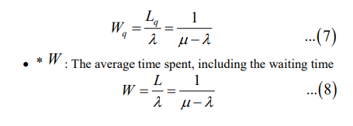

**Observations**

Below is one month daily customer data which was collected from the restaurant

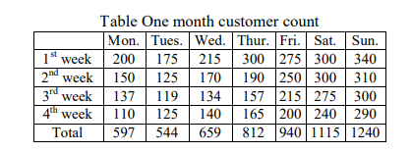

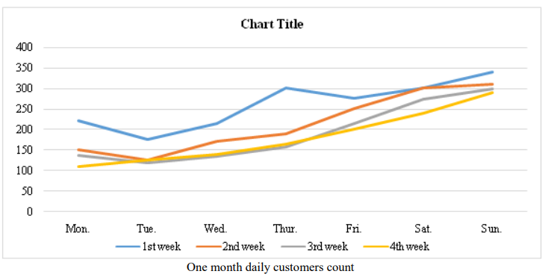

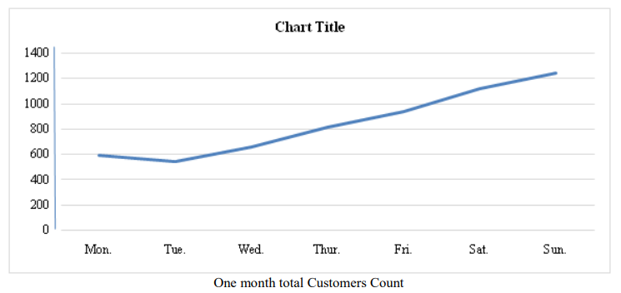

**Calculations**

It was investigated that, after Friday, during the weekend there are on average 210 people coming to the restaurant in 2(1/2) hours’ time of dinner. From this we obtain the arrival rate as;

λ=210/150=1.4 Customers/minute

We also found out from observations and discussions with the manager that each customer spend 50 minutes on average in the restaurant (W )the queue length is around 25 people ( Lq ) on average and waiting time is around 15 minutes. It can be shown that by (7)that the observed actual waiting time does not differ much when compared with to the theoretical waiting time as shown below

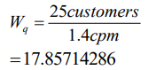

Next, we will calculate the average number of people in the restaurant using (6)

L cpm = × 1.4 50min = 70customers

Using (2) & (5) we can also calculate the service and utilization rate as shown below;

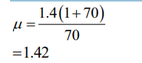

Probability of customers going away

=P (more than 10 people in the queue)

=P (more than110 people in the restaurant)

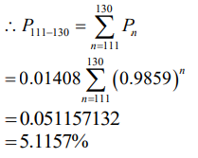

**Conclusion**

The utilization rate at the restaurant is very large (0.9859). This is only utilization rate during lunch and dinner on Saturday and Sunday.

• In case the customer waiting time is less than 15mins, the number of customers that will be served per minute will increase. When the service rate is higher the utilization rate will be lower.

• The queue model formulation is much simpler than to provide simulation model.

• This research can help to increase the quality of service by anticipating if there are many customers in the queue.

-

# CODE:

