**PROBLEM STATEMENT -1**

**PROBLEM STATEMENT-2**

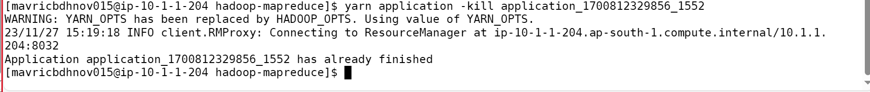



yarn logs -applicationId application_1700812329856_1552 -appOwner mavricbdhnov015

