Real-Time Project Exercise – MuleSoft Transport Management

OBJECTIVE

TripEasy is a startup company providing a platform to perform booking services for land, air and sea transport across the world.

This platform will enable customers to query location routes and the departure schedule from multiple transport providers, and make booking directly to the platform. The platform will enable the customer to make payments, and issues tickets to the customers. Customer also will be able

This platform will connect to the respective transport providers back end systems, to query for the available routes and schedules and make purchases, track their booking and make changes to their bookings. This platform will also provide the capability for the regulatory agencies to manage their bookings, and all updates will be reflected to the transport provider back-end system.

API lanscape

1.System Api

1.Mobile application Booking system
2.Web application booking system.

2.process Api

Consolidate all routes and schedules from from both travelontip and
fastgo routes and schedules.

3.Experience API
Connecting to the mobile application and web application of the system layer for consolidating routes and schedules from both end points.

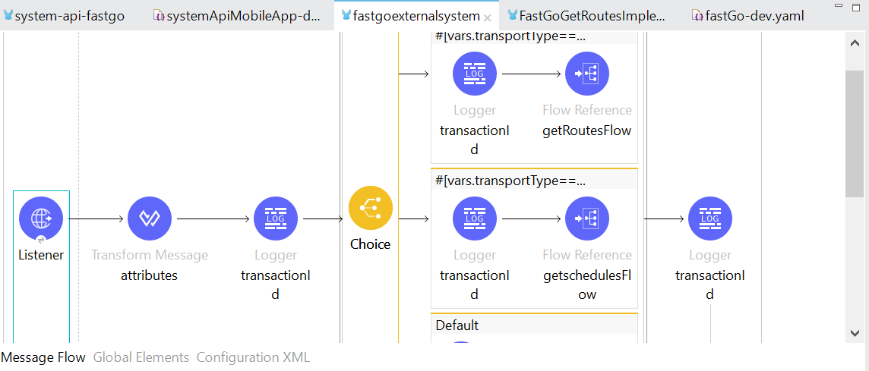

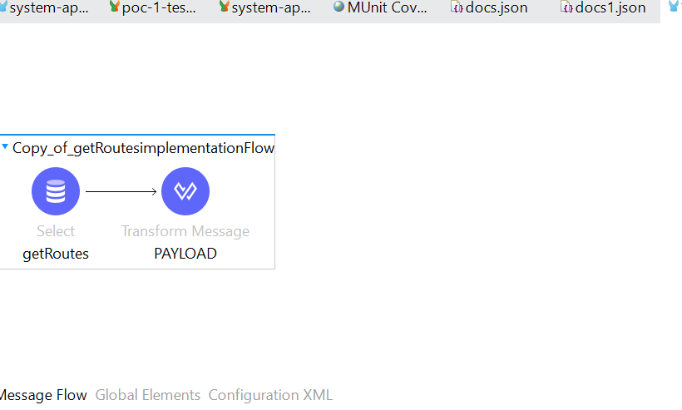
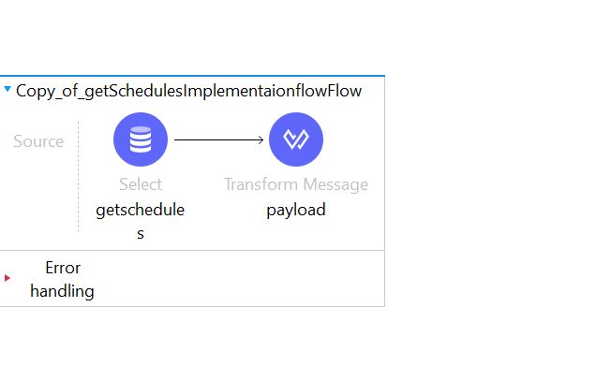
FASTGO Routes Response

http://localhost:8084/fastgo/routes

[
{
"companyName":"fastgo",
"destinationLocationCode":"BEN-SG",
"originLocationCode":"KLG-MY"
}
]

FASTGO Schedules Response

http://localhost:8084/fastgo/schedules

[
{
"toLocation":"KLG-MY",
"availableSeats":8,
"departureDateTime":"2019-09-09T00:00:00",
"fromLocation":"BEN_SG",
"companyName":"fastGo"
}
]

Sys api FastGo Routes

http://localhost:8087/api/Bus/fastgo/Routes

[
{
"departureLocationCode": "BEN-SG",
"arrivalLocationCode": "BEN-SG"
}
]

sys api FastGo schedules

[
{
"toLocation": "KLG-MY",
"availableSeats": 8,
"departureDateTime": "2019-09-09T00:00:00",
"fromLocation": "BEN_SG",
"companyName": "fastGo"
},
{
"toLocation": "BEN_SG",
"availableSeats": 10,
"departureDateTime": "2020-12-23T00:00:00",
"fromLocation": "KLG_MY",
"companyName": "fasttgo"
}
]

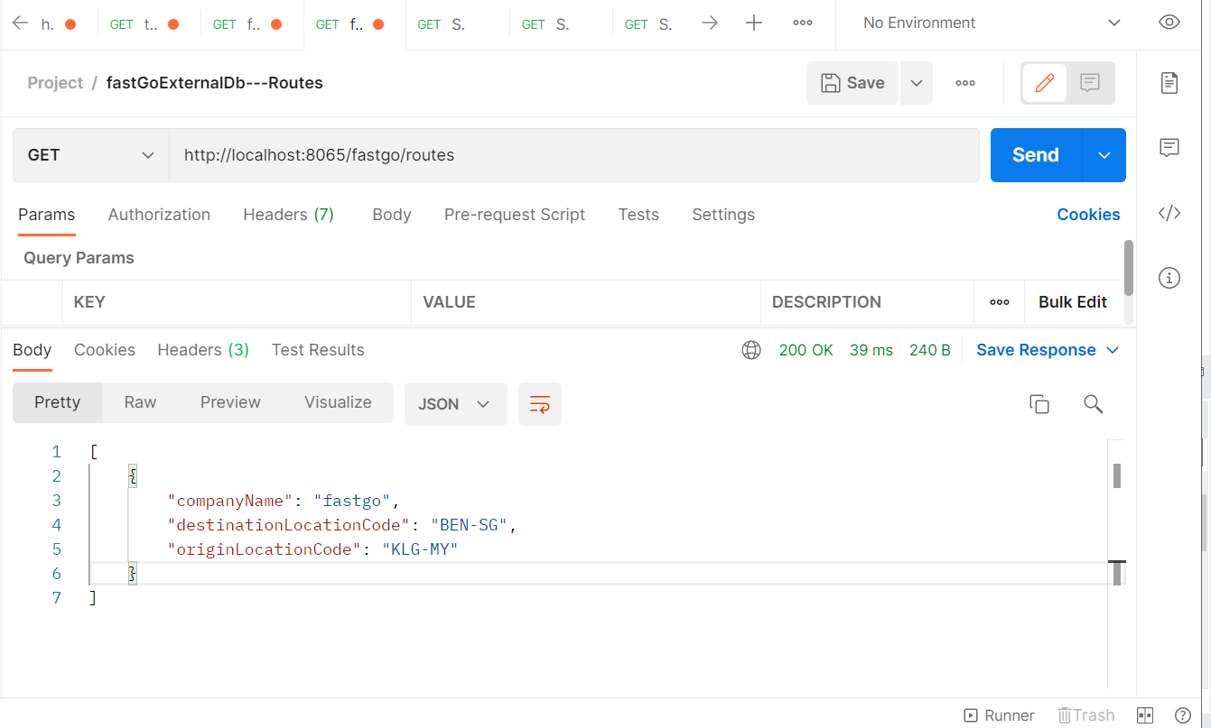
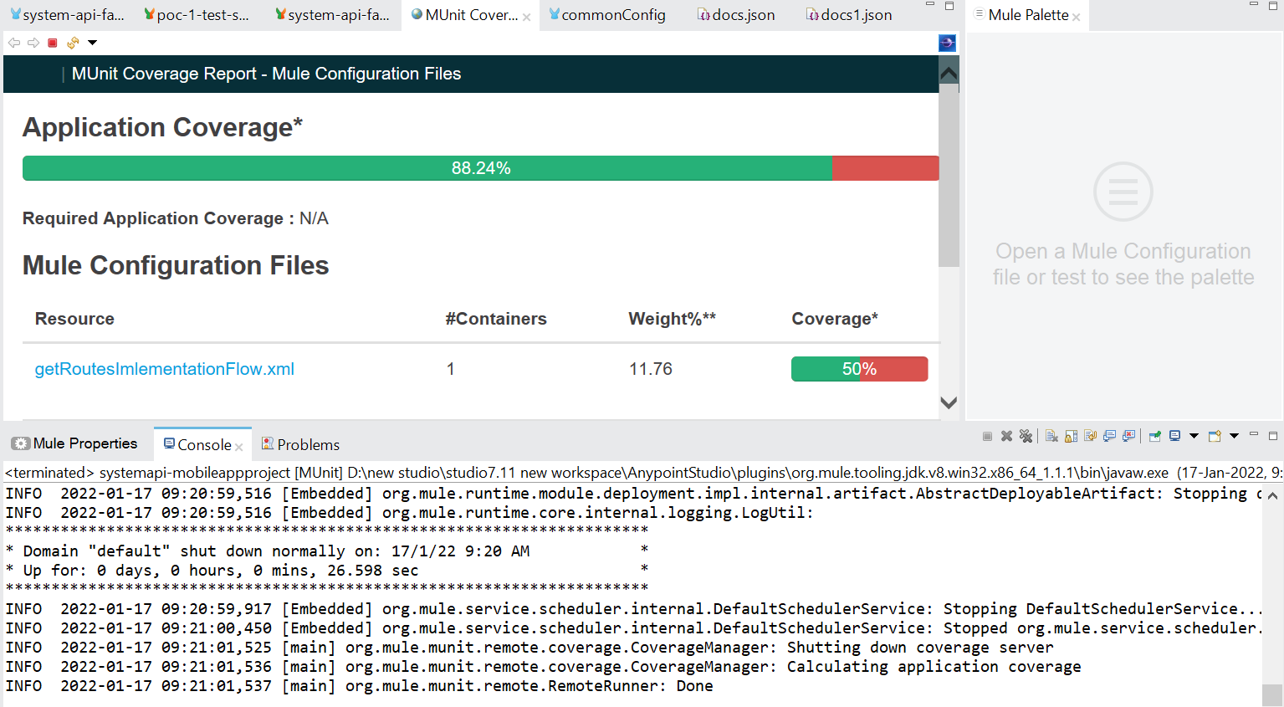

Test coverage of System layer Web application

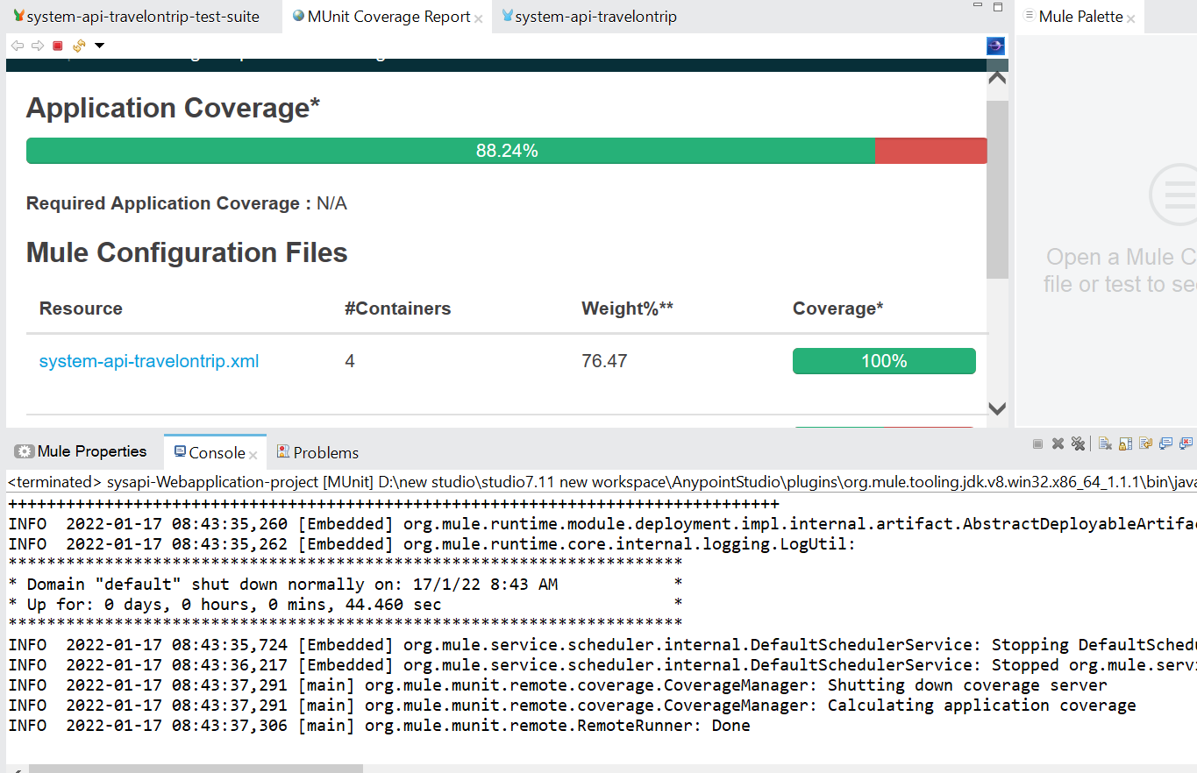

ProcessApifastGo Routes Response:

[
{
"comapanyCode": "Transactinal",
"originLocation": {
"locationCode": "BEN-SG",
"locationDesc": "beavuna singapore"
},
"DestinationLocation": {
"locationCode": "BEN-SG",
"locationDesc": "Klang Malaysia"
}
},
{
"comapanyCode": "Transactinal",
"originLocation": {
"locationCode": "BEN-SG",
"locationDesc": "beavuna singapore"
},
"DestinationLocation": {
"locationCode": "BEN-SG",
"locationDesc": "Klang Malaysia"

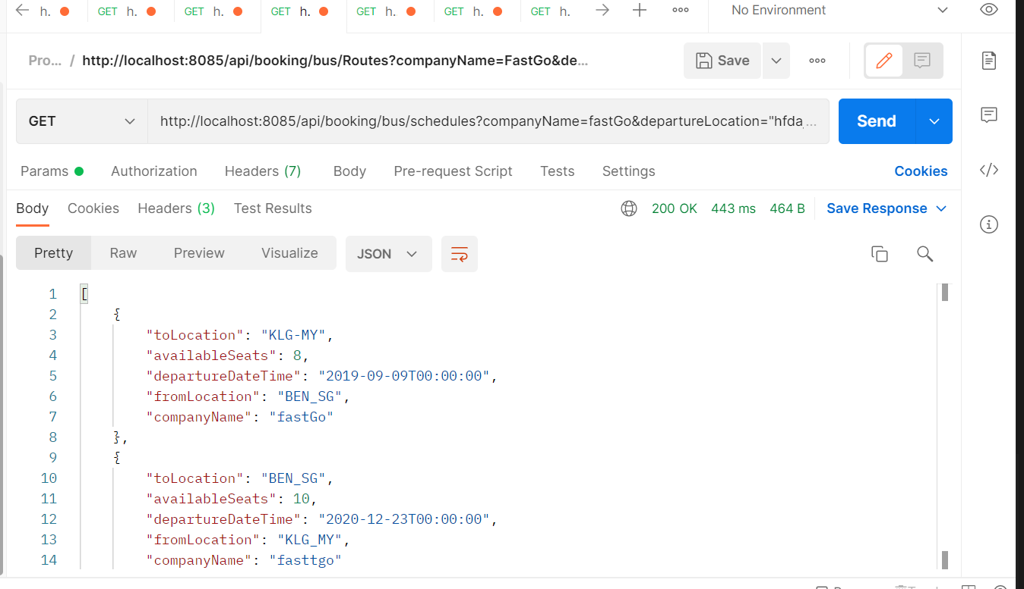

}
}
]

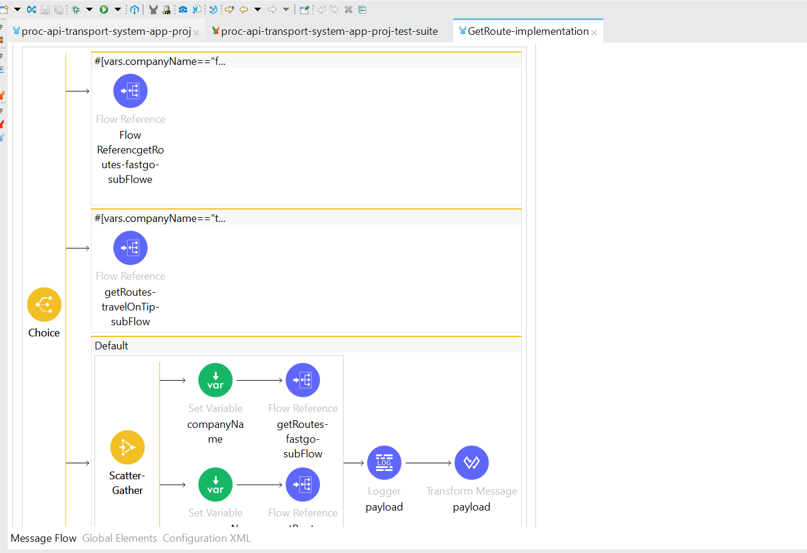

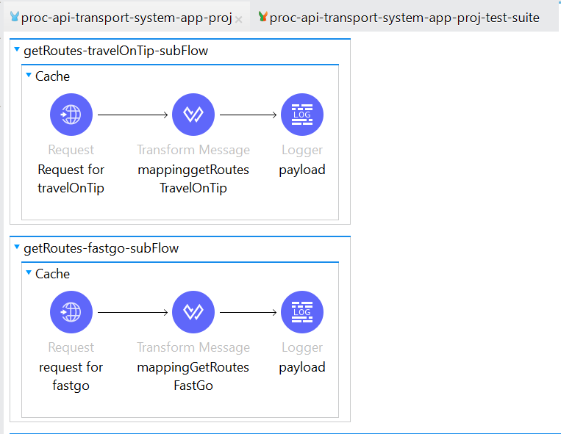
Experience Api

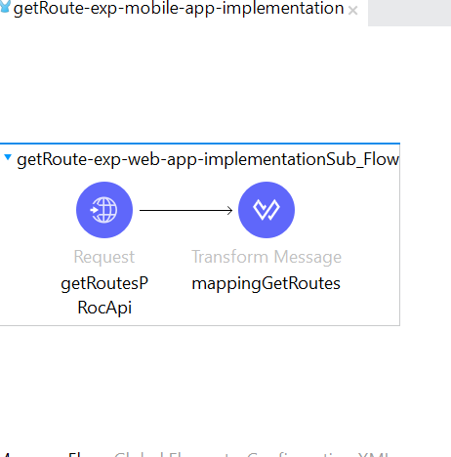
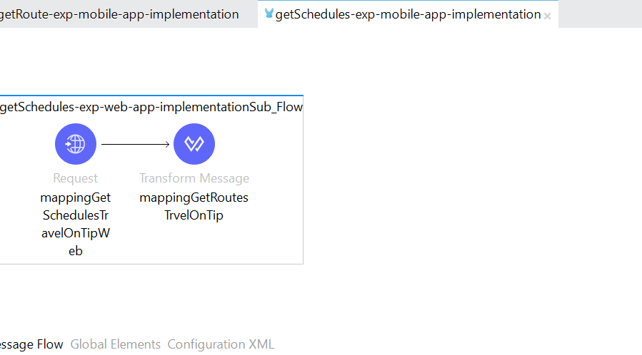

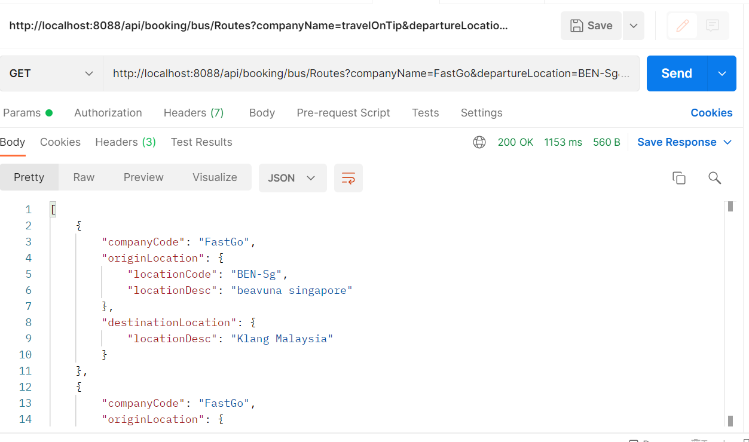

TtavelontipRoutesEXperience APi

