FODS-Lab1

**Q1)**

Import data and save it in your disk space

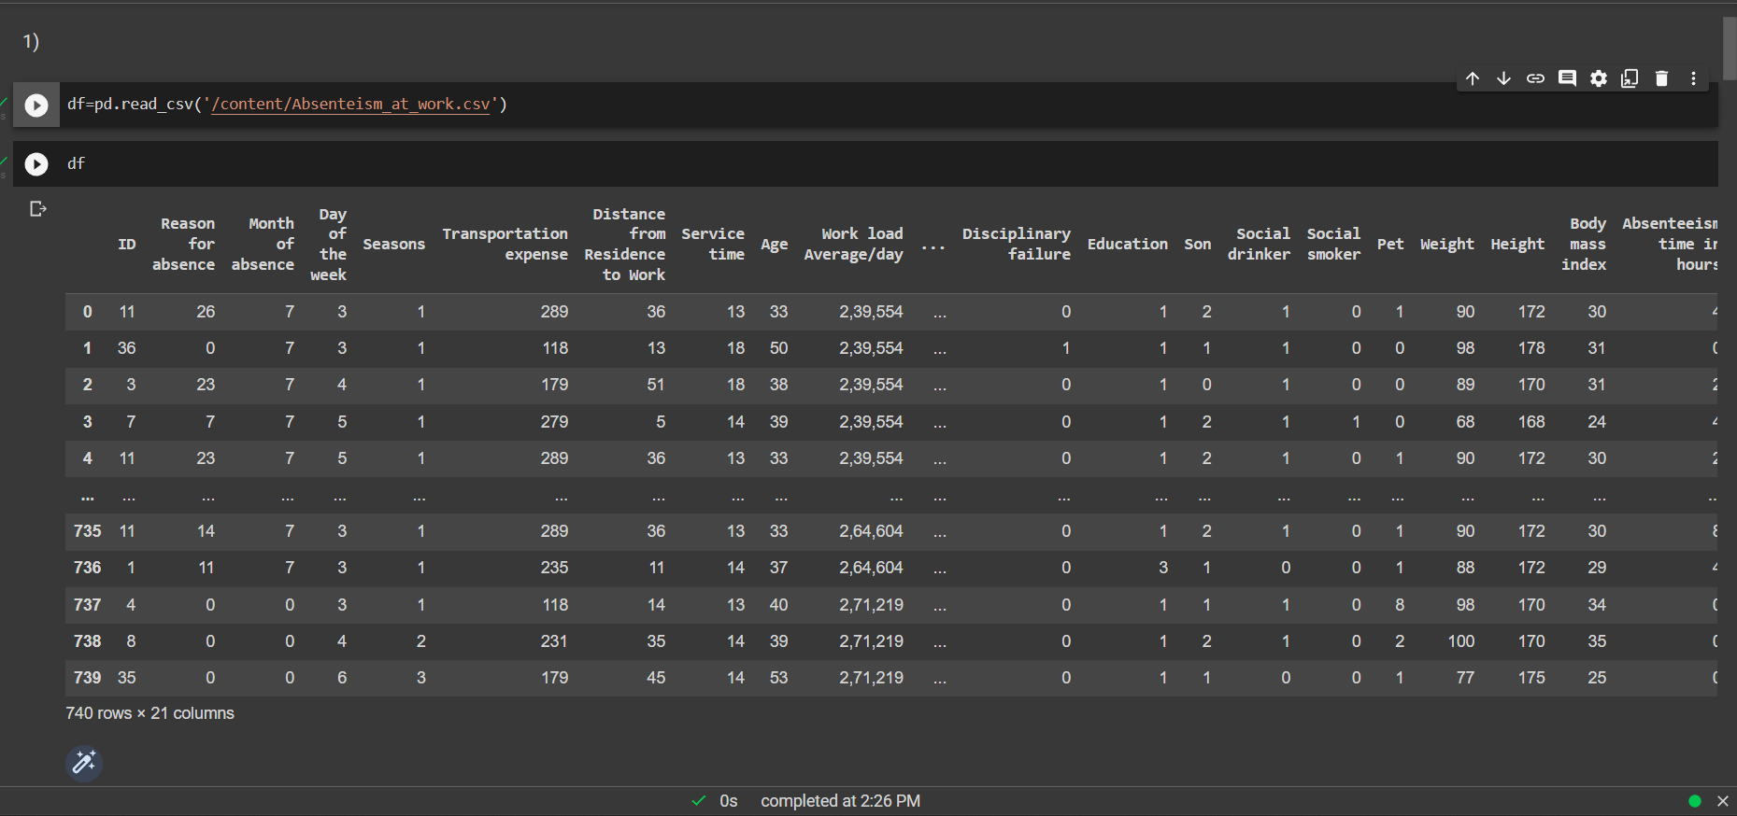

**Q2)** Drop the columns not required for your analysis

**Q4)** Perform an outlier analysis for any two columns

**Q5)** Do a correlation analysis of any two variables.

**Q6)** Describe the data

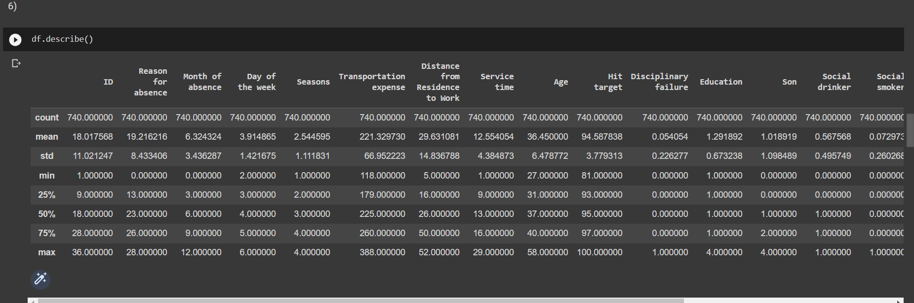

**Q7)** Display the first 3 rows

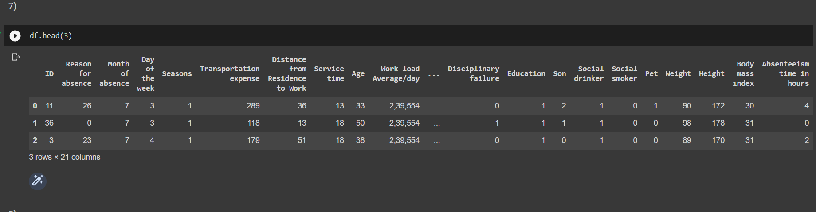

**Q8)** Display the last 4 rows

**Q9)** Locate the first row corresponding to the last 3 digits of your Roll No

**Q10)** How many rows of data do you have?

**Q11)** Display the first 5 columns of the first row

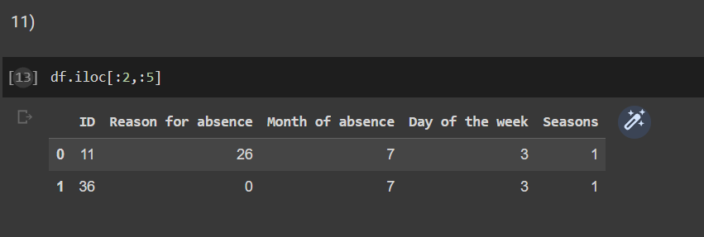

**Q12)** Count the number of people affected with the diseases of the circulatory system

**Q13)** Split people according to their body mass index into two groups: overweight (25 to 30) and obese (>30)

**Q14)** Evaluate the characteristics of the population distribution with mean and, deviation (a) Average age of highschoolers (b) Average age of graduates (c) Average age of postgraduates

**Q15)** Compute the mean and the variance of "transportation expenses” for medical consultations

**Q16)** Draw a histogram for age of Social drinkers. Histogram should be step-filled with bin of size 20. Find the skew of this distribution, and comment if it is positive or negative (5).

