FICformer: A Multi-factor Fuzzy Bayesian Imputation Cross-former for Big Data-driven Agricultural Decision Support Systems
Smart sensors are employing in agriculture sector to improve crop growth as the sensors are deployed to sense and send dynamic environment details like temperature, humidity, co2 and many other parameters. This values are input to ML or DL algorithms to predict crop growth or to maintain necessary temperature in the field.
Smart sensors send enormous amount of information which is called as Bigdata and this data will be processed and saved at then cloud server side where cloud will run ML algorithms to predict future temperature or required water level or can even predict future crop growth.
Utilizing smart sensors can also make ML algorithms to predict incorrect values due to presence of missing values in the sense array. To overcome from this issue author of this paper employing ‘Fuzzy Bayesian Imputation’ algorithm which will reconstruct dataset by replacing missing data with the help of Bayesian calculated fuzzy values. After imputation author has used second algorithm called encoder decoder by combining Transformer with attention (FICformer) to enhance forecasting which is reducing ML algorithm forecasting error rate.
Propose FICformer algorithm consists of two parts describing below
- The fuzzy Bayesian imputation module is introduced to fill in the missing values in smart agriculture environmental data to obtain complete data and improve the interpretability of the model.
- A dimensional temporal attention module is designed under the framework of transformer and used as encoder and decoder for modelling feature-implied information, and a pooling mechanism is introduced between the layers to reduce the complexity.
Fuzzy Bayesian imputation: This algorithm combines matrix factorization (MF) with time varying vector auto-regression. It incorporates fuzzy inference to model uncertainty in the parameter space and utilizes Bayesian inference to handle uncertainty effectively. The proposed approach maximizes accuracy in filling missing data, improves data utilization, and enhances interpretability.
Propose FICformer Model: This algorithm consists of dimensional temporal cross-attention mechanism based on the transformer encoder-decoder framework. This mechanism captures dimensional and temporal characteristics among multiple variables. The encoder calculates hidden states, and the decoder performs dynamic decoding to enhance feature extraction and information representation of implicit relations in subspaces. We introduce a pooling mechanism after the attention layer to simplify the model complexity. This mechanism prioritizes high-contribution feature values, reduces information redundancy, and lowers computational costs.
Note: To test fuzzy imputation author has developed 3 more algorithms but in all algorithms FICformer is giving less forecasting error, so we have implemented FICformer algorithm and then compare its performance with existing LSTM algorithm.
Each algorithm performance is evaluated in terms of RSME (root mean square error), MAE (mean absolute error), RSE (relative square error) and many more but we are implementing this 3 metrics. RMSE and other metrics refers to difference between true and forecasting values so the lower the difference the better is the algorithm.
To train and test above algorithm performance author has used Tomato smart sensor dataset but this dataset not publish on internet so we used available dataset from KAGGLE repository. This dataset can be download from below URL.
https://www.kaggle.com/datasets/datasetengineer/smart-farming-data-2024-sf24
Extension Concept
In propose work to enhance algorithm performance author has concentrate on missing values imputation and then using encoder and decoder model to predict crop growth from sensor data but not utilize any advance algorithms by combining multiple layers to form a HYBRID or Stacked models.
Extension1: in this extension we have designed hybrid model by combining propose FICformer with GRU layer. Combining multiple algorithms is known as hybrid model and always known for algorithm performance improvement.
Extension2: in this extension to further reduce forecasting error we have designed a STACKED model by combining FICformer + Bidirectional + GRU and this stack model reducing error rate 20%.
SCREEN SHOTS
We have coded this project using JUPYTER notebook for model training and evaluation and then utilize FLASK web framework to predict crop growth.
To run JUPYTER double click on ‘runJupyter.bat’ file to get below page
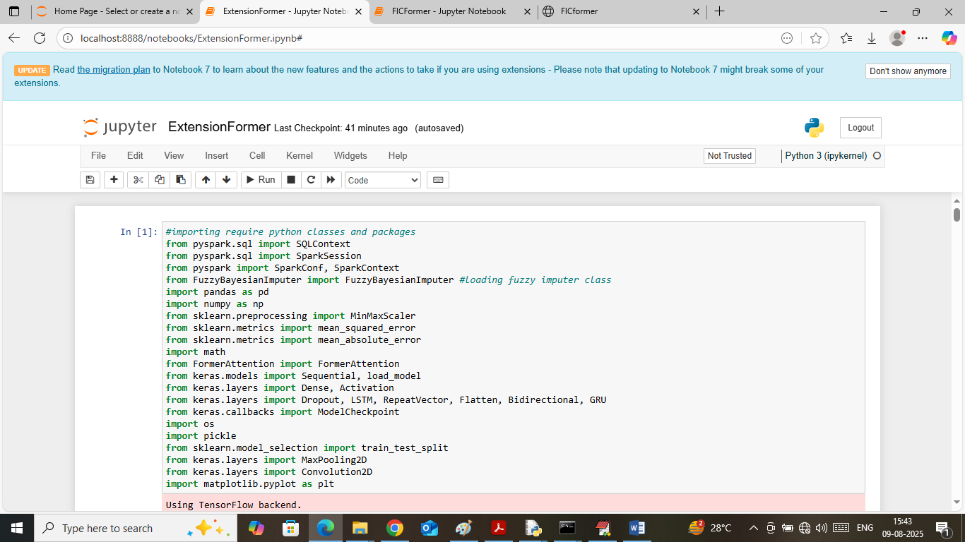
In above screen importing required python classes and packages
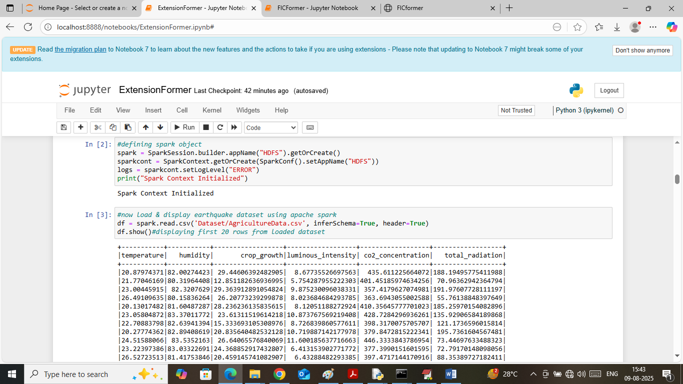
In above screen initializing spark object to load and process Bigdata and then displaying loaded dataset values
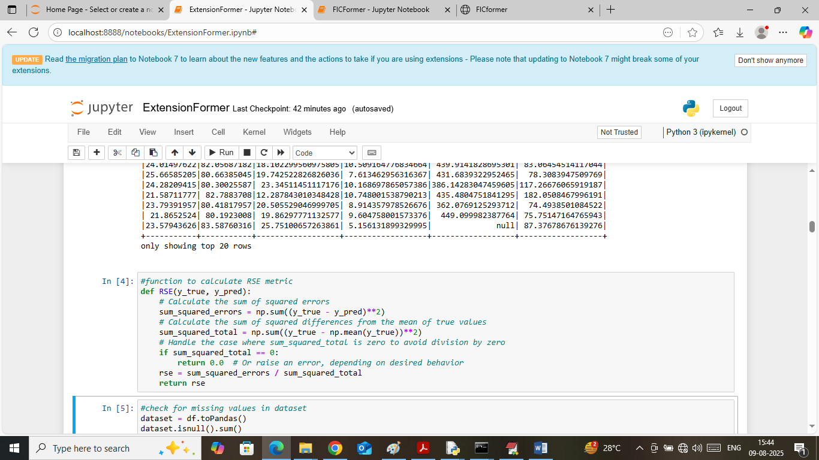
In above screen defining function to calculate RSE error
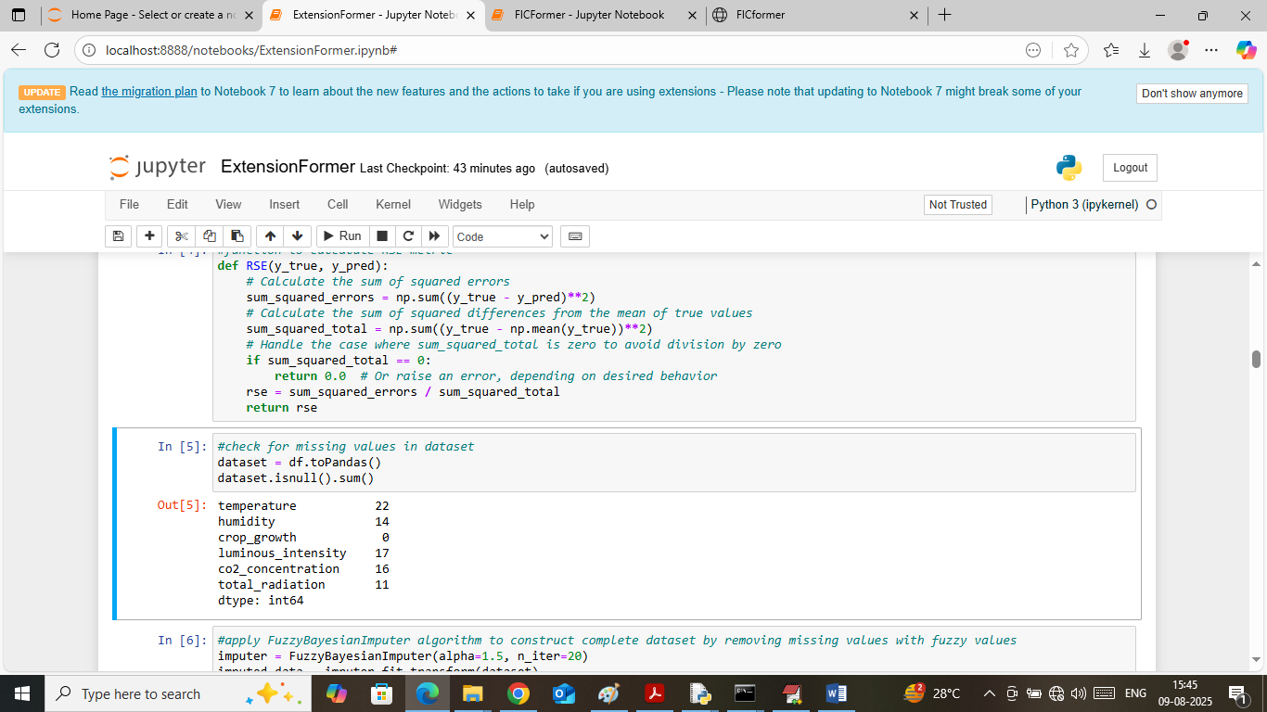
In above screen identifying and displaying number of missing values exists in dataset each column
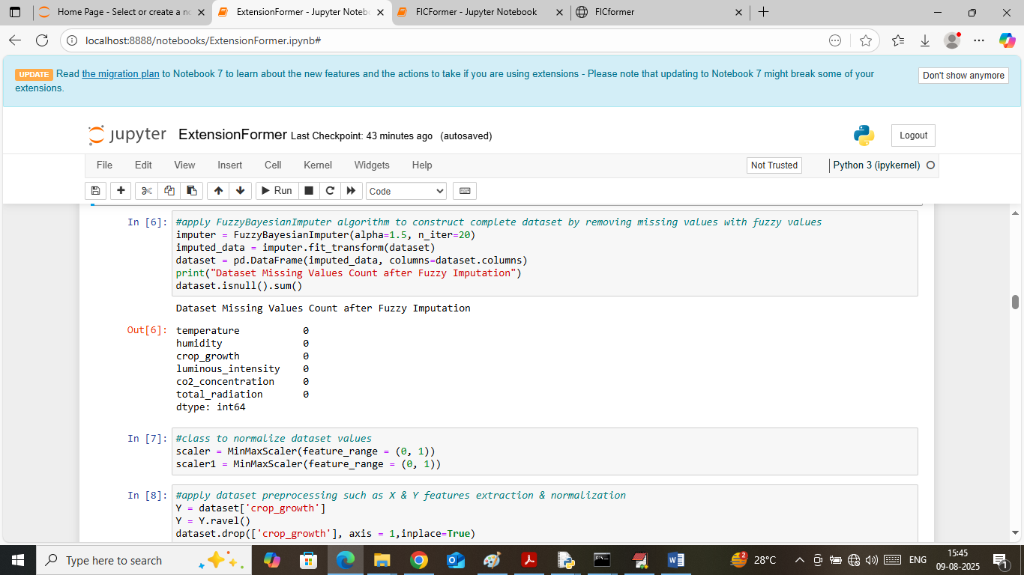
In above screen reconstructing dataset by applying Bayesian Fuzzy imputation algorithm and after reconstruction we got 0 missing values
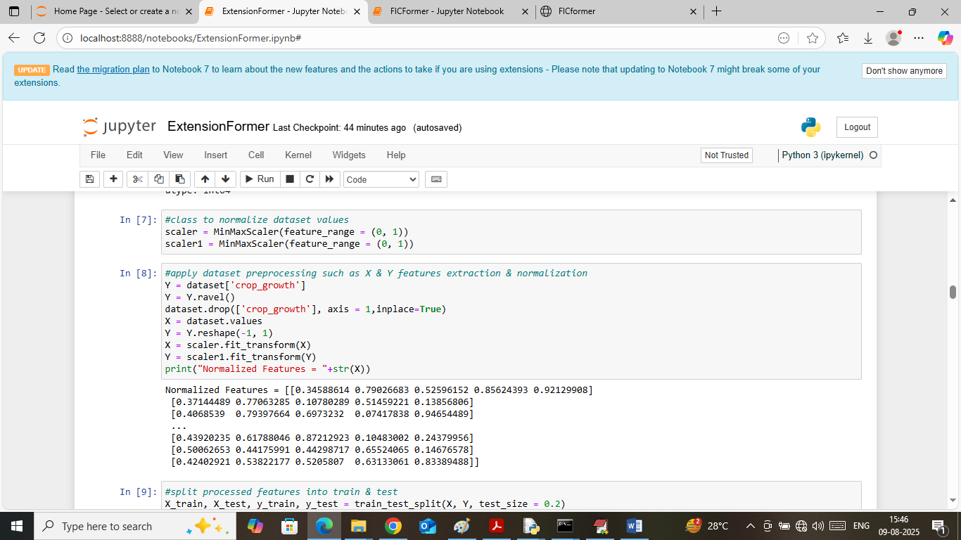
In above screen defining MINMAX scaler normalization object and then extracting X and Y training data and then normalizing them using MINMAX and then displaying normalized values
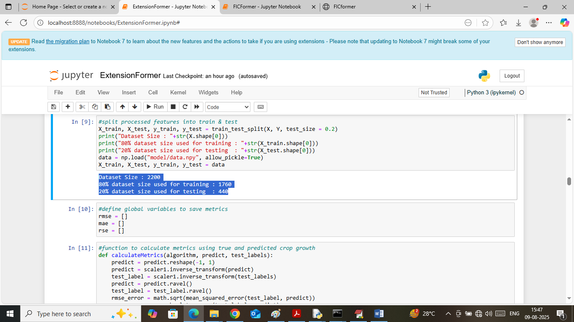
In above screen splitting dataset into train and test where application using 80% data for training and 20% for testing and then defining function to calculate RMSE, RSE and MAE error
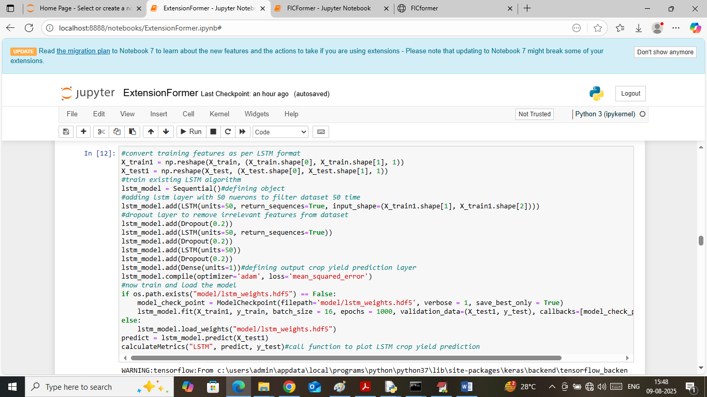
In above screen training existing LSTM algorithm on training data and then applying trained model on 20% test data to get below metrics output
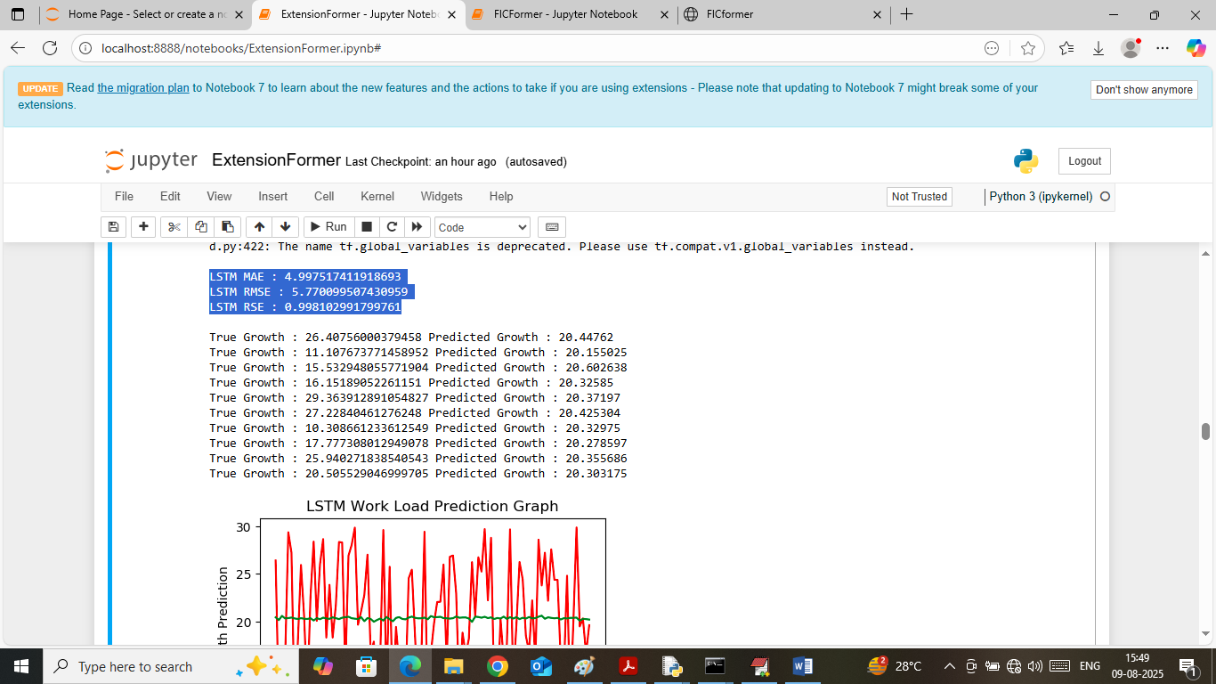
In above screen can see LSTM RSE value as 0.99 and can see RMSE and MAE values and values should be closer to 0 to prove algorithm best but above LSTM performance is not good. In next lines I am displaying true and predicted growth and can see huge difference in both values. Below is the LSTM forecasting graph
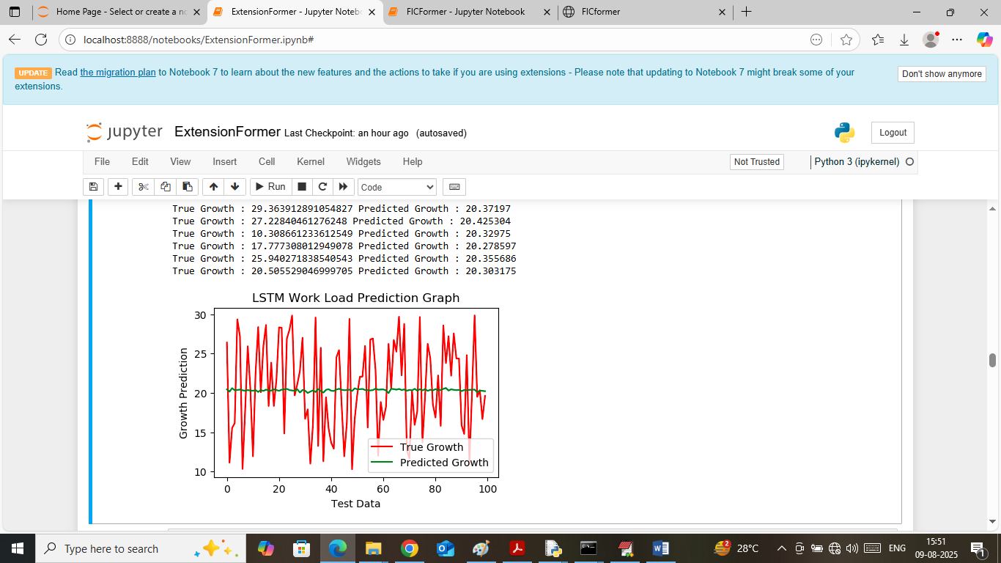
In above LSTM forecasting graph x-axis represents ‘Number of Test data’ and y-axis represents ‘growth’. Red line represents true growth and green line represents predicted growth and can see huge gap between both values so LSTM prediction are not good.
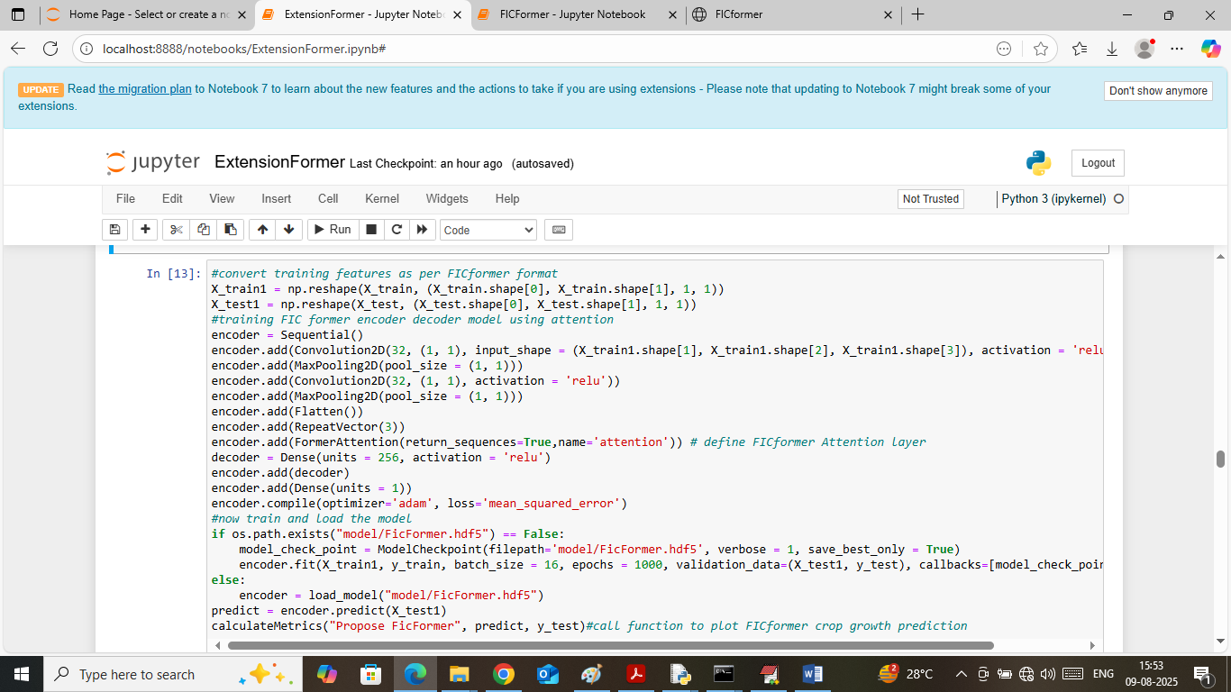
In above screen training propose FICformer algorithm and below is the forecasting result
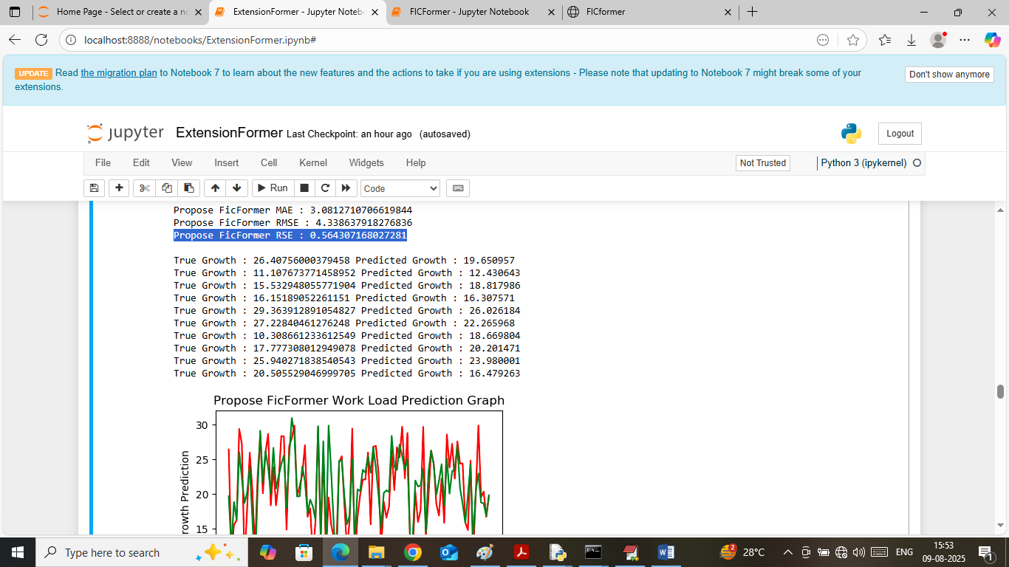
In above screen propose FICformer got 0.56 RSE values and can see other metrics also. In graph both lines are overlapping so can say propose FICformer is accurate in forecasting
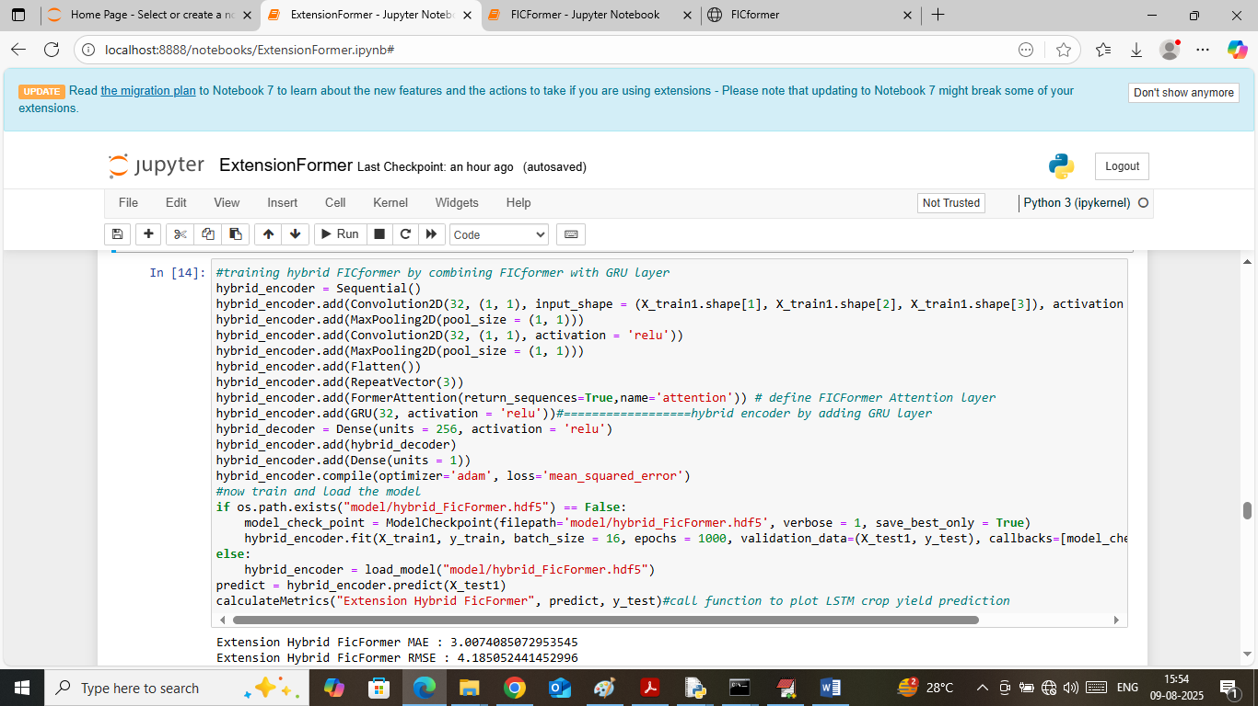
In above screen training extension hybrid model and below is the forecasting output
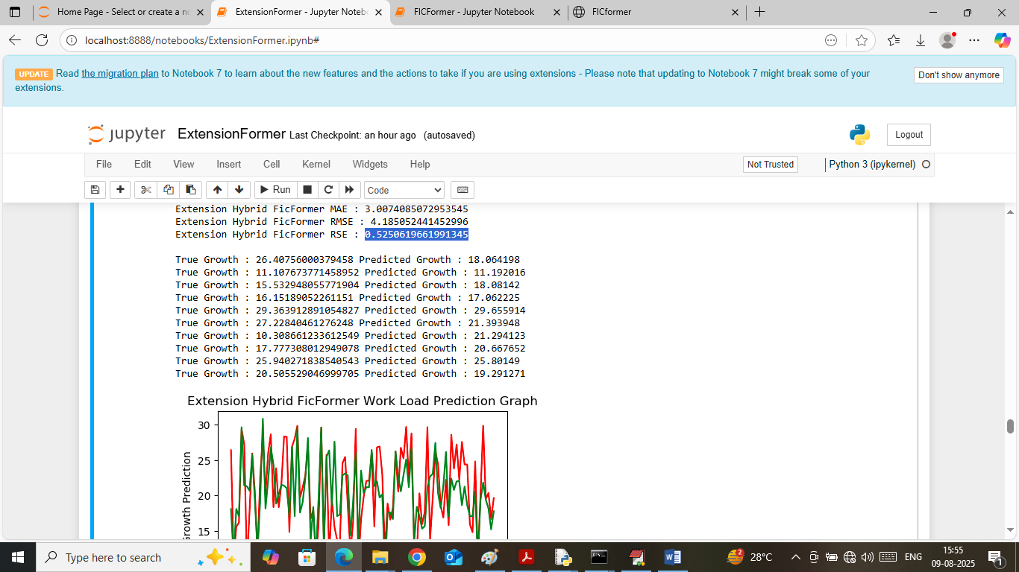
In above screen extension1 got 0.52 RSE error and can see other metrics also
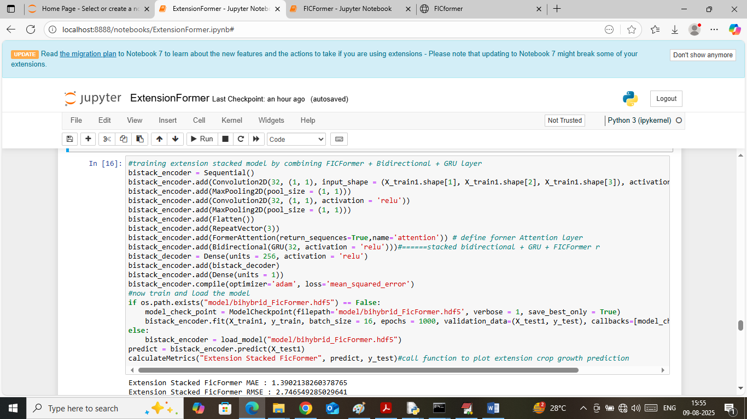
In above screen training extension2 stack model and below is the forecasting output
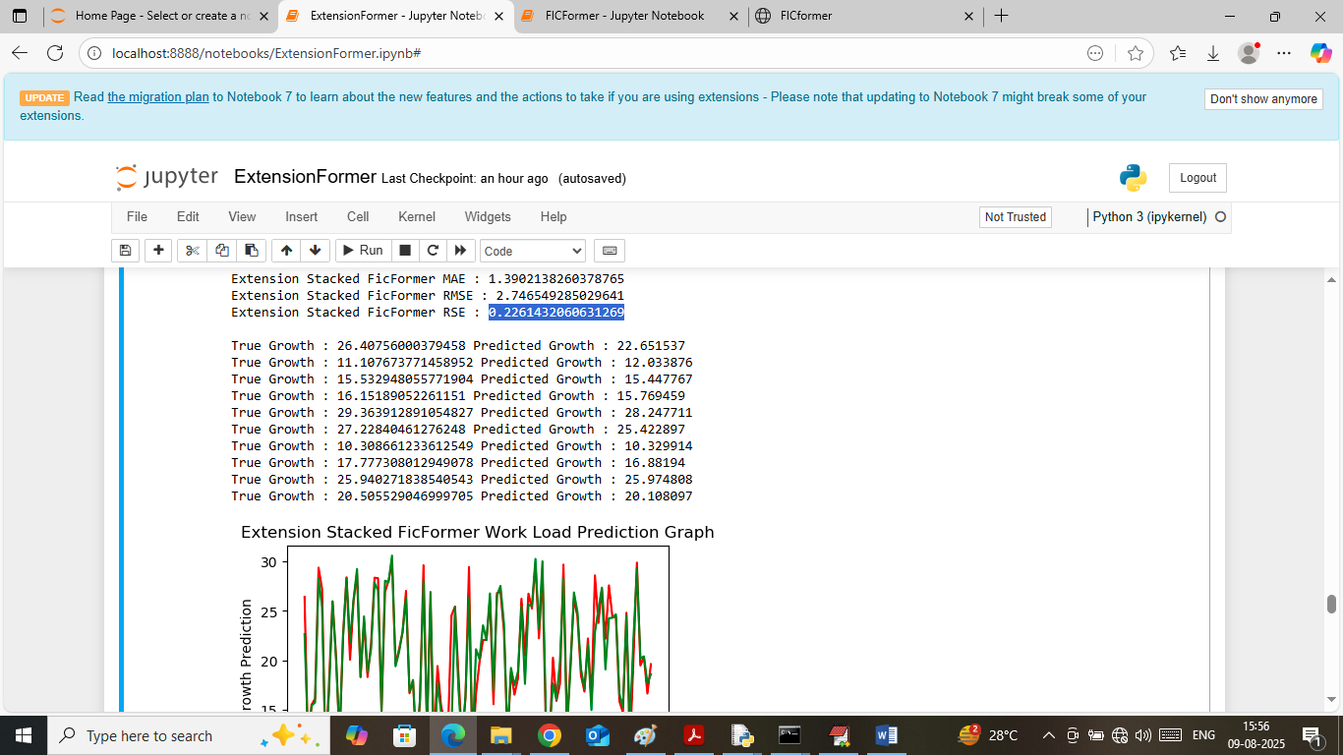
In above screen extension 2 got 0.22 % RSE error which is lower than all algorithms
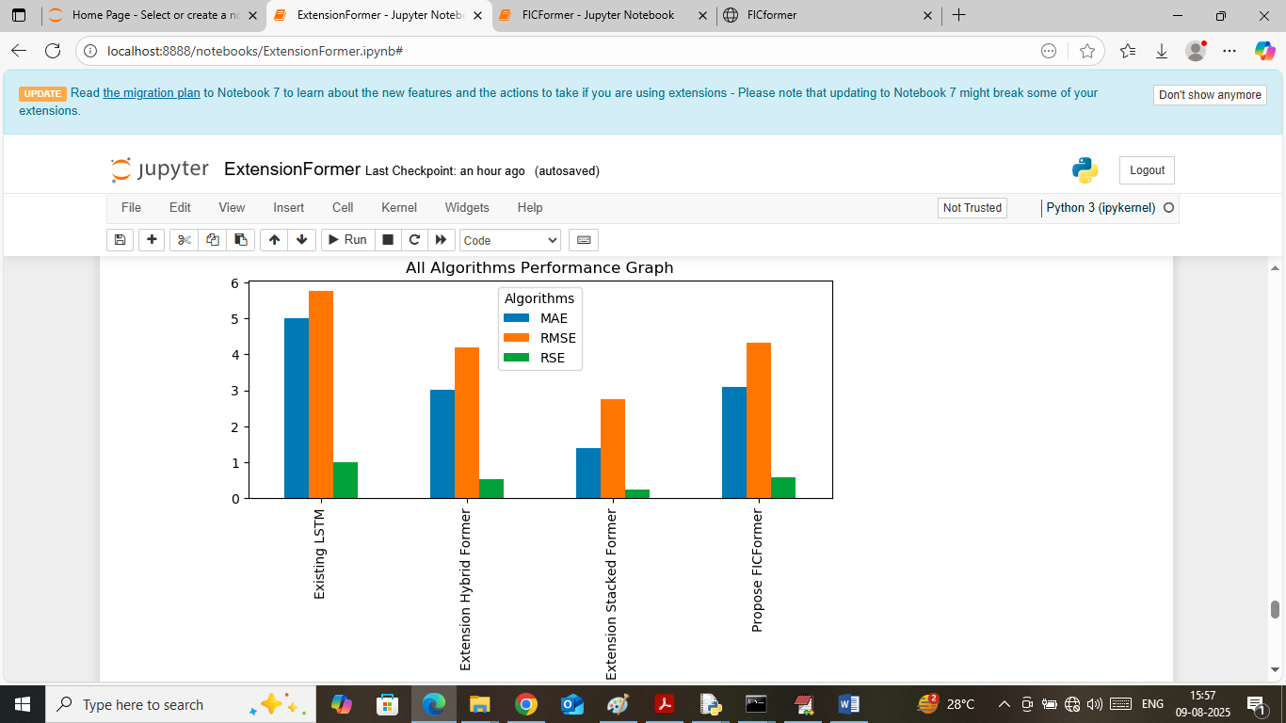
In above screen displaying all algorithms error comparison graph where x-axis represents algorithm names and y-axis represents metrics in different colour bars. In above graph can see propose and extension models got less errors
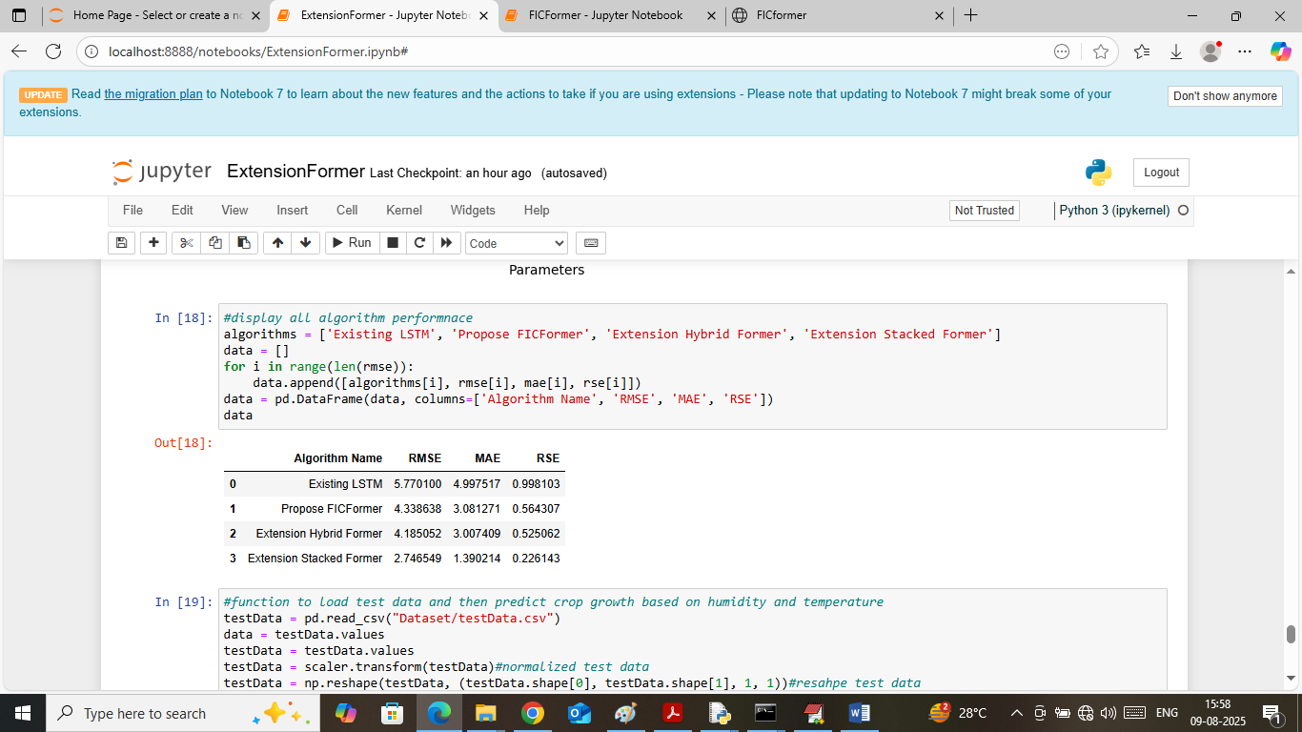
In above screen showing all algorithm performance in tabular format
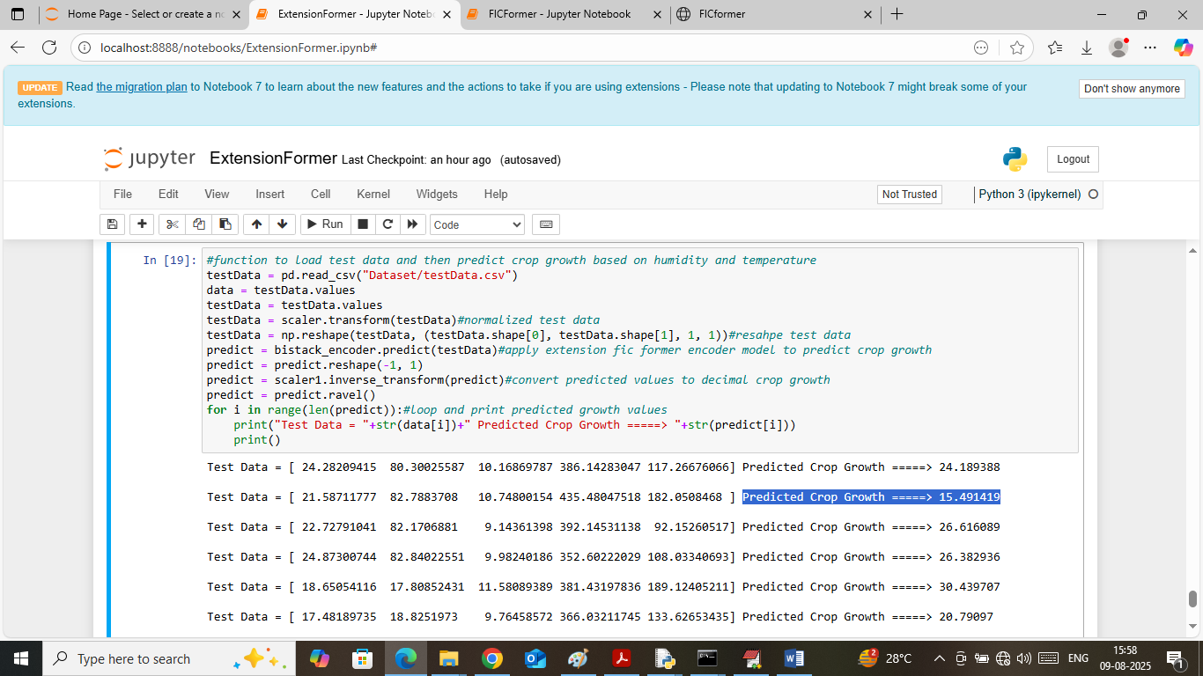
In above screen reading test data values and then applying pre-processing and then applying extension model to perform forecasting. In output panel in square bracket can see TEST data values and after = arrow symbol can see predicted crop growth.
FLASK output
To run flask web module double click on ‘runFlask.bat’ file to start flask server and then will get below page
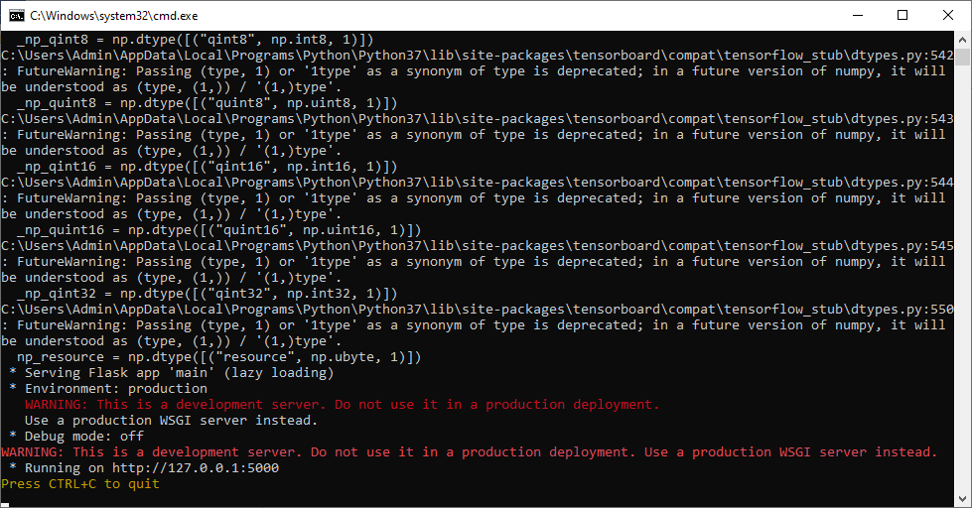
In above screen flask server started and now open browser and enter URL as http://127.0.0.1:5000 and then press enter key to get below page

In above screen click on ‘Register’ link to get below page

In above screen click on ‘Register Button’ after providing details to get below page

In above screen click on ‘User Login’ or directly login with the details link to get below page

In above screen user is login by entering username and password and then press button to get below page

In above screen click on ‘Forecast Crop Growth’ link to get below page
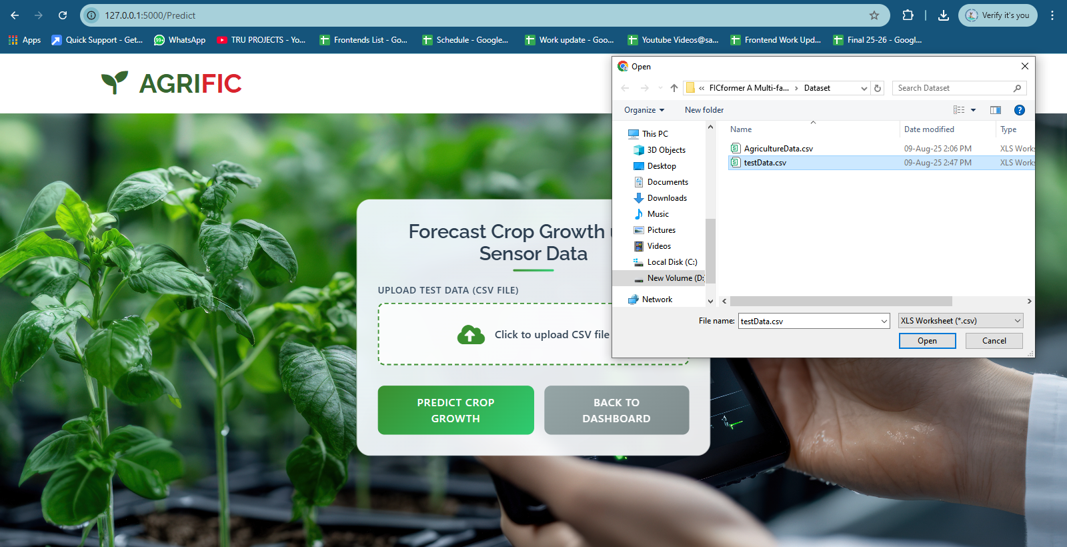
In above screen selecting and uploading ‘testData.csv’ file and then click on ‘buttons’ to get below page
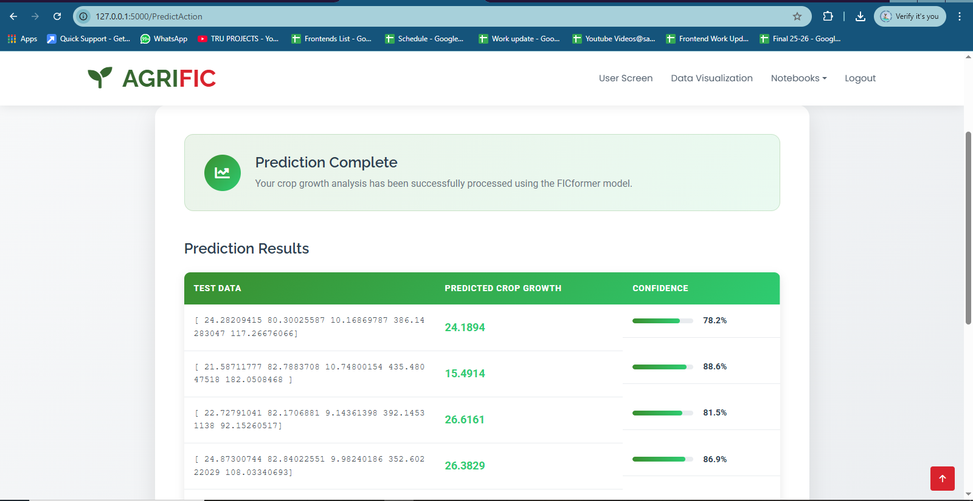
In above screen in first column can see TEST data values and in second column can see forecasted crop growth, third column Confidence Score.
In above screen click on ‘Data Visualization’ link to get below page
