Table of Contents

🛣️ RoadSense AI – AI-Based Road Damage and Pothole Detection
Detects and classifies road surface damage (Longitudinal Crack, Transverse Crack, Alligator Crack, Pothole) in images and videos using a YOLOv8-small object detector trained on the India subset of the RDD2022 / CRDDC2022 dataset, served through a Streamlit web app.
Live demo: https://roadsenseai01.streamlit.app/ (free tier – may be slow or sleeping; see Deployment) Full technical documentation: 02_DOCUMENTATION.md (architecture, code walkthrough, model internals, troubleshooting, how-to guides) Course: B.Tech CSE, 5th semester, Machine Learning project (CSBB 311) – National Institute of Technology Delhi Supervisor: Dr. Gautam Kumar
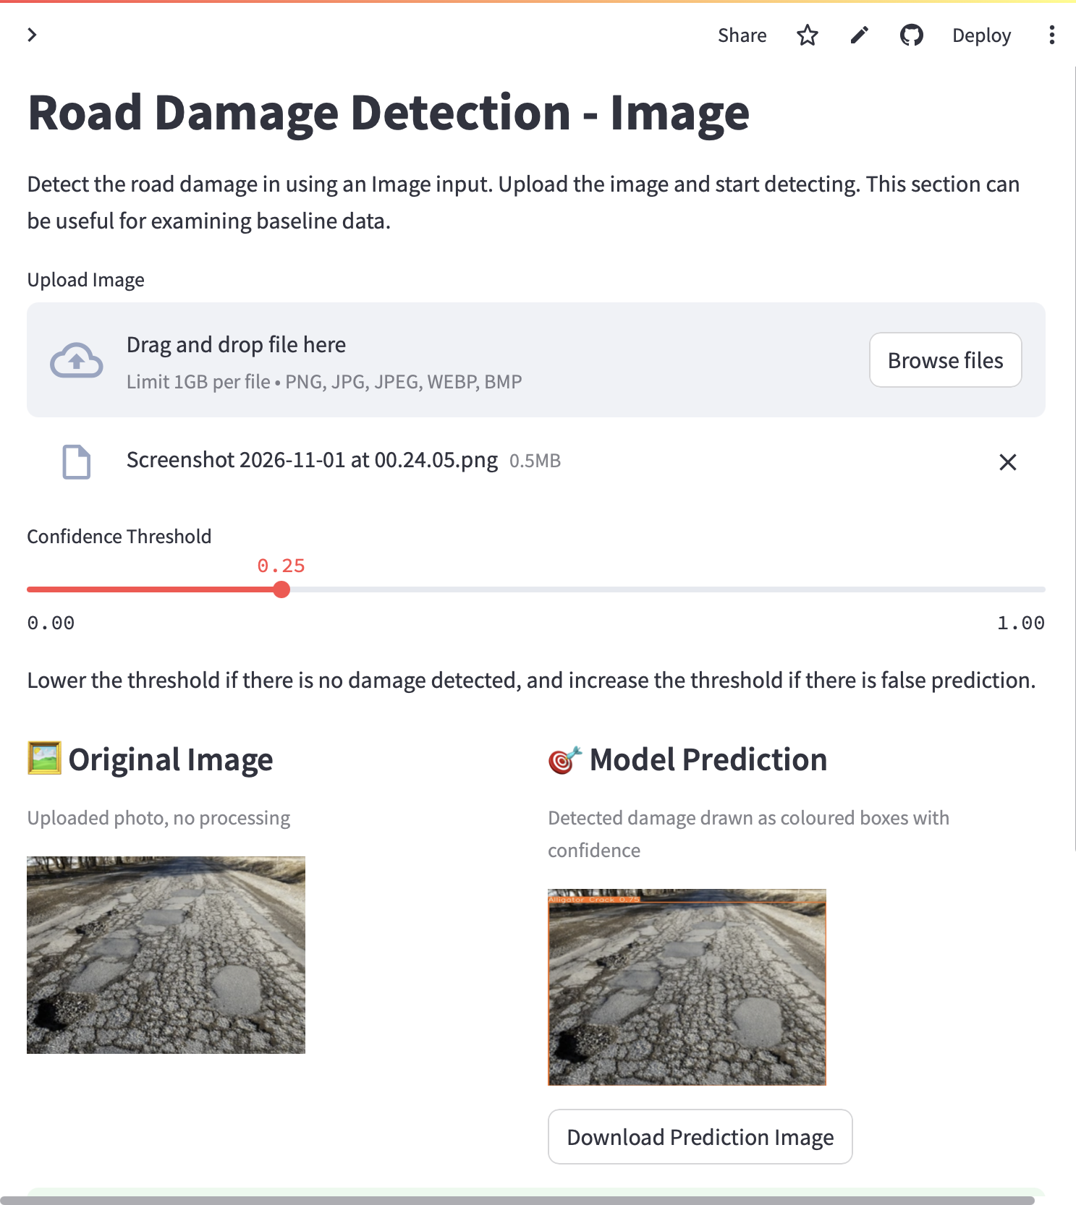
Image Detection page of the deployed app

Table of contents
- Project in one minute
- Repository structure
- The problem and why it is object detection
- Dataset – RDD2022 / CRDDC2022
- Data preparation, step by step
- Data and ML concepts you must know
- Choosing the model – why YOLOv8s
- Training
- Evaluation and results
- Image analysis pipeline
- Video analysis pipeline
- Deployment
- Run it yourself
- Known limitations and future work
- Interview / viva question bank
- Team, credits, licences

⚠️ Read before your viva – facts to verify with the team
These are things a careful examiner could probe. Settle them as a team and keep your answers consistent. 1. Weights provenance. models/YOLOv8_Small_RDD.pt is the baseline weight file of the upstream open-source project oracl4/RoadDamageDetection (the app even downloads it from that URL if the file is missing). Our contribution, as stated in this README, is to study, re-run, evaluate and extend that protocol on the India subset and to build the app. Do not claim to have trained those exact weights from scratch unless the team really did (the training run logs / args.yaml would prove it). 2. Split sizes. The saved output cells of training/0_PrepareDatasetYOLOv8.ipynb print 3594 / 399 (train / val) for India, while the evaluation run (2_EvaluationTesting.ipynb) validates on 1,294 images / 2,272 instances. Those outputs come from different runs. Quote the evaluation figures (1,294 / 2,272) – they are the ones behind every result in this repo – and be ready to say the prep-notebook output is from an earlier run of the upstream notebook. 3. Video page channel order. pages/3_Video Detection.py converts frames BGR→RGB before predict, but Ultralytics expects BGR numpy arrays (the image page was fixed, the video page was not). The output video looks right, but the model sees colour-swapped frames, which can slightly hurt accuracy. See limitations.

1. Project in one minute
Input | A road photo (PNG/JPG/JPEG/WEBP/BMP) or an .mp4 video
Output | The same image/video with a coloured box, class name and confidence around every damaged region; a table of detections; a download button
Classes (4) | Longitudinal Crack (D00), Transverse Crack (D10), Alligator Crack (D20), Pothole (D40)
Data | RDD2022 – India subset (7,706 training images, Pascal VOC XML)
Model | YOLOv8s (single-stage, anchor-free), 11.1 M parameters, 28.4 GFLOPs, fine-tuned from COCO weights
Result | Precision 0.584 · Recall 0.523 · mAP@0.5 0.547 · mAP@0.5:0.95 0.254 on 1,294 validation images
Speed | ≈ 13 ms/image on an RTX 2060 GPU (~75 FPS); ≈ 160 ms/image on the free cloud CPU
App | Streamlit multi-page app (Home · Image · Video · Realtime “coming soon”), deployed on Streamlit Community Cloud
The ML life cycle followed:
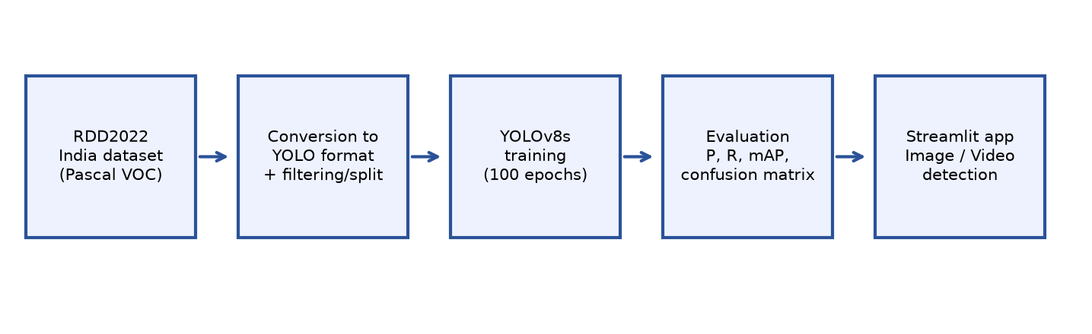
Overall pipeline
Collect data → convert annotations → clean/filter → split → choose model → train → evaluate → build app → deploy

2. Repository structure
RoadDamageDetection/
├── Home.py # Landing page (Streamlit entry point)
├── pages/
│ ├── 1_Realtime Detection.py # "Coming soon" placeholder
│ ├── 2_Image Detection.py # Image upload → detection → table + download
│ └── 3_Video Detection.py # .mp4 upload → frame-by-frame detection → download
├── models/YOLOv8_Small_RDD.pt # Trained YOLOv8s weights (~85 MB)
├── training/
│ ├── 0_PrepareDatasetYOLOv8.ipynb # VOC XML → YOLO txt, filter classes, split
│ ├── 1_TrainingYOLOv8.ipynb # Train YOLOv8s
│ ├── 2_EvaluationTesting.ipynb # Validate: P, R, mAP, confusion matrix
│ ├── dataset/rddIndiaFiltered/rdd_India.yaml # dataset config
│ ├── tools/make_figures.py # regenerates figures/*.png
│ └── yolov8n.pt, yolov8s.pt # COCO pre-trained starting weights
├── sample_utils/download.py # downloads weights if missing
├── figures/ # PR curve, confusion matrix, validation batch images, demo GIFs
├── docs/
│ ├── ML Project Report.docx # Full project report (with figures)
│ └── figures/ # Diagrams and screenshots used here and in the report
├── requirements.txt # pinned Python dependencies
├── packages.txt # apt packages for Streamlit Cloud (libgl1, libglib2.0-0)
└── .streamlit/config.toml # 1 GB upload limit, light theme

3. The problem and why it is object detection
Road inspection in India is mostly manual: slow, subjective, expensive, and large parts of the road network are rarely surveyed. Unrepaired cracks and potholes grow every monsoon and cause accidents and vehicle damage. A smartphone camera plus a trained model can make inspection faster, cheaper, consistent and scalable.
Which ML task is this?
Task | Output | Fits?
Image classification | One label per image (“this image has a pothole”) | ❌ A frame can hold several damages of different types; engineers need to know where
Object detection | Box + class + confidence for every object | ✅ Exactly what we need
Semantic/instance segmentation | A class (or mask) for every pixel | ➖ More precise (crack width/area) but needs expensive pixel-level labels; RDD2022 only has boxes
So the problem is supervised, multi-class object detection with four classes. The hard parts: cracks are thin and low-contrast and easily confused with shadows, road markings, joints and patches; potholes change appearance with lighting, water and size; the model must be fast enough for video; and non-experts must be able to use it.

4. Dataset – RDD2022 / CRDDC2022
RDD2022 is the dataset of the Crowdsensing-based Road Damage Detection Challenge 2022 (IEEE Big Data Cup 2022). It contains about 47,420 smartphone road images from six countries (Japan, India, Czech Republic, Norway, United States, China – the latter split into MotorBike and Drone sub-sets) with more than 55,000 annotated damage instances. Images are collected “crowdsensing” style – ordinary cameras on ordinary vehicles – which makes it realistic for a low-cost system like ours.
Number of training images per sub-set (from the notebook output):
Japan | India | China-Drone | China-MotorBike | Czech | Norway | United States
10,506 | 7,706 | 2,401 | 1,977 | 2,829 | 8,161 | 4,805
Annotation format: one Pascal VOC XML file per image with <size> (width/height) and one <object> per damage with <name> (damage code) and <bndbox> (xmin, ymin, xmax, ymax in pixels).
Damage codes used (the 4 official CRDDC classes):
Class ID | Code | Name | What it is
0 | D00 | Longitudinal Crack | Crack running parallel to the road direction
1 | D10 | Transverse Crack | Crack running across the road
2 | D20 | Alligator Crack | Interconnected cracks forming a mesh (fatigue failure)
3 | D40 | Pothole | Bowl-shaped cavity where surface material has broken away
Other codes can appear in annotation files (D01, D11 construction joints; D43 crosswalk blur; D44 white-line blur; D50 manhole/utility hole). They are not our task, so the conversion script drops them.
Why only India? - Road surfaces, markings, traffic, lighting and camera mounting differ per country. Training and testing on the target domain (Indian roads) gives a model that matches the use case and avoids domain-shift noise from, e.g., Norwegian winter roads or Japanese roads. - A single-country set trains faster on a 6 GB GPU and keeps the experiment clean and explainable. - Trade-off: less data than all six countries combined (see limitations).
Why no test set? The official RDD2022 test annotations are not public (they were used for the challenge leaderboard). We therefore split the labelled training images into train/validation ourselves.
Class balance (validation set, 2,272 instances):
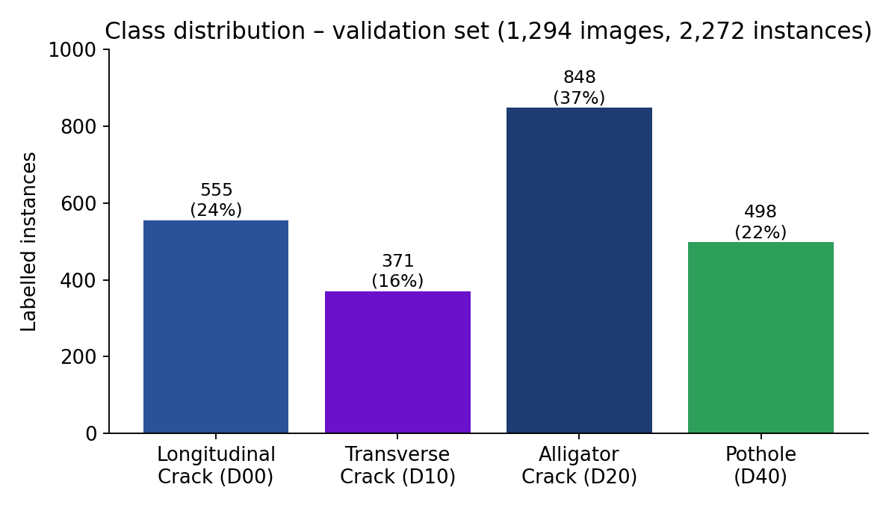
Class distribution
Alligator cracks are the most frequent (37%), transverse cracks the rarest (16%). Imbalance is one reason transverse cracks score lowest.

5. Data preparation, step by step
Implemented in training/0_PrepareDatasetYOLOv8.ipynb.

5.1 Convert Pascal VOC → YOLO format
YOLO wants one .txt per image, one line per box: class x_center y_center width height, all normalised to 0–1 by the image size.
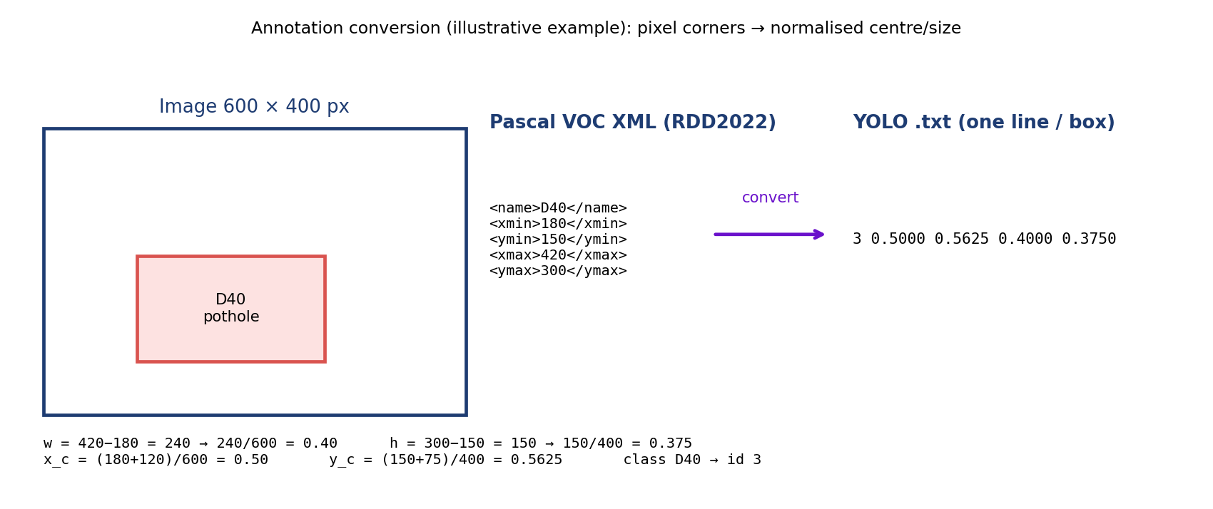
VOC to YOLO conversion
w = xmax − xmin h = ymax − ymin
cx = xmin + w/2 cy = ymin + h/2
w_n = w / image_width h_n = h / image_height
cx_n = cx / image_width cy_n = cy / image_height
Why normalise? Labels become independent of image resolution, so the same file works when the image is resized to 640 × 640 for training.
The function convertPascal2YOLOv8 maps the codes (D00→0, D10→1, D20→2, D40→3, anything else → “ignored”) and writes only classes < 4.

5.2 Background images (negative samples)
Images with no usable damage are kept only up to 10 % of the dataset size. Why? A model that never sees “nothing to detect” produces false alarms on clean roads; but too many empty images would swamp the positives and push the model toward predicting nothing. 10 % is a compromise.

5.3 Train / validation split
CopyDatasetSplit shuffles with random.seed(1337) and splits 90 % train / 10 % validation, copying images and labels to images/{train,val} and labels/{train,val}. The fixed seed makes the split reproducible. The dataset YAML (rdd_India.yaml) lists the train/val folders and the 4 class names.
Caveat to mention honestly: random image-level splitting can put near-duplicate frames from the same road/video in both sets (data leakage), which makes validation scores a little optimistic. A split by road/sequence would be stricter.

5.4 Resulting evaluation set
1,294 images (177 background), 2,272 labelled instances: Longitudinal 555 · Transverse 371 · Alligator 848 · Pothole 498.

6. Data and ML concepts you must know
Short, exam-ready definitions grouped by topic. (Every one of these is a possible question.)

6.1 Data concepts
- Supervised learning – learning from labelled examples (image + boxes + classes).
- Bounding box – rectangle around an object; stored as corners (VOC) or centre/size (YOLO).
- Annotation / label noise – humans label thin cracks inconsistently; this caps the achievable accuracy.
- Normalisation – scaling coordinates to 0–1 (labels) and pixel values to 0–1 (images) so training is stable and resolution-independent.
- Train / validation / test – train fits the weights; validation tunes choices and monitors overfitting; test is touched once for the final unbiased number. We have no public test set, so the validation split doubles as our report set.
- Data leakage – information from validation leaking into training (e.g. near-duplicate frames) → over-optimistic scores.
- Class imbalance – unequal class frequencies; rare classes are learned worse. Remedies: more data, class weights, oversampling, focal loss, targeted augmentation.
- Background / negative images – images without objects; reduce false positives.
- Data augmentation – random label-preserving changes (flip, scale, translate, HSV colour jitter, mosaic) that enlarge the effective dataset and improve generalisation.
- Mosaic augmentation – stitches 4 training images into one. We switched it off (mosaic=0.0) because stitching cuts and rescales thin cracks and creates artificial borders that look like cracks.
- Domain shift – train and deployment data differ (country, camera, weather) → accuracy drops.
- Transfer learning – start from weights trained on a big dataset (COCO, 80 everyday classes) and fine-tune. Early layers already know edges/textures; we only adapt to roads. Faster, needs less data, usually more accurate.

6.2 Model/training concepts
- Epoch – one full pass over the training set (we use 100). Batch size – images per weight update (32). Iteration – one update.
- Learning rate (LR) – step size of gradient descent. Warm-up – start with a tiny LR for the first 5 epochs so fresh heads don’t destroy pre-trained features. Cosine schedule – LR decays smoothly like a half-cosine, so late training takes small, stable steps.
- Overfitting – train score ≫ validation score (model memorises). Underfitting – both low. Signs: watch val loss/mAP curves; fixes: more data, augmentation, early stopping, smaller model, weight decay.
- Loss – the number being minimised. YOLOv8 uses box loss (CIoU + Distribution Focal Loss), classification loss (binary cross-entropy) – there is no separate objectness term (anchor-free).
- Seed – fixing the random seed (1337) makes runs reproducible (GPU non-determinism aside).
- Checkpoint (save_period=10) – saved weights every 10 epochs so training can be resumed.
- Anchor boxes – pre-defined box shapes older detectors regress from. YOLOv8 is anchor-free: it predicts the box directly from each grid location – fewer hyper-parameters, better with odd shapes like long thin cracks.
- Stride / feature map – the network predicts at strides 8, 16, 32 (80×80, 40×40, 20×20 grids for a 640 input) to catch small, medium, large objects.
- NMS (non-maximum suppression) – many overlapping boxes are predicted for one object; NMS keeps the highest-confidence box and removes others whose IoU with it exceeds a threshold.

6.3 Evaluation concepts
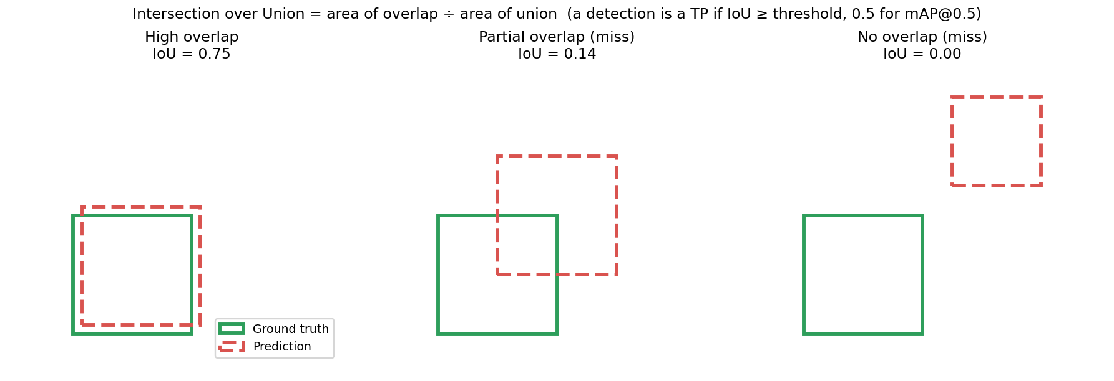
IoU
- IoU = overlap area ÷ union area of predicted and true box.
- TP – correct class and IoU ≥ threshold. FP – a box with no matching true damage (or wrong class). FN – real damage that no box matched. TN – not meaningful in detection (infinite empty boxes).
- Precision = TP/(TP+FP) – of what I flagged, how much was real? Recall = TP/(TP+FN) – of what is real, how much did I find? F1 = 2PR/(P+R).
- Confidence threshold (τ) – minimum score to display a box. Low τ → high recall, low precision; high τ → opposite. This is why the app has a slider.
- PR curve – precision vs recall as τ sweeps; AP = area under it for one class; mAP = mean AP over classes.
- mAP@0.5 – IoU threshold 0.5 (lenient). mAP@0.5:0.95 – averaged over IoU 0.5, 0.55 … 0.95 (strict, the COCO metric; rewards tight boxes).
- Confusion matrix – rows/cols = classes + “background”; shows class mix-ups, missed objects (FN → predicted as background) and false alarms (FP on background).
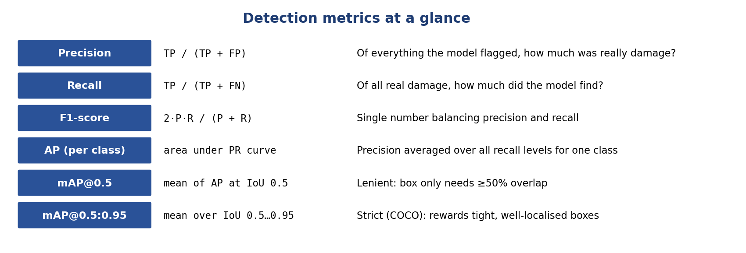
Metrics cheat sheet

7. Choosing the model – why YOLOv8s

7.1 Requirements
- Must localise and classify multiple damages per image → object detection.
- Must be fast (video, ideally real-time) → single-stage.
- Must be accurate on small/thin objects → multi-scale features.
- Must be trainable on one 6 GB consumer GPU and servable on a free CPU host → small model.
- Must have pre-trained weights and a mature tool-chain (train, validate, export, plot) → open source, active.

7.2 Alternatives considered (design rationale – we did not train these)
Family | Strengths | Why not chosen
Faster R-CNN (two-stage) | High accuracy, strong baseline | Slower and heavier; harder to serve on CPU/video
SSD / RetinaNet | Fast single-stage | Anchor tuning needed; SSD weaker on small objects; older tool-chains
YOLOv5 | Mature, popular | Anchor-based; YOLOv8 is its successor with better accuracy/speed
DETR / RT-DETR (transformers) | No NMS, global context | Long training schedules, more data and GPU memory; less friendly for a small project
Segmentation (Mask R-CNN, YOLOv8-seg) | Pixel-accurate masks | Needs pixel labels; RDD2022 only has boxes
YOLOv8 ✅ | Single-stage, anchor-free, fast, strong accuracy, COCO weights, full tool-chain | –

7.3 Why the small variant (s)?
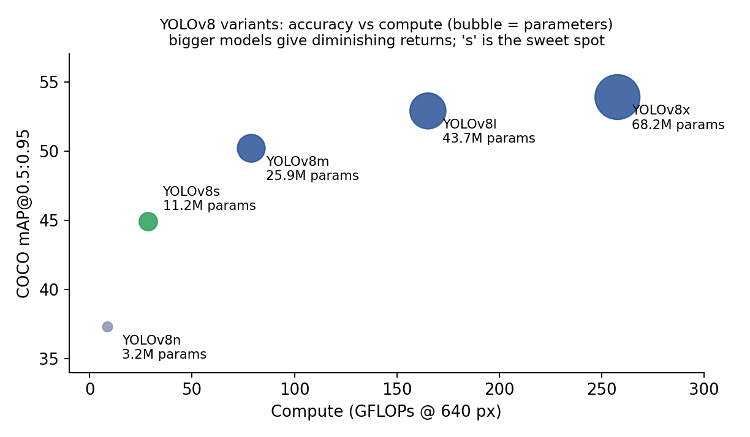
YOLOv8 sizes
Variant | Params | GFLOPs | COCO mAP@0.5:0.95
YOLOv8n | 3.2 M | 8.7 | 37.3
YOLOv8s | 11.2 M | 28.6 | 44.9
YOLOv8m | 25.9 M | 78.9 | 50.2
YOLOv8l | 43.7 M | 165.2 | 52.9
YOLOv8x | 68.2 M | 257.8 | 53.9
(Published Ultralytics COCO numbers; our road model: 11.1 M params, 28.4 GFLOPs with 4 classes.) n loses too much accuracy for thin cracks; m and above need ~2.3×–6× the parameters and ≥2.8× the compute for modest gains and would not fit comfortably on a free CPU host; s is the knee of the curve. A larger model is listed as future work.

7.4 How YOLOv8 works (30-second version)
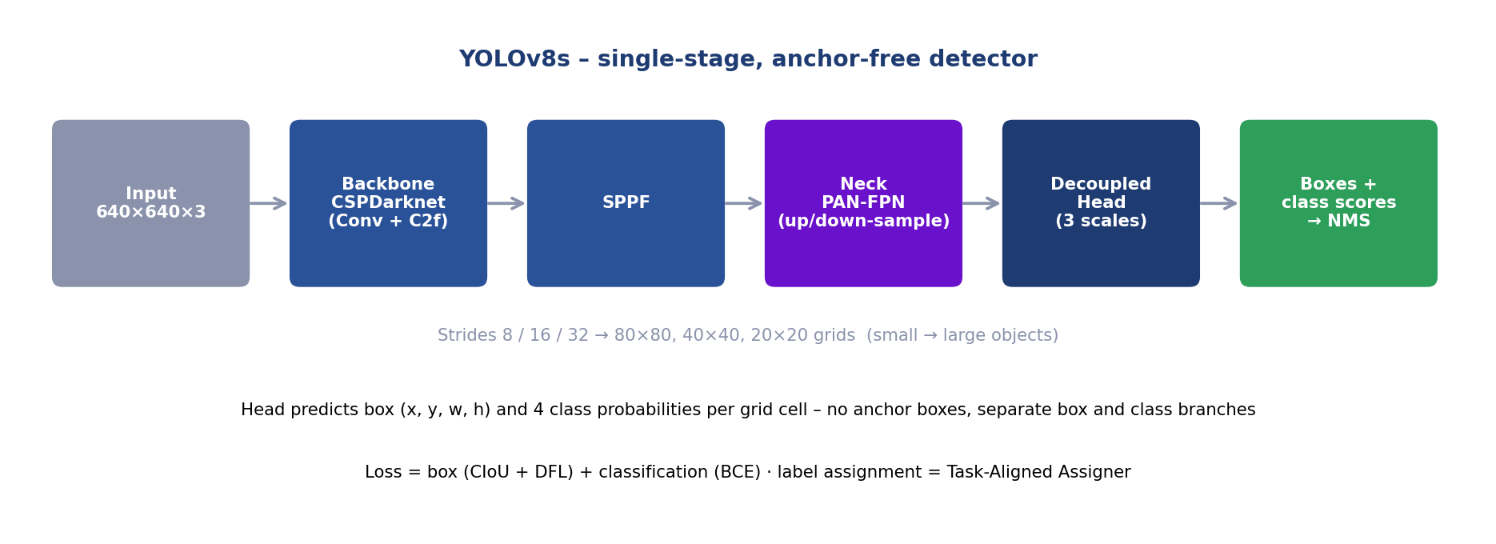
YOLOv8 architecture
- Backbone (CSPDarknet with C2f blocks + SPPF) – turns the image into feature maps at several scales (edges → textures → shapes).
- Neck (PAN-FPN) – mixes high-resolution detail with deep semantic features (top-down and bottom-up paths) so small cracks and big potholes are both seen.
- Decoupled head – separate branches predict where (box) and what (class) at each grid cell of the three scales; no anchors.
- Training-time label assignment – the Task-Aligned Assigner decides which grid cells are responsible for which ground-truth box.
- Inference – every cell proposes a box + class scores; low-confidence ones are dropped (τ) and NMS removes duplicates.
“You Only Look Once”: the whole image goes through the network once, instead of proposing regions first and classifying them (two-stage).

8. Training
Implemented in training/1_TrainingYOLOv8.ipynb.
model = YOLO('yolov8s.pt') # COCO pre-trained
model.train(data='rdd_India.yaml', epochs=100, warmup_epochs=5,
batch=32, imgsz=640, save_period=10, workers=1,
seed=1337, cos_lr=True, mosaic=0.0)
Setting | Value | Why
Base weights | yolov8s.pt (COCO) | Transfer learning
Epochs / warm-up | 100 / 5 (5 %) | Enough to converge on ~thousands of images; warm-up protects pre-trained features
Batch size | 32 | Fits a 6 GB GPU at 640 px; stable gradients
Image size | 640 × 640 | YOLO standard; cracks stay visible; speed/accuracy balance
LR schedule | Cosine (cos_lr=True) | Smooth decay, good final convergence
Mosaic | Off (0.0) | Preserves thin cracks (see §6.1)
Seed | 1337 | Reproducibility
Checkpoints | every 10 epochs | Resume with resume=True
Other | Ultralytics defaults (optimizer auto, HSV colour jitter, scale/translate, horizontal flip, weight decay) | Not changed
Hardware | NVIDIA RTX 2060 (6 GB), CUDA, PyTorch 2.0, Ultralytics 8.0.201
resume=True continues an interrupted run from last.pt.

9. Evaluation and results
training/2_EvaluationTesting.ipynb runs model.val() on the validation split.
Validation set: 1,294 images, 2,272 instances (≈ 13 ms/img on RTX 2060: 0.7 pre + 9.3 inference + 3.4 post).
Class | Instances | Precision | Recall | F1 | mAP@0.5 | mAP@0.5:0.95
Longitudinal Crack | 555 | 0.573 | 0.471 | 0.517 | 0.501 | 0.235
Transverse Crack | 371 | 0.522 | 0.433 | 0.473 | 0.454 | 0.177
Alligator Crack | 848 | 0.659 | 0.684 | 0.671 | 0.709 | 0.373
Pothole | 498 | 0.584 | 0.503 | 0.540 | 0.524 | 0.229
All | 2,272 | 0.584 | 0.523 | 0.552 | 0.547 | 0.254
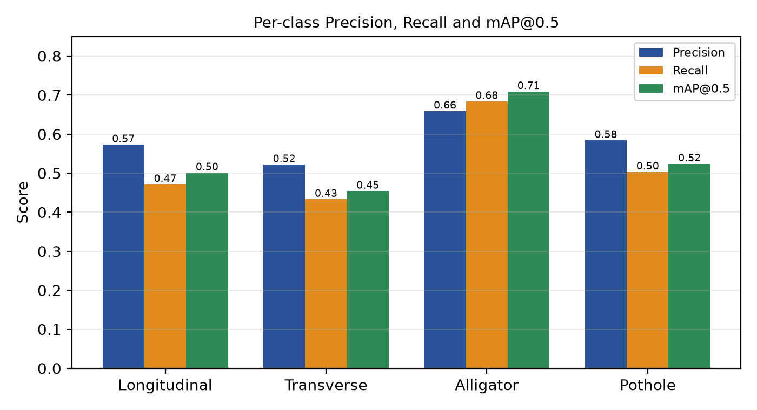
Per-class metrics
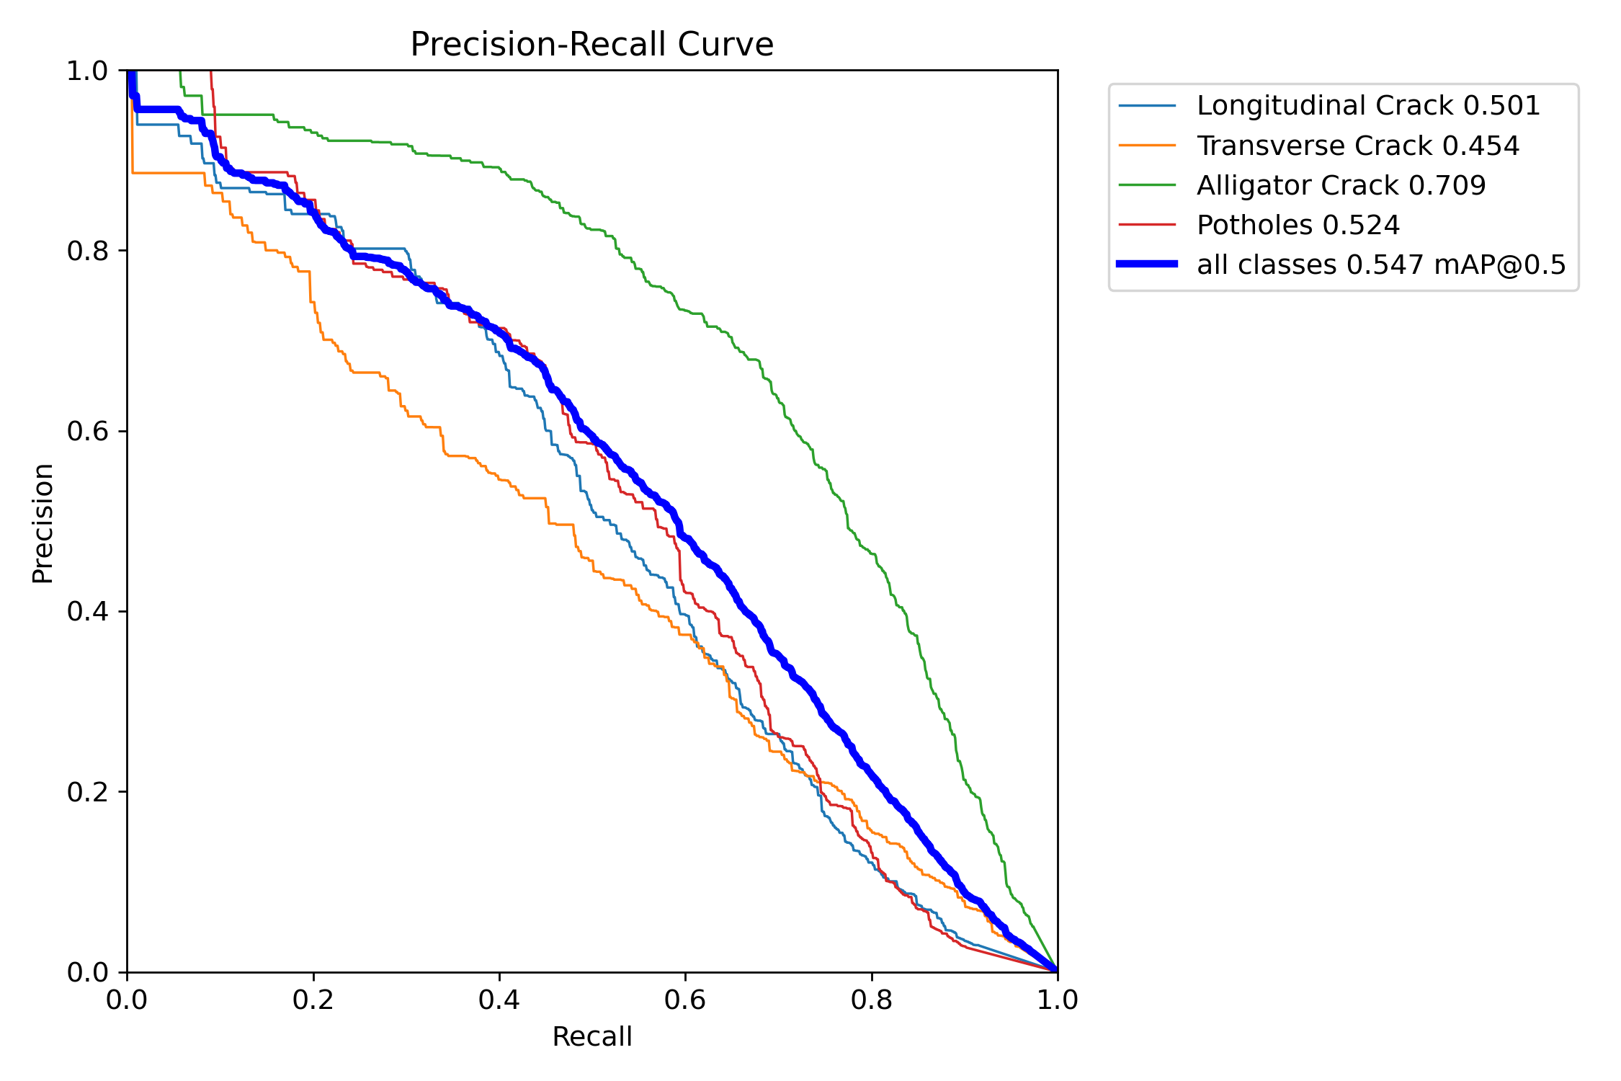
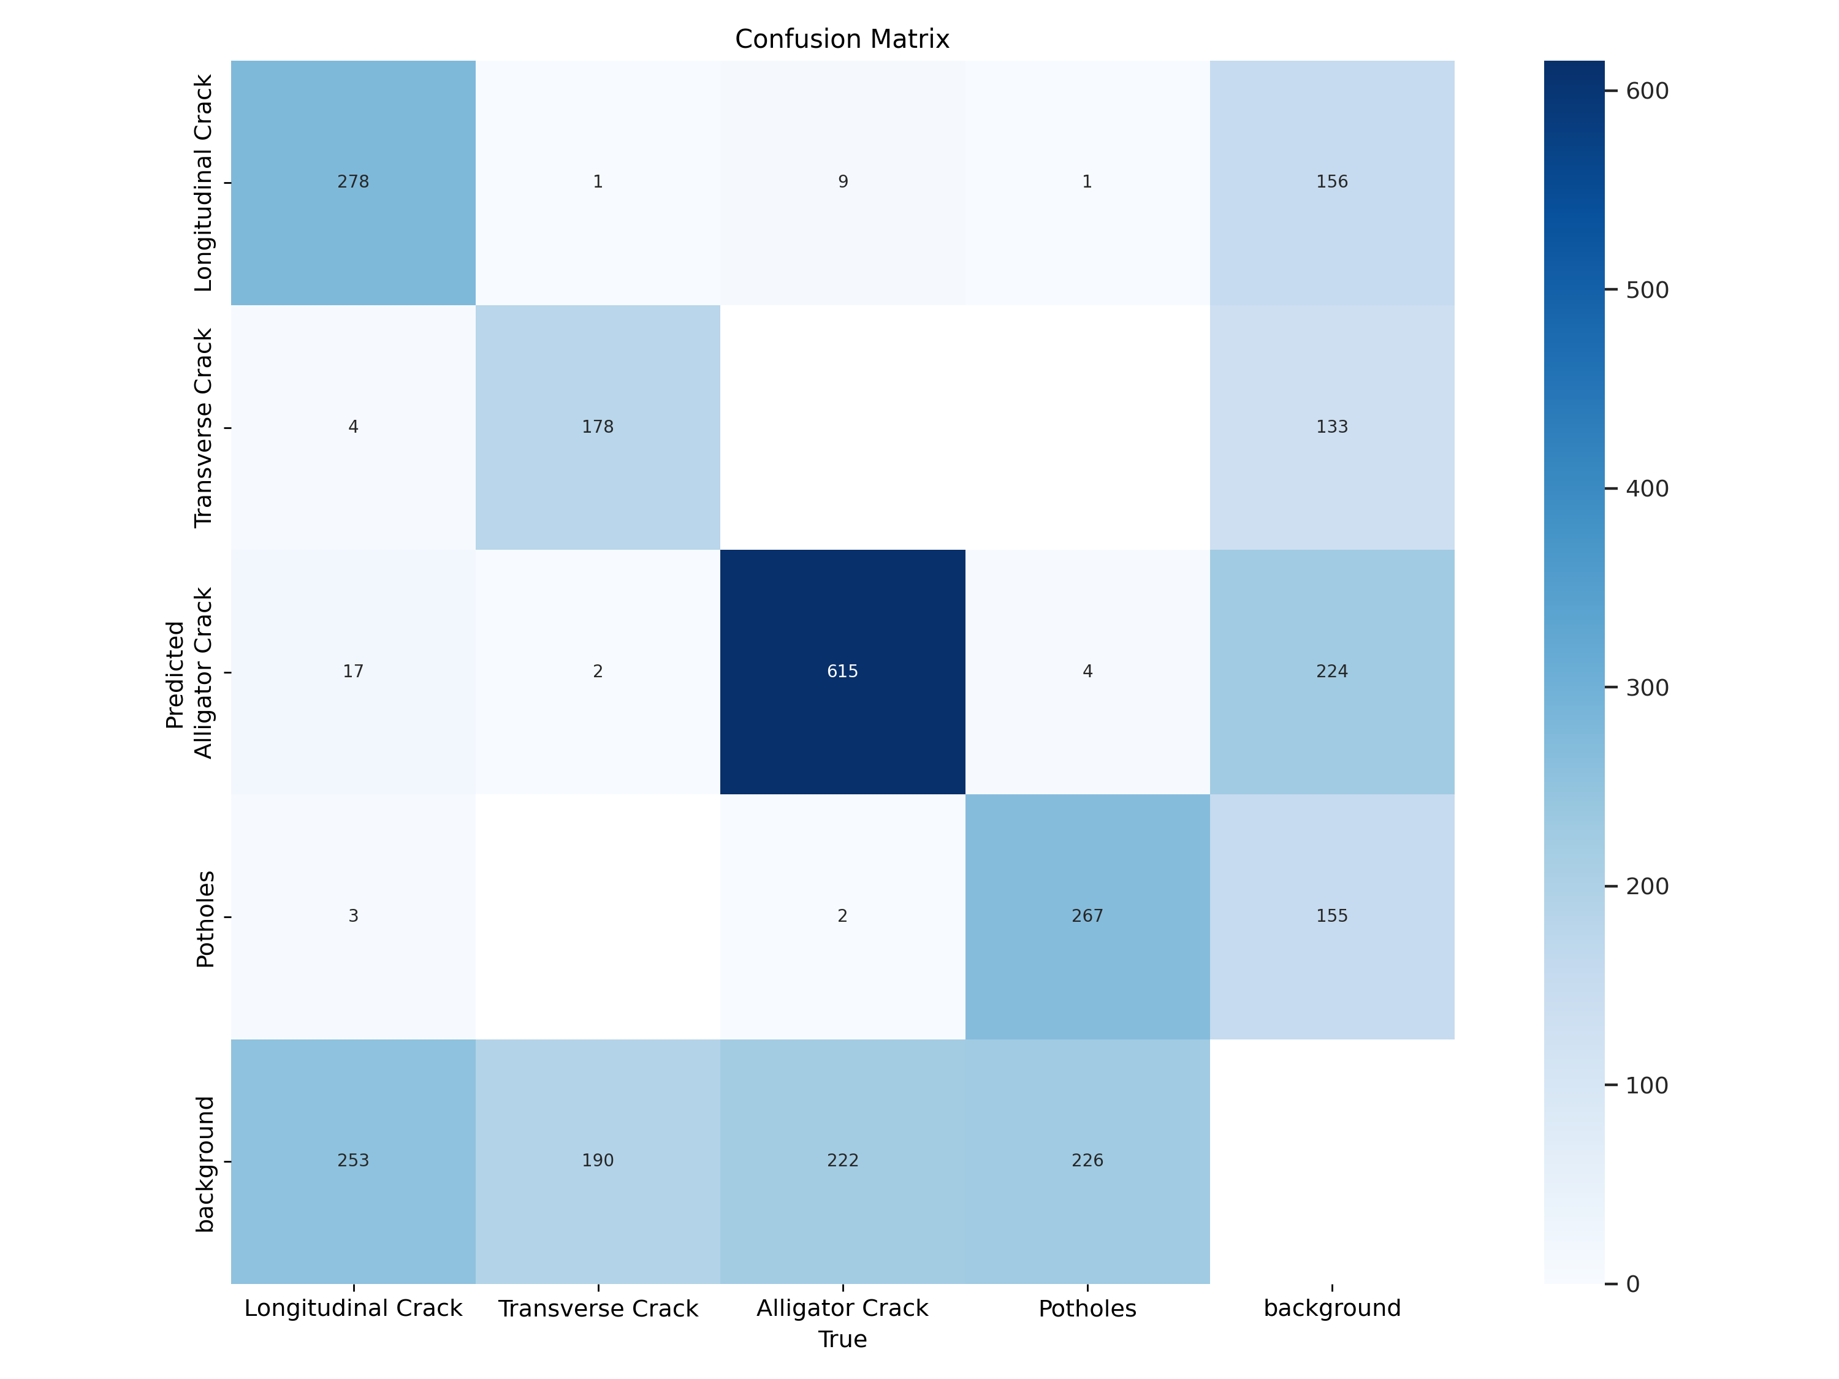
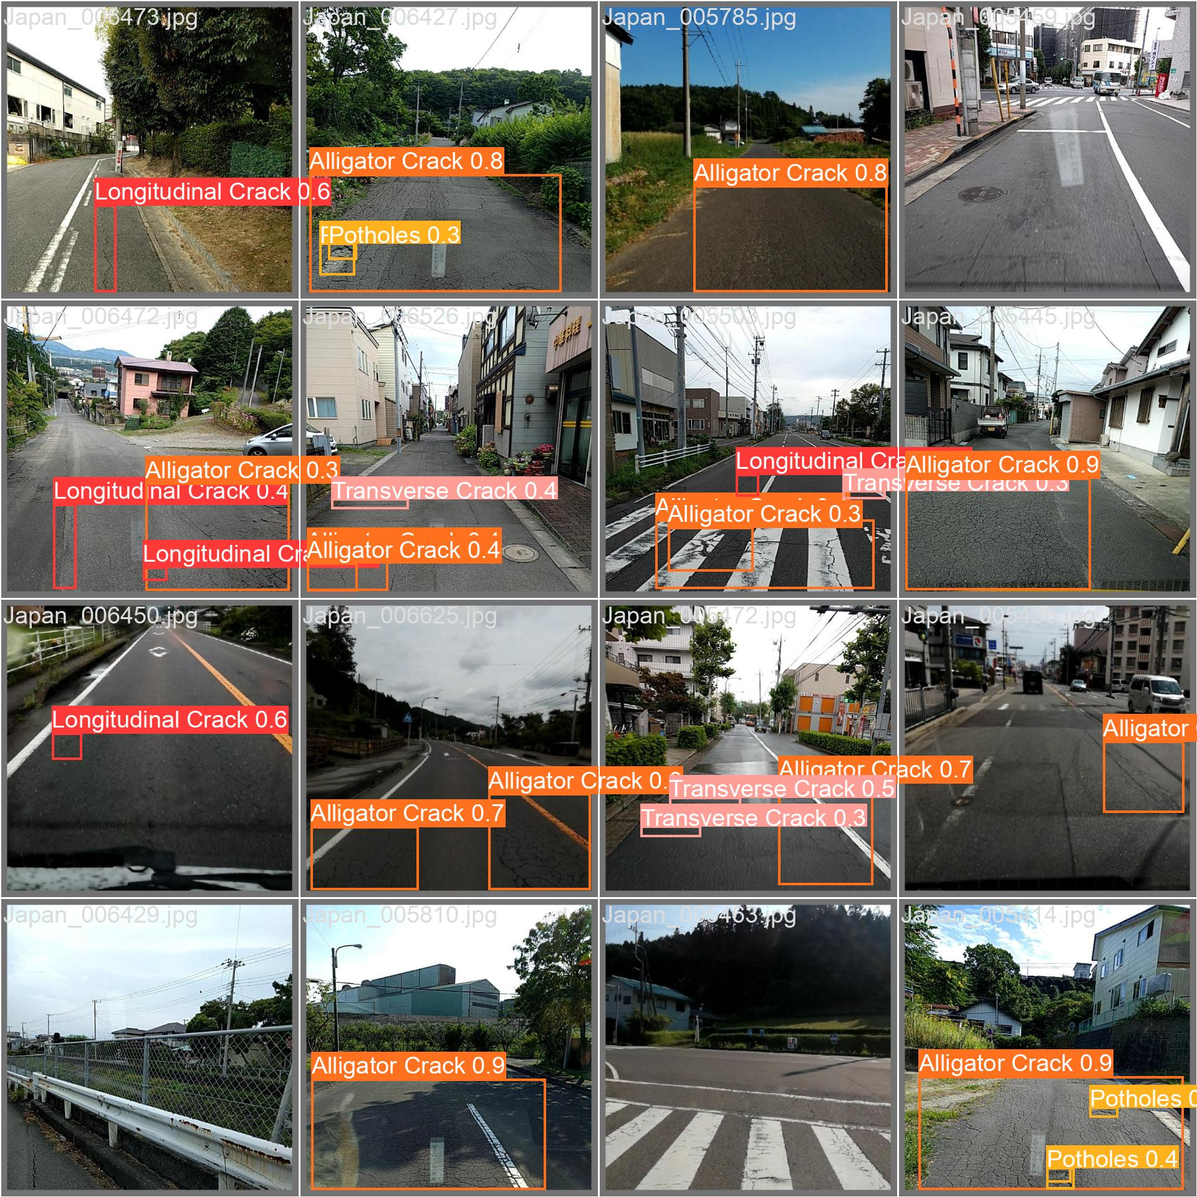
Predictions on a validation batch

How to read the results
- Alligator cracks are best (0.709 mAP@0.5): large, textured, distinctive, and the most frequent class.
- Transverse cracks are worst (0.454): thin, short, few pixels at 640 px, easily confused with joints/edges/shadows, and the rarest class.
- Classes are rarely confused with each other. In the confusion matrix only a handful of cases go between damage types (e.g. 9 longitudinal → alligator, 17 alligator → longitudinal). The errors are mostly missed damage (≈ 190–253 per class predicted as background) and false alarms on background (≈ 133–224 per class).
- PR curve: precision stays high (> ~0.8) up to ~0.3 recall, then falls – so raising τ gives cleaner but fewer detections.
- mAP@0.5:0.95 (0.254) ≪ mAP@0.5 (0.547): the model finds damage but boxes are not always tight – expected, because crack extents are ambiguous even for human labellers.
- Is 0.547 good? For this dataset, yes, it is a reasonable baseline: road damage is a hard, noisy-label problem. It is not production grade (about half of the thin cracks are missed) – we are explicit about that.

10. Image analysis pipeline
File: pages/2_Image Detection.py · diagram below (top row).
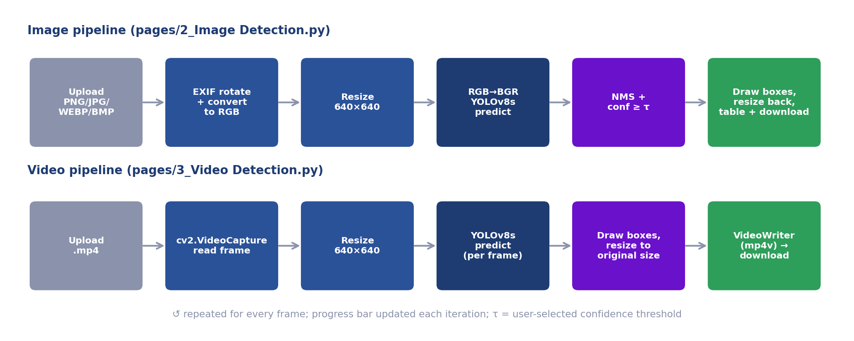
Inference pipelines
- Upload (st.file_uploader: PNG, JPG, JPEG, WEBP, BMP).
- Normalise: ImageOps.exif_transpose (phones store rotation in EXIF – without this the model sees a sideways road) → .convert("RGB") (handles grayscale, RGBA/PNG transparency, palette images).
- Resize to 640 × 640 with cv2.INTER_AREA (good for down-scaling) – matches the training resolution.
- Colour order: convert RGB → BGR because Ultralytics treats numpy arrays as BGR (OpenCV convention).
- Inference: net.predict(img, conf=τ) – the network produces boxes; confidence filter τ and NMS are applied. Default τ = 0.25 (lowered from 0.50 because confidence on thin cracks is naturally modest).
- Post-process: results[0].plot() draws boxes/labels → BGR→RGB → resize back to the original size so the output has the user’s resolution.
- Present: original and annotated side by side, a table (class + confidence, sorted), a warning if nothing was detected (“lower the threshold”), and a PNG download.
- Model loading: YOLO(...) is created once and stored in st.session_state so it isn’t reloaded on every interaction. download_file fetches the weights if absent.
Fixes the team made to this pipeline: RGB normalisation, EXIF rotation, consistent RGB/BGR, more formats, default τ = 0.25, detection summary table.

11. Video analysis pipeline
File: pages/3_Video Detection.py · diagram above (bottom row).
- Upload an .mp4; the file is written to ./temp/video_input.mp4.
- cv2.VideoCapture reads metadata (width, height, FPS, frame count → duration).
- For every frame: resize to 640 × 640 → net.predict(conf=τ) (default τ = 0.5 on this page) → draw boxes → resize back to the original width/height → write with cv2.VideoWriter (mp4v codec, same FPS) to ./temp/video_infer.mp4; the current frame is shown live and a progress bar is updated.
- When finished: download button for the annotated video and a restart button.
Design notes: - Frame-by-frame, independent detection – no tracking, so the same pothole can get a new detection each frame and cannot be counted uniquely. Tracking (ByteTrack/BoT-SORT, built into Ultralytics) + counting is a natural extension. - mp4v codec because pip-installed OpenCV has no H.264 (licensing); browsers often can’t play mp4v inline, hence the download button. - Speed: ≈ 13 ms/frame on GPU; ≈ 160 ms/frame on the free cloud CPU – long videos take minutes. Throttle: cloud CPU may be limited further. - Realtime (webcam) is deliberately a “coming soon” page: it needs streamlit-webrtc + a TURN server on cloud hosting and further latency evaluation.

12. Deployment
Hosted on Streamlit Community Cloud (free), straight from this GitHub repo: main file Home.py, Python 3.11.
File | Purpose
requirements.txt | Pinned pip dependencies; first line --extra-index-url https://download.pytorch.org/whl/cpu installs the CPU-only PyTorch build (smaller, no CUDA)
packages.txt | apt packages needed by OpenCV: libgl1, libglib2.0-0
.streamlit/config.toml | maxUploadSize = 1000 MB, light theme
Real problems hit during deployment (good interview material):
Symptom | Cause | Fix
Package 'libgl1-mesa-glx' has no installation candidate | Streamlit Cloud moved to Debian trixie, which dropped that package | Use libgl1 (+ libglib2.0-0) in packages.txt
av==10.0.0 fails to install | No pre-built wheel for Python 3.11/3.12 → tries to compile PyAV, needs ffmpeg dev libs | Pin av==12.3.0 (has wheels)
Large/slow install, memory pressure | Default PyTorch wheel bundles CUDA | CPU wheel index line
“our app … we’ve temporarily reduced its CPU” | Free-tier fair-use throttling of CPU-heavy apps (YOLO on CPU) | Wait for expiry; lower frame rate/size; or move to Hugging Face Spaces
pip warning: streamlit 1.28.0 requires rich<14 | A transitive package pulled rich 15 | Harmless so far; pin rich<14 if it ever breaks
Free-tier limits: ~1 GB RAM, shared CPU, app sleeps when idle. Alternatives: Hugging Face Spaces (more RAM), Render/Railway/Docker on a VM, or a GPU host for real-time use.

13. Run it yourself
git clone https://github.com/Harshitjhamb/RoadSense_AI.git
cd RoadSense_AI
python -m venv .venv && source .venv/bin/activate # Python 3.10/3.11
pip install -r requirements.txt # pulls CPU PyTorch
streamlit run Home.py # http://localhost:8501
(On Linux you may also need sudo apt install libgl1 libglib2.0-0. GPU users: install the CUDA build of PyTorch from pytorch.org first.)
Retrain from scratch 1. Download RDD2022 from the RoadDamageDetector page and keep the India folder. 2. Edit the ROOTDIR / baseOutputDir paths in training/0_PrepareDatasetYOLOv8.ipynb and run it. 3. Run 1_TrainingYOLOv8.ipynb (≈ hours on an RTX 2060), then 2_EvaluationTesting.ipynb. 4. Regenerate the explanatory figures: python training/tools/make_figures.py.

14. Known limitations and future work
Limitations (be upfront about them in a viva): - Moderate accuracy on thin cracks (mAP@0.5 0.45–0.50); roughly half of thin cracks are missed at the default operating point. - No independent test set – scores are from a 10 % validation split of the training images; random splitting may leak near-duplicates → slightly optimistic. - Domain/device bias – Indian smartphone images only. - Video page channel order – frames are passed as RGB although Ultralytics expects BGR; output colours look right but the model sees swapped channels (the Image page does it correctly). Fix: remove the BGR→RGB conversion before predict (and adjust the later conversions). - Aspect-ratio squashing – images are resized to 640 × 640 without padding (letterbox), slightly distorting wide frames. Passing the original image and imgsz=640 lets Ultralytics letterbox correctly. - Shared temp files – ./temp/video_input.mp4 / video_infer.mp4 are fixed names, so two simultaneous users would overwrite each other. - No severity or GPS, no tracking/counting in video, no realtime page. - Free-hosting limits – slow, throttled, ~1 GB RAM.
Future work: realtime webcam / in-vehicle detection (WebRTC + TURN or edge device) · GPS-tagged map of damage · severity estimation (size/depth, PCI-style score) · bigger model (YOLOv8m), higher resolution (960/1280), crack-friendly augmentation and class re-balancing · add other countries for generalisation · segmentation masks for crack area · object tracking to count unique potholes · ONNX/TensorRT/TFLite export for phones and Jetson · maintenance dashboard and reports · proper held-out test set and split-by-road evaluation.

15. Interview / viva question bank
Answers are written to be spoken in 20–60 seconds. Where a number is quoted it comes from this repo’s evaluation.

A. The project (opening questions)
Q1. Explain your project in 30 seconds. We built RoadSense AI, a system that detects and classifies road damage – longitudinal, transverse, alligator cracks and potholes – in images and videos. We trained a YOLOv8-small detector on the India subset of the RDD2022 dataset, evaluated it (mAP@0.5 = 0.547 on 1,294 validation images, ~13 ms/image on a GPU) and deployed it as a Streamlit web app where a user uploads an image or video and gets annotated results to download.
Q2. What problem does it solve and who would use it? Manual road inspection is slow, subjective and expensive, so many roads go unsurveyed. A camera-only system lets municipal bodies, contractors, fleet operators or even citizens screen roads cheaply and consistently and prioritise repairs before damage grows.
Q3. What is novel / what did you contribute? The project builds on the open-source oracl4 RoadDamageDetection baseline. Our contributions: restricting and re-running the protocol on the India subset, re-evaluating it, fixing the image pipeline (RGB normalisation, EXIF rotation, RGB/BGR consistency, extra formats, threshold 0.25, detection table), redesigning the app, writing the report/documentation and deploying it to the cloud. (Align this answer with what your team actually did – see the verification box at the top.)
Q4. Why object detection and not classification or segmentation? One image can contain several damages of different types and engineers need locations. Classification gives only one label per image. Segmentation would give crack area but needs pixel-level labels; our dataset has bounding boxes only.
Q5. Which technologies did you use? Python, PyTorch 2.0, Ultralytics YOLOv8 (8.0.201), OpenCV (headless), NumPy, Pillow, Streamlit, Jupyter, BeautifulSoup + tqdm for data prep; GitHub + Streamlit Community Cloud for hosting; RTX 2060 for training.
Q6. Show me the end-to-end flow. Data (RDD2022 India) → VOC→YOLO conversion and class filter → background retention and 90/10 split → YOLOv8s fine-tuning → validation metrics → weights in models/ → Streamlit pages that load the weights and run predict on uploaded images/video → annotated output.

B. Dataset and data concepts
Q7. What is RDD2022 and why did you choose it? A public multi-country dataset (~47k smartphone images, six countries, 55k+ damage boxes) from the Crowdsensing-based Road Damage Detection Challenge 2022. It is the largest open, consistently annotated road-damage dataset, includes India (our target), uses standard damage codes and has a clear licence for research.
Q8. Why only the India subset? It matches our deployment domain, avoids domain shift from other countries’ roads and cameras, makes training feasible on a 6 GB GPU, and keeps the study focused. The cost is less data; adding other countries is future work.
Q9. What do D00, D10, D20, D40 mean? D00 longitudinal crack (along the road), D10 transverse crack (across), D20 alligator crack (interconnected mesh – fatigue cracking), D40 pothole (bowl-shaped cavity). Other codes (D01, D11, D43, D44, D50) are dropped.
Q10. What format are the annotations and how did you convert them? Pascal VOC XML with pixel corner boxes. YOLO needs class cx cy w h normalised to 0–1. We compute width/height from corners, the centre, divide by image width/height, and write one .txt per image (convertPascal2YOLOv8). Example: box (180,150)-(420,300) in a 600×400 image → 3 0.5 0.5625 0.4 0.375.
Q11. Why normalise the coordinates? So labels don’t depend on image resolution; the same label file stays valid when the image is resized to 640×640 or augmented.
Q12. Why did you keep some background images and why only 10 %? Negative examples teach the model that “no damage” is a valid answer and reduce false positives on clean roads. Too many would dominate the loss and bias the model to predict nothing, so we cap them at 10 % of the dataset.
Q13. How did you split the data? Why 90/10 and a seed? Random shuffle with seed 1337, 90 % train / 10 % validation. 90/10 keeps most data for learning while leaving ~1.3k images for a stable estimate; the seed makes the split reproducible. We had no public test set because RDD2022 test labels are withheld.
Q14. Is there any data leakage? What would you do better? Possibly: consecutive frames of the same road may land in both sets, making scores optimistic. A better protocol splits by road/video sequence and keeps a truly separate test set.
Q15. Is the data imbalanced? How did you handle it? Yes: alligator 37 %, longitudinal 24 %, pothole 22 %, transverse 16 % of validation instances. We did not re-weight; the effect shows up as lower accuracy on transverse cracks. Remedies: class weights, oversampling, targeted augmentation, more data.
Q16. What preprocessing/augmentation did you apply? Offline: format conversion, class filtering, background control. Online (training): Ultralytics defaults (HSV colour jitter, scale, translate, horizontal flip) with mosaic disabled. At inference: RGB conversion, EXIF fix, resize to 640×640.
Q17. Why did you disable mosaic augmentation? Mosaic stitches four images and rescales/crops them; for thin cracks this can cut a crack or create synthetic edges that look like cracks, harming precision. We prioritised label fidelity over augmentation strength.
Q18. What is label noise and does it affect you? Annotators disagree about where a crack starts/ends and whether faint cracks exist. It limits attainable mAP@0.5:0.95 and explains why tight-box accuracy (0.254) is much lower than loose-box accuracy (0.547).
Q19. What is domain shift? When deployment data differs from training data (new country, camera, lighting). Our model is trained on Indian smartphone images and may degrade elsewhere.
Q20. Why is the test set missing and is your evaluation valid? The challenge’s test annotations are not public. Our numbers are validation-set results; they are valid for comparing configurations and giving an estimate, but a bit optimistic versus completely unseen roads. We state this openly.

C. Model choice
Q21. Why YOLOv8 and not Faster R-CNN, SSD, RetinaNet or DETR? We need speed for video and a model small enough for a free CPU host. Faster R-CNN (two-stage) is more accurate in some settings but slower and heavier; SSD is weaker on small objects; RetinaNet needs anchor tuning; DETR needs long training and more data. YOLOv8 is single-stage, anchor-free, ships COCO weights and a full train/val/export pipeline. (These are design rationales; we did not train the others.)
Q22. Why the small variant? It is the knee of the accuracy/compute curve: ~11 M parameters, 28 GFLOPs, COCO mAP 44.9. Nano loses too much accuracy; medium costs ~2.3× parameters and ~2.8× compute for a modest gain and strains a free host. It trains comfortably on a 6 GB GPU.
Q23. Explain how YOLO works. The image is resized and passed once through a CNN (backbone → neck → head). The head predicts, for each cell of three grids (80×80, 40×40, 20×20), a box and class scores. Low-confidence predictions are removed and NMS deletes duplicates. One pass = very fast.
Q24. What is the difference between one-stage and two-stage detectors? Two-stage (Faster R-CNN) first proposes regions, then classifies/refines each – accurate, slower. One-stage (YOLO, SSD) predicts boxes and classes directly in one pass – faster, historically a bit less accurate, now nearly equal.
Q25. What does “anchor-free” mean and why does it help? Older detectors regress offsets from predefined anchor boxes whose sizes/ratios must be tuned. YOLOv8 predicts the box directly from each location (distances to box edges), removing anchor hyper-parameters and handling unusual shapes like long thin cracks more naturally.
Q26. What are the backbone, neck and head? Backbone: CSPDarknet with C2f blocks and SPPF – extracts features. Neck: PAN-FPN – merges multi-scale features. Head: decoupled – separate branches for box regression and classification.
Q27. What loss functions does YOLOv8 use? Box loss = CIoU + Distribution Focal Loss; classification loss = binary cross-entropy; positives are chosen by the Task-Aligned Assigner. No objectness branch.
Q28. What is transfer learning and why use it here? Initialising from COCO-trained weights. Low-level features (edges, textures) transfer to roads, so we converge faster and need less data than training from scratch.
Q29. Why not train from scratch or use a bigger model? From scratch needs far more data/compute and usually ends worse. A bigger model would be slower, riskier to overfit and heavier to deploy; it is future work.
Q30. Model size and parameters? 11,127,132 parameters, 168 layers after fusing Conv+BN, 28.4 GFLOPs, weight file ≈ 85 MB.

D. Training
Q31. List your training hyper-parameters and justify them. 100 epochs, 5 warm-up epochs, batch 32, 640×640, cosine LR, mosaic off, seed 1337, checkpoints every 10 epochs, workers 1. Batch 32 fits 6 GB at 640 px; warm-up protects pretrained features; cosine decay gives smooth convergence; mosaic off protects thin cracks.
Q32. What is an epoch, batch and iteration? Epoch: one pass over all training images. Batch: images per update (32). Iteration: one weight update (≈ train images / 32 per epoch).
Q33. What is the learning rate, warm-up and cosine schedule? LR is the gradient-descent step size. Warm-up starts it very small and ramps up over the first 5 epochs to avoid wrecking pretrained weights. Cosine decay lowers it smoothly to near zero for stable final convergence.
Q34. How do you detect overfitting and what did you do about it? Compare training and validation loss/mAP per epoch; a widening gap or rising val loss signals overfitting. Mitigations: transfer learning, augmentation, a fixed number of epochs with checkpoints (pick best.pt by validation fitness), weight decay.
Q35. Which optimizer? Ultralytics’ default optimizer=auto (SGD with momentum for long runs, AdamW for short ones), with weight decay. (Check args.yaml of your run before quoting the exact one.)
Q36. How did you make training reproducible? Fixed seed 1337 for the split and training, pinned library versions, notebooks for every step, saved dataset YAML.
Q37. How would you resume a crashed run? YOLO('.../weights/last.pt').train(resume=True) – we save checkpoints every 10 epochs.
Q38. What hardware did you use and how long did it take? RTX 2060 6 GB with CUDA; roughly hours for 100 epochs. (State the real duration from your run log.)
Q39. What does imgsz=640 do and could higher help? Images are resized to 640 for the network. Higher (960/1280) keeps thin cracks visible and probably raises recall but costs memory and speed; a good future experiment.

E. Evaluation metrics
Q40. Define precision, recall, F1. Precision = TP/(TP+FP) – how many detections were right. Recall = TP/(TP+FN) – how many real damages were found. F1 = harmonic mean 2PR/(P+R). Ours: P 0.584, R 0.523, F1 0.552.
Q41. What is IoU? Overlap area divided by union area of the predicted and true boxes; used to decide whether a detection counts as a true positive.
Q42. What is AP, mAP, mAP@0.5 and mAP@0.5:0.95? AP = area under one class’s precision-recall curve; mAP = mean over classes. @0.5 requires IoU ≥ 0.5 (lenient); @0.5:0.95 averages over IoU 0.5–0.95 (strict). Ours: 0.547 and 0.254.
Q43. Why is mAP@0.5:0.95 so much lower than mAP@0.5? Detections are found but boxes aren’t tight enough for high IoU thresholds. Crack extents are ambiguous and thin boxes are very sensitive to a few pixels’ error.
Q44. Why not use accuracy? Accuracy needs true negatives, which aren’t defined in detection (infinite empty boxes) and would be dominated by background. Precision/recall/mAP evaluate the detections themselves.
Q45. What does the confusion matrix tell you? It shows damage-type mix-ups (very few) and the main error modes: missed damage (predicted as background, ~190–253 per class) and false alarms on background (~133–224 per class). So the model rarely confuses classes; its main weakness is sensitivity to faint/thin damage.
Q46. What does the PR curve show? Precision vs recall as the confidence threshold varies; precision stays above ~0.8 until recall ~0.3 then drops. It justifies the threshold slider.
Q47. Which class performs best/worst and why? Best alligator (mAP@0.5 0.709): big, textured, most frequent. Worst transverse (0.454): thin, short, rare, confusable with joints/shadows.
Q48. How do you choose the confidence threshold? It’s a precision–recall trade-off. For screening (don’t miss anything) use a low τ such as 0.25; for few false alarms use a higher τ such as 0.5. Ideally pick τ that maximises F1 on validation; the app exposes it as a slider (default 0.25 image / 0.5 video).
Q49. What is NMS and its IoU threshold? Non-maximum suppression keeps the best-scoring box among heavily overlapping ones and removes the rest; Ultralytics’ prediction default IoU threshold is 0.7.
Q50. Is 54.7 % mAP good? It is a reasonable baseline for a noisy, thin-object problem but not production grade. Honest framing: strong on alligator cracks, weak on thin cracks; usable as a screening aid with a human in the loop.
Q51. How would you improve the metrics? More data (other countries), larger model, higher resolution, crack-friendly augmentation, class re-balancing, tiling for small cracks, ensembling/TTA, cleaner labels, longer training, hyper-parameter tuning.
Q52. How would you evaluate it properly in the real world? Collect a new set of roads/devices never used in training, evaluate on the whole pipeline (video, motion blur, night), measure per-class P/R and per-km detection counts against an engineer’s survey.

F. Image and video analysis
Q53. Walk me through what happens when I upload an image. Read with PIL → fix EXIF rotation → convert to RGB → resize to 640×640 → convert to BGR → YOLO.predict(conf=τ) → draw boxes → resize back to original size → show original vs prediction, a detection table and a download button.
Q54. Why EXIF handling? Phone photos store orientation in metadata; without exif_transpose the model receives a sideways image and detects poorly.
Q55. Why convert to RGB? Uploads may be grayscale, palette or RGBA (PNG with transparency); the model needs exactly 3 channels.
Q56. Why RGB↔BGR conversions? PIL/Streamlit use RGB; OpenCV/Ultralytics treat numpy arrays as BGR. Mismatched order swaps channels and subtly degrades predictions and colours.
Q57. Why resize to 640×640 and what’s the downside? It matches the training size. Downside: it ignores aspect ratio (no letterbox), slightly distorting wide images; letterboxing would be more faithful.
Q58. How is video processed? Frame by frame with OpenCV: read, resize, predict, draw, resize back, write to an .mp4 with VideoWriter at the original FPS; progress bar and live preview; then download.
Q59. Can it run in real time? On the RTX 2060, ~13 ms/frame ≈ 75 FPS, so yes in principle. On the free cloud CPU ~160 ms/frame (≈ 6 FPS) – not real time; that’s why the Realtime page is “coming soon”.
Q60. Why does the video page default to 0.5 while the image page uses 0.25? The image page’s default was deliberately lowered to 0.25 after we observed that confidence on thin cracks is modest; the video page still carries the inherited 0.5. A stricter value does reduce flickering false positives across repeated frames, but the honest answer is that the two defaults should be aligned or chosen from the validation F1-vs-confidence curve. Both are user-adjustable.
Q61. Does video detection track objects? No – each frame is independent, so a pothole is re-detected every frame and cannot be counted uniquely. Adding a tracker (ByteTrack/BoT-SORT) would enable counting and temporal smoothing.
Q62. Why mp4v codec? pip OpenCV lacks H.264 due to licensing; mp4v always works, but browsers may not play it inline, so we provide a download.
Q63. What happens with multiple users at once? Streamlit runs a script per session, but the video page uses fixed temp filenames, so simultaneous uploads can collide. Fix: unique temp names (e.g. tempfile.NamedTemporaryFile).
Q64. How is the model loaded and cached? Once per session using st.session_state; the weights are downloaded if missing. A better approach is @st.cache_resource to share one copy across sessions.
Q65. What would be different for a webcam/real-time feature? streamlit-webrtc for capture, a TURN server for NAT traversal on cloud, a lighter or GPU-served model, frame skipping and tracking.

G. Deployment and engineering
Q66. How did you deploy and what broke? Pushed to GitHub, connected the repo on Streamlit Community Cloud with Home.py. Fixes: libgl1-mesa-glx removed on Debian trixie → libgl1; av==10.0.0 has no 3.11 wheel → av==12.3.0; CPU-only PyTorch wheel index for a lighter install.
Q67. Why opencv-python-headless? Servers have no display; headless omits GUI libraries (still needs libgl1/libglib2.0-0).
Q68. What is packages.txt vs requirements.txt? requirements.txt = Python (pip) packages; packages.txt = system (apt) packages on Streamlit Cloud.
Q69. Why was the app throttled and what are the alternatives? Free tier limits CPU for heavy apps. Alternatives: Hugging Face Spaces (more RAM), Docker on a VM or Cloud Run, or a GPU host. Also reduce load: frame skipping, smaller input, cap video length.
Q70. How would you scale it to many users? Separate the model into an inference API (FastAPI/Triton), use a GPU, queue video jobs (Celery/Redis), store results in object storage, add auth and rate limits.
Q71. How would you run it on a phone or edge device? Export to ONNX / TFLite / CoreML / TensorRT (model.export(...)), possibly quantise to INT8, or use YOLOv8n for speed.
Q72. How do you version models/data? Weights in the repo (or Git LFS / releases), fixed dataset YAML, seeds and pinned versions; for larger projects DVC/MLflow/W&B.
Q73. What security/privacy issues exist? Uploaded images may contain faces/number plates; handle with consent, don’t store beyond the session, blur plates, and validate/limit upload size and type (limit currently 1 GB).
Q74. Licence considerations? Ultralytics YOLOv8 is AGPL-3.0 (copyleft – distributing/serving modified versions has obligations; commercial licence available); the dataset has its own research terms; the upstream project is credited.

H. Tricky and “gotcha” questions
Q75. Your mAP is only 0.547 – isn’t that poor? For thin, low-contrast, noisily labelled objects it’s an acceptable baseline; the best class reaches 0.709. mAP@0.5:0.95 is deliberately strict. We present it as a screening tool and list concrete ways to improve.
Q76. Isn’t your validation set also what you tuned on? Is that cheating? We did no heavy hyper-parameter search against it, but with no public test set the validation split is also the reporting set, so the numbers can be mildly optimistic. We say so; a held-out, road-disjoint test set is the right fix.
Q77. Did you train the model yourselves? (Answer truthfully, consistently with your team.) If the baseline weights were used: “We used the published YOLOv8s road-damage weights from the upstream project as our baseline, re-ran the evaluation on the India validation split, and the training protocol is documented and reproducible in our notebooks.” If you retrained: cite your run logs/args.yaml.
Q78. The prep notebook says 3,594/399 but you validate on 1,294 images – why? The saved output in the prep notebook is from an earlier/upstream run; all reported results come from the evaluation run on the 1,294-image validation set. We can regenerate the split deterministically with seed 1337.
Q79. Why are the image and video default thresholds different? See Q60 – the image default was tuned (0.25), the video default was left at the inherited 0.5. It is a known inconsistency, easy to fix, and both are adjustable by the user.
Q80. Could the model detect a pothole in a photo of a water puddle/manhole/shadow? Possibly, those are known false-positive sources (we have 133–224 false alarms per class on background). More negative examples and hard-negative mining would reduce this.
Q81. How does it handle night, rain, motion blur? Not specifically trained or evaluated for them; accuracy likely drops. Mitigation: augmentation (blur, brightness), more diverse data, image enhancement.
Q82. What would you do with another month? Split-by-road test set; try YOLOv8m at 960 px; add class re-balancing and augmentation tuned to cracks; video tracking + counting; GPS tagging and a map dashboard; fix the video channel order and letterbox resize; Hugging Face/GPU deployment.
Q83. What ethical concerns are there? Misdetections could misdirect repair funds or give false safety assurance; mitigate with a human in the loop and reporting confidence; privacy of captured images; fairness across regions with different road types.
Q84. How do you know the app output is correct and not just pretty boxes? Quantitatively via validation metrics, qualitatively by comparing predictions with ground truth on validation batches (figures/val_batch2_labels.jpg vs val_batch2_pred.jpg), and by testing the app on external images.
Q85. Explain the difference between bias and variance in this project. High bias (underfitting) would show low scores on both train and val – e.g. a too-small model missing thin cracks. High variance (overfitting) would show great train but poor val scores – risk with limited data. Transfer learning, augmentation and a mid-sized model balance the two.

16. Team, credits, licences
Team (B.Tech CSE, NIT Delhi): Devam Kharbanda (241210037) · Gufran Alam (241210042) · Harshit Jhamb (241210047) · Abhiram Kavitharkika (241210058) · Krish Karandikar (241210065) – supervised by Dr. Gautam Kumar.
Credits and licences - Builds on the open-source RoadDamageDetection project by oracl4, whose training protocol, baseline YOLOv8s weights and Streamlit app structure we studied, re-ran, evaluated and extended. Full credit to the original author; the repository history preserves their commits. - Dataset: RDD2022 / CRDDC2022 – Arya, Maeda, Ghosh, Toshniwal, Sekimoto, “RDD2022: A multi-national image dataset for automatic road damage detection”, arXiv:2209.08538. - Model framework: Ultralytics YOLOv8 (AGPL-3.0). - Web framework: Streamlit. Computer vision: OpenCV. Deep learning: PyTorch. - Further reading: Redmon et al., You Only Look Once (CVPR 2016); Lin et al., Microsoft COCO (ECCV 2014).
Full write-up with figures: 04_ML_Project_Report.docx.

