Table of Contents

RoadSense AI – Complete Technical Documentation
A single, detailed reference for everything in this project: data, concepts, model internals, code, metrics, deployment, operations, troubleshooting and extension guides. Companion files: 01_README.md (overview) · 03_Interview_Questions_and_Concepts.md (85 interview questions) · 04_ML_Project_Report.docx (formal report).
Contents
- Scope and summary
- System architecture
- File-by-file reference
- Dataset in depth
- Data-preparation code walkthrough
- Model in depth (YOLOv8)
- Training reference
- Evaluation in depth
- Application internals
- Using the model from code / CLI
- Deployment and operations
- Reproducibility checklist
- How-to guides (extending the project)
- Test plan
- Provenance, known issues and limitations
- Glossary
- References

1. Scope and summary
Goal. Automatically detect and classify road-surface damage in photographs and videos so that inspection becomes faster, cheaper, more consistent and scalable than manual surveys.
Task type. Supervised, multi-class object detection (box + class + confidence per damage instance).
Classes.
ID | Code | Name | Visual cue
0 | D00 | Longitudinal Crack | Thin line along the direction of travel
1 | D10 | Transverse Crack | Thin line across the road
2 | D20 | Alligator Crack | Mesh of interconnected cracks
3 | D40 | Pothole | Bowl-shaped hole, dark interior
Headline numbers (validation set: 1,294 images, 2,272 instances; RTX 2060):
Metric | Value
Precision / Recall / F1 | 0.584 / 0.523 / 0.552
mAP@0.5 | 0.547
mAP@0.5:0.95 | 0.254
Inference | 0.7 ms pre + 9.3 ms model + 3.4 ms post ≈ 13.4 ms/image (~75 FPS)
Cloud CPU inference (observed in the deployed app log) | ≈ 160 ms/image
Model | YOLOv8s, 168 layers (fused), 11,127,132 parameters, 28.4 GFLOPs, ~85 MB weights
Deliverables. Training notebooks · weights · Streamlit app (image + video) · report · this documentation · README with interview Q&A.
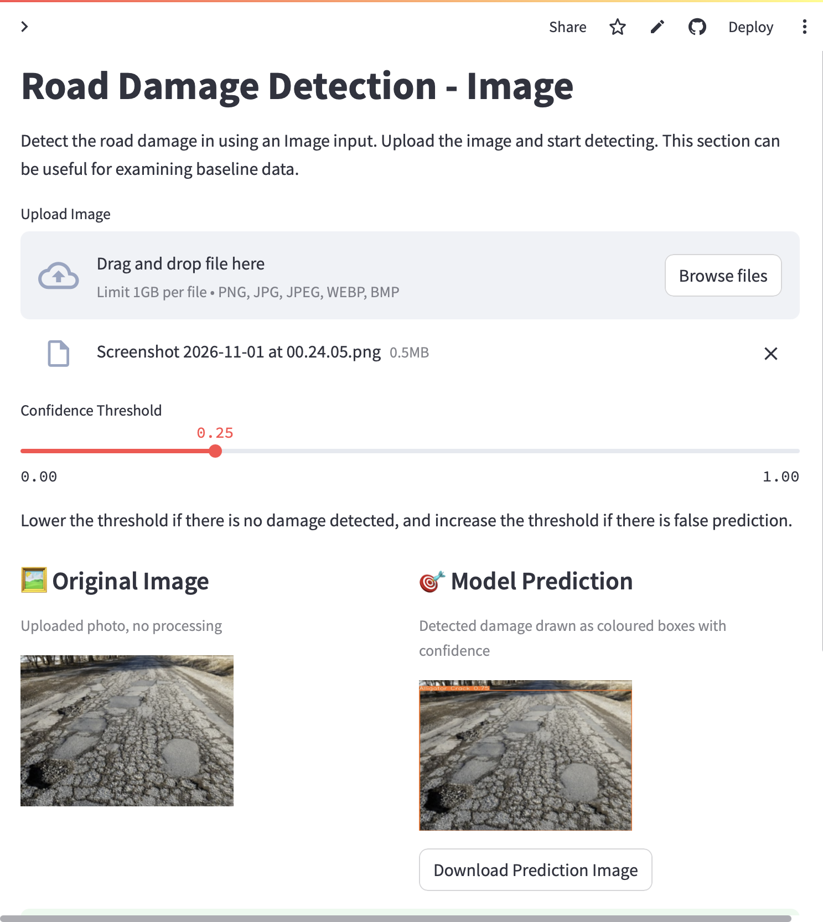
The deployed Image Detection page

2. System architecture

2.1 Offline (training) side
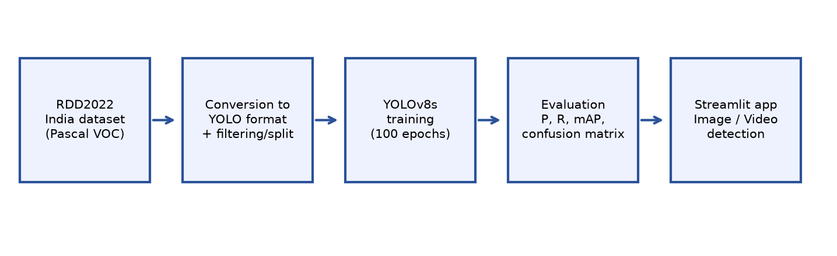
Overall pipeline
RDD2022 India (images + Pascal VOC XML)
│
▼ 0_PrepareDatasetYOLOv8.ipynb
parse XML → keep D00/D10/D20/D40 → normalise boxes → YOLO .txt
│ + keep ≤10 % background images
▼ + shuffle (seed 1337) → 90 % train / 10 % val
images/{train,val} labels/{train,val} rdd_India.yaml
│
▼ 1_TrainingYOLOv8.ipynb (YOLOv8s from COCO weights, 100 epochs)
runs/…/weights/{best.pt,last.pt} + curves + logs
│
▼ 2_EvaluationTesting.ipynb (model.val)
P, R, F1, mAP50, mAP50-95, PR curve, confusion matrix
│
▼
models/YOLOv8_Small_RDD.pt ← shipped with the app

2.2 Online (serving) side
Browser ──HTTP/WebSocket──► Streamlit server (Python process, one script run per user interaction)
│
┌────────────────┼──────────────────┐
▼ ▼ ▼
Home.py pages/2_Image…py pages/3_Video…py
│ │
└──► ultralytics.YOLO(weights) ──► PyTorch (CPU on cloud)
│ │
PIL/NumPy/OpenCV OpenCV VideoCapture/Writer
│ │
annotated PNG annotated MP4 (./temp/)
Key properties: - Stateless model, stateful session. Weights are loaded once per browser session into st.session_state. - Streamlit rerun model. Every widget interaction reruns the page script top-to-bottom; expensive work must be cached or guarded. - CPU-only on the free cloud. CUDA is not available; the CPU wheel of PyTorch is installed.

3. File-by-file reference
Path | Role | Details
Home.py | Landing page | st.set_page_config, custom CSS (hero banner, cards, chips), lists classes, features, team, placeholder link pills
pages/1_Realtime Detection.py | Placeholder | Shows “Coming soon” + explanation; no model code
pages/2_Image Detection.py | Image inference | Upload → normalise → predict → annotate → table → download
pages/3_Video Detection.py | Video inference | Upload .mp4 → frame loop → annotated .mp4 → download
sample_utils/download.py | Weights downloader | download_file(url, path, expected_size) – skips if the file exists with the exact size (89,569,358 bytes), else streams it with a progress bar
sample_utils/get_STUNServer.py | Legacy helper | Finds the geographically nearest public STUN server for WebRTC. Currently unused (Realtime page disabled) but kept for the future webcam feature
models/YOLOv8_Small_RDD.pt | Weights | The shipped detector (4 classes)
training/0_PrepareDatasetYOLOv8.ipynb | Data prep | VOC→YOLO, class filter, background cap, split
training/1_TrainingYOLOv8.ipynb | Training | YOLO('yolov8s.pt').train(...), resume cell
training/2_EvaluationTesting.ipynb | Evaluation | YOLO(weights).val(data=yaml)
training/dataset/rddIndiaFiltered/rdd_India.yaml | Dataset config | Paths + 4 class names
training/yolov8n.pt, yolov8s.pt | COCO pre-trained checkpoints | Starting points
training/tools/make_figures.py | Figure generator | Re-creates the diagrams
resource/ | Result images and demo GIFs | PR curve, confusion matrix, validation batch labels/predictions, banner
requirements.txt | Python deps | Pinned; first line selects the CPU PyTorch wheel index
packages.txt | apt deps (Streamlit Cloud) | libgl1, libglib2.0-0
.streamlit/config.toml | Streamlit config | maxUploadSize = 1000 (MB), light theme
.gitignore | Ignore rules | Bytecode, notebook checkpoints, temp/*, training runs/wandb

3.1 Pinned dependencies and why
Package | Version | Purpose / note
torch | 2.0.0 (CPU wheel) | Deep-learning runtime
ultralytics | 8.0.201 | YOLOv8 implementation (training, validation, predict, plot)
opencv-python-headless | 4.8.0.74 | Image/video I/O, resize, colour conversion; headless = no GUI libs
numpy | 1.24.3 | Arrays (compatible with torch 2.0)
Pillow | 9.5.0 | Image decoding, EXIF transpose
streamlit | 1.28.0 | Web UI
streamlit-webrtc | 0.47.1 | Reserved for the future realtime page
av | 12.3.0 | PyAV (needed by streamlit-webrtc); 10.0.0 had no wheel for Python ≥ 3.11
requests | 2.28.2 | Used by the STUN helper

4. Dataset in depth

4.1 Origin
RDD2022 – the data release of the Crowdsensing-based Road Damage Detection Challenge 2022 (CRDDC2022, IEEE Big Data Cup). About 47,420 images and 55,000+ annotated damages from Japan, India, the Czech Republic, Norway, the United States and China (MotorBike and Drone sub-sets). Images were captured by smartphones/cameras mounted on vehicles (“crowdsensing”) and annotated with bounding boxes.
Training-split image counts (from the preparation notebook output):
Sub-set | Japan | India | China-Drone | China-MotorBike | Czech | Norway | USA
Images | 10,506 | 7,706 | 2,401 | 1,977 | 2,829 | 8,161 | 4,805
Test images are distributed without labels (challenge protocol), so we create our own validation split.

4.2 Raw layout (India)
RDD2022_all_countries/India/train/
├── images/ *.jpg
└── annotations/xmls/ *.xml (Pascal VOC)

4.3 Pascal VOC annotation (input)
<annotation>
<size><width>720</width><height>720</height><depth>3</depth></size>
<object>
<name>D40</name>
<bndbox><xmin>180</xmin><ymin>150</ymin><xmax>420</xmax><ymax>300</ymax></bndbox>
</object>
<object> … </object>
</annotation>
Coordinates are absolute pixels, origin top-left, corners (xmin, ymin, xmax, ymax).

4.4 YOLO annotation (output)
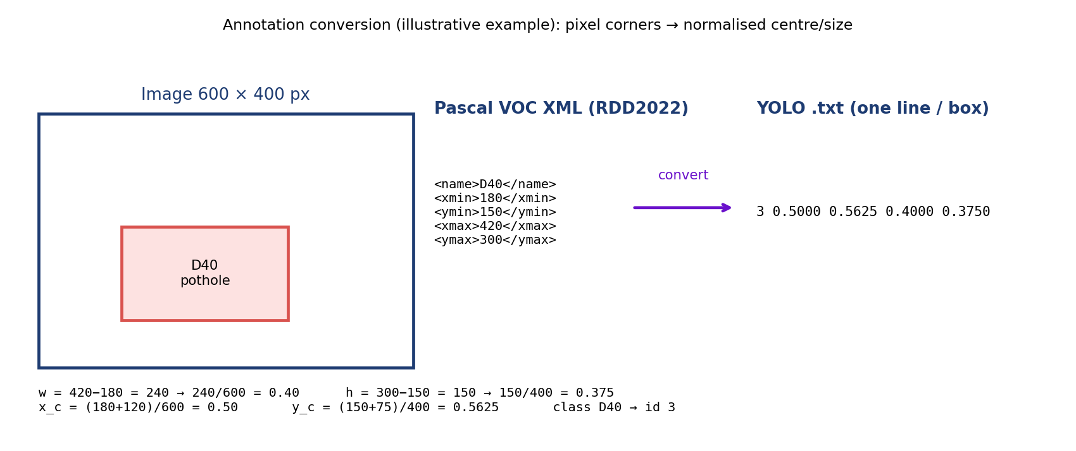
Pascal VOC to YOLO conversion
One <image>.txt per image; one line per box; space-separated; all values relative (0–1) except the class id:
<class_id> <x_center> <y_center> <width> <height>
3 0.5000 0.5625 0.4000 0.3750
An image with no damage has an empty .txt file (a “background” image).

4.5 Directory layout and YAML consumed by Ultralytics
training/dataset/rddIndiaFiltered/
├── rdd_India.yaml
└── India/
├── images/{train,val}/*.jpg
└── labels/{train,val}/*.txt
path: rddIndiaFiltered
train: [India/images/train]
val: [India/images/val]
names: {0: Longitudinal Crack, 1: Transverse Crack, 2: Alligator Crack, 3: Potholes}
Ultralytics finds a label by replacing /images/ with /labels/ in the image path and the extension with .txt.

4.6 Statistics of the evaluation (validation) split
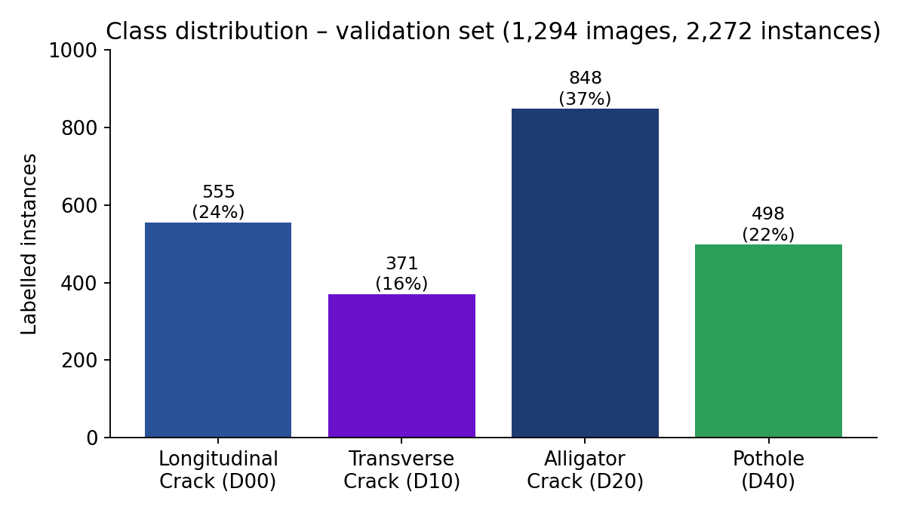
Class distribution in the validation set
Property | Value
Images | 1,294 (177 backgrounds, 0 corrupt)
Instances | 2,272
Longitudinal / Transverse / Alligator / Pothole | 555 / 371 / 848 / 498
Share | 24 % / 16 % / 37 % / 22 %
Instances per image | ≈ 1.76 on average (over all images)

4.7 Data-quality considerations
- Label noise (ambiguous crack extent, faint cracks unlabelled).
- Class imbalance (transverse rarest).
- Near-duplicate frames (vehicle-mounted capture) → leakage risk with random splits.
- Small objects (thin cracks cover few pixels at 640 px).
- Variation in camera, height, lighting, wetness, road material, shadows.

5. Data-preparation code walkthrough
File: training/0_PrepareDatasetYOLOv8.ipynb.

5.1 convertPascal2YOLOv8(filePath)
- Parse the XML with BeautifulSoup ('xml' parser).
- Read width and height from <size>.
- For each <object>: map <name> through class_mapping (D00→0, D10→1, D20→2, D40→3, D01→4, D11→5, D43→6, D44→7, D50→8, anything else → 10).
- Compute w = xmax − xmin, h = ymax − ymin, cx = xmin + w/2, cy = ymin + h/2; divide by image width/height; round to 4 decimals.
- Create …/labels/ (two levels above the XML folder) and write <name>.txt, only for class ids < 4 (the drop-filter).
- Images whose boxes are all filtered out produce an empty .txt (they become background candidates).

5.2 CopyDatasetSplit(baseDir)
- random.seed(1337).
- List all images and all label files (sorted – so index i pairs image i with label i; this relies on identical file stems).
- Walk through labels: keep every non-empty one; keep an empty one only while _counter < int(len(images) × 0.10).
- Shuffle indices; first 90 % → train, remaining 10 % → val.
- shutil.copy2 images and labels into images/{train,val} and labels/{train,val}.

5.3 Pitfalls to remember
- Paths in the notebook are absolute to the original author’s machine – edit ROOTDIR and baseOutputDir first.
- Sorting-based pairing assumes every image has a label file (the conversion step guarantees that).
- Rounding to 4 decimals limits positional precision to ~1/10,000 of the image – negligible.
- The split is image-level and random, not road-level.

6. Model in depth (YOLOv8)

6.1 Overall design
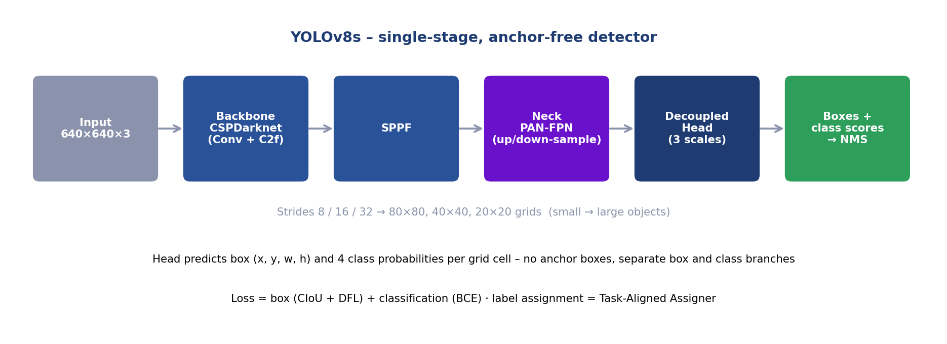
YOLOv8s architecture
Single-stage, anchor-free detector with a decoupled head. One forward pass over a 640 × 640 image yields predictions at three scales.
Scale | Stride | Grid (640 input) | Responsible for
P3 | 8 | 80 × 80 | Small objects
P4 | 16 | 40 × 40 | Medium
P5 | 32 | 20 × 20 | Large
Total candidate predictions: 80² + 40² + 20² = 8,400 per image.

6.2 Components
- Backbone – CSPDarknet-style stack of Conv (+BN+SiLU) layers and C2f blocks (cross-stage partial with more gradient paths than YOLOv5’s C3); ends with SPPF (fast spatial pyramid pooling) to enlarge the receptive field.
- Neck – PAN-FPN: a top-down path injects semantics into high-resolution maps, a bottom-up path pushes fine localisation back up.
- Head – decoupled: one branch regresses box distances, another predicts class scores; no objectness score.
- Activation – SiLU; normalisation – BatchNorm (fused into Conv at inference → “168 layers (fused)”).

6.3 Box representation and decoding
For each grid cell the head predicts the distance from the cell centre to the four box sides (left, top, right, bottom). With Distribution Focal Loss each distance is predicted as a discrete probability distribution over reg_max = 16 bins; the expected value of the distribution is the distance (in stride units). The distances are converted to (x1, y1, x2, y2) in pixels.

6.4 Loss function
Total loss (weighted sum, default gains box = 7.5, cls = 0.5, dfl = 1.5):
L = 7.5·L_box + 0.5·L_cls + 1.5·L_dfl
- Classification loss L_cls – binary cross-entropy per class on the class logits (multi-label style; no softmax).
- Box loss L_box – CIoU: L_CIoU = 1 − IoU + ρ²(b, b_gt)/c² + α·v where ρ is the distance between centres, c the diagonal of the smallest enclosing box, v = (4/π²)(arctan(w_gt/h_gt) − arctan(w/h))² penalises aspect-ratio mismatch and α = v / ((1 − IoU) + v).
- DFL – for a target distance y between bins y_i and y_{i+1} with predicted probabilities S_i, S_{i+1}: L_DFL = −[(y_{i+1} − y)·log S_i + (y − y_i)·log S_{i+1}] It pushes probability mass to the two bins around the true value, giving sharper localisation of ambiguous edges.

6.5 Label assignment – Task-Aligned Assigner (TAL)
For each ground-truth box, candidate cells whose centres lie inside it are scored by an alignment metric t = s^α · u^β (s = predicted score for the true class, u = IoU of the predicted box with the ground truth; Ultralytics uses α = 0.5, β = 6, top-k = 10). The top-k cells become positives for that box; conflicts are resolved by the highest IoU. This couples classification confidence with localisation quality.

6.6 Inference post-processing
- Take class scores (sigmoid) and decoded boxes for all 8,400 candidates.
- Drop candidates with max class score < conf (τ).
- Non-maximum suppression (per class): sort by score, keep the best, discard boxes with IoU > iou (default 0.7) against it, repeat.
- Return at most max_det (300) boxes, scaled back to the input image coordinates.

6.7 Transfer learning
Initial weights yolov8s.pt were trained on COCO (80 classes). The classification head is re-initialised for 4 classes; everything else starts from COCO values and is fine-tuned end-to-end.

6.8 Why this model (summary)
Single-stage speed, anchor-free simplicity (good for odd-shaped cracks), multi-scale neck, COCO weights, complete tool-chain, and the small variant’s sweet-spot compute.
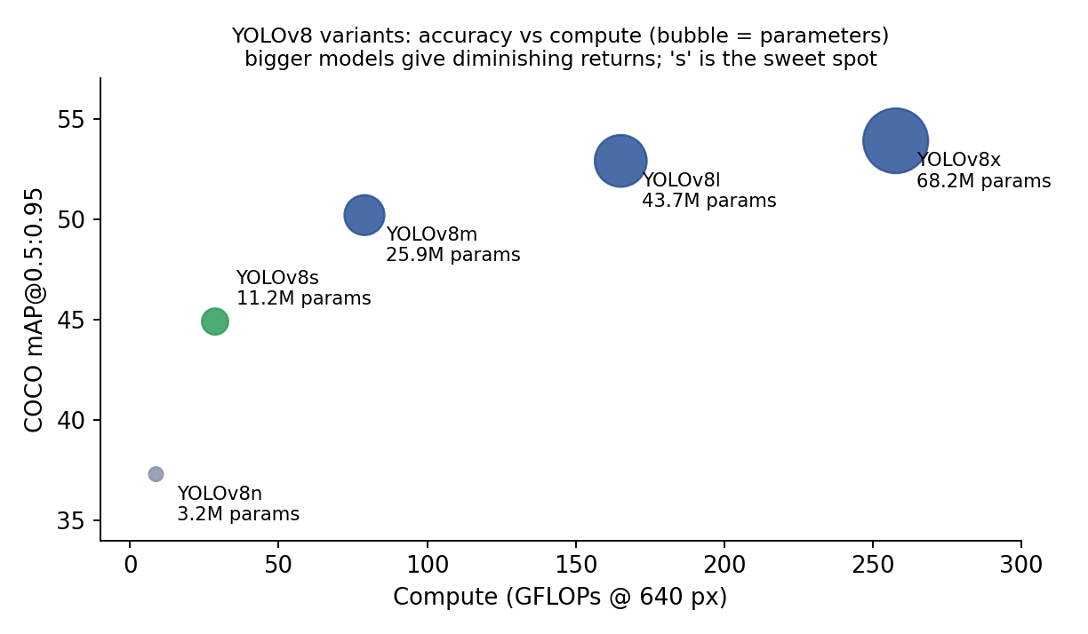
YOLOv8 variants: accuracy vs compute
Variant | Params (M) | GFLOPs | COCO mAP50-95
n | 3.2 | 8.7 | 37.3
s | 11.2 | 28.6 | 44.9
m | 25.9 | 78.9 | 50.2
l | 43.7 | 165.2 | 52.9
x | 68.2 | 257.8 | 53.9

7. Training reference

7.1 Command used
from ultralytics import YOLO
model = YOLO('yolov8s.pt')
model.train(data='…/rdd_India.yaml', epochs=100, warmup_epochs=5, batch=32,
imgsz=640, save_period=10, workers=1, project='runs/RDD_India',
name='Baseline_YOLOv8Small_Filtered', seed=1337, cos_lr=True, mosaic=0.0)

7.2 Hyper-parameter reference (what each means)
Parameter | Value used | Default (v8.0.201) | Meaning / effect
epochs | 100 | 100 | Passes over the training set
warmup_epochs | 5 | 3 | Epochs of LR/momentum ramp-up
batch | 32 | 16 | Images per weight update
imgsz | 640 | 640 | Training/inference resolution
cos_lr | True | False | Cosine learning-rate decay instead of linear
mosaic | 0.0 | 1.0 | Probability of 4-image mosaic augmentation
seed | 1337 | 0 | Random seed
save_period | 10 | −1 | Save a checkpoint every N epochs
workers | 1 | 8 | Data-loader worker processes
lr0, lrf | default | 0.01, 0.01 | Initial LR; final LR = lr0·lrf
momentum, weight_decay | default | 0.937, 0.0005 | Optimiser momentum; L2 regularisation
optimizer | default auto | auto | Chooses SGD (long runs) or AdamW (short runs) from the iteration count
patience | default | 50 | Early-stop if no fitness gain for 50 epochs
HSV / scale / translate / flip | default | h .015, s .7, v .4 / .5 / .1 / lr-flip .5 | Online augmentation
Confirm the exact optimiser and values for your run in runs/…/args.yaml.

7.3 Learning-rate schedule
warm-up (epochs 0–4: LR rises from ≈ 0 to lr0, momentum from 0.8 → 0.937) → cosine decay from lr0 to lr0·lrf over the remaining epochs.

7.4 Training outputs (inside runs/<project>/<name>/)
File | Content
weights/best.pt | Checkpoint with the best fitness (0.1·mAP50 + 0.9·mAP50-95)
weights/last.pt | Most recent epoch (used for resume=True)
weights/epochN.pt | Every save_period epochs
results.csv, results.png | Per-epoch losses and metrics, plotted
confusion_matrix.png, PR_curve.png, F1_curve.png, P_curve.png, R_curve.png | Final evaluation plots
labels.jpg, train_batch*.jpg, val_batch*_labels.jpg, val_batch*_pred.jpg | Dataset statistics and visual checks
args.yaml | Every hyper-parameter used

7.5 What to watch in results.png
- train/box_loss, train/cls_loss, train/dfl_loss should fall steadily.
- val/*_loss should fall then flatten; rising val loss while train loss falls = overfitting.
- metrics/mAP50(B) and mAP50-95(B) should rise and plateau.

7.6 Resuming
YOLO('runs/RDD_India/<name>/weights/last.pt').train(resume=True)

7.7 Resource notes
RTX 2060 (6 GB): batch 32 at 640 px fits; if you see CUDA out-of-memory reduce batch to 16 or imgsz to 512. CPU-only training is possible but impractical.

8. Evaluation in depth

8.1 Definitions (detection version)
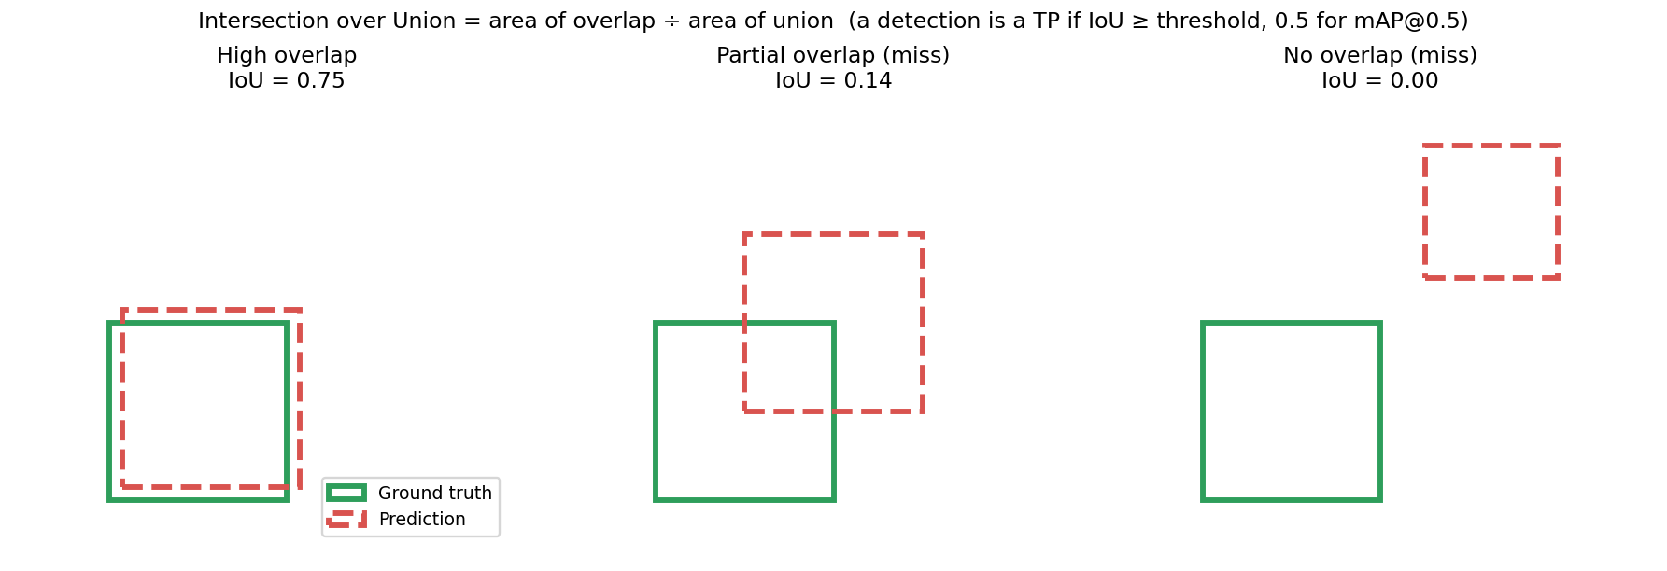
Intersection over Union
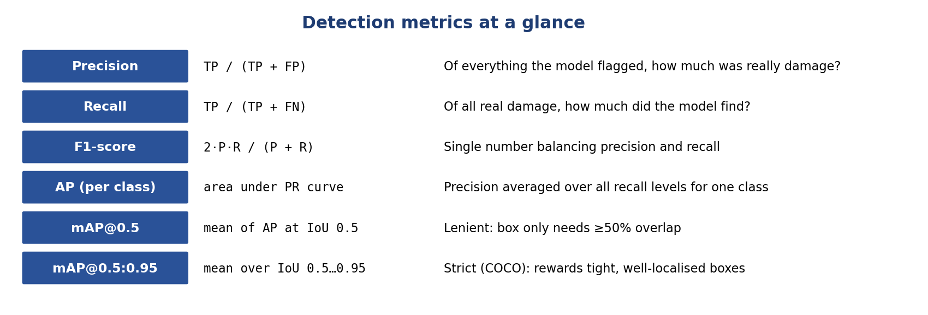
Metrics cheat-sheet
- Match rule: a prediction is a TP if its class equals the ground truth’s and IoU ≥ threshold, and that ground truth isn’t already matched by a higher-scoring prediction; else FP. Unmatched ground truths are FN.
- Precision P = TP/(TP+FP), Recall R = TP/(TP+FN), F1 = 2PR/(P+R).
- AP = area under the interpolated precision-recall curve (101-point interpolation in Ultralytics/COCO style); mAP = mean AP across classes; mAP50-95 additionally averages over IoU thresholds 0.50, 0.55, …, 0.95.

8.2 Worked example (toy, 1 class, IoU ≥ 0.5)
Predictions sorted by confidence, with 4 ground-truth objects in total:
Rank | Conf | Matches a GT? | Cumulative TP | Cumulative FP | Precision | Recall
1 | 0.95 | yes | 1 | 0 | 1.00 | 0.25
2 | 0.90 | yes | 2 | 0 | 1.00 | 0.50
3 | 0.80 | no | 2 | 1 | 0.67 | 0.50
4 | 0.70 | yes | 3 | 1 | 0.75 | 0.75
5 | 0.40 | no | 3 | 2 | 0.60 | 0.75
Make precision monotonically non-increasing from the right (interpolation) and integrate over recall: AP ≈ 0.25·1.00 + 0.25·1.00 + 0.25·0.75 + 0.25·0 (recall 0.75–1.0 never reached) ≈ 0.69. The detector never finds the fourth object, which caps recall at 0.75.

8.3 Results table (validation set)
Class | Inst. | P | R | F1 | mAP50 | mAP50-95
Longitudinal Crack | 555 | 0.573 | 0.471 | 0.517 | 0.501 | 0.235
Transverse Crack | 371 | 0.522 | 0.433 | 0.473 | 0.454 | 0.177
Alligator Crack | 848 | 0.659 | 0.684 | 0.671 | 0.709 | 0.373
Pothole | 498 | 0.584 | 0.503 | 0.540 | 0.524 | 0.229
All | 2,272 | 0.584 | 0.523 | 0.552 | 0.547 | 0.254
P and R are reported at the confidence that maximises F1 across classes (Ultralytics’ convention); F1 is derived as 2PR/(P+R).
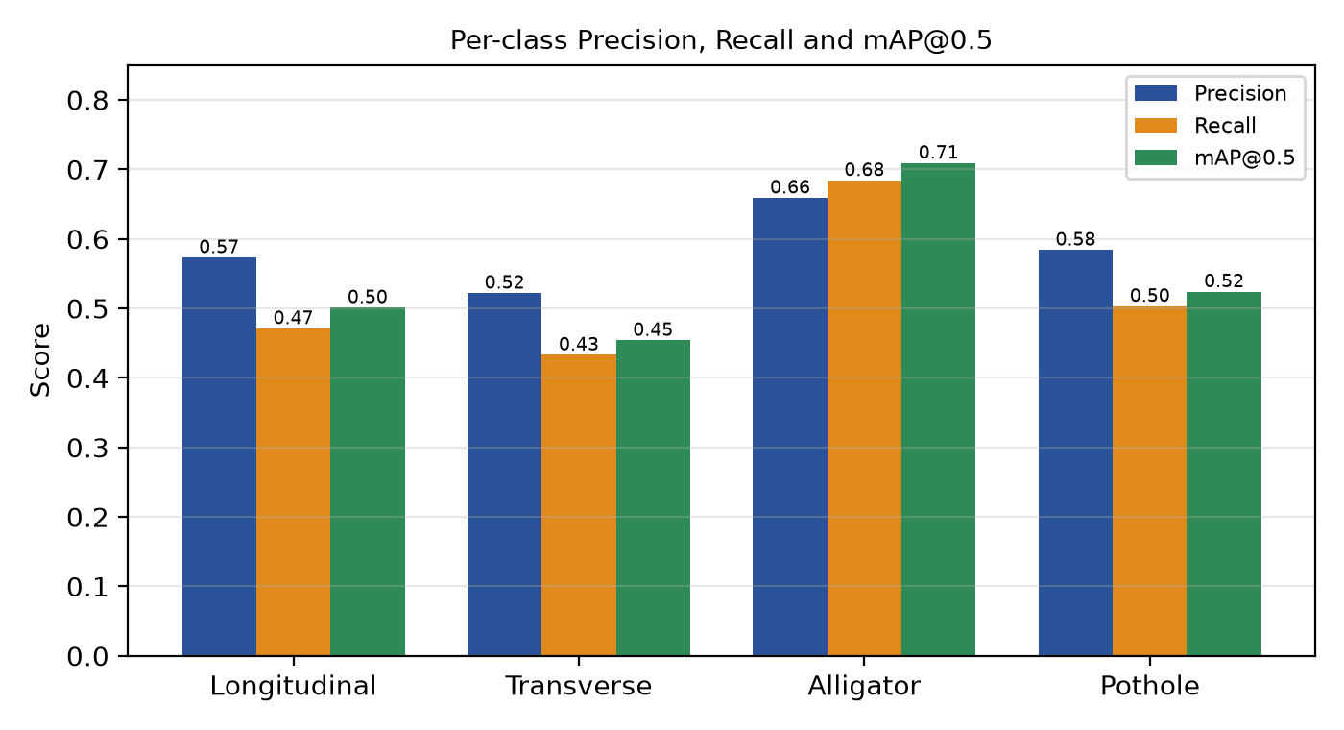
Per-class precision, recall and mAP
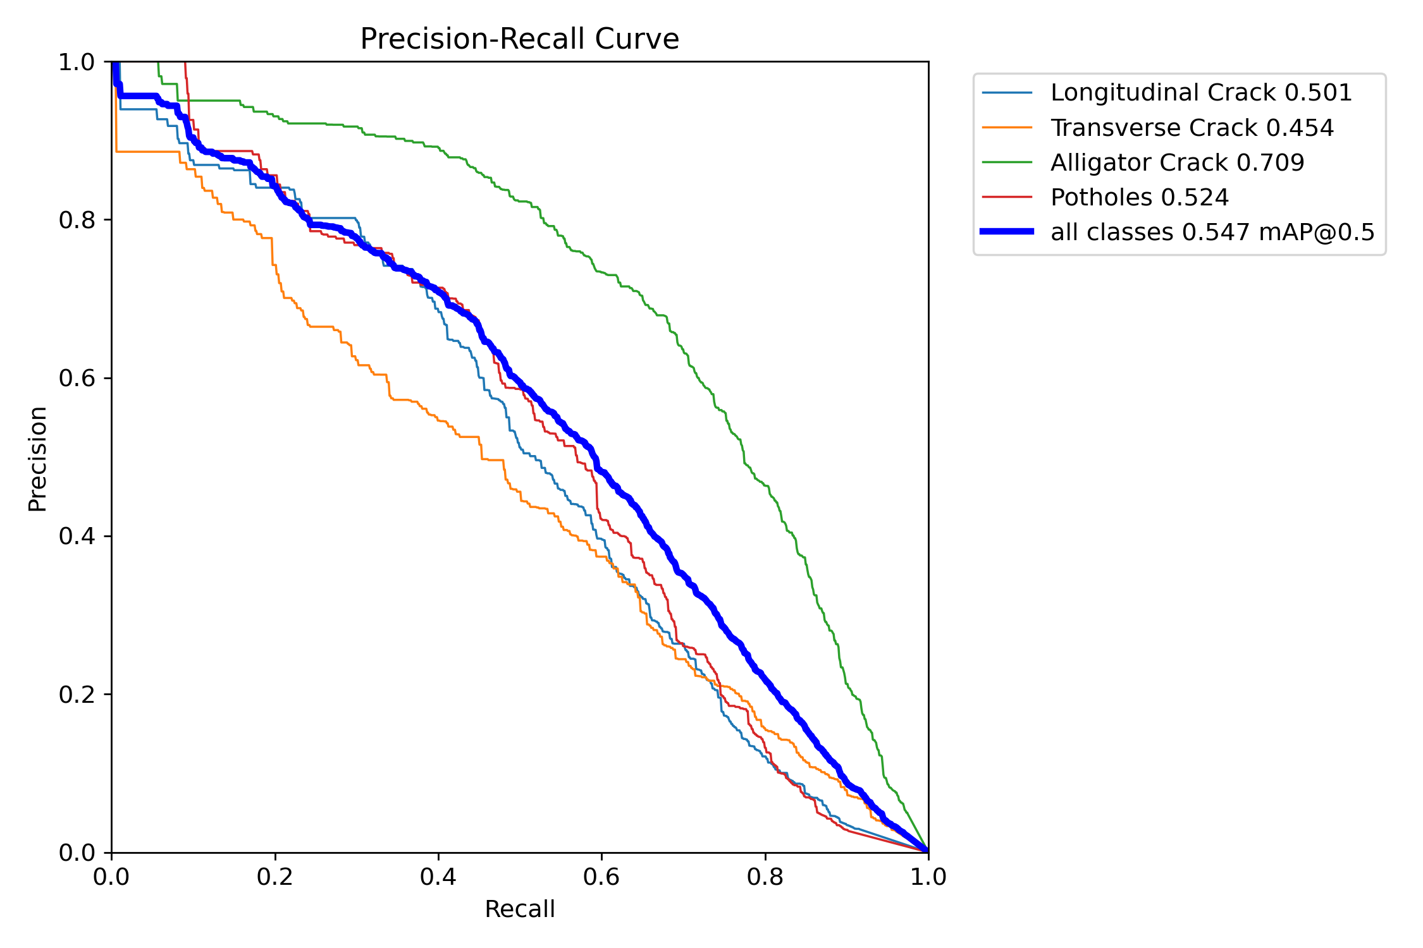
Precision-Recall curve
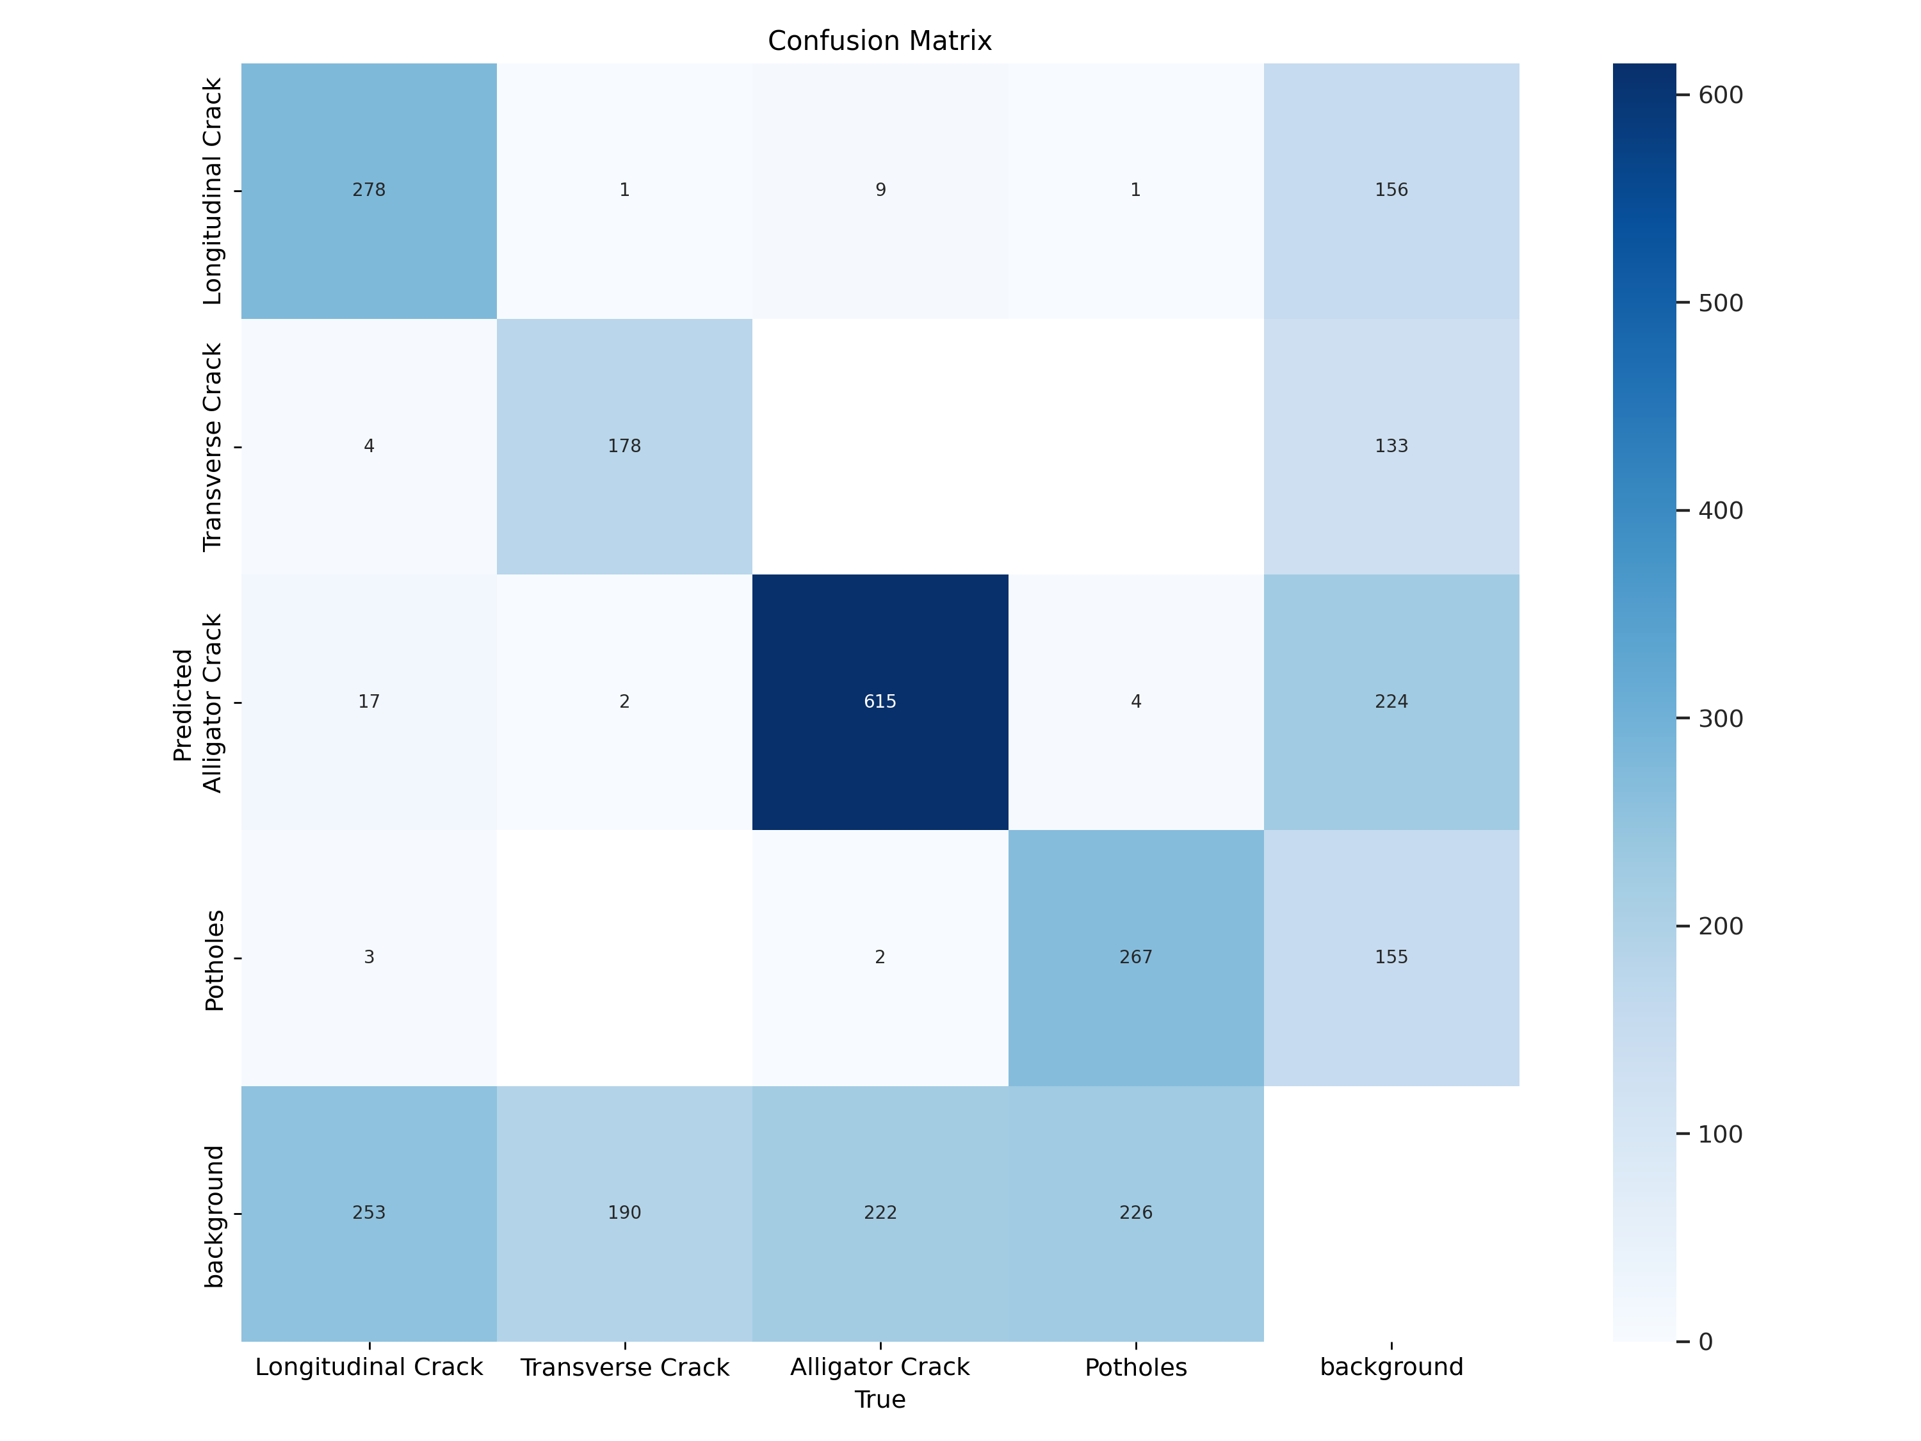
Confusion matrix
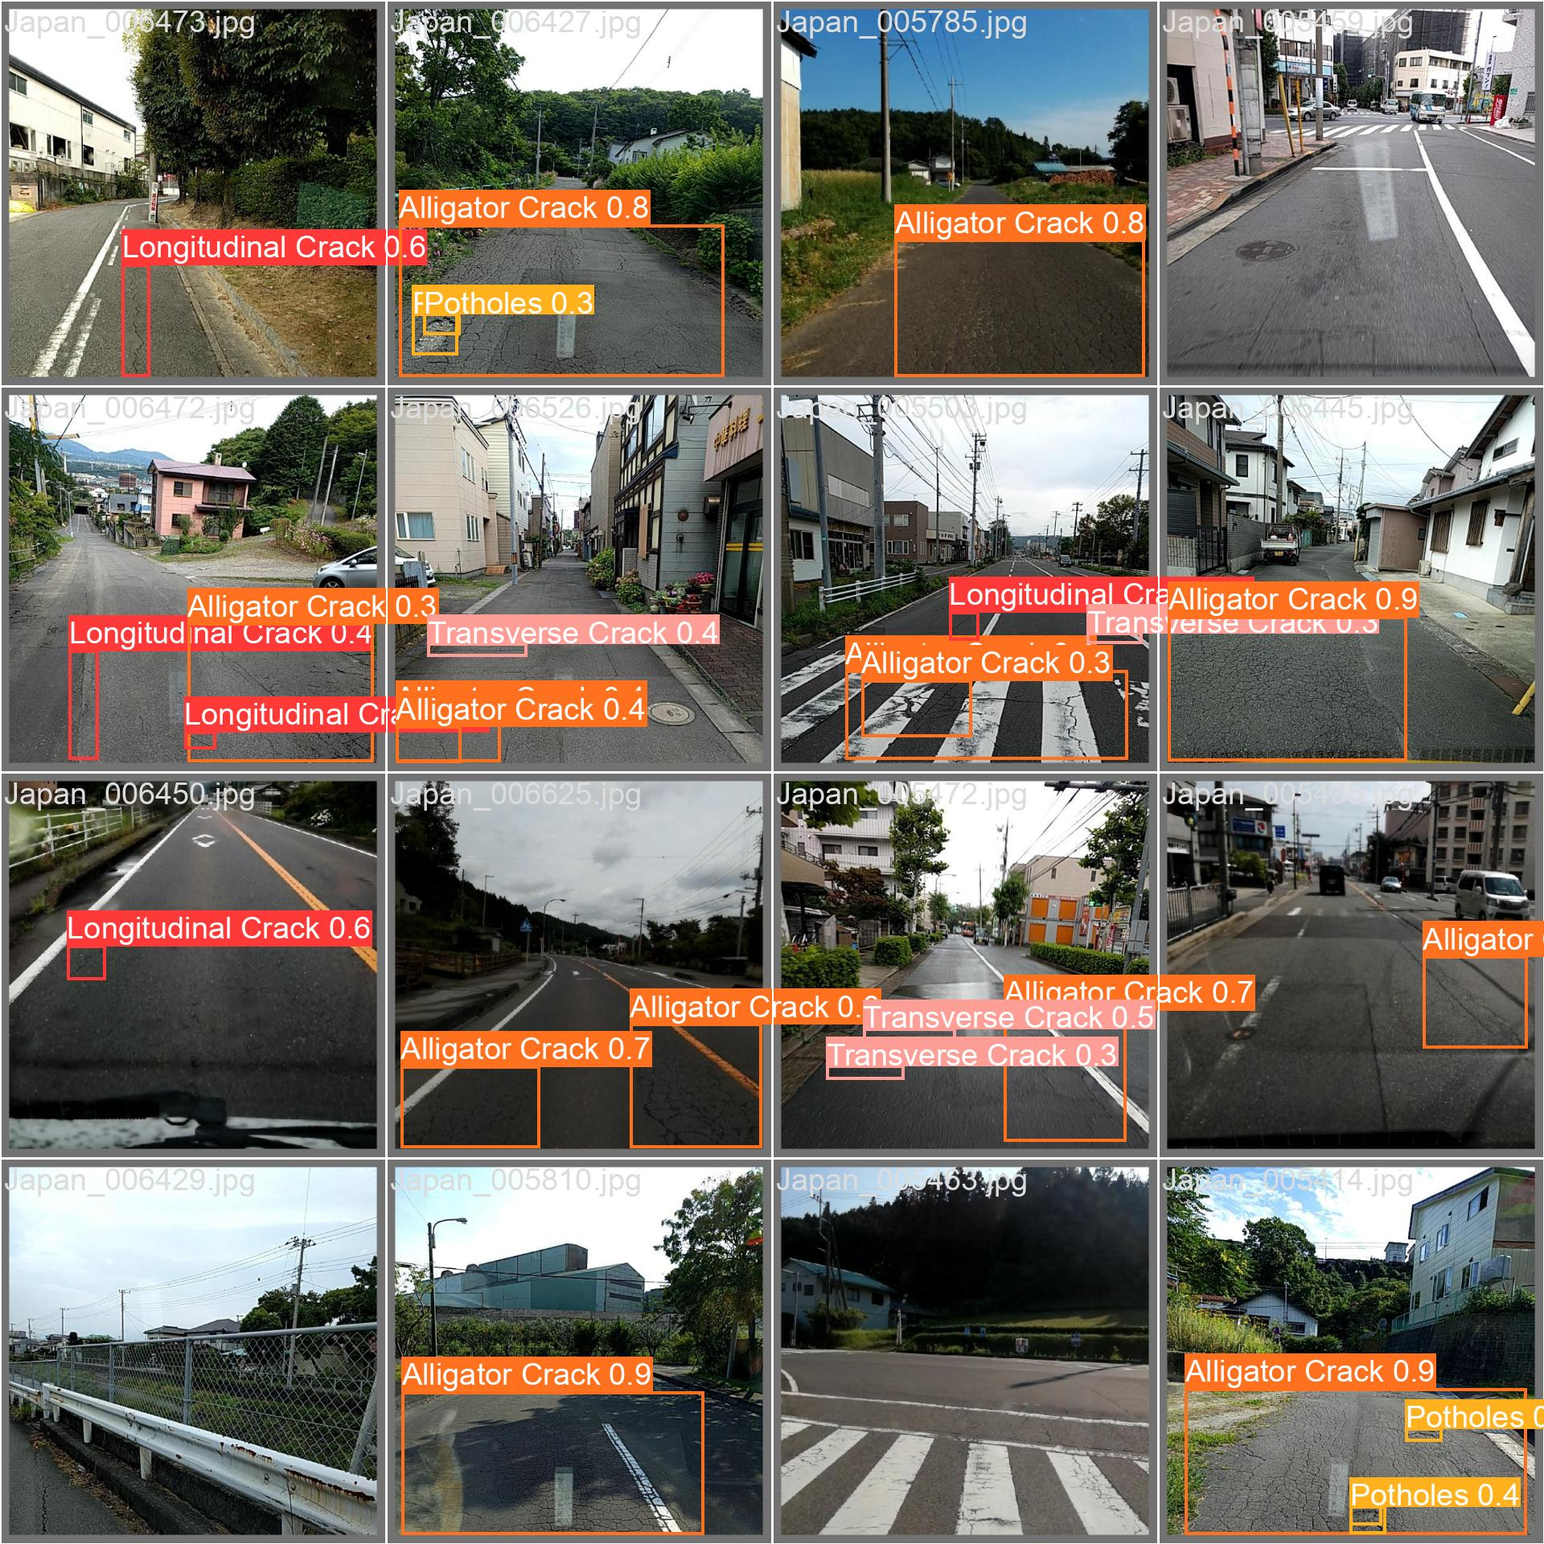
Predictions on a validation batch

8.4 Error analysis (from the confusion matrix in the report)
Error type | Evidence | Interpretation
Missed damage (FN) | 253 / 190 / 222 / 226 instances of the four classes predicted as background | Main error: faint or thin damage below the confidence cut
False alarms (FP) | 133–224 background boxes per class | Shadows, joints, patches, markings, wet patches
Class confusion | e.g. 9 longitudinal→alligator, 17 alligator→longitudinal | Rare; the classifier separates types well when it sees damage
Best class | Alligator (615 correct) | Large, textured, frequent
Worst class | Transverse | Thin, short, rare

8.5 Choosing an operating point
Lower τ → more recall, more false alarms. For screening use τ ≈ 0.25; for report-quality overlays use τ ≈ 0.5. To pick τ rigorously, read the F1-vs-confidence curve (F1_curve.png) and choose the peak.

8.6 Speed
Speed: 0.7 ms preprocess, 9.3 ms inference, 0.0 ms loss, 3.4 ms postprocess per image on RTX 2060. On the cloud CPU the app log shows 2.0 ms preprocess, 161.0 ms inference, 1.1 ms postprocess for a 640 × 640 input.

9. Application internals
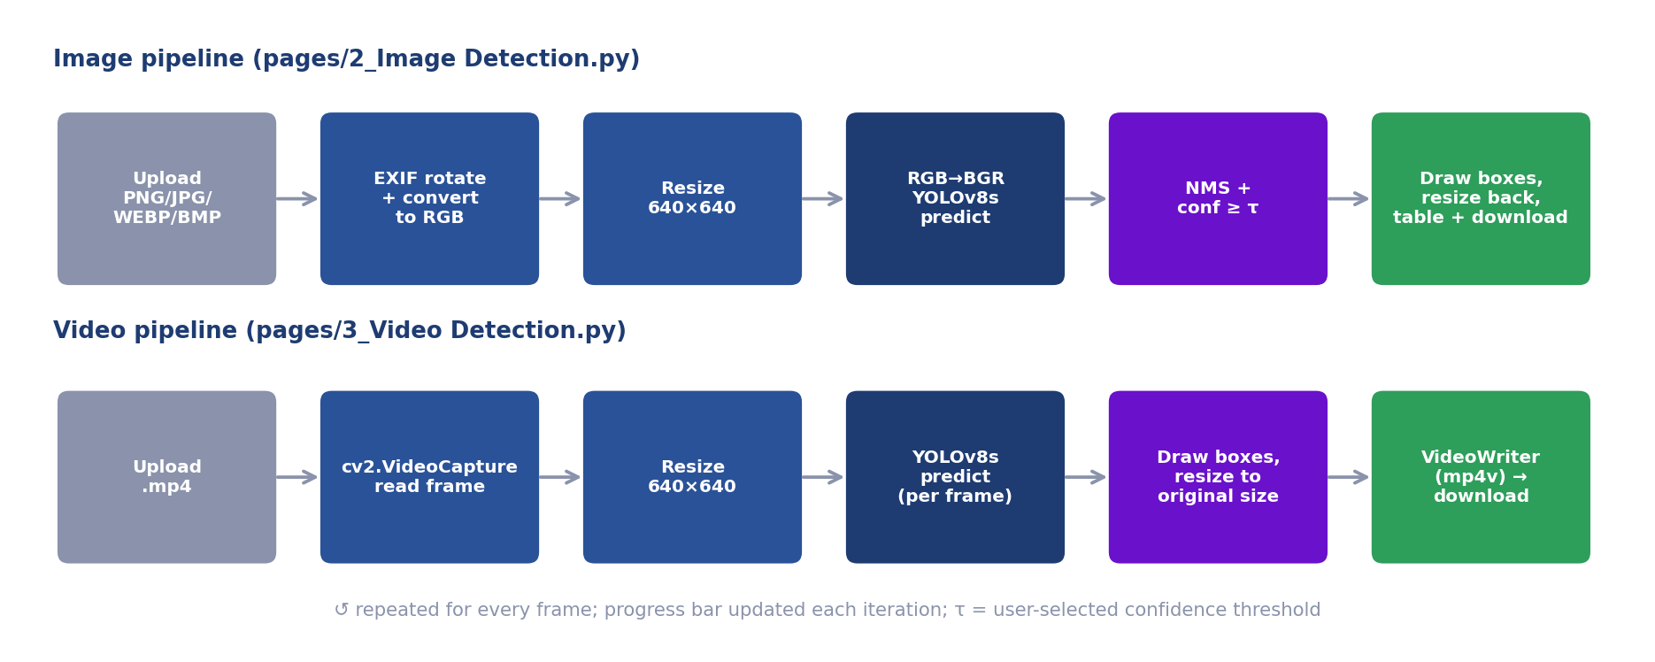
Image and video inference pipelines

9.1 Streamlit execution model (important)
Streamlit re-executes the whole page script whenever a widget changes. Therefore: - The model is stored in st.session_state["yolov8smallrdd"] and reused. - Heavy work is placed behind conditions (if image_file is not None, if st.button(...)). - Multi-page apps are formed from Home.py + files in pages/ (sidebar order follows the numeric prefix).

9.2 pages/2_Image Detection.py
Step | Code idea | Why
Ensure weights | download_file(MODEL_URL, MODEL_LOCAL_PATH, expected_size=89569358) | Re-download if missing/corrupt (size check)
Load model once | st.session_state cache → YOLO(MODEL_LOCAL_PATH) | Avoid reload per interaction
Upload | st.file_uploader(type=[png, jpg, jpeg, webp, bmp]) | Accepted formats
Threshold | st.slider(0.0–1.0, default 0.25, step 0.05) | Precision/recall control
Normalise | ImageOps.exif_transpose → convert("RGB") | Orientation and channel fixes
Resize | cv2.resize((640, 640), INTER_AREA) | Match training size
Predict | net.predict(cv2.cvtColor(img, RGB2BGR), conf=τ) | Ultralytics expects BGR
Annotate | results[0].plot() (BGR) → RGB → resize to original | Draw, then restore user size
Report | st.success + st.table (class, confidence %), or st.warning if empty | Transparent output
Download | PNG bytes via BytesIO → st.download_button | Save result
Detection(NamedTuple) holds class_id, label, score, box per detection; CLASSES = ["Longitudinal Crack","Transverse Crack","Alligator Crack","Potholes"] maps ids to names (must match the YAML order).

9.3 pages/3_Video Detection.py
Step | Detail
State | st.session_state.runningInference disables the uploader/slider/button during processing
Save upload | write_bytesio_to_file("./temp/video_input.mp4", file)
Metadata | cv2.VideoCapture → width, height, FPS, frame count → duration mm:ss
Writer | cv2.VideoWriter(temp_file_infer, fourcc('mp4v'), fps, (w, h))
Loop | read frame → cvtColor(BGR2RGB) → resize 640×640 → predict(conf=τ) → plot() → resize to (w, h) → cvtColor(RGB2BGR) → write → st.image live preview → progress bar
Finish | st.success, download button (video/mp4), “Restart Apps” (st.rerun())
Default τ | 0.5
Known issue: the RGB frame is passed to predict, which assumes BGR (see §15).

9.4 Home.py
Pure presentation: HTML/CSS via st.markdown(..., unsafe_allow_html=True) for the hero banner, feature cards, class chips, team avatars and link placeholders.

9.5 .streamlit/config.toml
[server]
maxUploadSize = 1000 # MB – the file-uploader limit
[theme]
base = "light"

9.6 Files and storage
- Weights: models/YOLOv8_Small_RDD.pt (committed, 85 MB – under GitHub’s 100 MB limit).
- Temp: ./temp/video_input.mp4, ./temp/video_infer.mp4 – fixed names, overwritten on each run, not cleaned automatically (git-ignored).

10. Using the model from code / CLI

10.1 Python
from ultralytics import YOLO
model = YOLO("models/YOLOv8_Small_RDD.pt")
res = model.predict("road.jpg", conf=0.25, imgsz=640)[0] # path input → letterboxed automatically
for b in res.boxes:
print(model.names[int(b.cls)], float(b.conf), b.xyxy[0].tolist())
res.save("annotated.jpg") # writes the annotated image

10.2 Video / webcam / folder
model.predict("road.mp4", conf=0.4, save=True) # annotated video in runs/detect/predict
model.track("road.mp4", tracker="bytetrack.yaml", persist=True) # adds persistent IDs

10.3 CLI
yolo detect predict model=models/YOLOv8_Small_RDD.pt source=road.jpg conf=0.25
yolo detect val model=models/YOLOv8_Small_RDD.pt data=training/dataset/rddIndiaFiltered/rdd_India.yaml
yolo export model=models/YOLOv8_Small_RDD.pt format=onnx # also tflite, engine, coreml

10.4 Input conventions (important)
Input type | Colour order assumed by Ultralytics
File path / URL | Handled correctly (decoded internally)
PIL.Image | RGB
numpy.ndarray | BGR (OpenCV convention)

11. Deployment and operations

11.1 Streamlit Community Cloud – step by step
- Push the repo (public) to GitHub.
- https://share.streamlit.io → Create app → from GitHub.
- Repository Harshitjhamb/RoadSense_AI, branch main, main file Home.py.
- Advanced settings → Python 3.11.
- Deploy. The platform clones the repo, installs packages.txt (apt) then requirements.txt (pip), provisions a container and starts Streamlit. Pushing to main redeploys automatically.
Live URL: https://roadsenseai01.streamlit.app/

11.2 Environment facts
- OS image: Debian (trixie at the time of deployment), CPU-only, ~1 GB RAM, shared CPU.
- Apps sleep after inactivity and wake on the next visit.
- Resource governance: heavy apps are CPU-throttled (message: “we’ve temporarily reduced its CPU … throttle will expire at …”).

11.3 Troubleshooting matrix
Symptom / log line | Root cause | Resolution
E: Package 'libgl1-mesa-glx' has no installation candidate | Package removed in Debian trixie | packages.txt → libgl1, libglib2.0-0
ImportError: libGL.so.1: cannot open shared object file | Missing system lib for OpenCV | Add libgl1 to packages.txt
ImportError: libgthread-2.0.so.0 | Missing glib | Add libglib2.0-0
av==10.0.0 build error (ffmpeg headers / pkg-config) | No wheel for Python ≥ 3.11 → source build | Use av==12.3.0 or newer
Could not find a version that satisfies the requirement torch==… | Wrong index / Python version | Keep the CPU --extra-index-url; use Python 3.10/3.11
streamlit 1.28.0 requires rich<14 (pip warning) | Transitive rich 15 | Ignore, or pin rich<14
App slow / “reduced its CPU” banner | Fair-use throttle | Wait; reduce frames/size; move to Hugging Face Spaces / GPU host
App crashes / restarts on large video | Memory (≈1 GB) or timeout | Shorter video, lower resolution, frame skipping, bigger host
Weights download loop | File size ≠ expected_size | Ensure the committed .pt is exactly 89,569,358 bytes (or update the constant)
st.image shows wrong colours | RGB/BGR mix-up | Keep conversions consistent (see §9)
Uploaded phone photo detects nothing | Sideways image | Ensure exif_transpose is applied
Output video won’t play in browser | mp4v codec | Download and play locally, or re-encode with ffmpeg -c:v libx264
CUDA not found on the cloud | CPU-only host | Expected; the CPU wheel is used

11.4 Alternative hosting
Option | Pros | Cons
Hugging Face Spaces (Streamlit/Docker) | Free tier with more RAM (≈16 GB) | Public by default, queueing
Docker on a VM / Cloud Run / Render | Full control | Cost, ops
GPU instance (EC2/GCP) | Real-time video | Cost
Edge (Jetson/phone) | Offline, low latency | Export + optimisation work

11.5 Minimal Dockerfile (if you move off Streamlit Cloud)
FROM python:3.11-slim
RUN apt-get update && apt-get install -y --no-install-recommends libgl1 libglib2.0-0 && rm -rf /var/lib/apt/lists/*
WORKDIR /app
COPY requirements.txt .
RUN pip install --no-cache-dir -r requirements.txt
COPY . .
EXPOSE 8501
CMD ["streamlit", "run", "Home.py", "--server.port=8501", "--server.address=0.0.0.0"]

11.6 Operational hygiene
- Don’t commit the raw dataset or runs/ (large; ignored).
- Keep weights < 100 MB for plain GitHub, otherwise use Git LFS or Releases.
- Periodically clean ./temp/ on long-running hosts.
- Pin versions; upgrade deliberately and re-run a smoke test (§14).

12. Reproducibility checklist
- Python 3.10/3.11 environment; pip install -r requirements.txt
- Download RDD2022; keep the India folder
- Edit notebook paths; run 0_Prepare… (seed 1337 → identical split)
- Confirm the dataset YAML paths resolve
- 1_Training… with the exact arguments in §7.1; archive args.yaml, results.csv
- 2_Evaluation… on the val split; compare against §8.3
- Save the final best.pt → models/; update expected_size in the two pages if the file size changes
- Record: GPU model, driver/CUDA, library versions, training time, git commit
Sources of non-determinism: GPU kernels (cuDNN), data-loader worker order, library version drift.

13. How-to guides (extending the project)

13.1 Fix the video page colour order (recommended)
In pages/3_Video Detection.py, remove the BGR→RGB conversion before inference and do the display conversion only for st.image:
ret, frame = videoCapture.read() # BGR
results = net.predict(frame, conf=score_threshold, imgsz=640) # BGR in, letterboxed
annotated_bgr = results[0].plot() # BGR out, original size
cv2writer.write(annotated_bgr) # BGR for VideoWriter
imageLocation.image(cv2.cvtColor(annotated_bgr, cv2.COLOR_BGR2RGB))
This also removes the aspect-ratio squashing (Ultralytics letterboxes) and an extra resize.

13.2 Speed up CPU video processing
- Process every Nth frame (reuse the previous annotation for skipped frames), or
- Resize input to imgsz=416/480 (re-evaluate accuracy), or
- Export to ONNX/OpenVINO and run with onnxruntime, or
- Cap upload length/size.

13.3 Use unique temp files (multi-user safe)
import tempfile, os
tmp_in = tempfile.NamedTemporaryFile(delete=False, suffix=".mp4").name
tmp_out = tempfile.NamedTemporaryFile(delete=False, suffix=".mp4").name
# … process … then os.remove(tmp_in); os.remove(tmp_out)

13.4 Share one model across sessions
@st.cache_resource
def load_model(path): return YOLO(path)
net = load_model(str(MODEL_LOCAL_PATH))

13.5 Add object tracking and counting
Use model.track(source, tracker="bytetrack.yaml", persist=True); count unique box.id values per class to report “N potholes in this clip”.

13.6 Add a new damage class
- Add the code to the conversion filter/mapping (class id 4, update if class_list[i] < 4 → < 5).
- Extend names: in the YAML and CLASSES in both app pages.
- Re-run split, retrain (the head size changes), re-evaluate, update docs.

13.7 Try a bigger model / higher resolution
YOLO('yolov8m.pt').train(..., imgsz=960, batch=8) (reduce batch to fit memory); compare mAP per class and speed; keep the same seed and split for a fair comparison.

13.8 Handle class imbalance
Oversample transverse-crack images, tune the cls loss gain, collect more examples, or add targeted augmentations (small rotations, brightness, blur).

13.9 Add GPS + map output (sketch)
Read GPS from image EXIF (PIL.ExifTags) or the video’s telemetry; store (lat, lon, class, conf) per detection; plot with pydeck/folium; aggregate by road segment.

13.10 Enable realtime webcam
streamlit-webrtc + VideoProcessorBase with a callback that runs predict on each frame; supply ICE/TURN servers (STUN alone fails on many cloud networks); expect to need a GPU or a nano model for smooth FPS.

13.11 Export for mobile / edge
model.export(format="tflite", int8=True) / "onnx" / "engine" (TensorRT) / "coreml"; validate accuracy after quantisation.

14. Test plan
# | Test | Input | Expected
1 | Smoke | Open the app | Home renders; sidebar shows 3 pages
2 | Image – JPG | Road photo with obvious potholes | Boxes + table; PNG downloads
3 | Image – PNG with alpha | RGBA PNG | No crash; processed as RGB
4 | Image – grayscale | 1-channel JPG | No crash
5 | Image – rotated phone photo (EXIF) | Portrait photo | Detection on upright image
6 | Image – clean road | No damage | Warning message; output = original
7 | Threshold slider | 0.05 vs 0.8 on the same image | More boxes at low τ, fewer at high τ
8 | Large image | 4000 × 3000 | Works (resized internally); output resized back
9 | Video – short mp4 | 10–20 s clip | Progress bar → success → downloadable output
10 | Video – wrong type | .avi | Rejected by uploader
11 | Video – corrupt | Broken mp4 | “Error opening the video file”
12 | Weights missing | Delete models/*.pt locally | Auto-download with progress bar
13 | Model regression | yolo val | mAP50 ≈ 0.547 on the saved val split
14 | Realtime page | Open | “Coming soon” message
15 | Concurrency (known risk) | Two users upload videos at once | May collide on temp files – see §13.3

15. Provenance, known issues and limitations

15.1 Provenance – verify and state accurately
- Weights. models/YOLOv8_Small_RDD.pt is the baseline weight file of the upstream project oracl4/RoadDamageDetection; the app downloads it from that repository if absent. Claim only what the team actually did (re-running / evaluating / extending) unless you hold your own training logs.
- Which countries were the weights trained on? .gitignore still lists a dataset folder named rddJapanIndiaFiltered and the preparation notebook’s saved output shows both Japan and India being copied, which suggests the upstream run used Japan + India. Our documentation describes an India-only protocol (config rdd_India.yaml). If asked, say precisely which weights were trained on what; if the shipped weights came from the Japan + India run, say so, and report the India-validation result as an evaluation on Indian roads.
- Split sizes. The prep notebook’s saved output (India: 3,594 train / 399 val) is from a different run than the evaluation (1,294 val images, 2,272 instances). Quote the evaluation numbers for results.

15.2 Known issues
Area | Issue | Impact | Fix
Video page | RGB frames passed to a BGR-expecting model | Small accuracy loss | §13.1
Both pages | Square 640 × 640 resize without letterbox | Slight distortion of wide images | §13.1
Video page | Fixed temp file names | Collisions with concurrent users | §13.3
Both pages | Model cached in session_state (per session) | Extra memory per user | §13.4
Video page | mp4v output | May not play inline in browsers | Re-encode to H.264
Video page | Different default τ (0.5) than Image (0.25) | Inconsistent UX | Align or pick via F1 curve
Hosting | CPU throttling, ~1 GB RAM | Slow/unstable on long videos | Alternative host; frame skipping
Home page | “GitHub / Documentation / Report” pills say “Coming soon” | Cosmetic | Add real links

15.3 Limitations of the study
- No independent test set; random split may leak near-duplicates.
- Domain limited to Indian smartphone imagery; not tested at night, in heavy rain or with motion blur.
- Boxes only (no severity, depth or area); no GPS; no tracking in video.
- Moderate accuracy on thin cracks (mAP@0.5 0.45–0.50).

16. Glossary
Term | Meaning
Alligator crack | Network of interconnected cracks (fatigue failure) resembling alligator skin
Anchor box | Predefined box shape used by older detectors as regression reference
Anchor-free | Predicts boxes directly from grid locations, no anchors
AP / mAP | Average Precision (area under PR curve) / mean over classes
Augmentation | Random label-preserving transformations of training data
Background image | Image with no labelled objects (negative sample)
Backbone / Neck / Head | Feature extractor / multi-scale fusion / prediction layers
Batch size | Samples per optimisation step
BCE | Binary cross-entropy loss
BGR / RGB | Channel orders (OpenCV/Ultralytics numpy = BGR; PIL/display = RGB)
Bounding box | Rectangle localising an object
C2f | YOLOv8’s cross-stage partial block with two-path feature flow
Checkpoint | Saved model weights at some training point
CIoU | Complete-IoU box loss (overlap + centre distance + aspect ratio)
COCO | Large generic detection dataset (80 classes) used for pre-training
Confidence (score) | Model’s estimated probability that a detection is correct for its class
Confusion matrix | Table of predicted vs true classes (+ background)
CRDDC2022 | Crowdsensing-based Road Damage Detection Challenge 2022
Data leakage | Validation information present in training, inflating scores
DFL | Distribution Focal Loss for box-edge regression
Domain shift | Train/deploy data distribution mismatch
EXIF | Image metadata (orientation, GPS, camera)
Epoch / iteration | Full pass over data / one weight update
F1 | Harmonic mean of precision and recall
FLOPs / GFLOPs | Floating-point operations (compute cost)
FN / FP / TP / TN | False negative / false positive / true positive / true negative
Fine-tuning | Continuing training of a pre-trained model on new data
IoU | Intersection over Union of two boxes
Letterbox | Resize preserving aspect ratio and pad to a square
Longitudinal / Transverse crack | Crack along / across the direction of travel
Mosaic | Augmentation stitching four images
NMS | Non-maximum suppression – removes duplicate overlapping boxes
Normalisation | Scaling values (coordinates/pixels) to a standard range (0–1)
Overfitting / underfitting | Memorising training data / failing to learn it
PAN-FPN | Path-aggregation feature pyramid network (neck)
Pascal VOC | XML annotation format with pixel-corner boxes
Precision / Recall | Share of detections that are right / share of real objects found
PR curve | Precision as a function of recall across thresholds
RDD2022 | Road Damage Dataset 2022
SiLU | Smooth activation function x·sigmoid(x)
SPPF | Spatial Pyramid Pooling – Fast
STUN / TURN | Protocols that help WebRTC traverse NATs (TURN relays traffic)
Stride | Down-sampling factor between input and a feature map
TAL | Task-Aligned Assigner for positive-sample selection
Transfer learning | Re-using weights learned on another task
Validation set | Held-out data for monitoring/evaluation during development
Warm-up | Gradual LR increase at the start of training
YOLO | “You Only Look Once” single-pass detector family

17. References
- D. Arya, H. Maeda, S. K. Ghosh, D. Toshniwal, Y. Sekimoto, “RDD2022: A multi-national image dataset for automatic road damage detection,” arXiv:2209.08538, 2022. Data: github.com/sekilab/RoadDamageDetector
- D. Arya et al., “Crowdsensing-based Road Damage Detection Challenge (CRDDC’2022),” IEEE Big Data, 2022.
- G. Jocher, A. Chaurasia, J. Qiu, “Ultralytics YOLOv8,” 2023 – docs.ultralytics.com
- J. Redmon, S. Divvala, R. Girshick, A. Farhadi, “You Only Look Once,” CVPR 2016.
- T.-Y. Lin et al., “Microsoft COCO: Common Objects in Context,” ECCV 2014.
- Z. Zheng et al., “Distance-IoU Loss: Faster and Better Learning for Bounding Box Regression” (CIoU), AAAI 2020.
- X. Li et al., “Generalized Focal Loss” (DFL), NeurIPS 2020.
- C. Feng et al., “TOOD: Task-aligned One-stage Object Detection” (TAL), ICCV 2021.
- A. Paszke et al., “PyTorch,” NeurIPS 2019.
- oracl4, “RoadDamageDetection” – github.com/oracl4/RoadDamageDetection
- Streamlit documentation – docs.streamlit.io · OpenCV – opencv.org

