Algorithm Performance Measurement and Benchmarking Tool
Lab Assignment 2 - Final Report

1. Introduction

Importance of algorithm analysis
Algorithm analysis tells us how the running time and memory of a program grow as the input grows. Two programs that give the same answer can differ enormously in cost, so choosing the right one matters before deployment.

Need for performance measurement
Theory (Big-O) describes growth but hides constants, hardware, and language overhead. Measuring real execution time and memory lets us check theory against practice and see where an algorithm that is fine on small data becomes too slow on large data.
This project is a Streamlit tool (app.py) with a benchmarking engine (benchmark_engine.py), a search module (search_analysis.py) and code snippets (code_benchmark.py). Time is measured with time.perf_counter (average of several runs) and peak memory with tracemalloc.

2. Experimental Results

Search benchmark (worst case: last element)
Algorithm | Size | Time_ms | Memory_KB | Operations
Linear Search | 100 | 0.0289 | 0.1172 | 100
Binary Search | 100 | 0.0084 | 0.0 | 7
Linear Search | 1000 | 0.7311 | 0.207 | 1000
Binary Search | 1000 | 0.01 | 0.1562 | 10
Linear Search | 10000 | 5.3986 | 0.207 | 10000
Binary Search | 10000 | 0.0151 | 0.1562 | 14
Linear Search | 50000 | 29.1193 | 0.207 | 50000
Binary Search | 50000 | 0.01 | 0.1562 | 16
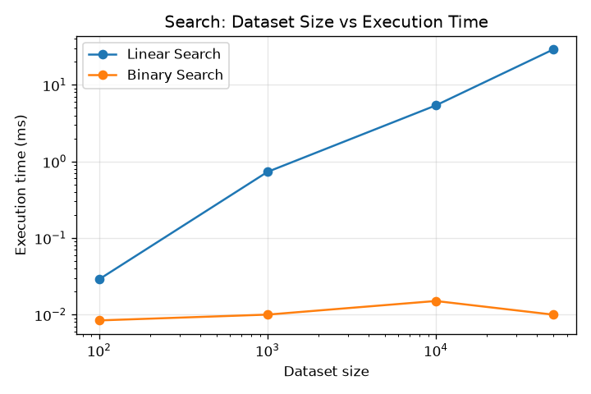

Factorial benchmark
Algorithm | Size | Time_ms | Memory_KB | Operations
Recursive Factorial | 100 | 0.072 | 0.4297 | 100
Iterative Factorial | 100 | 0.0443 | 0.2266 | 99
Recursive Factorial | 500 | 0.7911 | 8.3555 | 500
Iterative Factorial | 500 | 0.3536 | 1.1289 | 499
Recursive Factorial | 1000 | 1.8343 | 23.9805 | 1000
Iterative Factorial | 1000 | 2.367 | 2.3672 | 999
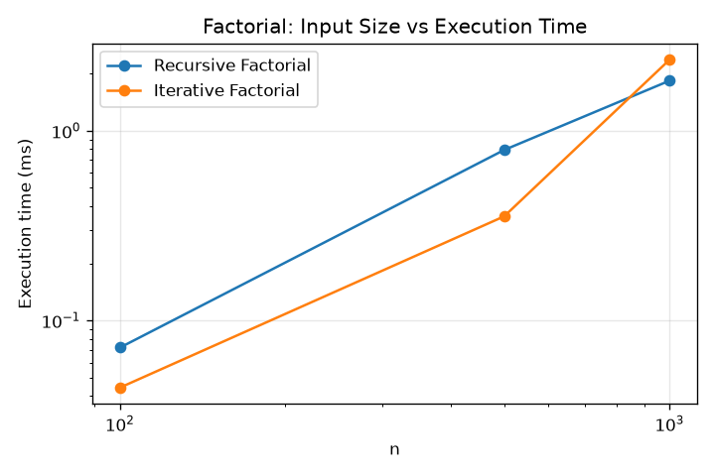

Loop benchmark
The nested loop performs n x n work, so its largest size is 5,000 (25 million operations) instead of 50,000 (2.5 billion), which would take many minutes.
Algorithm | Size | Time_ms | Memory_KB | Operations
Single Loop | 100 | 0.0213 | 0.0938 | 100
Single Loop | 1000 | 0.3346 | 0.125 | 1000
Single Loop | 5000 | 1.183 | 0.125 | 5000
Single Loop | 10000 | 2.9256 | 0.125 | 10000
Single Loop | 50000 | 13.8235 | 0.1328 | 50000
Nested Loop | 100 | 1.8195 | 0.1406 | 10000
Nested Loop | 500 | 68.7639 | 0.2344 | 250000
Nested Loop | 1000 | 339.7817 | 0.2344 | 1000000
Nested Loop | 2000 | 1090.008 | 0.2344 | 4000000
Nested Loop | 5000 | 5919.1506 | 0.2344 | 25000000
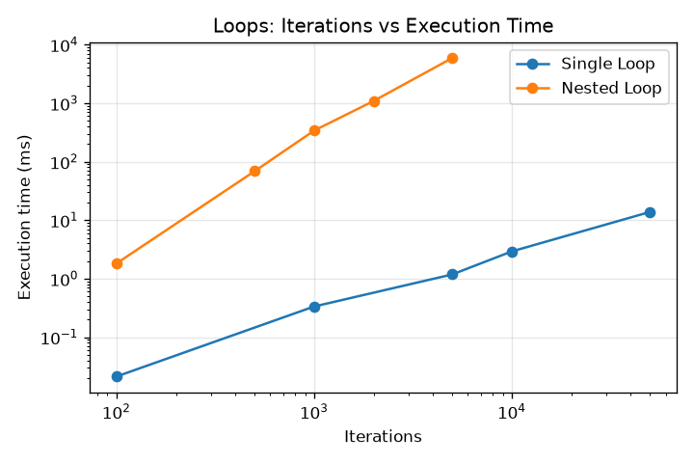

Complexity table: theoretical vs observed
Algorithm | Theoretical | Largest Size | Time (ms) | Memory (KB) | Log-log slope | Observed growth
Linear Search | O(n) | 50000 | 29.1193 | 0.21 | 1.09 | Roughly linear
Binary Search | O(log n) | 50000 | 0.01 | 0.16 | 0.05 | Almost flat (constant / logarithmic)
Recursive Factorial | O(n) | 1000 | 1.8343 | 23.98 | 1.42 | Between linear and quadratic
Iterative Factorial | O(n) | 1000 | 2.367 | 2.37 | 1.65 | Between linear and quadratic
Single Loop | O(n) | 50000 | 13.8235 | 0.13 | 1.03 | Roughly linear
Nested Loop | O(n^2) | 5000 | 5919.1506 | 0.23 | 2.07 | Roughly quadratic or worse

Screenshots of outputs
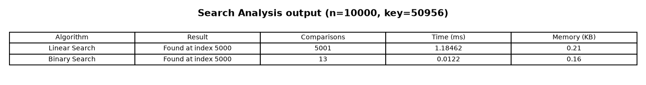
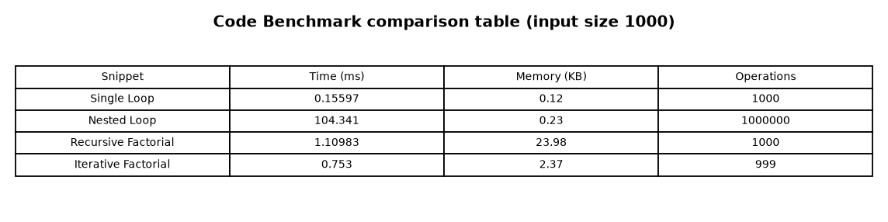
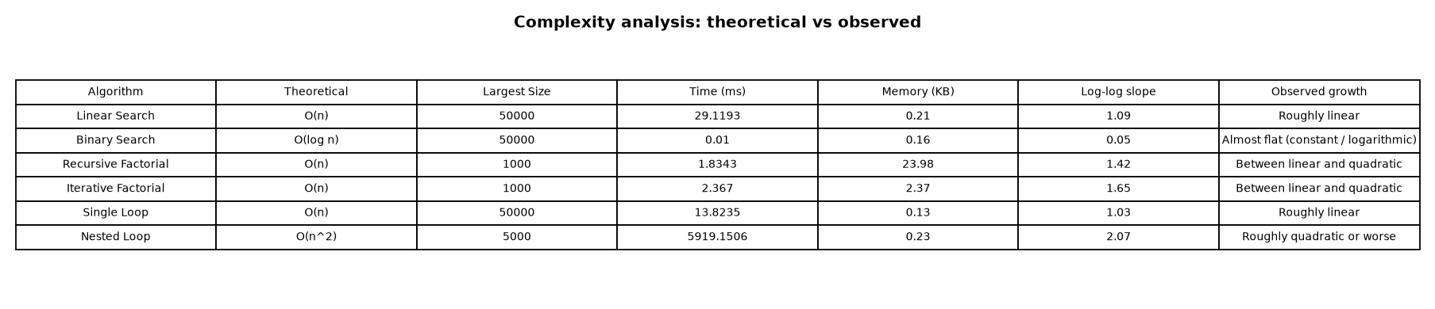

3. Analysis

Comparison of search algorithms
At 50,000 elements linear search took 29.119 ms and made 50,000 comparisons, while binary search took 0.0100 ms and made 16 comparisons (about 2912x faster). Linear search time grows in proportion to n; binary search time is nearly flat, matching O(n) and O(log n). Binary search needs sorted data, which is the price of its speed.

Recursive vs iterative implementations
For n=1000 the recursive version took 1.834 ms and 24.0 KB; the iterative version took 2.367 ms and 2.4 KB. Both do n multiplications, so timing is similar (differences are small and noisy), but recursion uses roughly 10x more memory because each call adds a stack frame (O(n) space vs O(1) extra space for iteration).

Single loop vs nested loop
At 5,000 iterations the single loop took 1.183 ms and the nested loop 5919.2 ms (about 5004x slower). Each 2x increase in n roughly quadruples the nested loop time, confirming O(n^2), while the single loop doubles, confirming O(n).

Complexity analysis and observations
- The log-log slope of time vs size approximates the exponent: about 1 for linear search and the single loop, about 0 for binary search, and about 2 for the nested loop.
- Factorial slopes are above 1 (about 1.4-1.7) even though the loop count is O(n): the numbers become huge integers, so each multiplication itself costs more as n grows.
- Very small timings (binary search, ~0.01 ms) are noisy, so averages of several runs are used.
- Memory of search and loop programs is tiny because they store no new data structures.

Which is better, and time-space trade-offs
- Search: binary search is better for large sorted data; linear search is fine for tiny or unsorted data.
- Factorial: iterative is better (same time, much less memory, no recursion limit).
- Loops: a single pass is far better; avoid nested loops when a single pass will do.
- Trade-off: recursion trades memory for simpler code; binary search trades a sorting step up front for fast lookups.

4. Conclusion

Key findings
Measured results agree with theory: growth in input size affects O(n^2) code far more than O(n) code, and O(log n) code barely changes. Theory ignores costs such as big-integer arithmetic and stack memory, which measurement reveals.

Most efficient implementations observed
- Binary Search (search)
- Iterative Factorial (factorial)
- Single Loop (loops)

Future enhancements
- Add sorting algorithms and more search techniques (jump, interpolation).
- Let users paste and benchmark their own code snippets.
- Add average/best-case inputs and confidence intervals over many runs.
- Export benchmark reports from the app as CSV or PDF.

References
Horowitz, Sahni, Rajasekaran - Fundamentals of Computer Algorithms; Python, Streamlit, matplotlib and memory_profiler documentation.

