Framepath

Product & UX review
  - Course structure, learning experience and learner navigation

01 Course structure and lesson format
Organise the course into modules, with lessons nested within each module. Assign one or more assignments at the module level instead of a separate assignment for every lesson. The interface should reflect this hierarchy.
Lesson format: Watch and Reflect (with simulation).

02 Beginner plan and dashboard
Improve the Beginner plan user experience. Rework the dates section, especially “Start later”: the current flow is confusing and only offers the option to add weeks.
Show the pathway’s expected output or learning outcome on the plan dashboard, so learners understand what they will gain from completing it.

03 Watch: storytelling lesson sequence
Lesson: “How videos tell a story / Storytelling 101”. Reorder the videos as follows:
1. Give me 9min, and I'll improve your storytelling skills by 176%
2. Directing without words: Visual Storytelling — the current Video 1.

04 Make: assignment naming and emphasis
Give each task a clear name and number so it can be tracked across the course. Make the task instructions more prominent than the upload section; the assignment should receive the main visual emphasis.
Details to define: The notes do not specify the simulation behaviour or the exact replacement for the “Start later” controls.

AI review and reflection

05 Reflect: feedback and waiting state
Reported issue: The Reflect section shows a waiting state while AI reviews the learner’s work, with a “See it in My Work” option below it. Following that link does not show the feedback in My Work.
Requested change: Ensure the review feedback appears in My Work when available. During the review wait, show information, facts or quotes relevant to the course the learner is taking.

Reference screen
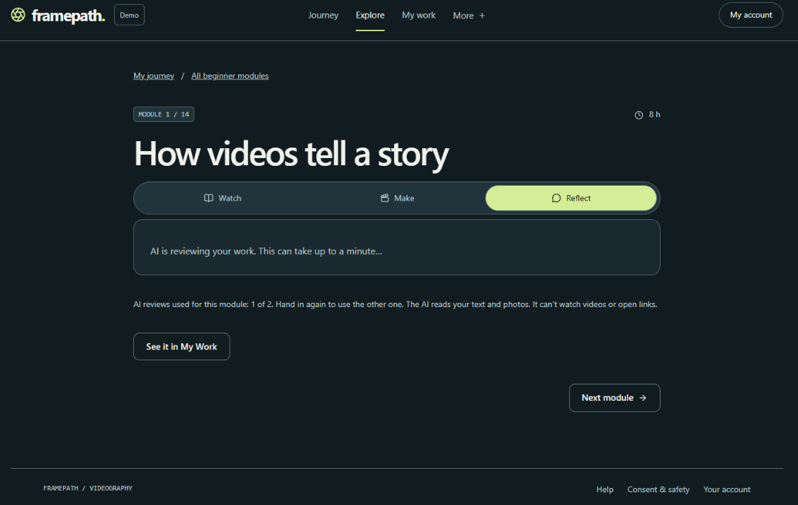
Figure 1. Reflect waiting state and “See it in My Work”. Source: Review.docx, page 2. Empty outer margins have been cropped for readability; the interface content is unchanged.

Navigation and My Work

06 Preserve the learner’s navigation context
Opened from a module: When a learner selects “See it in My Work”, provide a clear way to return to the originating module instead of sending them only to the general My Work page.
Opened directly: When My Work is opened independently, show a general dashboard of the learner’s overall training.

Reference screen
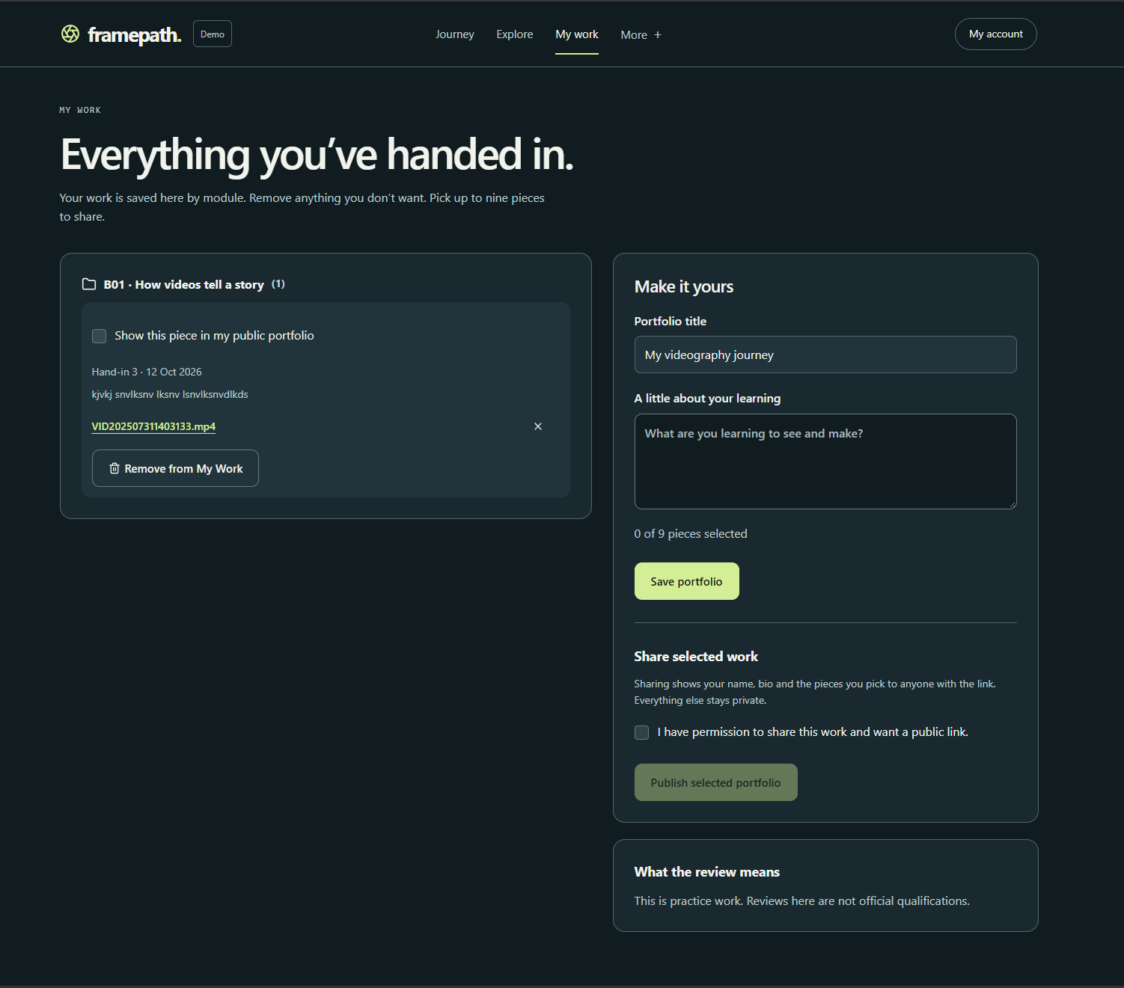
Figure 2. My Work submission and portfolio view. Source: Review.docx, page 3. This screen accompanies the navigation and dashboard feedback above.

Access and course completion

07 Restricted content from Module 3
From Module 3 onward, task content is still visible in Watch even though the learner cannot upload the task. Grey out the restricted section and provide an unlock option that redirects to the paid self-paced pathway.
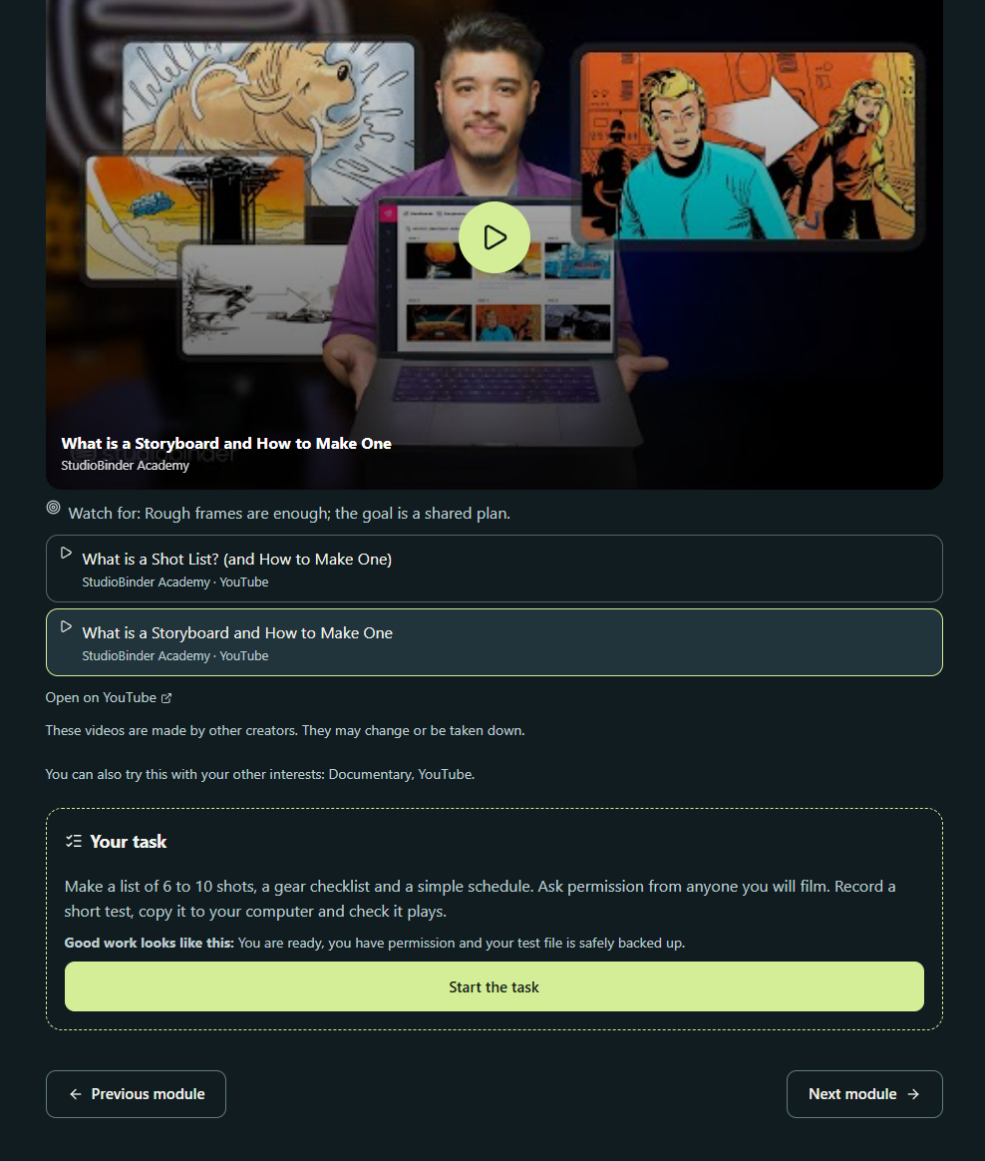
Figure 3. Task content visible in Watch. Source: Review.docx, page 4. The requested change is to show a clear locked state for the restricted section.

08 Course closure
Add a course-closure segment at the end of the final module.

09 Future enhancement: concurrent pathways
Consider allowing free learners to take one pathway at a time, while paid learners can take multiple pathways concurrently. Three pathways is a tentative suggestion, not a confirmed limit.

