This section can have other non-highlighted sections greyed out.
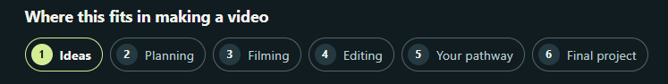

Lets have a two column section for this. First column will be the GIF and other one have a brief description of the lesson.
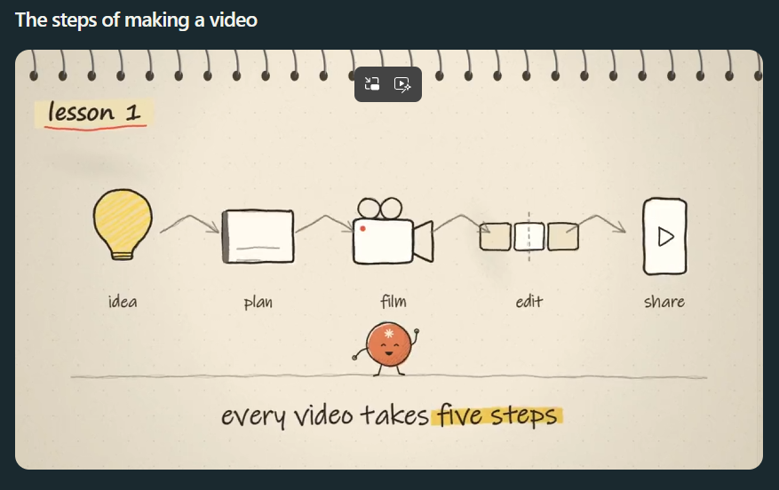

Same here it can have two column sections. One will have the video and the other will have the titles list on the right.
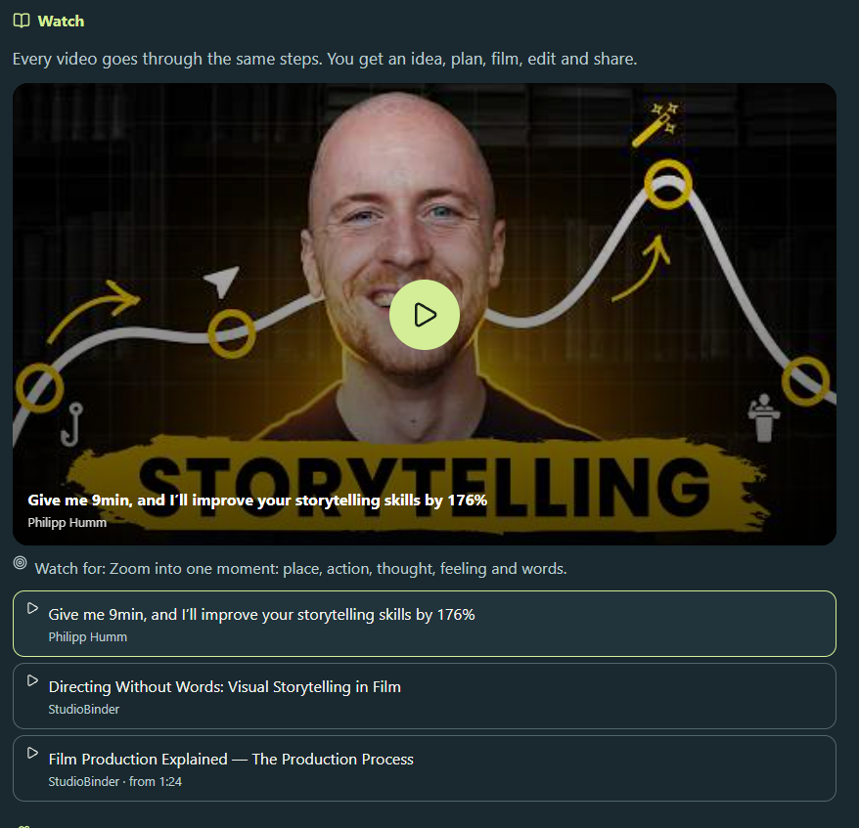

Reflect should be something from the overall lesson including the videos summary as well. Right now, below the reflect question has the answers in the GIF itself.
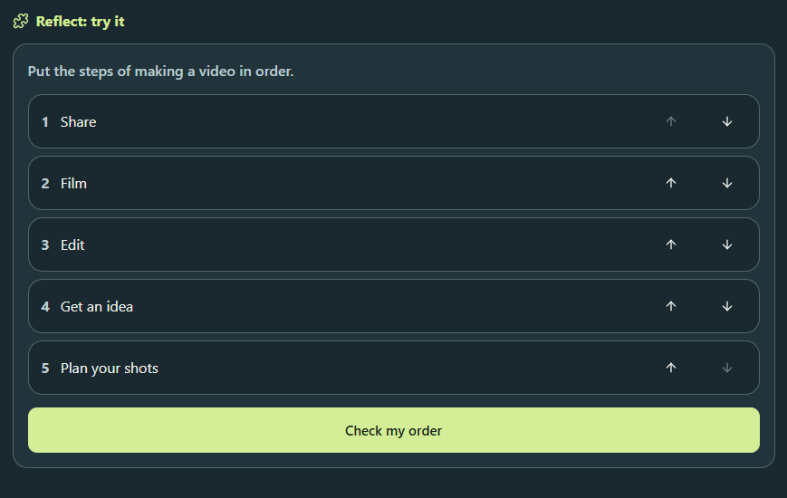

Start the task section should only appear only for the last lesson.
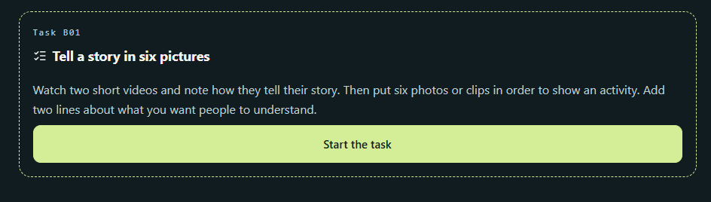

My Work section layout to be made like the below image.

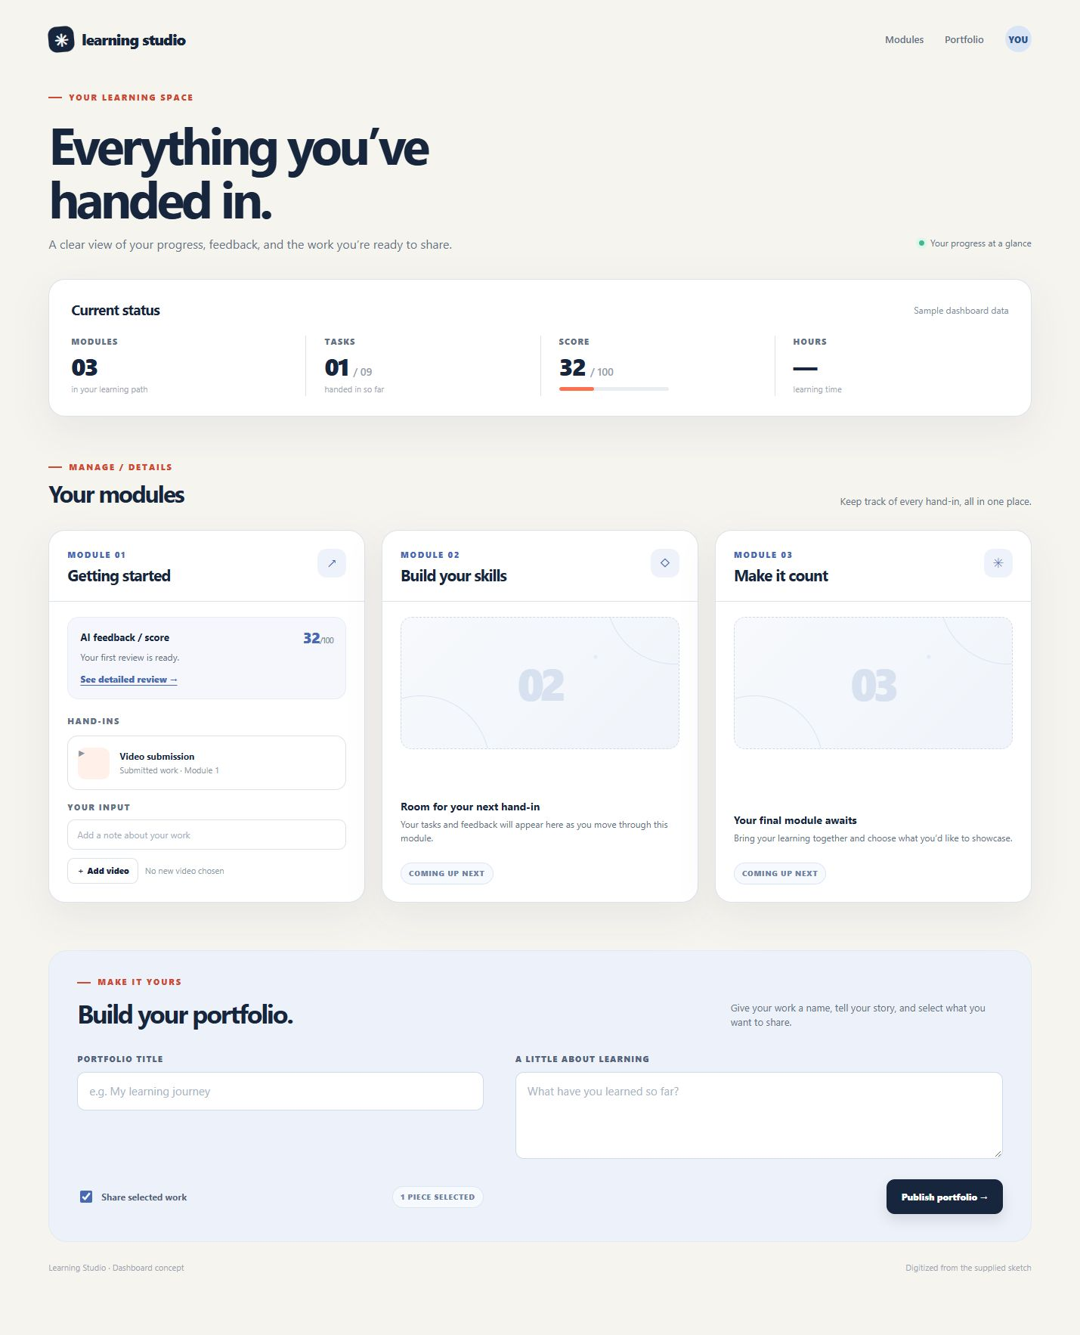
There should be a separate portfolio page with more like a resume which will have further options to create a link to share to people. Should have options to make it public or unlisted. This section will be more like behance/artstation. The learners can see other people work, like, comment and so on as well.

