Trader Performance vs. Market Sentiment
Hyperliquid Historical Trades × Bitcoin Fear/Greed Index (2023–2025)
Prepared by Harshit | Data Science Assignment | Primetrade.ai

1. Executive Summary
This analysis merges 211,224 individual Hyperliquid trade executions from 32 accounts across 246 assets with the daily Bitcoin Fear/Greed Index for 2023–2025, joined on calendar date (99.997% match rate). The goal was to test whether market-wide sentiment regimes are associated with measurable differences in trader profitability, risk-taking, and directional behavior.
The headline finding is counter-intuitive: traders were not more profitable in Greed regimes and not worse off in Fear regimes. Extreme Greed produced the highest win rate (89.2%) and the highest average profit per closed trade ($130.21), while Fear (not Extreme Fear) generated the single largest pool of total profit ($3.36M). Extreme Fear — the regime most associated with panic and capitulation — was actually the weakest performing regime on every profitability metric measured.
Below are the full sentiment-level statistics, followed by supporting charts and detailed interpretation.

Performance Summary by Sentiment Regime
Sentiment | Trades | Win Rate | Total PnL | Avg PnL/Close | Median Size
Extreme Fear | 21,400 | 76.2% | $739,110 | $71.03 | $766
Fear | 61,837 | 87.3% | $3,357,155 | $112.63 | $736
Neutral | 37,686 | 82.4% | $1,292,921 | $71.20 | $548
Greed | 50,303 | 76.9% | $2,150,129 | $85.40 | $555
Extreme Greed | 39,992 | 89.2% | $2,715,171 | $130.21 | $500
Table 1 — Aggregated trade statistics across 211,224 trades, joined to daily Fear/Greed classification.

2. Key Visualizations

2.1 Total Profitability by Sentiment
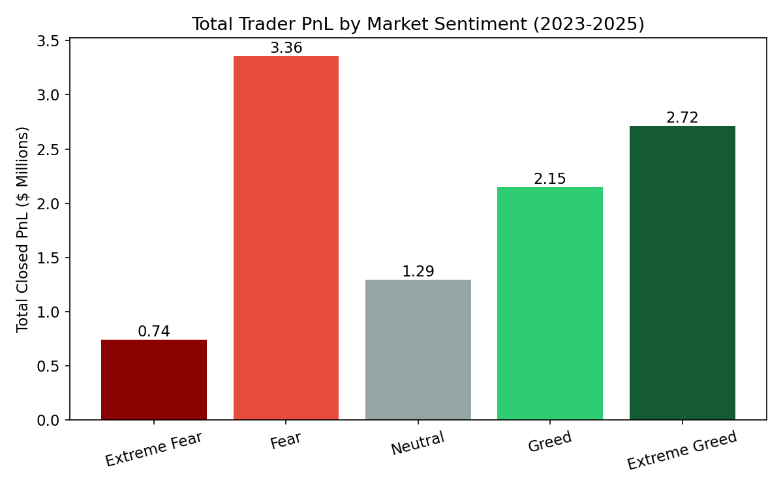
Figure 1 — Fear (not Extreme Fear or Extreme Greed) generated the largest absolute PnL pool, mainly because it also carried the highest trading volume.
Fear regimes accounted for $3.36M of the $10.25M total closed PnL over the period — nearly a third of all profits — despite representing only ~24% of trading days. This is driven primarily by volume: Fear days saw the highest average daily trading volume ($5.3M/day) of any regime.

2.2 Win Rate by Sentiment
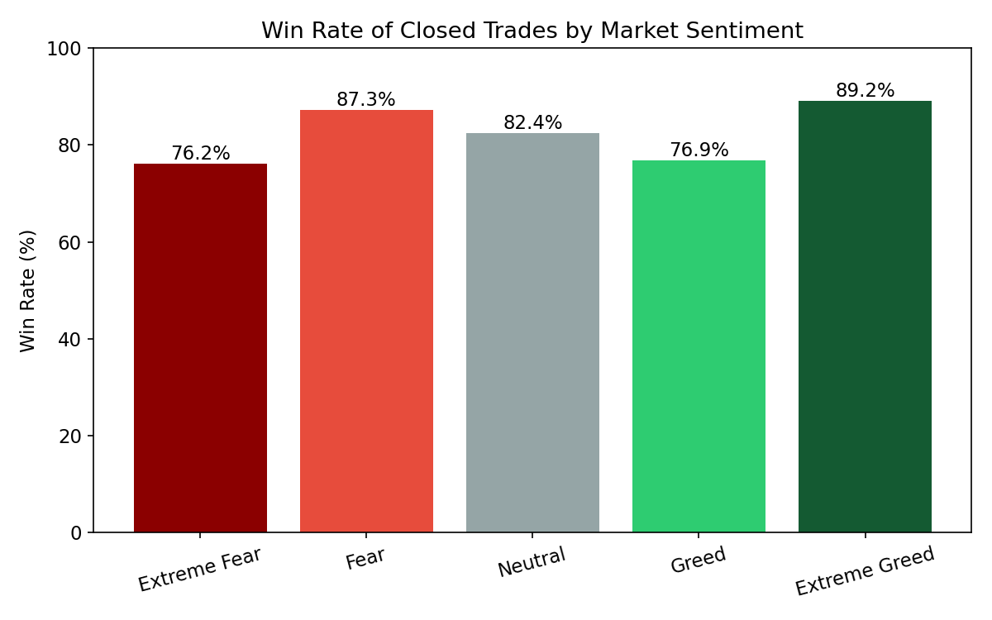
Figure 2 — Win rate rises at both emotional extremes, but is highest in Extreme Greed.
Win rate follows a mild U-shape: Neutral and Greed sit lowest (76–82%), while Extreme Fear (76.2%) and especially Extreme Greed (89.2%) and Fear (87.3%) are higher. This suggests traders in this sample are more selective — or momentum aligns more favorably — during periods of stronger sentiment conviction, whether fearful or euphoric, than during ambiguous Neutral/Greed conditions.

2.3 Median Return per Trade
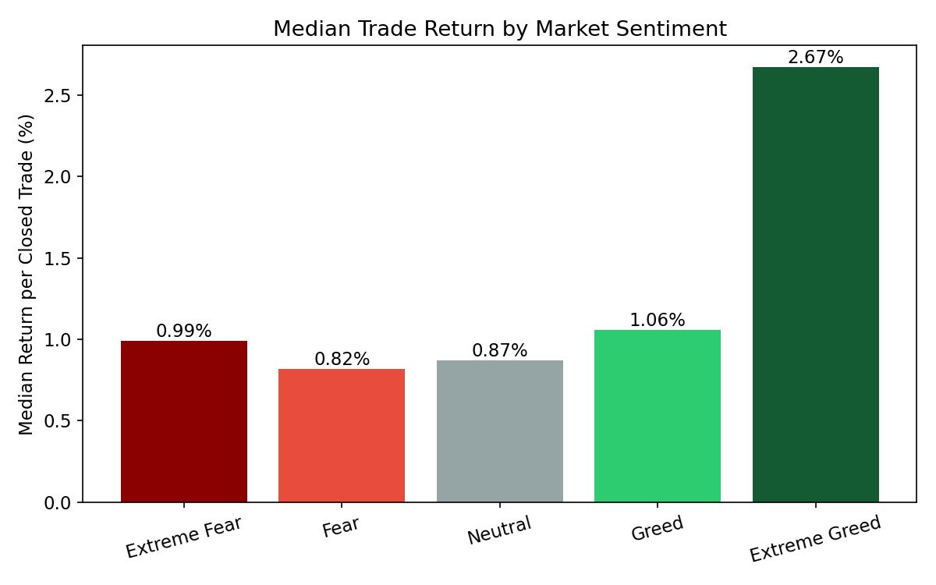
Figure 3 — Median % return on capital deployed, by sentiment (robust to outliers).
Median return per closed trade is highest in Extreme Greed (2.67%) — roughly 2.5–4x every other regime. Extreme Fear produces the thinnest median edge (0.99%), reinforcing that panic conditions are the hardest to profit from, even though most trades still close positive.

2.4 Trading Activity by Sentiment
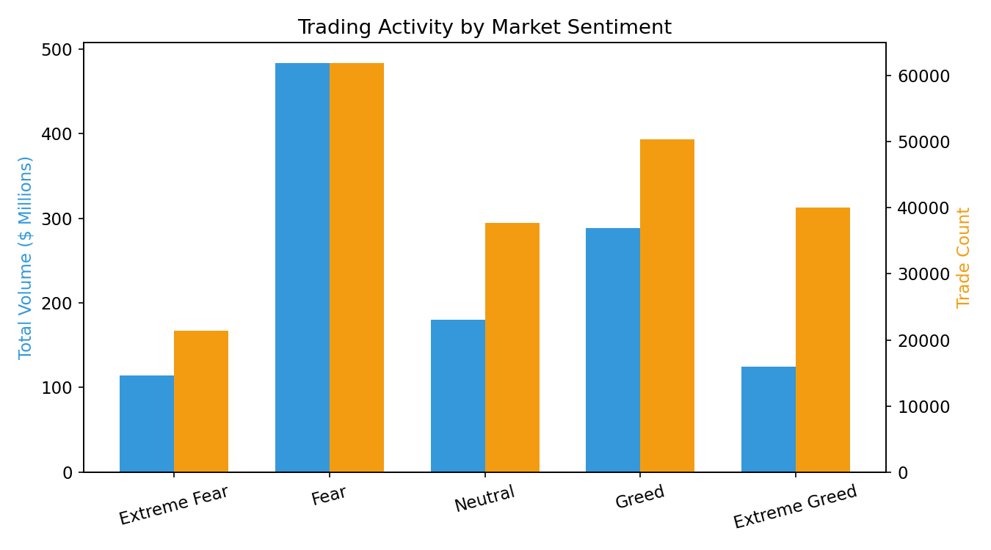
Figure 4 — Both trade count and dollar volume peak during Fear, and are lowest during Greed/Extreme Greed.
Traders in this dataset were substantially more active — both in number of trades and dollar volume — when the market was fearful than when it was greedy. This is consistent with fear-driven markets producing more volatility and more entry/exit opportunities, and/or traders actively working positions (adding, hedging, cutting losses) more often under stress.

2.5 Cumulative PnL Over Time
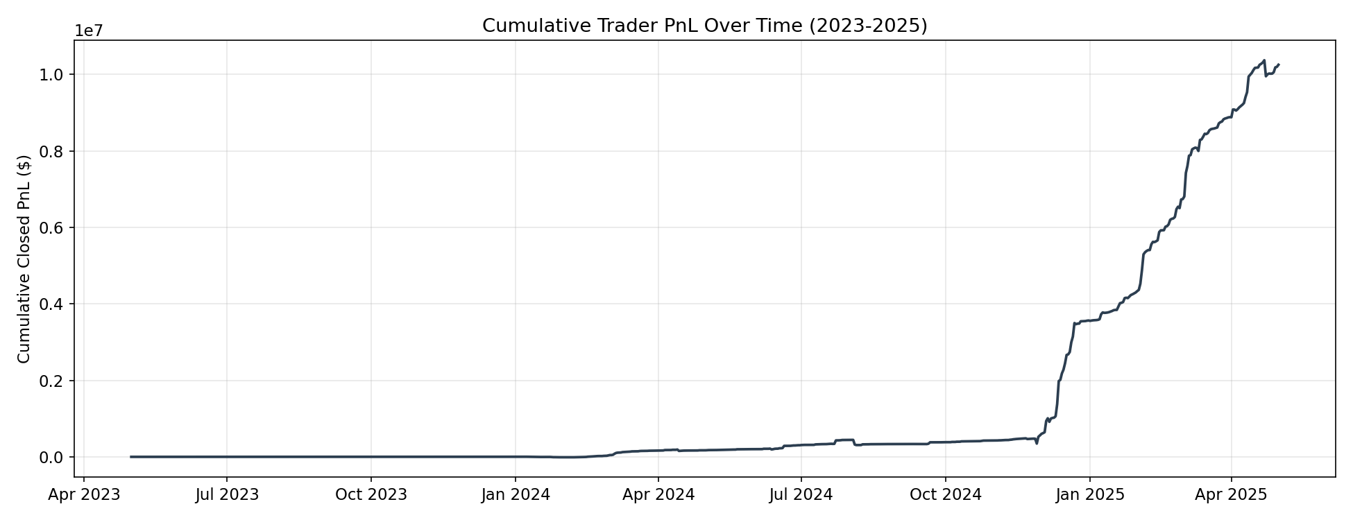
Figure 5 — Cumulative closed PnL across the full sample period.
Cumulative profit is not smooth — it is punctuated by sharp step-changes, consistent with a small number of large, concentrated wins (or losses) rather than steady grind-it-out profitability. This lines up with the account-concentration finding in Section 3.

2.6 Position Sizing by Sentiment
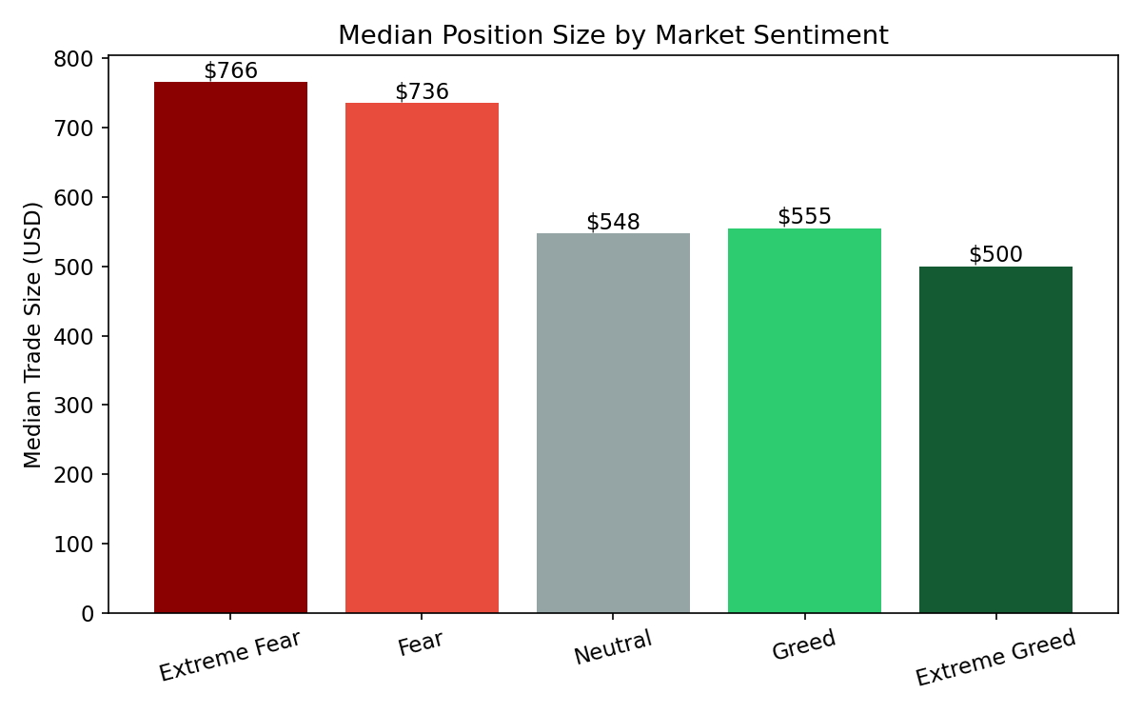
Figure 6 — Median trade size is largest in Fear, smallest in Extreme Greed.
Median trade size is highest during Fear ($736) and lowest during Extreme Greed ($500), a ~47% difference. Traders appear to size up during fearful conditions — potentially averaging into dips or defending positions — and size down during euphoric conditions, perhaps taking more numerous, smaller speculative bets.

2.7 Long vs. Short Performance
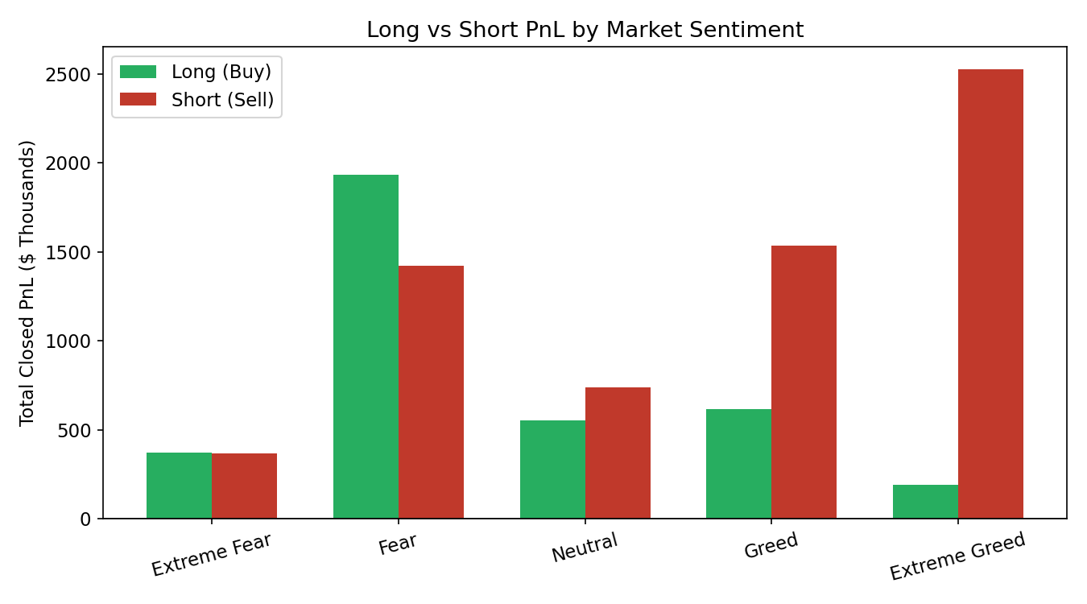
Figure 7 — Short (Sell) positions dominate profitability in Greed and Extreme Greed; Long (Buy) positions dominate in Fear.
The clearest directional pattern in the dataset: Buy-side (long) trades were more profitable during Fear and Extreme Fear, while Sell-side (short) trades were dramatically more profitable during Greed and Extreme Greed — average short PnL per trade in Extreme Greed ($176) was over 6x average long PnL ($29) in that same regime. This is intuitive: greedy/euphoric markets are more likely to be near local tops, rewarding contrarian shorts, while fearful markets are more likely near local bottoms, rewarding contrarian longs.

3. Additional Findings

3.1 Profit Concentration
Profitability is highly concentrated: the top 5 of 32 accounts account for roughly 62% of total closed PnL. Any strategy conclusions drawn from this dataset should be read as describing a small number of dominant, likely more sophisticated traders rather than the 'average' participant.

3.2 Fees & Net Profitability
Net PnL after trading fees remains positive in every sentiment regime, confirming the gross win-rate advantage isn't erased by transaction costs. Fear retains the largest net profit pool ($3.26M after fees), followed by Extreme Greed ($2.69M).

3.3 Asset Concentration
Profitability is also concentrated by asset. A handful of tokens — an unlabeled perpetual ('@107'), HYPE, SOL, ETH, and BTC — drove the large majority of gains, while a small number of meme/altcoins (TRUMP, FARTCOIN, ADA, IO, PAXG) were net losers across the full period, with TRUMP alone responsible for roughly -$365K in cumulative losses.

3.4 Correlation Check
A simple correlation between the daily numeric Fear/Greed value and daily total closed PnL was weak and slightly negative (r ≈ -0.08), confirming that sentiment alone is not a strong linear predictor of daily profitability — the relationship is regime-dependent and directional (long/short) rather than continuous.

4. Strategic Recommendations
- Bias direction to sentiment extremes, not just sentiment level: the data supports leaning long during Fear/Extreme Fear and leaning short during Greed/Extreme Greed — consistent with a contrarian, mean-reversion overlay rather than trend-following on sentiment alone.
- Treat Extreme Fear with caution, not aggression: despite being the 'panic' regime, it produced the weakest win rate and thinnest median return of all five regimes — sizing up purely because sentiment is extreme is not supported by this data.
- Extreme Greed offers the best risk-adjusted edge per trade (highest win rate and median return), but traders in this sample also used smaller position sizes there — suggesting reduced number of high-conviction, smaller bets outperforms large directional bets in euphoric conditions.
- Apply asset-level filters alongside sentiment: a small set of majors/L1s (BTC, ETH, SOL, HYPE) and one dominant perpetual drove most gains, while low-cap/meme exposure (TRUMP, FARTCOIN) was a consistent drag — sentiment-based sizing should be paired with asset selection discipline.
- Because profit is concentrated in ~5 of 32 accounts, any sentiment-based playbook built from this dataset should be validated against a broader/more representative trader sample before being generalized as 'smart trading strategy' guidance.

5. Methodology & Limitations
- Trades were joined to daily Fear/Greed classification by calendar date (IST); 6 of 211,224 trades (0.003%) fell outside the Fear/Greed index date range and were excluded.
- 'Win rate' and returns are computed only on trades with non-zero Closed PnL (104,402 of 211,224 rows), since Closed PnL is 0 for position-opening/adding trades that haven't been realized yet.
- The dataset does not include an explicit leverage field, so leverage-based risk analysis was not performed; Size USD and Start Position were used as size/exposure proxies instead.
- This is an observational, not causal, analysis — sentiment regimes correlate with trader outcomes but the direction of causality (does sentiment drive behavior, or does concurrent price action drive both sentiment and PnL) cannot be established from this data alone.

