**AIM: False Position Method (Regula Falsi ) and Newton Ralphson Method algorithms with example.**

**False Position Method (Regula Falsi ):-**

**Code:**

clc

clear all

close all

y = input('Enter the Function');

a = input('Enter the Value of a:');

b = input('Enter the Value of b:');

e = input('Enter the error:');

i = 1;

fa = feval(y,a);

fb = feval(y,b);

if fa*fb > 0

disp('No Roots');

else

c = a-(a-b)* fa/(fa-fb);

fc = feval(y,c);

fprintf('\n\na\t\t\tb\t\t\tc\t\t\tf(c)\n');

while abs(fc) > e

d(i)=abs(fc);

fprintf('%f\t%f\t%f\t%f\n',a,b,c,fc);

if fa*fc < 0

b=c;

else

a=c;

end

fa = feval(y,a);

fb = feval(y,b);

c = a-(a-b)* fa/(fa-fb);

fc = feval(y,c);

i = i + 1;

end

fprintf('Root is: %f\n',c);

fprintf('Number of Iteration:%f',i)

end

plot(d)

Q1) Find the root of f(x) = x^3 – x - 1 by using Bisection Method in the interval [1, 2] with a tolerance of 0.001

Output:-

Enter the Function@(x) x^3 - x -1

Enter the Value of a:1

Enter the Value of b:2

Enter the error:0.001

a b c f(c)

1.000000 2.000000 1.166667 -0.578704

1.166667 2.000000 1.253112 -0.285363

1.253112 2.000000 1.293437 -0.129542

1.293437 2.000000 1.311281 -0.056588

1.311281 2.000000 1.318989 -0.024304

1.318989 2.000000 1.322283 -0.010362

1.322283 2.000000 1.323684 -0.004404

1.323684 2.000000 1.324279 -0.001869

Root is: 1.324532

Number of Iteration:9.000000>>

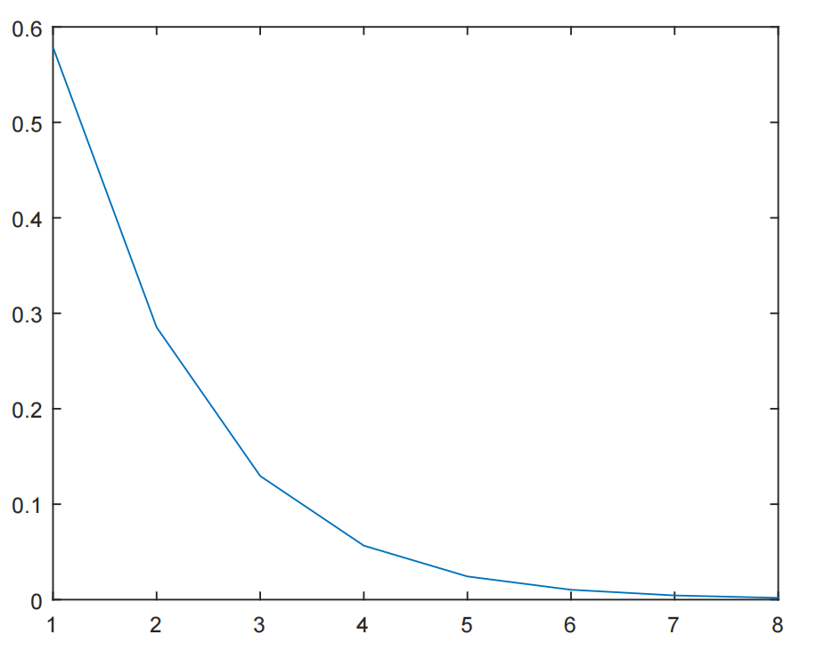

Q2) Find the root of f(x) = x^3 - x^2 + 2 by using Bisection Method in the interval [-10, 10] with a tolerance of 0.01

Output:

Enter the Function @(x) x^3 - x^2 + 2

Enter the Value of a:-10

Enter the Value of b:10

Enter the error:0.01

a b c f(c)

-10.000000 10.000000 0.980000 1.980792

-10.000000 0.980000 0.960228 1.963329

-10.000000 0.960228 0.940665 1.947497

-10.000000 0.940665 0.921294 1.933196

-10.000000 0.921294 0.902099 1.920330

-10.000000 0.902099 0.883065 1.908814

-10.000000 0.883065 0.864179 1.898568

-10.000000 0.864179 0.845426 1.889519

-10.000000 0.845426 0.826794 1.881598

-10.000000 0.826794 0.808272 1.874744

-10.000000 0.808272 0.789850 1.868895

-10.000000 0.789850 0.771516 1.863998

-10.000000 0.771516 0.753260 1.860000

-10.000000 0.753260 0.735075 1.856852

-10.000000 0.735075 0.716952 1.854508

-10.000000 0.716952 0.698881 1.852923

-10.000000 0.698881 0.680857 1.852056

-10.000000 0.680857 0.662871 1.851866

-10.000000 0.662871 0.644918 1.852315

-10.000000 0.644918 0.626990 1.853364

-10.000000 0.626990 0.609083 1.854977

-10.000000 0.609083 0.591190 1.857119

-10.000000 0.591190 0.573306 1.859754

-10.000000 0.573306 0.555428 1.862849

-10.000000 0.555428 0.537550 1.866370

-10.000000 0.537550 0.519669 1.870284

-10.000000 0.519669 0.501781 1.874556

-10.000000 0.501781 0.483882 1.879155

-10.000000 0.483882 0.465970 1.884047

-10.000000 0.465970 0.448043 1.889199

-10.000000 0.448043 0.430097 1.894577

-10.000000 0.430097 0.412131 1.900149

-10.000000 0.412131 0.394143 1.905881

-10.000000 0.394143 0.376133 1.911738

-10.000000 0.376133 0.358098 1.917686

-10.000000 0.358098 0.340039 1.923691

-10.000000 0.340039 0.321955 1.929717

-10.000000 0.321955 0.303846 1.935729

-10.000000 0.303846 0.285713 1.941691

-10.000000 0.285713 0.267556 1.947567

-10.000000 0.267556 0.249376 1.953320

-10.000000 0.249376 0.231175 1.958913

-10.000000 0.231175 0.212954 1.964308

-10.000000 0.212954 0.194716 1.969468

-10.000000 0.194716 0.176463 1.974356

-10.000000 0.176463 0.158197 1.978933

-10.000000 0.158197 0.139922 1.983161

-10.000000 0.139922 0.121640 1.987003

-10.000000 0.121640 0.103357 1.990422

-10.000000 0.103357 0.085075 1.993378

-10.000000 0.085075 0.066799 1.995836

-10.000000 0.066799 0.048534 1.997759

-10.000000 0.048534 0.030284 1.999111

-10.000000 0.030284 0.012055 1.999856

-10.000000 0.012055 -0.006147 1.999962

-10.000000 -0.006147 -0.024318 1.999394

-10.000000 -0.024318 -0.042450 1.998122

-10.000000 -0.042450 -0.060537 1.996113

-10.000000 -0.060537 -0.078574 1.993341

-10.000000 -0.078574 -0.096553 1.989777

-10.000000 -0.096553 -0.114467 1.985397

-10.000000 -0.114467 -0.132310 1.980178

-10.000000 -0.132310 -0.150074 1.974098

-10.000000 -0.150074 -0.167751 1.967139

-10.000000 -0.167751 -0.185335 1.959285

-10.000000 -0.185335 -0.202817 1.950522

-10.000000 -0.202817 -0.220190 1.940841

-10.000000 -0.220190 -0.237447 1.930232

-10.000000 -0.237447 -0.254579 1.918690

-10.000000 -0.254579 -0.271579 1.906215

-10.000000 -0.271579 -0.288439 1.892806

-10.000000 -0.288439 -0.305151 1.878468

-10.000000 -0.305151 -0.321709 1.863208

-10.000000 -0.321709 -0.338104 1.847035

-10.000000 -0.338104 -0.354330 1.829964

-10.000000 -0.354330 -0.370379 1.812010

-10.000000 -0.370379 -0.386245 1.793193

-10.000000 -0.386245 -0.401920 1.773535

-10.000000 -0.401920 -0.417398 1.753060

-10.000000 -0.417398 -0.432673 1.731795

-10.000000 -0.432673 -0.447739 1.709771

-10.000000 -0.447739 -0.462590 1.687020

-10.000000 -0.462590 -0.477222 1.663577

-10.000000 -0.477222 -0.491628 1.639477

-10.000000 -0.491628 -0.505804 1.614759

-10.000000 -0.505804 -0.519746 1.589462

-10.000000 -0.519746 -0.533450 1.563628

-10.000000 -0.533450 -0.546912 1.537300

-10.000000 -0.546912 -0.560128 1.510520

-10.000000 -0.560128 -0.573097 1.483332

-10.000000 -0.573097 -0.585815 1.455781

-10.000000 -0.585815 -0.598280 1.427913

-10.000000 -0.598280 -0.610491 1.399771

-10.000000 -0.610491 -0.622446 1.371402

-10.000000 -0.622446 -0.634144 1.342848

-10.000000 -0.634144 -0.645584 1.314155

-10.000000 -0.645584 -0.656767 1.285366

-10.000000 -0.656767 -0.667691 1.256523

-10.000000 -0.667691 -0.678359 1.227668

-10.000000 -0.678359 -0.688770 1.198841

-10.000000 -0.688770 -0.698925 1.170081

-10.000000 -0.698925 -0.708826 1.141427

-10.000000 -0.708826 -0.718475 1.112913

-10.000000 -0.718475 -0.727873 1.084575

-10.000000 -0.727873 -0.737023 1.056445

-10.000000 -0.737023 -0.745926 1.028556

-10.000000 -0.745926 -0.754587 1.000935

-10.000000 -0.754587 -0.763008 0.973611

-10.000000 -0.763008 -0.771191 0.946610

-10.000000 -0.771191 -0.779140 0.919956

-10.000000 -0.779140 -0.786860 0.893670

-10.000000 -0.786860 -0.794352 0.867772

-10.000000 -0.794352 -0.801622 0.842282

-10.000000 -0.801622 -0.808672 0.817216

-10.000000 -0.808672 -0.815508 0.792589

-10.000000 -0.815508 -0.822133 0.768414

-10.000000 -0.822133 -0.828552 0.744703

-10.000000 -0.828552 -0.834768 0.721465

-10.000000 -0.834768 -0.840786 0.698709

-10.000000 -0.840786 -0.846611 0.676441

-10.000000 -0.846611 -0.852247 0.654668

-10.000000 -0.852247 -0.857698 0.633394

-10.000000 -0.857698 -0.862968 0.612621

-10.000000 -0.862968 -0.868063 0.592350

-10.000000 -0.868063 -0.872987 0.572584

-10.000000 -0.872987 -0.877744 0.553320

-10.000000 -0.877744 -0.882339 0.534557

-10.000000 -0.882339 -0.886776 0.516294

-10.000000 -0.886776 -0.891059 0.498526

-10.000000 -0.891059 -0.895193 0.481249

-10.000000 -0.895193 -0.899182 0.464459

-10.000000 -0.899182 -0.903030 0.448150

-10.000000 -0.903030 -0.906741 0.432316

-10.000000 -0.906741 -0.910320 0.416951

-10.000000 -0.910320 -0.913770 0.402047

-10.000000 -0.913770 -0.917096 0.387596

-10.000000 -0.917096 -0.920301 0.373592

-10.000000 -0.920301 -0.923390 0.360025

-10.000000 -0.923390 -0.926365 0.346886

-10.000000 -0.926365 -0.929231 0.334168

-10.000000 -0.929231 -0.931990 0.321862

-10.000000 -0.931990 -0.934648 0.309957

-10.000000 -0.934648 -0.937206 0.298445

-10.000000 -0.937206 -0.939669 0.287317

-10.000000 -0.939669 -0.942039 0.276562

-10.000000 -0.942039 -0.944320 0.266172

-10.000000 -0.944320 -0.946515 0.256137

-10.000000 -0.946515 -0.948626 0.246448

-10.000000 -0.948626 -0.950657 0.237095

-10.000000 -0.950657 -0.952611 0.228069

-10.000000 -0.952611 -0.954490 0.219361

-10.000000 -0.954490 -0.956296 0.210961

-10.000000 -0.956296 -0.958034 0.202861

-10.000000 -0.958034 -0.959704 0.195051

-10.000000 -0.959704 -0.961310 0.187522

-10.000000 -0.961310 -0.962853 0.180267

-10.000000 -0.962853 -0.964336 0.173275

-10.000000 -0.964336 -0.965762 0.166540

-10.000000 -0.965762 -0.967132 0.160053

-10.000000 -0.967132 -0.968449 0.153806

-10.000000 -0.968449 -0.969714 0.147790

-10.000000 -0.969714 -0.970929 0.141999

-10.000000 -0.970929 -0.972097 0.136425

-10.000000 -0.972097 -0.973218 0.131060

-10.000000 -0.973218 -0.974295 0.125897

-10.000000 -0.974295 -0.975330 0.120930

-10.000000 -0.975330 -0.976324 0.116151

-10.000000 -0.976324 -0.977278 0.111554

-10.000000 -0.977278 -0.978195 0.107133

-10.000000 -0.978195 -0.979075 0.102881

-10.000000 -0.979075 -0.979920 0.098793

-10.000000 -0.979920 -0.980732 0.094862

-10.000000 -0.980732 -0.981511 0.091083

-10.000000 -0.981511 -0.982259 0.087451

-10.000000 -0.982259 -0.982977 0.083959

-10.000000 -0.982977 -0.983667 0.080603

-10.000000 -0.983667 -0.984329 0.077378

-10.000000 -0.984329 -0.984964 0.074279

-10.000000 -0.984964 -0.985574 0.071302

-10.000000 -0.985574 -0.986159 0.068441

-10.000000 -0.986159 -0.986721 0.065693

-10.000000 -0.986721 -0.987260 0.063052

-10.000000 -0.987260 -0.987778 0.060516

-10.000000 -0.987778 -0.988274 0.058080

-10.000000 -0.988274 -0.988751 0.055740

-10.000000 -0.988751 -0.989208 0.053493

-10.000000 -0.989208 -0.989647 0.051335

-10.000000 -0.989647 -0.990069 0.049263

-10.000000 -0.990069 -0.990473 0.047273

-10.000000 -0.990473 -0.990861 0.045363

-10.000000 -0.990861 -0.991233 0.043529

-10.000000 -0.991233 -0.991590 0.041767

-10.000000 -0.991590 -0.991933 0.040077

-10.000000 -0.991933 -0.992262 0.038453

-10.000000 -0.992262 -0.992577 0.036895

-10.000000 -0.992577 -0.992880 0.035399

-10.000000 -0.992880 -0.993170 0.033964

-10.000000 -0.993170 -0.993449 0.032586

-10.000000 -0.993449 -0.993716 0.031263

-10.000000 -0.993716 -0.993972 0.029993

-10.000000 -0.993972 -0.994218 0.028775

-10.000000 -0.994218 -0.994454 0.027606

-10.000000 -0.994454 -0.994681 0.026483

-10.000000 -0.994681 -0.994898 0.025406

-10.000000 -0.994898 -0.995106 0.024373

-10.000000 -0.995106 -0.995306 0.023381

-10.000000 -0.995306 -0.995498 0.022429

-10.000000 -0.995498 -0.995682 0.021516

-10.000000 -0.995682 -0.995858 0.020640

-10.000000 -0.995858 -0.996028 0.019799

-10.000000 -0.996028 -0.996190 0.018992

-10.000000 -0.996190 -0.996346 0.018218

-10.000000 -0.996346 -0.996495 0.017476

-10.000000 -0.996495 -0.996638 0.016763

-10.000000 -0.996638 -0.996776 0.016080

-10.000000 -0.996776 -0.996908 0.015424

-10.000000 -0.996908 -0.997034 0.014794

-10.000000 -0.997034 -0.997155 0.014191

-10.000000 -0.997155 -0.997272 0.013612

-10.000000 -0.997272 -0.997383 0.013056

-10.000000 -0.997383 -0.997490 0.012523

-10.000000 -0.997490 -0.997593 0.012012

-10.000000 -0.997593 -0.997692 0.011521

-10.000000 -0.997692 -0.997786 0.011050

-10.000000 -0.997786 -0.997877 0.010599

-10.000000 -0.997877 -0.997963 0.010166

Root is: -0.998047

Number of Iteration:227.000000>>

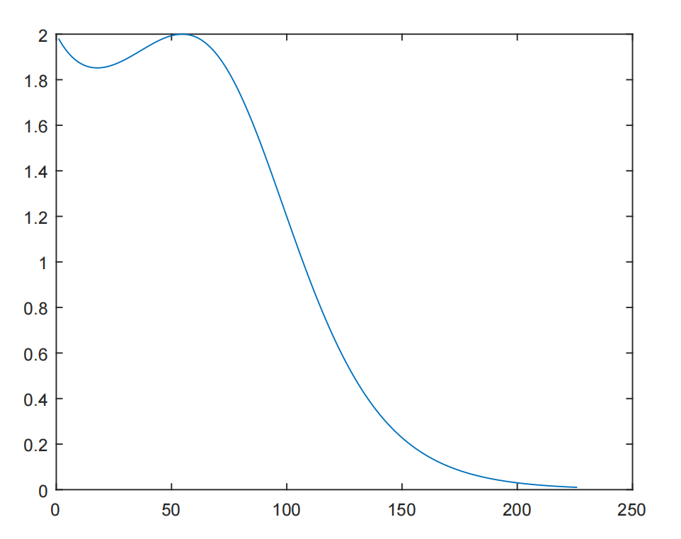

Q3) Find the root of f(x) = cos(x) – x*exp(x) by using Bisection Method in the interval [0, 1] with a tolerance of 0.00001

Enter the Function @(x) cos(x) - x*exp(x)

Enter the Value of a:0

Enter the Value of b:1

Enter the error:0.00001

a b c f(c)

0.000000 1.000000 0.314665 0.519871

0.314665 1.000000 0.446728 0.203545

0.446728 1.000000 0.494015 0.070802

0.494015 1.000000 0.509946 0.023608

0.509946 1.000000 0.515201 0.007760

0.515201 1.000000 0.516922 0.002539

0.516922 1.000000 0.517485 0.000829

0.517485 1.000000 0.517668 0.000271

0.517668 1.000000 0.517728 0.000088

0.517728 1.000000 0.517748 0.000029

Root is: 0.517754

Number of Iteration:11.000000>>

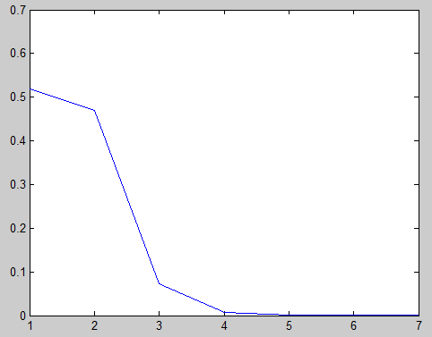

**Newton Ralphson:**

**Code:**

clc

clear all

close all

f = @(x) x^3 - x -1;

g = @(x) 3*x^2-1;

a = input('Enter the Initial Guess (a): ');

e = input('Enter the Error Tolerance: ');

n = input('Enter the Number of Iteration:');

step = 1;

fa = feval(f,a);

while abs(fa) > e

err(step)=abs(fa);

fa = feval(f,a);

ga = feval(g,a);

if ga == 0

disp('Mathematical Error');

break;

end

b = a - fa/ga;

fprintf('step=%d\ta=%f\tf(a)=%f\n ',step ,a,fa);

a = b;

if step > n

disp('Not Convergent');

break;

end

step = step + 1;

end

fprintf('Root is: %f\n',a);

fprintf('Number of Iterations: %d\n',step);

plot(err);

Q1)Find the root of f(x)=x^3 – x – 1 by using Newton Ralphson position method in the interval [1,2] with a tolerance of 0.001

Enter the function:@(x) x^3-x-1

Enter the derivative of y function:@(x)3*x^2-1

Enter the value of a:1

Enter the error0.01

Enter the maximum number of iteration:15

step=1 a=1.000000 f(a)=-1.000000

step=2 a=1.500000 f(a)=0.875000

step=3 a=1.347826 f(a)=0.100682

step=4 a=1.325200 f(a)=0.002058

Root is 1.324718

Q2) Find the root of f(x) = x^3-x^2+2 by using Newton Ralphson method in the interval [-1,1] with a tolerance of 0.01

Enter the function:@(x)x^3-x^2+2

Enter the derivative of y function:@(x) 3*x^2-2*x

Enter the value of a:-10

Enter the error0.01

Enter the maximum number of iteration:15

step=1 a=-10.000000 f(a)=-1098.000000

step=2 a=-6.568750 f(a)=-324.580032

step=3 a=-4.292320 f(a)=-95.505774

step=4 a=-2.796693 f(a)=-27.695808

step=5 a=-1.843567 f(a)=-7.664544

step=6 a=-1.291500 f(a)=-1.822157

step=7 a=-1.051329 f(a)=-0.267318

step=8 a=-1.001995 f(a)=-0.009990

Root is -1.000003

Q3)Find the root of f(x)=cos(x)-x*exp(x) by using Newton Ralphson method in the interval [0,1] with a tolerance of 0.00001

Enter the function:@(x)cos(x)-x*exp(x)

Enter the derivative of y function:@(x)(-sin(x))-x*exp(x)-exp(x)

Enter the value of a:0

Enter the error0.00001

Enter the maximum number of iteration:15

step=1 a=0.000000 f(a)=1.000000

step=2 a=1.000000 f(a)=-2.177980

step=3 a=0.653079 f(a)=-0.460642

step=4 a=0.531343 f(a)=-0.041803

|  |
| --- |
| Name: Harshit Kr. Singh |
| Roll Number: 22052118 |

step=5 a=0.517910 f(a)=-0.000464

step=6 a=0.517757 f(a)=-0.000000

Root is 0.517757