INPUT:

import java.applet.\*;

import java.awt.\*;

import java.awt.event.ActionEvent;

import java.awt.event.ActionListener;

public class Activity extends Applet implements ActionListener {

TextField t1;

int prevValue;

String operator;

boolean answer;

int currentPage;

Label pageLabel;

public void init() {

Label label1 = new Label("Harshit Kumar Singh");

add(label1);

t1 = new TextField(10);

t1.setPreferredSize(new Dimension(200, 30));

add(t1);

currentPage = 1;

pageLabel = new Label();

add(pageLabel);

showPageOne();

}

public void actionPerformed(ActionEvent e) {

String s = e.getActionCommand();

int currentValue = Integer.parseInt(t1.getText());

if (currentPage == 1) {

if (s.equals("+")) {

prevValue = currentValue;

operator = s;

t1.setText("");

answer = false;

} else if (s.equals("=")) {

int result = performOperation(prevValue, currentValue, operator);

t1.setText(Integer.toString(result));

answer = true;

} else if (s.equals("Next")) {

currentPage = 2;

showPageTwo();

}

} else if (currentPage == 2) {

if (s.equals("-")) {

prevValue = currentValue;

operator = s;

t1.setText("");

answer = false;

} else if (s.equals("=")) {

int result = performOperation(prevValue, currentValue, operator);

t1.setText(Integer.toString(result));

answer = true;

} else if (s.equals("Previous")) {

currentPage = 1;

showPageOne();

} else if (s.equals("Next")) {

currentPage = 3;

showPageThree();

}

} else if (currentPage == 3) {

if (s.equals("\*")) {

prevValue = currentValue;

operator = s;

t1.setText("");

answer = false;

} else if (s.equals("=")) {

int result = performOperation(prevValue, currentValue, operator);

t1.setText(Integer.toString(result));

answer = true;

} else if (s.equals("Previous")) {

currentPage = 2;

showPageTwo();

} else if (s.equals("Exit")) {

System.exit(0);

}

} else {

}

}

private int performOperation(int num1, int num2, String operator) {

switch (operator) {

case "+":

return num1 + num2;

case "-":

return num1 - num2;

case "\*":

return num1 \* num2;

default:

return 0;

}

}

private void showPageOne() {

removeAll();

pageLabel.setText("Harshit Kumar Singh");

add(pageLabel);

add(t1);

Button addBtn = new Button("+");

addBtn.addActionListener(this);

addBtn.setPreferredSize(new Dimension(100, 50));

Button equalBtn = new Button("=");

equalBtn.addActionListener(this);

equalBtn.setPreferredSize(new Dimension(100, 50));

Button nextBtn = new Button("Next");

nextBtn.addActionListener(this);

nextBtn.setPreferredSize(new Dimension(100, 50));

add(addBtn);

add(equalBtn);

add(nextBtn);

validate();

}

private void showPageTwo() {

removeAll();

pageLabel.setText("22052118");

add(pageLabel);

add(t1);

Button subBtn = new Button("-");

subBtn.addActionListener(this);

subBtn.setPreferredSize(new Dimension(100, 50));

Button equalBtn = new Button("=");

equalBtn.addActionListener(this);

equalBtn.setPreferredSize(new Dimension(100, 50));

Button prevBtn = new Button("Previous");

prevBtn.addActionListener(this);

prevBtn.setPreferredSize(new Dimension(100, 50));

Button nextBtn = new Button("Next");

nextBtn.addActionListener(this);

nextBtn.setPreferredSize(new Dimension(100, 50));

add(subBtn);

add(equalBtn);

add(prevBtn);

add(nextBtn);

validate();

}

private void showPageThree() {

removeAll();

pageLabel.setText("CSE-11");

add(pageLabel);

add(t1);

Button multBtn = new Button("\*");

multBtn.addActionListener(this);

multBtn.setPreferredSize(new Dimension(100, 50));

Button equalBtn = new Button("=");

equalBtn.addActionListener(this);

equalBtn.setPreferredSize(new Dimension(100, 50));

Button prevBtn = new Button("Previous");

prevBtn.addActionListener(this);

prevBtn.setPreferredSize(new Dimension(100, 50));

Button exitBtn = new Button("Exit");

exitBtn.addActionListener(this);

exitBtn.setPreferredSize(new Dimension(100, 50));

add(multBtn);

add(equalBtn);

add(prevBtn);

add(exitBtn);

validate();

}

}

OUTPUT:

PageOne():

-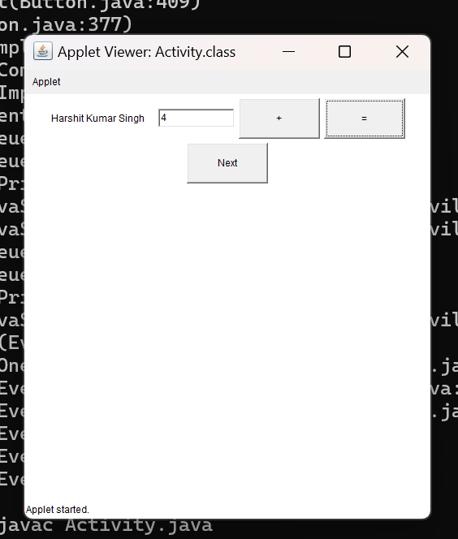

PageTwo():

: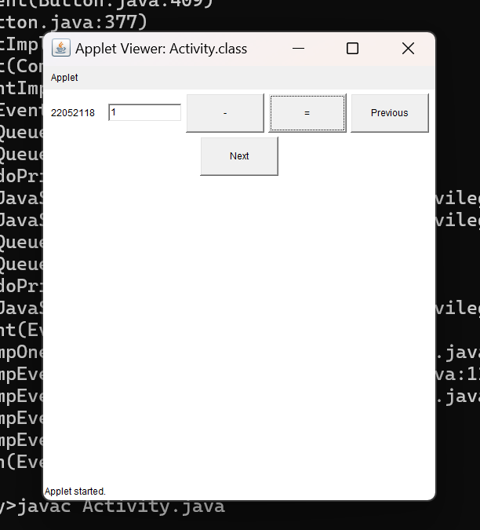

PageThree():

