**Docker installation and basic container operations, Build an image from Dockerfile**

For Window and MacOS

We can simply install Docker in window and MacOS by downloading Docker Desktop related to operating systems and install it.

After installing, we can verify it by using following commands

docker –version

**For Linux**

We simply run following commands in terminal to download and install in our Linux Operating system.

$ sudo apt update

$ sudo apt install docker.io -y

$ sudo docker --version

$ sudo systemctl status docker

$ sudo systemctl start docker

$ sudo systemctl enable docker

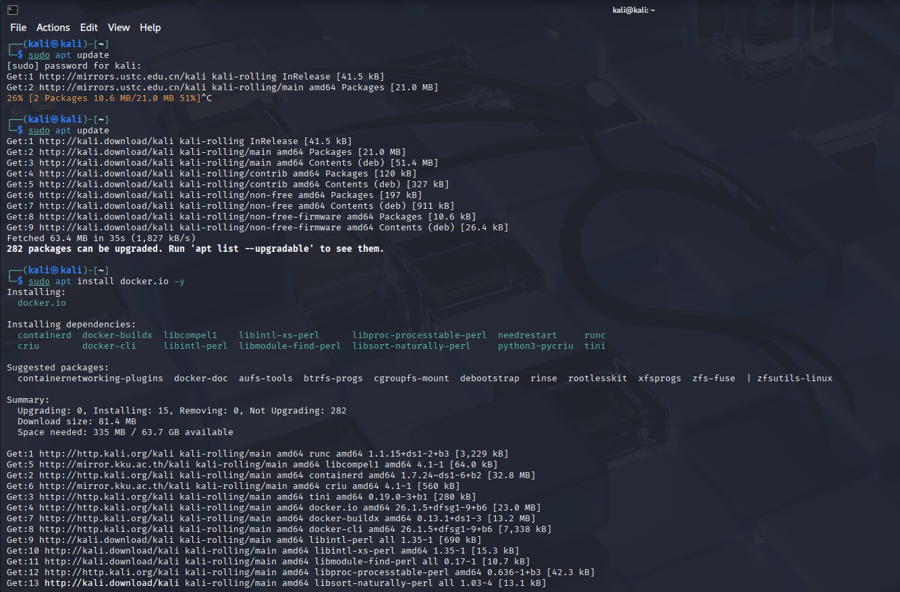

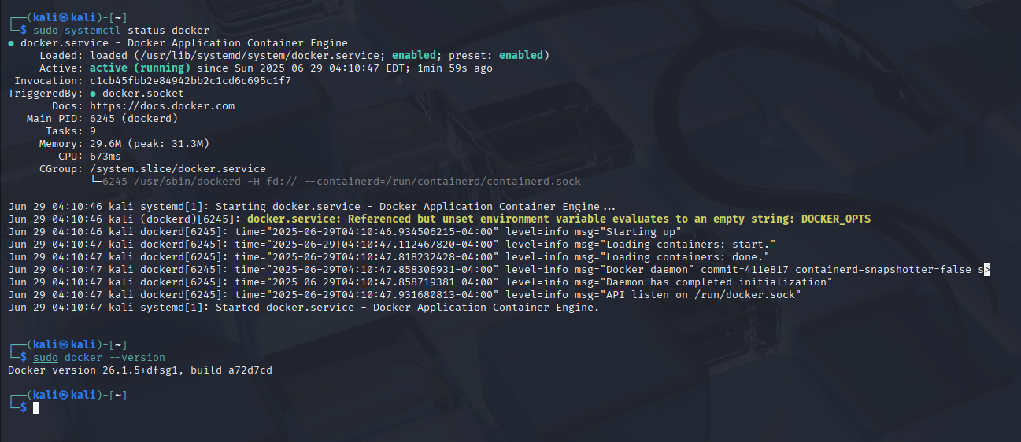

By running above commands, we have successfully installed docker in active running state.

There are some **basic container operations** as follows:

Pull an Image

$ sudo docker pull alpine

Run a container

$ sudo docker run -it alpine /bin/sh

List running containers

$ sudo docker ps

List all containers

$ sudo docker ps -a

Stop a containers

$ sudo docker stop <container_id>

Remove containers

$ sudo docker rm <container_id>

**Dockerfile**

We will create a simple Dockerfile and run it as following

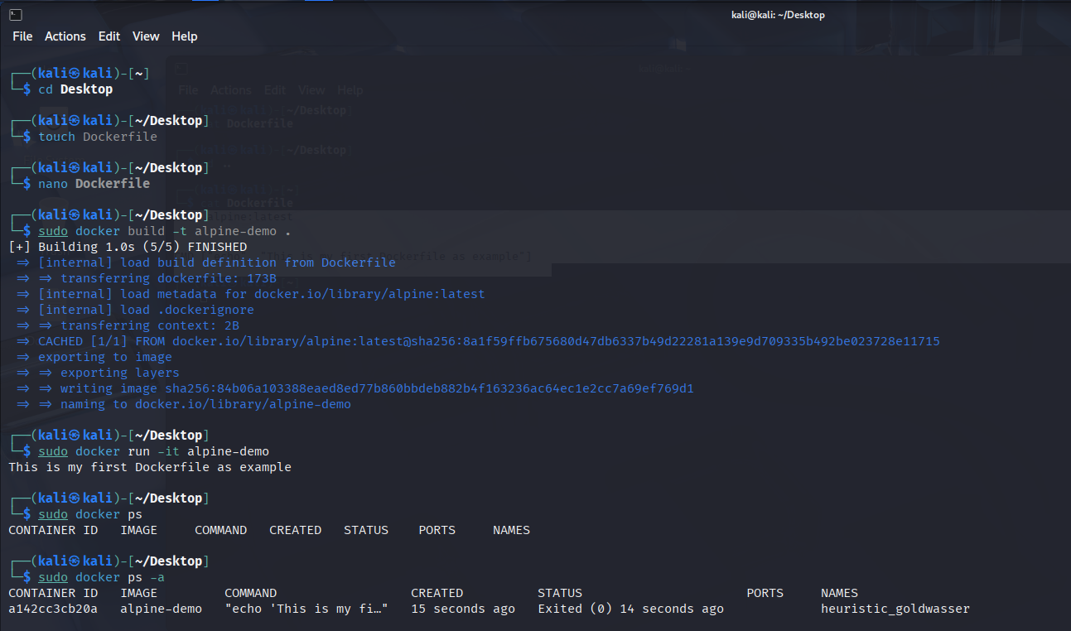We

We have a Dockerfile as follow:

FROM alpine:latest

CMD ["echo", "This is my first Dockerfile as example"]

After saving Dockerfile, we have build docker image and then directly run it for only once time to perform it’s functionality and at same time, it will Exited

In such a way, we have created a Dockerfile and run a container