Index

|  |  |  |
| --- | --- | --- |
| **Sr. No.** | **Contents** | **Page No.** |
| **1** | **Annexure I– Micro Project Proposal** | **1-2** |
| 1.Aims/Benefits of the Micro-Project | 1 |
| 2. Course Outcome Addressed | 1 |
| 3.Proposed Methodology | 1 |
| 4. Action Plan | 2 |
| 5. Resources Required | 3 |
| 6. Name of Team Members with Roll No.’s | 3 |
| **2** | **Annexure II – Micro Project Report** | **3-8** |
| 1.Rationale | 4 |
| 2.Aims/Benefits of the Micro-Project | 4 |
| 3.Course Outcome Achieved | 4 |
| 4. Literature Review | 4 |
| 5.Actual Methodology Followed | 4 |
| 5.1 Syntax | 5 |
| 5.2 Source code | 5-6 |
| 6.Actual Resources Used | 6 |
| 7.Outputs of Micro-Projects | 7 |
| 8. Skill developed / Learning out of this Micro-Project | 8 |
| 9. Applications of this Micro-Project | 8 |

## Annexure I

**Micro Project Proposal**

# *develop a Code editor applicaton using vb.net framework*

## Aims/Benefits of the Micro-Project:

* + Creating a useful and functional media player application that you can use yourself or share with others.
  + Improving your knowledge of Panel, Tab Index and Dock techniques.
  + Enhancing your programming skills in VB.NET and gaining experience in developing a desktop application.

## Course Outcome Addressed:

* CO1 - Use Visual Studio IDE to design application.
* CO2 - Develop GUI Application using Form Controls and its events.
* CO3 - Apply Object Oriented concepts in GUI Application.

## Proposed Methodology:

A trigger is a stored procedure in database which automatically invokes whenever a special event in the database occurs. For example, a trigger can be invoked when a row is inserted into a specified table or when certain table columns are being updated.

1. **Action Plan:**

|  |  |  |  |  |
| --- | --- | --- | --- | --- |
| **Sr.**  **No.** | **Details of Activity** | **Planned**  **Start date** | **Planned**  **Finish date** | **Name of Responsible**  **Team Members** |
| 1 | Search the information of  database | 14-09-2022  3:30 – 5:30 PM | 16-09-2022  3:30 – 5:30 PM | Akshay Dashrath Gitte |
| 2 | Collect the information of  trigger | 19-09-2022  3:30 – 5:30 PM | 23-09-2022  3:30 – 5:30 PM |
| 3 | Analysis of different  information | 26-09-2022  3:30 – 5:30 PM | 29-09-2022  3:30 – 5:30 PM |
| 4 | Analysis of information | 03-10-2022  3:30 – 5:30 PM | 06-10-2022  3:30 – 5:30 PM | Harsh Moreshwar  Kale  Sujit Sudhakar  Sukane |
| 5 | Compression of Database | 10-10-2022  3:30 – 5:30 PM | 13-10-2022  3:30 – 5:30 PM |
| 6 | Features of Database | 20-10-2022  3:30 – 5:30 PM | 01-11-2022  3:30 – 5:30 PM |
| 7 | Advantages and drawback  of trigger | 03-11-2022  3:30 – 5:30 PM | 07-11-2022  3:30 – 5:30 PM |
| 8 | Final report of project | 14-11-2022  3:30 – 5:30 PM | 17-11-2022  3:30 – 5:30 PM |

1. **Resources Required:**

|  |  |  |  |  |
| --- | --- | --- | --- | --- |
| **Sr. No**  **.** | **Name of resource / material** | **Specification** | **Quantity** | **Remarks** |
| 1 | Computer | WINDOWS 11,8GB  RAM | 1 |  |
| 2 | Operating System | WINDOWS 11 | 1 |  |
| 3 | Software | Oracle Database 10G | 1 |  |
| 4 | Browser | Google Chrome | 1 |  |

## Names of Team Members with Roll No.’s:

|  |  |  |  |
| --- | --- | --- | --- |
| **Sr.**  **No.** | **Enrollment No.** | **Name of Team Member** | **Roll No.** |
| 1 | 2110950049 | Akshay Dashrath Gitte | 01 |
| 2 | 2110950051 | Harsh Moreshwar Kale | 03 |
| 3 | 2210950151 | Kunal Nalwade | 60 |

**Mr. Omkare R. S.**

## Name and Signature of the Teacher

**Annexure – II**

**Micro-Project Report**

# TRIGGER ON GIVEN DATABASE

## Rationale:

Data communication are the exchange of data between two nodes via some form of link (transmission medium) such as cable. Now these Data are exchanged in three ways

1. Simplex

2. Half Duplex

3. Full Duplex

## Aims/Benefits of the Micro-Project:

* + Protocols in data communication are a set of rules that determine how data is transmitted over a network. They provide rules that define how a message is transmitted across a network.
  + Protocols are just agreed-upon ways to ensure that two or more communication entities connected together can recognize and talk to each other.
  + The main aim of protocols in data communication is to ensure that data is transmitted accurately and efficiently between devices. They provide a standard way of communicating between devices, which makes it easier for different devices to communicate with each other.

Some benefits of protocols include enabling different devices to communicate with each other regardless of their software and hardware differences, ensuring that data is transmitted accurately and efficiently between devices, and providing a secure way of transmitting data.

## Course Outcomes Achieved:

* CO-1: Create and Manage Database using SQL Commands.
* CO-2: Apply triggers on database and also create the procedure.
* CO-3: Create function according to condition.

## Literature Review:

Triggers are stored programs, which are automatically executed or fired when some events occur . Triggers are in fact written to be executed in response to any of the following events.

## Actual Methodology followed

* 1. **Syntax:**
* **Create trigger before update:-**

CREATE [ OR REPLACE ] TRIGGER *trigger_name*

BEFORE UPDATE

ON *table_name*

[ FOR EACH ROW ] DECLARE

-- variable declarations BEGIN

-- trigger code EXCEPTION

WHEN ...

-- exception handling END;

## Source Code:

* **Create trigger before update:-**

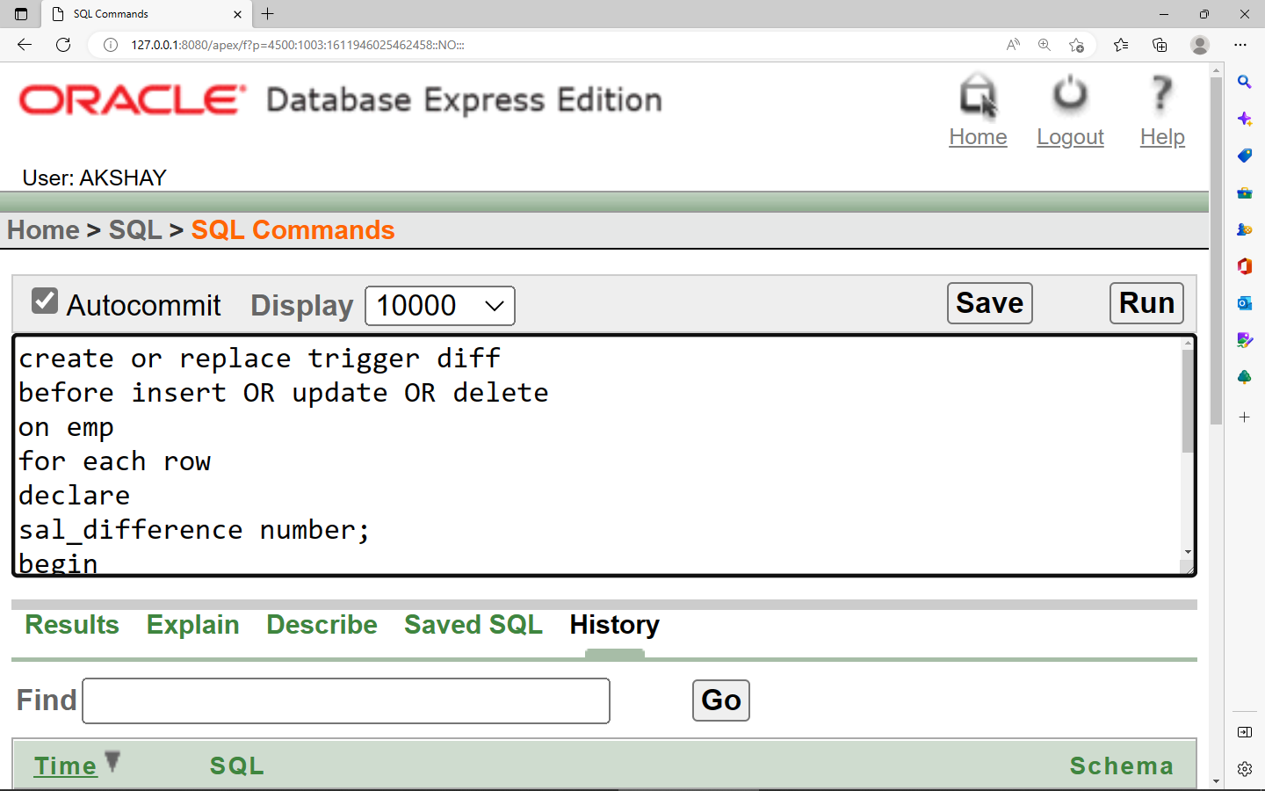

## 

## 6.Actual Resources Used:

|  |  |  |  |  |
| --- | --- | --- | --- | --- |
| **Sr.**  **No.** | **Name of resource / material** | **Specification** | **Quantity** | **Remarks** |
| 1 | Computer | WINDOWS 11,8 GB  RAM | 1 |  |
| 2 | Operating System | WINDOWS 11 | 1 |  |
| 3 | Software | Oracle Database 10G | 1 |  |
| 4 | Browser | Google Chrome | 1 |  |

**7.Outputs of Micro-Projects:**

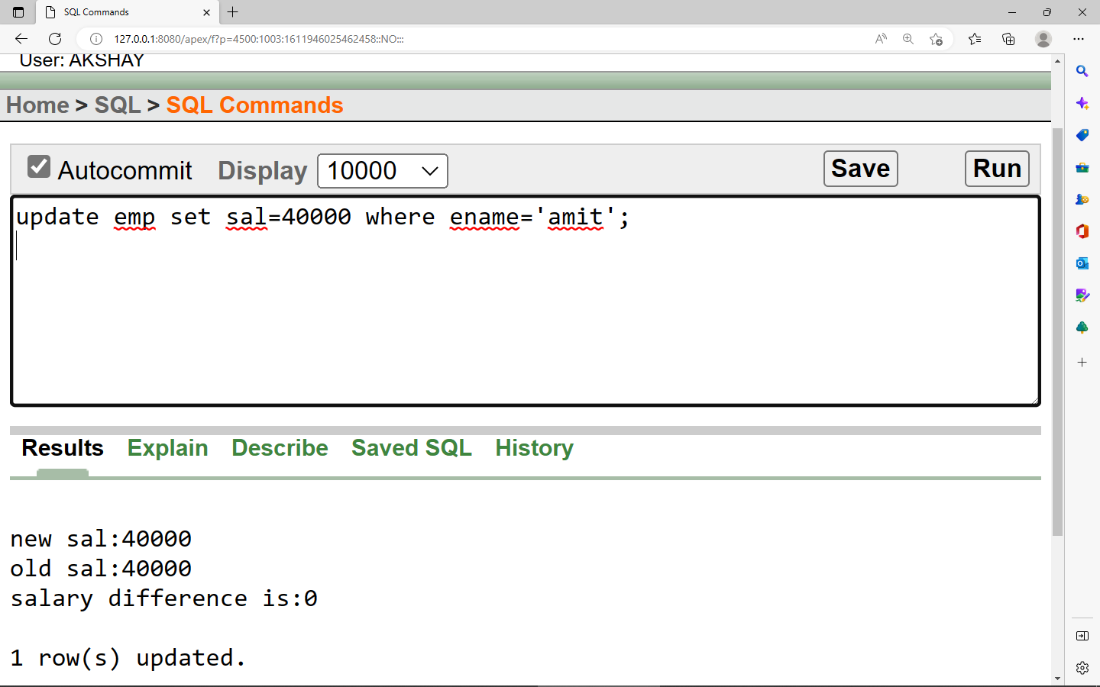

## 7.Skill developed / Learning out of this Micro-Project:

* + You can call stored procedures and functions from inside a trigger.
  + You can use triggers to implement referential integrity across databases. Unfortunately, SQL Server doesn't allow the creation of constraints between objects on different databases, but by using triggers you can simulate the behavior of constraints.

## 8.Applications of this Micro-Project:

By using a trigger you can keep track of the changes on a given table by writing a log record with information about the user that made the change and what was changed.