Index

|  |  |  |
| --- | --- | --- |
| **Sr. No.** | **Contents** | **Page No.** |
| **1** | **Annexure I– Micro Project Proposal** | **1-2** |
| 1.Aims/Benefits of the Micro-Project | 1 |
| 2. Course Outcome Addressed | 1 |
| 3.Proposed Methodology | 1 |
| 4. Action Plan | 2 |
| 5. Resources Required | 3 |
| 6. Name of Team Members with Roll No.’s | 3 |
| **2** | **Annexure II – Micro Project Report** | **3-8** |
| 1.Rationale | 4 |
| 2.Aims/Benefits of the Micro-Project | 4 |
| 3.Course Outcome Achieved | 4 |
| 4. Literature Review | 5 |
| 5.Actual Methodology Followed | 6-10 |
| 5.1 algorithm | 6-7 |
| 5.2 flowchart | 6-10 |
| 5.3 program |  |
| 6.Actual Resources Used | 11 |
| 7.Outputs of Micro-Projects | 11 |
| 8. Skill developed / Learning out of this Micro-Project | 12 |
| 9. Applications of this Micro-Project | 12 |

## Annexure I

**Micro Project Proposal**

# javaprogrambot

## Aims/Benefits of the Micro-Project:

* Applying the basic knowledge of Java for building project.
* Simple and interesting project that will help us in education.
* Chatting using CMD ,an interesting fact.

## Course Outcome Addressed:

* CO-1: implement Exception Handling.
* CO-2: Develop programs using object oriented methodology in java.
* CO-3:develop programs using multithreading.

## Proposed Methodology:

Java is simple and efficient language for application building and projects. This project is build on applying basic knowledge of java that has been earned through this course or subject. Use of classes, exception handling, string and thread method are applied for this project.

1. **Action Plan:**

|  |  |  |  |  |
| --- | --- | --- | --- | --- |
| **Sr.**  **No.** | **Details of Activity** | **Planned**  **Start date** | **Planned**  **Finish date** | **Name of Responsible**  **Team Members** |
| 1 | Search the information of  Topic | 10-02-2023  2:00 – 3:00 PM | 11-02-2023  2:00 – 3:00 PM | Kunal Nitin Nalwade |
| 2 | Collecting information | 17-02-2023  2:00 – 3:00 PM | 03-03-2023  2:00 – 3:00 PM | Akshay Dashrath Gitte |
| 3 | Analysis of data | 04-03-2023  2:00 – 3:00 PM | 10-03-2023  2:00 – 3:00 PM | Harsh Moreshwar kale |
| 4 | Creating format of project | 11-03-2023  2:00 – 3:00 PM | 17-03-2023  2:00 – 3:00 PM | Kunal Nitin Nalwade |
| 5 | Program writing and execution | 18-03-2023  2:00 – 3:00 PM | 25-03-2023  2:00 – 3:00 PM | Harsh Moreshwar kale |
| 6 | Detailing the project | 31-03-2023  2:00 – 3:00 PM | 01-04-2023  2:00 – 3:00 PM | Akshay Dashrath Gitte |
| 7 | Overview of the project | 07-04-2023  2:00 – 3:00 PM | 08-04-2023  2:00 – 3:00 PM | Akshay Dashrath Gitte |
| 8 | Final report of project | 15-04-2023  2:00 – 3:00 PM | 21-04-2023  2:00 – 3:00 PM | Kunal Nitin Nalwade |

1. **Resources Required:**

|  |  |  |  |  |
| --- | --- | --- | --- | --- |
| **Sr. No**  **.** | **Name of resource / material** | **Specification** | **Quantity** | **Remarks** |
| 1 | Computer | WINDOWS 11,8GB  RAM | 1 |  |
| 2 | Operating System | WINDOWS 11 | 1 |  |
| 3 | Browser | Google Chrome | 1 |  |
| 4 | software | Intellij | 1 |  |

## Names of Team Members with Roll No.’s:

|  |  |  |  |
| --- | --- | --- | --- |
| **Sr.**  **No.** | **Enrollment No.** | **Name of Team Member** | **Roll No.** |
| 1 | 2110950049 | Akshay Dashrath Gitte | 01 |
| 2 | 2110950051 | Harsh Moreshwar Kale | 03 |
| 3 | 2110950099 | Kunal Nitin Nalwade | 49 |

**Mr. Sugare D.D.**

## Name and Signature of the Teacher

**Annexure – II**

**Micro Project Report**

**JAVA PROGRAM BOT**

## Rationale:

Java is simple and efficient language for application building and projects. This project is built on applying basic knowledge of java that has been earned through this course or subject.

1. **Aims/Benefits of the Micro**-**Project:**

* Applying the basic knowledge of Java for building project.
* Simple and interesting project that will help us in education.
* Chatting using CMD, an interesting fact.

## Course Outcomes Achieved:

* CO-1: implement Exception Handling.
* CO-2: Develop programs using object oriented methodology in java.
* CO-3: develop programs using multithreading.

## 4.Literature Review:

Java programming bot is a program written to save time by giving a simple command to the program by the user.

Its designed class like `ProgramSet` is holds the all progams needed to the end user. Java programming bot uses the object oriented programming of the java and types the program very fast.

**5.Actual Methodology followed**

**5.1** **Algorithm:-**

1)Ascending order:

1. Load data from offset 500 to register CL (for count).
2. Travel from starting memory location to last and compare two numbers if first number is greater than second number then swap them.
3. First pass fix the position for last number.
4. Decrease the count by 1.
5. Again travel from starting memory location to (last-1, by help of count) and compare two numbers if first number is greater than second number then swap them.
6. Second pass fix the position for last two numbers.
7. Repeated.

2)Descending order:

1. Load data from offset 500 to register CL (for count).
2. Travel from starting memory location to last and compare two numbers if first number is smaller than second number then swap them.
3. First pass fix the position for last number.
4. Decrease the count by 1.
5. Again travel from starting memory location to (last-1, by help of count) and compare two numbers if first number is smaller than second number then swap them.
6. Second pass fix the position for last two numbers.
7. Repeat.

**5.2 flowchart:**

1)Ascending order:

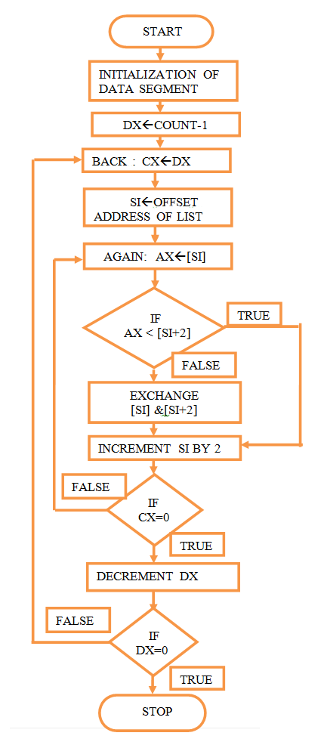

2)Descending order:

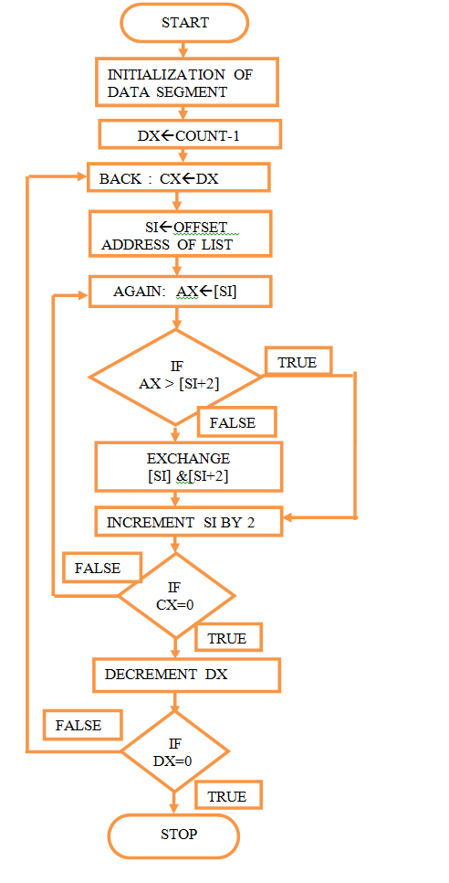

**5.3 Program:**

1)Ascending order:

ASSUME CS : CODE, DS : DATA

DATA SEGMENT

LIST DW 05H, 04H, 01H, 03H, 02H

COUNT EQU 05H

DATA ENDS

CODE SEGMENT

START: MOV AX, DATA

MOV DS, AX

MOV DX, COUNT - 1

BACK : MOV CX, DX

MOV SI,OFFSET LIST

AGAIN : MOV AX, [SI]

CMP AX, [SI + 2]

JC GO

XCHG AX, [SI + 2]

XCHG AX, [SI]

GO:INC SI

INC SI

LOOP AGAIN

DEC DX

JNZ BACK

HLT

CODE ENDS

END START

2)Descending order:

ASSUME CS : CODE, DS : DATA

DATA SEGMENT

LIST DW 03H, 04H, 01H, 05H, 02H

COUNT EQU 05H

DATA ENDS

CODE SEGMENT

START: MOV AX, DATA

MOV DS, AX

MOV DX, COUNT - 1

BACK : MOV CX, DX

MOV SI, OFFSET LIST

AGAIN : MOV AX, [SI]

CMP AX, [SI + 2]

JNC GO

XCHG AX, [SI + 2]

XCHG AX, [SI]

GO:INC SI

INC SI

LOOP AGAIN

DEC DX

JNZ BACK

HLT

CODE ENDS

END START

**6.Actual Resources Used:**

|  |  |  |  |  |
| --- | --- | --- | --- | --- |
| **Sr.**  **No.** | **Name of resource / material** | **Specification** | **Quantity** | **Remarks** |
| 1 | Computer | WINDOWS 11,8 GB  RAM | 1 |  |
| 2 | Operating System | WINDOWS 11 | 1 |  |
| 3 | Browser | Google Chrome | 1 |  |
| 4 | software | Intellij | 1 |  |

**7.Outputs of Micro-Projects:**

1. **Skill developed / Learning out of this Micro-Project:**

* Some more knowledge of Java programing is added.
* Learn to apply knowledge practically.
* Successfully applied basics of java.

## Applications of this Micro-Project:

* Useful for students in their education.
* Chatting with friends in local network, on CMD an interesting fact.