Index

|  |  |  |
| --- | --- | --- |
| **Sr. No.** | **Contents** | **Page No.** |
| **1** | **Annexure I– Micro Project Proposal** |  |
| 1.Aims/Benefits of the Micro-Project | 1 |
| 2. Course Outcome Addressed | 1 |
| 3.Proposed Methodology | 1 |
| 4. Action Plan | 2 |
| 5. Resources Required | 2 |
| 6. Name of student with roll no | 2 |
| **2** | **Annexure II – Micro Project Report** | **3-8** |
| 1.Rationale | 3 |
| 2.Aims/Benefits of the Micro-Project | 3 |
| 3.Course Outcome Achieve | 3 |
| 4. Literature Review | 4 |
| 5.Actual Methodology Followed | 5 |
| 6.Actual Resources Used | 9 |
| 7. Applications of this Micro-Project | 13 |

## Annexure I

**Micro Project Proposal**

# {MICROPROJECT_TITLE}

## Aims/Benefits of the Micro-Project:

* 1. Recognize the vast diversity of living organisms in terms of variety of size and complexity.
  2. Explain the meaning of biodiversity.
  3. Describe the levels of biodiversity.
  4. Appreciate the need for classification of living organisms.
  5. Justify the rationale underlying the five kingdom classification and the hierarchy in classification of living organisms.
  6. Argue in favor of binomial nomenclature with examples.
  7. Classify kingdom Plantae up to division; kingdom Animalia up to phyla and the chordates up to classes.
  8. Become aware of and take steps towards conserving biodiversity.

## Course Outcome Addressed:

* 1. Conserve Ecosystem and Biodiversity.

## Proposed Methodology:

Biodiversity is all the different kinds of life you’ll find in one area—the variety of animals, plants, fungi, and even microorganisms like bacteria that make up our natural world. Each of these species and organisms work together in ecosystems, like an intricate web, to maintain balance and support life.

Biodiversity supports everything in nature that we need to survive: food, clean water, medicine, and shelter.

Earth is the only planet in our solar system of eight planets on which life exists. Living organisms derive most of their requirements for survival from the non-living sources of earth. Every organism begins life as a single cell, there are plants which eat insects, and mushrooms that we relish as vegetarian food are fungi. Fungi are the group of organisms which subsist on dead and decaying matter. Certain bacteria live in oceanic vents at temperatures as high as 80ºC to 110 ºC.

This report deals with the diverse kinds of organisms found on earth and the ways and means of studying this vast biodiversity. It also emphasizes the need for conservation of biodiversity.

## Action Plan:

|  |  |  |  |  |
| --- | --- | --- | --- | --- |
| **Sr.**  **No.** | **Details of Activity** | **Planned Start date** | **Planned Finish date** | **Name of Responsible**  **Team Members** |
| 1 | Search the topic | 20/09/2021  4:30pm-  5:30pm | 22/09/2021  4:30pm-  5:30pm | {STUDENT_NAME} |
| 2 | Search the information | 27/09/2021  4:30pm-  5:30pm | 29/09/2021  4:30pm-  5:30pm |
| 3 | Find the meaning of Biodiversity | 04/10/2021  4:30pm-  5:30pm | 08/10/2021  4:30pm-  5:30pm |
| 4 | Find the information  about levels of biodiversity. | 11/10/2021  4:30pm-  5:30pm | 14/10/2021  4:30pm-  5:30pm |
| 5 | Five kingdoms of life. | 25/10/2021  4:30pm-  5:30pm | 29/10/2021  4:30pm-  5:30pm |
| 6 | Collecting the different images of  kingdoms | 08/11/2021  4:30pm-  5:30pm | 11/11/2021  4:30pm-  5:30pm |
| 7 | Making Index and Certificate of project | 22/11/2021  4:30pm-  5:30pm | 03/12/2021  4:30pm-  5:30pm |
| 8 | Finalizing Project with its report | 06/12/2021  4:30pm-  5:30pm | 10/12/2021  4:30pm-  5:30pm |

1. **Resources Required:**

|  |  |  |  |  |
| --- | --- | --- | --- | --- |
| **Sr. No**  **.** | **Name of resource / material** | **Specification** | **Quantity** | **Remarks** |
| 1 | Computer | WINDOWS 7,2GB RAM, 160GB HDD | 1 |  |
| 2 | Operating System | WINDOWS 7 | 1 |  |
| 3 | Browser | Chrome | 1 |  |

## Names of Team Member with Roll No:

|  |  |  |  |
| --- | --- | --- | --- |
| **Sr. No**  **.** | **Enrollment No.** | **Name of Team Member** | **Roll No.** |
| 1 | {STUDENT_ENR} | {STUDENT_NAME} | {ROLLNO} |

**{TEACHER_NAME}**

## Name and Signature of the Teacher

**Micro-Project Report**

**Annexure – II**

# {MICROPROJECT_TITLE}

## Rationale:

Biodiversity is a term used to describe the enormous variety of life on Earth. It can be used more specifically to refer to all of the species in one region or ecosystem. Biodiversity refers to every living thing, including plants, bacteria, animals, and humans. Scientists have estimated that there are around 8.7 million species of plants and animals in existence.

However, only around 1.2 million species have been identified and described so far, most of which are insects. This means that millions of other organisms remain a complete mystery.

Over generations, all of the species that are currently alive today have evolved unique traits that make them distinct from other species. These differences are what scientists use to tell one species from another.

Organisms that have evolved to be so different from one another that they can no longer reproduce with each other are considered different species. All organisms that can reproduce with each other fall into one species.

Scientists are interested in how much biodiversity there is on a global scale, given that there is still so much biodiversity to discover. They also study how many species exist in single ecosystems, such as a forest, grassland, tundra, or lake. A single grassland can contain a wide range of species, from beetles to snakes to antelopes. Ecosystems that host the most biodiversity tend to have ideal environmental conditions for plant growth, like the warm and wet climate of tropical regions. Ecosystems can also contain species too small to see with the naked eye. Looking at samples of soil or water through a microscope reveals a whole world of bacteria and other tiny organisms.

## Aims/Benefits of the Micro-Project:

* + 1. Recognize the vast diversity of living organisms in terms of variety of size and complexity.
    2. Explain the meaning of biodiversity.
    3. Describe the levels of biodiversity.
    4. Appreciate the need for classification of living organisms.
    5. Justify the rationale underlying the five kingdom classification and the hierarchy in classification of living organisms.
    6. Argue in favor of binomial nomenclature with examples.
    7. Classify kingdom Plantae up to division; kingdom Animalia up to phyla and the chordates up to classes.
    8. Become aware of and take steps towards conserving biodiversity.

## Course Outcomes Achieved:

* + 1. Conserve Ecosystem and Biodiversity.

## Literature Review:

We find living organisms all around us, even deep under the oceans and in the snow covered Arctic and Antarctica. There are organisms which are single celled and microscopic, as well as animals as large as the elephant, the rhinoceros, the hippopotamus and the whale. Have you seen the movie “Jurassic Park” by Steven Spielberg? From the movie you get an idea of how huge the dinosaurs were which roamed the earth millions of years ago and then became extinct. Also if you were to take a drop of water from the nearby pond and view it under a lens you will be amazed to see the enormous variety of organisms moving about in that drop of water. You might be wondering how many kinds of organisms there would be on earth! It is estimated that about 10 to 15 million different kinds of organisms have been found on earth including the ones that lived in the past. However, scientists have till date identified only over two million of them.

The enormous variety of organisms is termed biodiversity (bios means life and diversity means variety). There is not only diversity in size among organisms but also in complexity. eg. bacteria are simple single celled organisms and humans are made of a trillion cells and are highly complex.

All organisms have come to exist on earth because of evolution and are related through ancestry. You shall learn about evolution and its mechanism in the next (Lesson 20) entitled ‘History of Life on Earth’. The humans are at the top of the evolutionary ladder. It is sad that lots of different kinds of organisms have been lost due to the impact of human activities. Therefore, we have to be conscious and aware so that damage to the earth on which we live along with other organisms, is avoided.

### Levels of biodiversity:

All the varieties of living organisms on earth constitute biodiversity. Three levels of biodiversity have been recognized:

* + 1. Ecological/Ecosystem diversity:

Organism’s evolved features which helped them adapt to their surroundings or the ecosystems in which they live. There are different ecosystems and even related organisms living in different ecosystems may differ vastly from each other. For example tortoises are terrestrial and turtles are aquatic. Both are related but differ much especially in their feet. There is diversity of ecosystems—terrestrial ecosystems include forests, plains, deserts and mountains and aquatic ecosystems are sea, river, pond etc. Organisms living in these have evolved suitable adaptations. India has very diverse terrestrial and aquatic ecosystems.

* + 1. Species diversity:

Variety of species living in a certain geographical area constitutes species diversity. Individual organisms belonging to a particular species are similar and are able to undergo reproduction to produce fertile offspring. They cannot interbreed with another species. There is an enormous number of species of organisms as you have already learnt. It refers to the variety of genes contained within species of plants, animals and microorganisms.

* + 1. Genetic diversity:

Organisms are made of cells and cells in their nuclei contain chromosomes which bear the genes. Genes control the features of a particular species. Genes of individuals belonging to the same species are similar. Every species has a gene pool. Gene pool means all the different kinds of genes found in a species. The gene pool of a species differs from that of another species.

### Classification of organisms:

There 10-15 million species are supposed to have evolved on the earth till now. Try and calculate how much 10 million would be by adding zeroes after

1. Till now, approximately 2 million have been identified and named. How do scientists study and identify organisms? They do it by arranging organisms into groups and subgroups. Grouping of organism according to similarities and differences is termed classification. When an organism is classified into various categories a hierarchy is maintained. Accordingly, an organism belongs to Kingdom, Phylum, Class, Order, Family, Genus and Species in hierarchical order. These are groups to which an organism belongs and which express its evolutionary relationship with other organisms. Thus classification shows evolutionary relationships between organisms and is also termed Systematics. The science of classification or systematics is termed Taxonomy.

The scientific name of a human being is Homo sapiens. Homo sapiens mean the wise hominid. Humans are classified as follows:

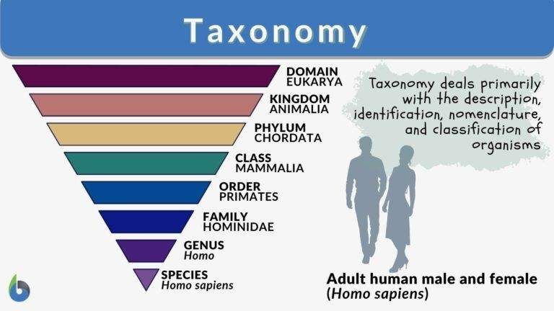

### The Three Domains of Classification:

All organisms are now classified into three major domains:

* 1. Archaebacteria are thermophilic or heat loving bacteria that live in high temperature vents.
  2. Eubacteria are single celled organisms without well-developed nucleus.
  3. Eukarya are all other organisms with a well formed nucleus in their cell/cells.

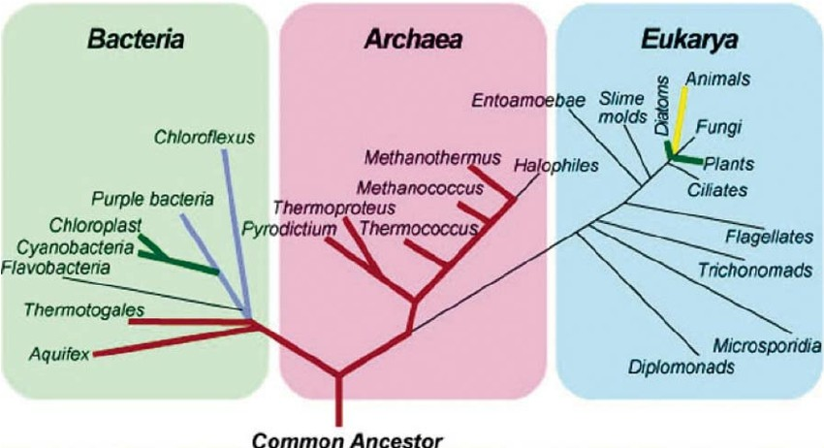

### The Five Kingdoms of Life:

Earlier there were only 2 kingdoms of plants and animals. Whittaker in 1969 suggested that bacteria should not be in plant kingdom and protozoa not in animal kingdom. He gave the five kingdom classification. Given below are the 5 kingdoms of life and their typical features.

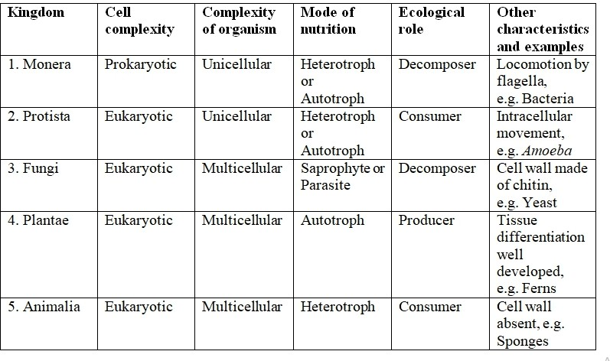

The kingdoms are further divided into divisions (as in bacteria, fungi and plantae) or phyla (as in Protoctista and Animalia). Every phylum includes several classes, Classes are divided into orders. Orders include families.

A family is made up of many genera (singular: genus). Every genus includes several species. Species are segregated from their related species under the same genus through reproductive barriers. This means that members of one species cannot interbreed with members of another species to produce fertile offspring.

### How organisms are named:

Every organism has a scientific name beside the name by which it is known in a particular language. For example, mango is its name in English, Aam in Hindi and Mangifera indica, its scientific name. In scientific naming, genus and species of the organism are mentioned. eg. Homo sapiens.

### The Scientific Name:

A Scientific name has several advantages and constitutes the specific identity of the specific organism.

1. It is understood all over the world.
2. It consists of two words, name of the Genus to which it belongs begins with a capital letter and name of the species to which it belongs, begins with a small letter e.g. cat is Felis domestica where Felis is the genus name and domestica the name of the species.
3. A scientific name is always written either in italics or underlined.
4. Having two names is the Binomial system of nomenclature (naming) introduced by the Swedish naturalist of 18th century, Carolus Linnaeus.

### Who’s Who in the Living World— Classification of Kingdoms Plantae and Animalia:

Every organism belongs to one of the five kingdoms of life.

* 1. Kingdom MONERA includes microscopic, single celled organisms with cell wall, no proper nucleus e.g. All bacteria.
  2. Kingdom PROTOCTISTA (PROTISTA)includes single celled organisms with well formed nucleus e.g. Amoeba, malarial parasite, Chlamydomonas.
  3. Kingdom FUNGI includes multicellular or many celled organisnms. The body is made of network (mycelium) of fine threads called hyphae. Fungi feed on dead decaying matter (saprotrophs) eg. Mushroom, yeast, bread mould.
  4. Kingdom PLANTAE includes: Multicellular eukaryotes with Carolus Linnaeus Fig. 19.8 Chlamydomonas SCIENCE AND TECHNOLOGY MODULE - 5 Classification of Living organisms The Living World 12 Notes cellulose cell wall and chlorophyll present in their cells Autotrophs and thus carry out photosynthesis.
  5. Kingdom ANIMALIA includes organisms with the following characteristics. Multicellular, eukaryotes. Hetrotrophic so feed on

plants or other animals Possess special organs for locomotion or movement from one place to another. Possess nervous system with sense organs.

### Classification of Plants:

Kingdom Plantae is divided into the following divisions.

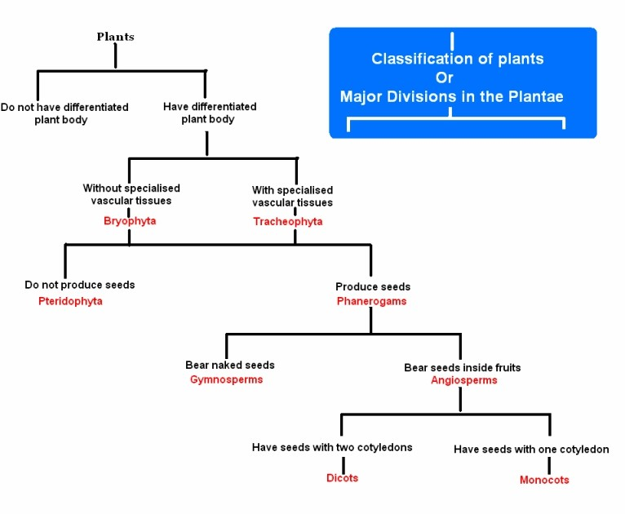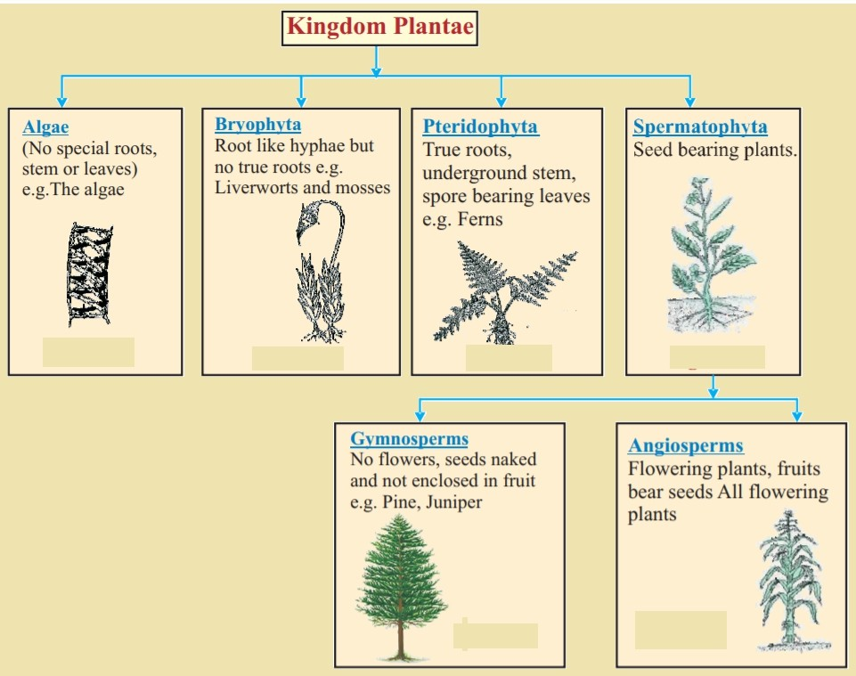

### Classification of Animals:

Kingdom Animalia is divided into the following divisions.

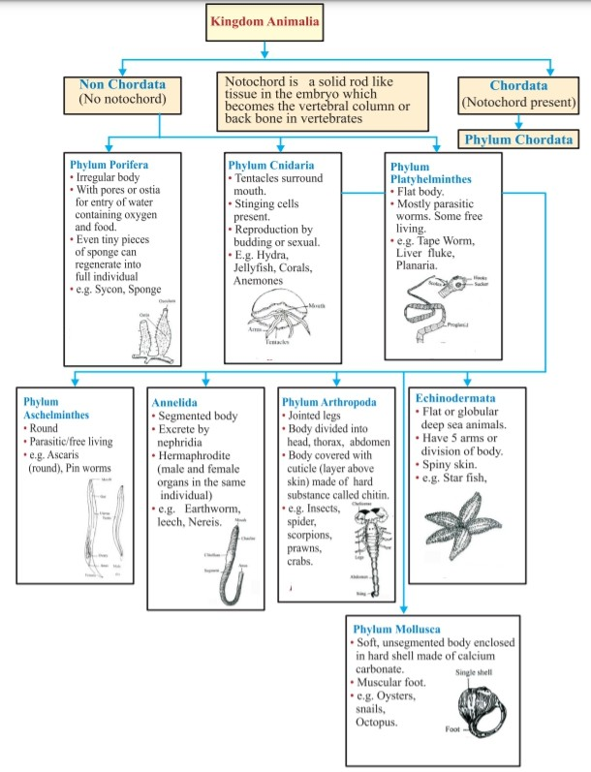

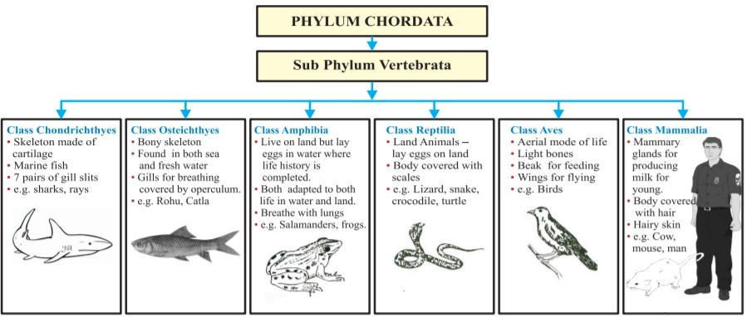

## 5 Actual Methodology Followed:

Since there is an enormous variety of living beings or organisms, their study requires dividing them into groups. Such grouping, based on similarities and differences between organisms is termed classification or systematics. Such grouping expresses evolutionary relationships between organisms as all organisms have resulted through the process of evolution. Study of classification is Taxonomy.

## Actual Resources Used:

|  |  |  |  |  |
| --- | --- | --- | --- | --- |
| **Sr.**  **No.** | **Name of resource / material** | **Specification** | **Quantit y** | **Remarks** |
| 1 | Computer | WINDOWS 7,2GB  RAM, 160GB HDD | 1 |  |
| 2 | Operating System | WINDOWS 7 | 1 |  |
| 3 | Browser | Chrome | 1 |  |

1. **Skill developed / Learning out of this Micro-Project:**

From this project we learned that:

* 1. An enormous biodiversity occurs on earth.
  2. Biodiversity is the term given to the variety of organisms that live on earth.
  3. Biodiversity exists at three levels:
     1. Ecological diversity,
     2. Species diversity
     3. Genetic diversity.
  4. All organisms are classified into three domains:

1. Archebacteria includes thermophilic bacteria.
2. Eubacteria includes all other bacteria.
3. Eukarya includes organisms other than bacteria.
   1. Further, all organisms are classified into 5 kingdoms which are based on 3 features:
      1. Prokaryotes or eukaryotes.
      2. Single celled or multicelled and
      3. Mode of feeding.
   2. Kingdom Plantae has five divisions namely Algae, Bryophyta, Pteridophyta, and Spermatophyta. Spermatophyta further divided into Gymnospermia and Angiospermia or flowering plants.
   3. Kingdom Animalia is grouped into non chordates which are further divided into the phyla Porifera, Cnidaria, Platyheminthes, Aschelminthes, Annelida, Arthropoda, Mollusca, and Echinodermata.
   4. The chordates which have notochord at some stage of life form a single phylum Chordate. Chordate vertebrates are divided into the classes Chondrichthyes (Cartilaginous fish) Osteichthyes (bony fish)

Amphibia (Frog, salamander), Reptilia (Lizards, snakes etc.) Aves (Birds) and Mammalia (rats, tigers, horses, humans).

## Applications of this Micro-Project:

1. It helps in the identification of living organisms as well as in understanding the diversity of living organisms.
2. Classification helps us to learn about different kinds of plants and animals, their features, similarities and differences.
3. It enables us to understand how complex organisms evolve from simpler organisms.

*********